End-to-End Server Performance Analytics Platform

Project Overview:
This project implements a complete end-to-end data engineering and analytics pipeline to monitor server performance metrics such as CPU usage, memory usage, uptime, and downtime. The solution follows a Bronze–Silver–Gold architecture, uses Azure Data Factory Mapping Data Flows for transformations, stores optimized data in Parquet format, visualizes insights in Power BI, and maintains full version control using GitHub.

Architecture:
Raw Server Logs + Metadata
. Azure Data Factory (ETL)
. ADLS Gen2 (Bronze, Silver, Gold)
. Power BI Dashboards

Bronze Layer:
Stores raw server logs without transformation for audit and replay purposes.
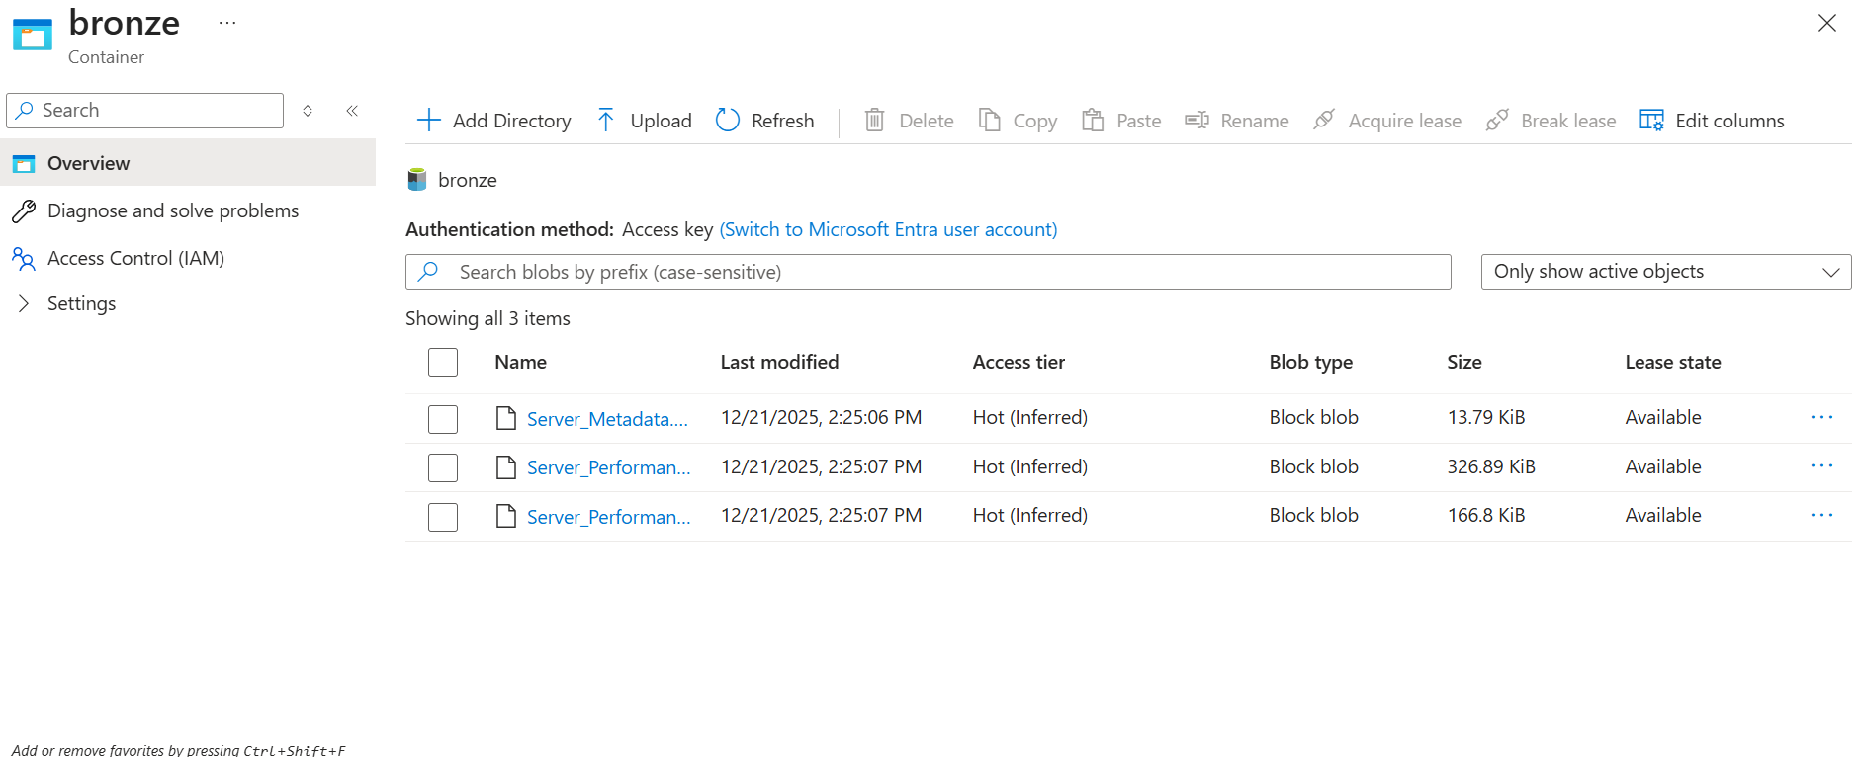

Silver Layer:
Cleansed and standardized data with null filtering, schema alignment, timestamp normalization, union of sources, and metadata joins.

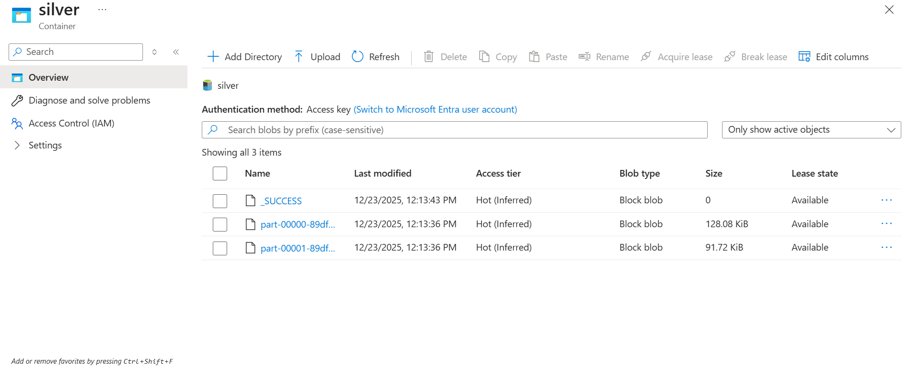

Gold Layer:
Aggregated KPIs grouped by server and date such as average CPU usage, average memory usage, total uptime, and downtime.

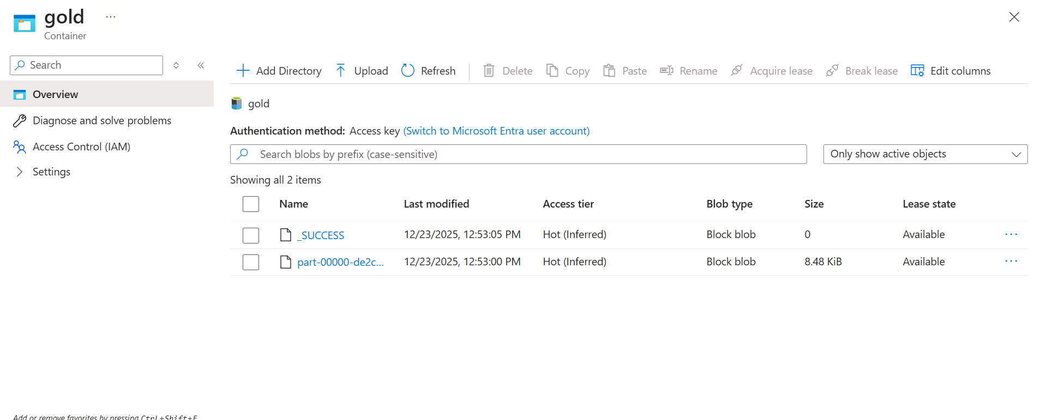

Azure Data Factory:
ADF pipelines orchestrate dataflows, manage dependencies, and load data into Silver and Gold layers.

- Bronze_To_Silver Pipeline

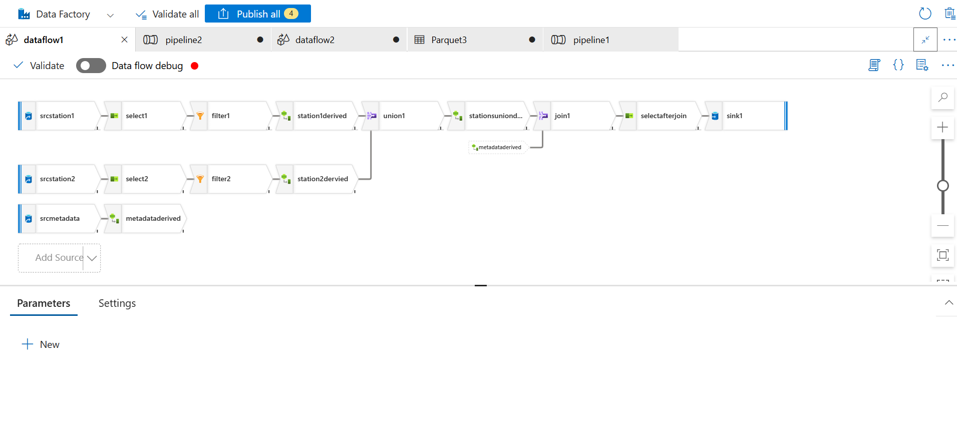
- Silver_To_Gold_Pipeline

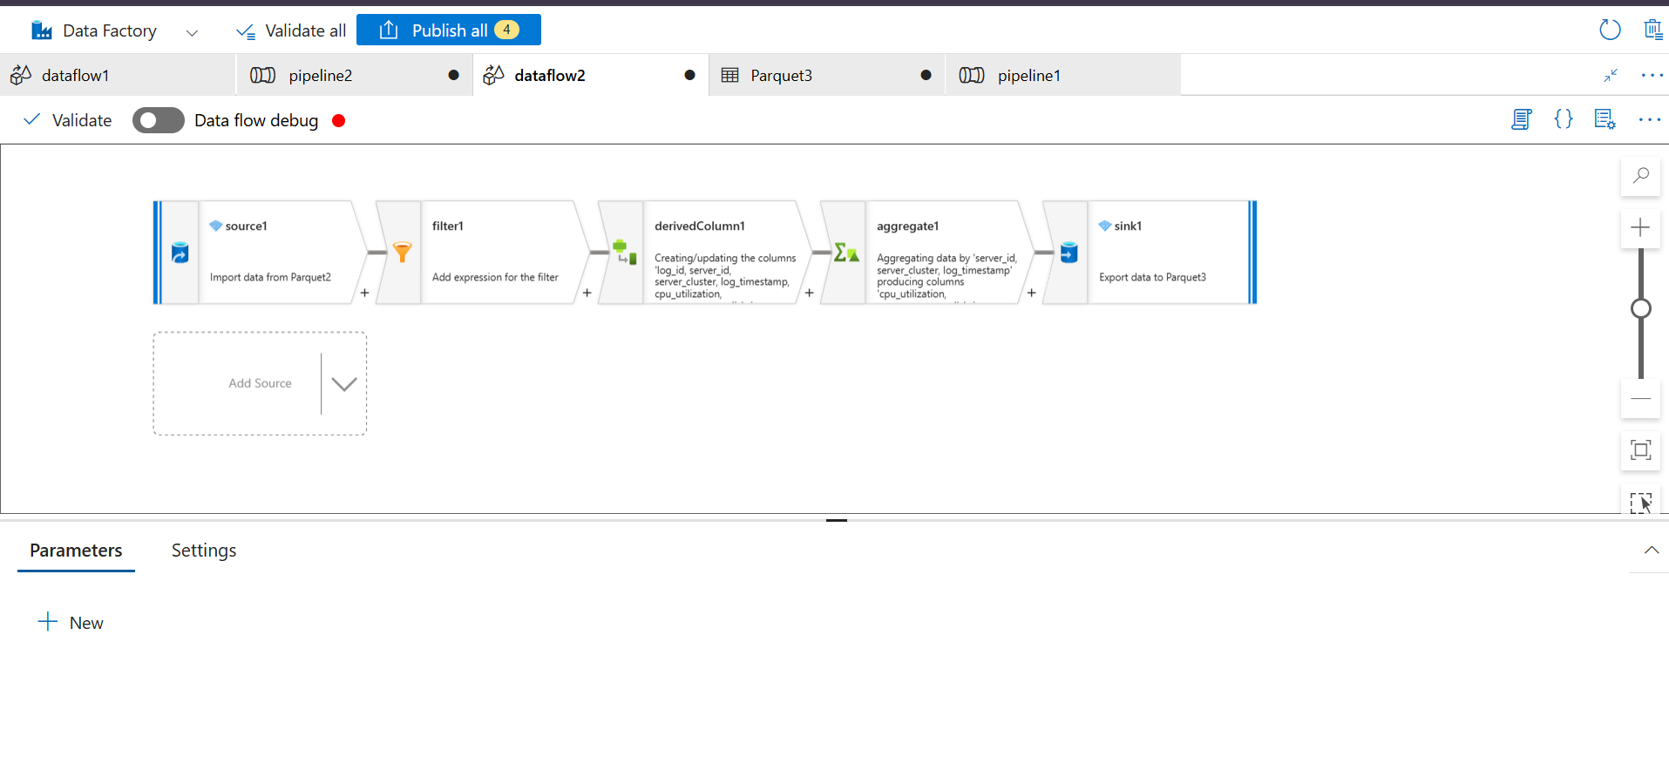
GitHub Integration:
All ADF artifacts (pipelines, dataflows, datasets, linked services) are version-controlled in GitHub using feature branches and pull requests.
Power BI Dashboard:
Includes KPI cards, trend analysis, server and cluster comparisons, scatter analysis, and slicers for interactivity.

