F74046307 林靄宏 Lab6 Report

A

1. True

Reason: Each class provides its own constructors that are specific to the class.

1. False

Reason: The “is-a” relationship represents inheritance; composition is “has-a”

1. False

Reason:Student has a is-a relationship with human and a has-a relationship with Course and Faculty.Because Student is not a king of Course or Faculty.

1. True

Reason:No matter what kind of inheritance,private member is always inaccessible to all derived classes

1. True

Reason:

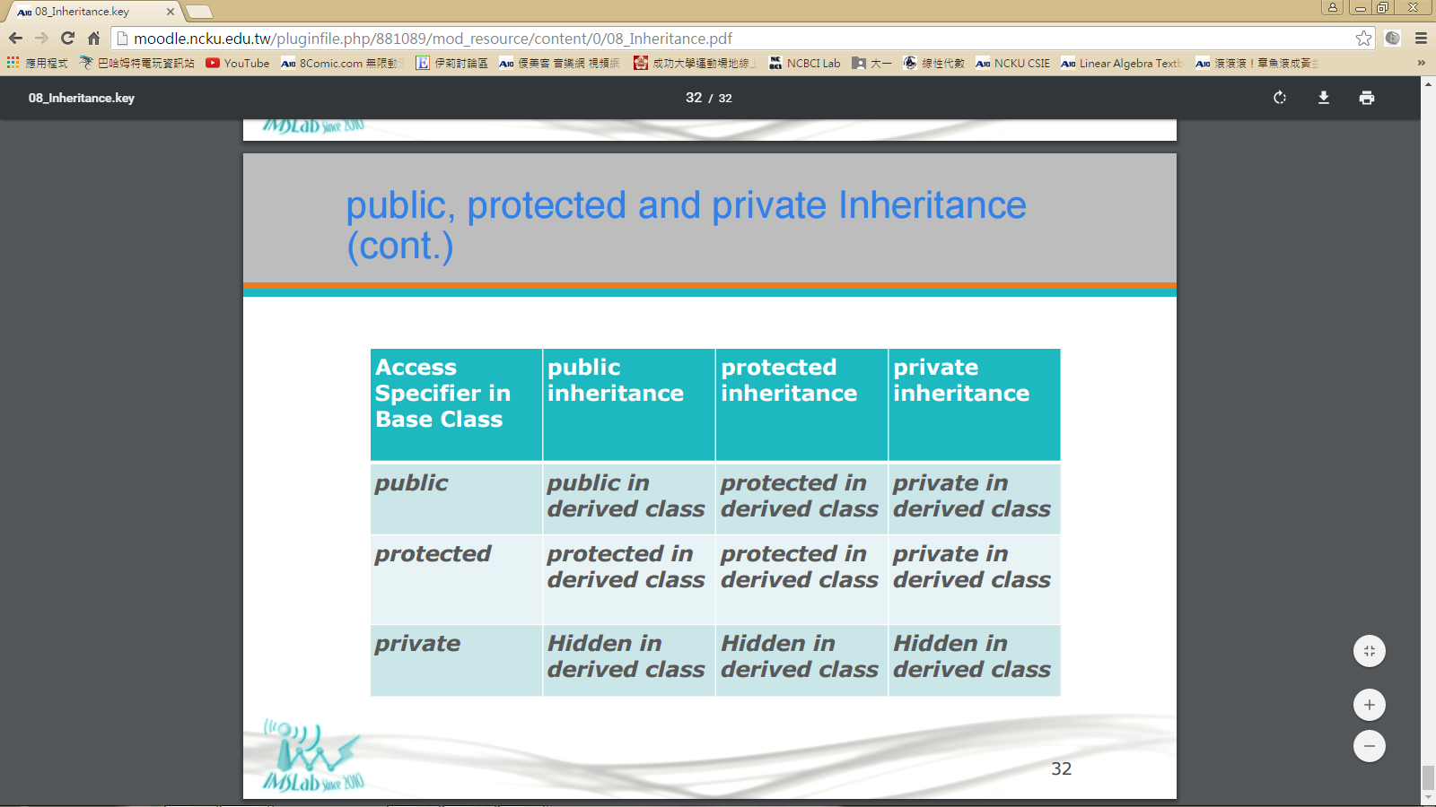 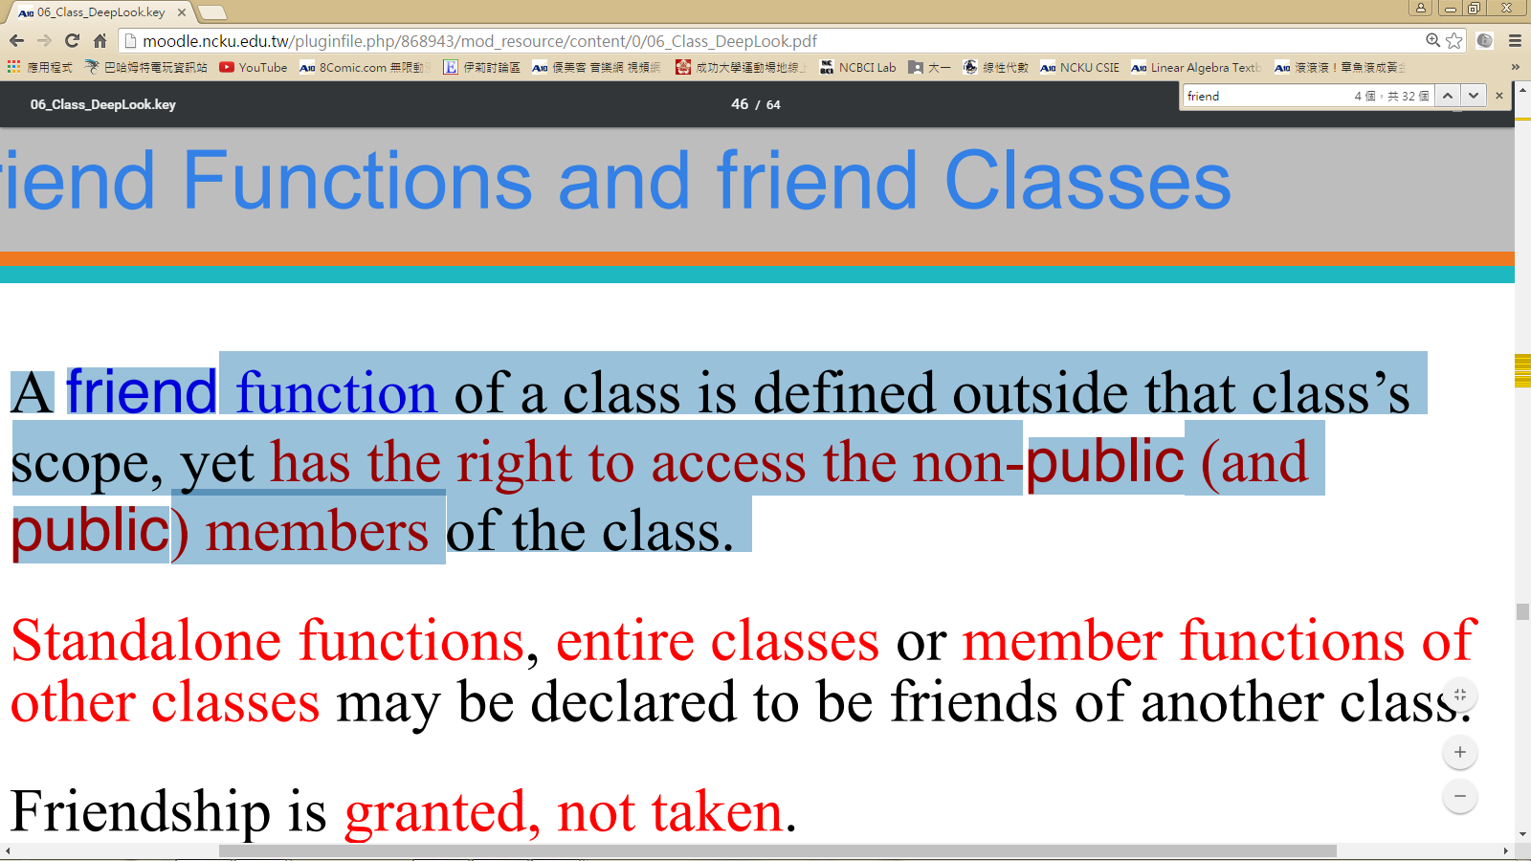

B

