# ALGORITHM

In all models we used **Decision Tree** algorithm and **Grid Search** for tuning the parameters like “max_depth” and “min_split” for getting better results.

# MODEL 1

In MODEL1 **Inputs** which will be used for training are

**-Order Created Time**

**-Location**

**-Total Orders to Assign**

**-Quantity**

**Ouput** value should be

**-Order Delivery Time**

For the better accuracy of prediction, we convert time into **sine** and **cosine** and results in numbers and graph are below.

**Results of sine graph**

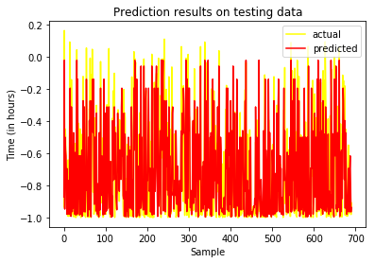

**Results of cosine graph**

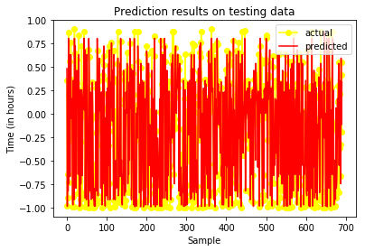

We will create formula which will merge both sine and cosine value, and give us final results in shape of minutes and hours.

MSE error is **0.05125897183684418**

R_Square is **0.7332288989702019**

Here is **Feature Importance** (It shows that, which inputs put more impact on algorithm, larger values means larger impact)

**'Qty': 0.0137901**

**'Location Code': 0.08292505**

**'Total Orders to Assign': 0.00845169**

**'Seconds_in_sine': 0.11641946**

**'Seconds_in_cosine': 0.7784137**

These results are way better than our earlier results because of time conversion in top sine and cosine. Earlier we converted time into hours and that time **R_square** was near to **0.23444**

# MODEL 2

In MODEL2 **Inputs** which will be used for training which will be

**-Biker Assigned Time**

**-Location**

**-Total Orders to Assign**

**-Quantity**

**-Biker Code**

**-Orders in Progress for Biker**

**Ouput** value should be

**-Order Delivery Time**

For the better results of prediction, First we convert time into seconds and then in **sine** and **cosine** and results are in numbers and graph below.

**Results of Sine Graph**

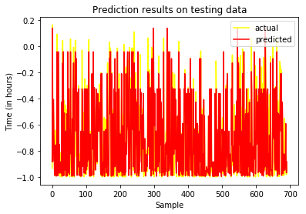

**Results of Cosine Graph**

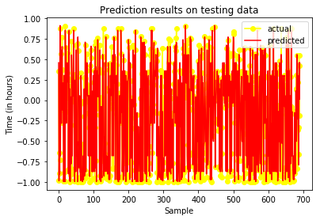

We will create formula which will merge both sine and cosine value, and give us final results in shape of minutes and hours.

Mean Squared Error **= 0.0350443492504242**

R Square **= 0.836404569414174**

Here is **Feature Importance** (It shows that, which inputs put more impact on algorithm, larger values means larger impact)

**'Seconds_in_sine': 0.09231608**

**'Seconds_in_cosine': 0.82291859**

**'Biker Code': 0.07079792**

**'Orders in Progress for Biker': 0.00412415**

**'Total Orders to Assign': 0.00376372**

**'Qty': 0.00607954**

# MODEL 3

We are also suggesting you model3 for better prediction of **Order Delivery Time**, what will happen in model3, we will get same inputs as we are taking in model2 including **Biker Accepted Time**

**Inputs**

**- Biker Accepted Time**

**-Location**

**-Total Orders to Assign**

**-Quantity**

**-Biker Code**

**-Orders in Progress for Biker**

**Ouput** value should be

**-Order Delivery Time**

For the better results of prediction, First we convert time into seconds and then in **sine** and **cosine** and results are in numbers and graph below.

**Results of Sine Graph**

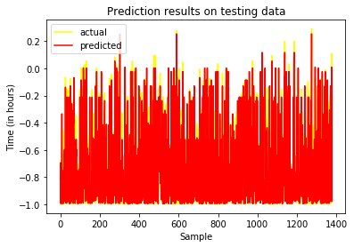

**Results of Cosine Graph**

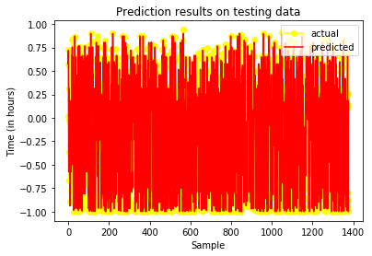

We will create formula which will merge both sine and cosine value, and give us final results in shape of minutes and hours.

Mean Squared Error **= 0.013312118612526711**

R Square **= 0.9354478618997288**

Here is **Feature Importance** (It shows that, which inputs put more impact on algorithm, larger values means larger impact)

**'Seconds_in_sine': 0.149910305**

**'Seconds_in_cosine': 0.826831101**

**'Biker Code': 0.0170844056**

**'Orders in Progress for Biker': 0.000 863075287**

**'Total Orders to Assign': 0.00 469851016**

**'Qty': 0.000 612603146**

# MODEL 4

We are also suggesting you model4 for better prediction of **Order Delivery Time**, what will happen in model4, we will get same inputs as we are taking in model3 including **Biker In Time**

**Inputs**

**- In Bike Time**

**-Location**

**-Total Orders to Assign**

**-Quantity**

**-Biker Code**

**-Orders in Progress for Biker**

**Ouput** value should be

**-Order Delivery Time**

For the better results of prediction, First we convert time into seconds and then in **sine** and **cosine** and results are in numbers and graph below.

**Results of Sine Graph**



**Results of Cosine Graph**



We will create formula which will merge both sine and cosine value, and give us final results in shape of minutes and hours.

Mean Squared Error **= 0.013312118612526711**

R Square **= 0.9354478618997288**

Here is **Feature Importance** (It shows that, which inputs put more impact on algorithm, larger values means larger impact)

**'Seconds_in_sine': 0.08.22195180**

**'Seconds_in_cosine': 0.881344472**

**'Biker Code': .0327068214**

**'Orders in Progress for Biker': 0.00 270981680**

**'Total Orders to Assign': 0.000383740410**

**'Qty':** **0.000635631540**

# Summary

As you see Model3 and Model4 is almost same because all parameters are same expect “**Biker in Time**” which is replacing “**biker accepted time**” and there is almost minor difference between both of them related to deliver y time.

We are converting time into sine and cosine because of cyclic nature time, so sine and cosine combine preserve the nature of clock , and it also gave us best accuracy.