University Of Engineering and Technology, Lahore
Computer Engineering Department

Course Name: | Course Code: CMPE-221L
Assignment Type: | Dated:
Semester: 2nd | Session: 2025 CYS FALL
Lab/Project/Assignment #: 1 | CLOs to be covered: CLO
Lab Title: Control Structures and Basic Programming in Java | Teacher Name: Hafiz Muhammad Mubashar
Lab Evaluation:

CLO1 | Apply appropriate programming techniques to create executable programs to solve well defined problems
 | Level1 | Level2 | Level3 | Level4 | Level5 | Level6
(5)
Total |  |  |  |  |  | /5
Rubrics for Current Lab Evaluation
Scale | Marks | Level | Rubric
Excellent | 5 | L1 | Submitted all lab tasks, BONUS task, have good understanding.
Very Good | 4 | L2 | Submitted the lab tasks but have good understanding
Good | 3 | L3 | Submitted the lab tasks but have weak understanding.
Basic | 2 | L4 | Submitted the lab tasks but have no understanding.
Barely Acceptable | 1 | L5 | Submitted only one lab task.
Not Acceptable | 0 | L6 | Did not attempt
LAB No 1
Lab Goals/Objectives:
- To understand the use of conditional statements in Java.
- To implement iterative statements such as for and while loops.
- To perform mathematical computations using Java.
- To develop problem-solving skills through programming.
- To understand user input handling using the Scanner class.
- To design programs based on real-world scenarios.

Equipment Required:

- IntelliJ IDEA Community Edition / NetBeans IDE

- Java Development Kit (JDK 13 or above)

- Windows Operating System

- Personal Computer or Laptop

Theory:

Introduction
Java is a high-level, object-oriented programming language that allows developers to create secure, portable, and platform-independent applications. One of the most important concepts in Java programming is control flow, which determines the order in which program statements are executed.

Scanner Class
The Scanner class is part of the java.util package and is used to receive input from the keyboard.
Syntax:
Scanner sc = new Scanner(System.in);
Example:
int number = sc.nextInt();

Conditional Statements
Conditional statements allow a program to make decisions depending on different conditions.

if Statement
Executes a block only if the condition is true.
Example
if(number > 0){
System.out.println("Positive");
}

if-else Statement
Provides two execution paths.
Example
if(number > 0){
System.out.println("Positive");
}
else{
System.out.println("Negative");
}

if-else-if
Used when multiple conditions need to be checked.
Example
if(marks >= 90){
System.out.println("A");
}
else if(marks >= 80){
System.out.println("B");
}
else{
System.out.println("C");
}

Loops
Loops execute a block repeatedly until a condition becomes false.
for Loop
Best suited when the number of iterations is known.
Syntax
for(initialization; condition; update){
// statements
}
Applications
- Factorial calculation
- Printing series
- Counting

while Loop
Executes repeatedly while the condition remains true.
Syntax
while(condition){
// statements
}
Applications
- Reversing numbers
- Division operations
- User-controlled iterations

Mathematical Operations
Java supports arithmetic operators for solving mathematical problems.
Common operators
- Addition (+)
- Subtraction (-)
- Multiplication (*)
- Division (/)
- Modulus (%)
These operators are used in factorial calculations, leap year checking, electricity bill generation, and reversing numbers.

Real-Life Applications
The concepts covered in this lab are widely used in software development, including:
- Billing systems
- Banking applications
- Calculator applications
- Student management systems
- Input validation systems
- Mathematical computation software

Lab Work:

Task 1:

Problem:

Modify the factorial program so that it displays an appropriate message when the user enters a negative number.

Code:

package Lab_1;
import java.util.Scanner;
public class Lab1_Task1 {
static int fac(int n) {
int result = 1;
int i = 1;
while (i <= n){
result = result * i;
++i;
}
return result;
// SECOND METHOD
// if (n == 0 || n == 1) {
// return 1.0F;
// }
//
// return n * (n - 1.0f);
}
static void main(String[] args) {
Scanner input = new Scanner(System.in);
int user_input;
System.out.print("Enter a number to calculate the factorial: ");
user_input = input.nextInt();
if (user_input < 0) {
System.out.print("There's No Factorial for Negative");
return;
};
System.out.println("Factorial of " + user_input + " is: " + fac(user_input));
}
}

Result:

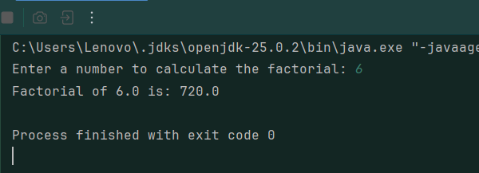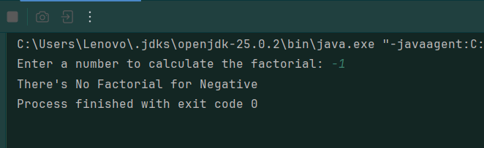

Task 2:

Problem:
Generate either an increasing or decreasing series depending upon the starting and ending values entered by the user

Code:

package Lab_1;
import java.util.Scanner;
public class Lab1_Task2 {
static void dec(int s, int e){
for(; s >= e; s--) {
System.out.print(s + " ");
}
}
static void inc(int s, int e) {
for(; s <= e; s++) {
System.out.print(s + " ");
}
}
static void main(String[] args) {
Scanner input = new Scanner(System.in);
int start, end;
System.out.print("Enter a Starting number: ");
start = input.nextInt();
System.out.print("Enter Ending number: ");
end = input.nextInt();
if (start < end){
inc(start, end);
}
else if (start > end) {
dec(start, end);
}
else {
System.out.print(start);
}
}
}

Result:

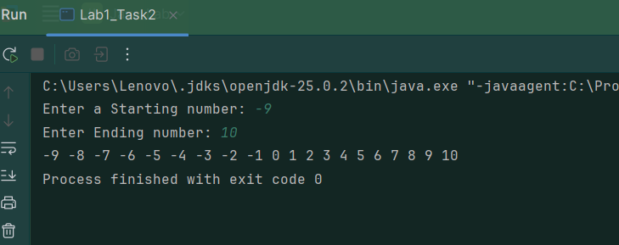

Task No.3:

Problem:

Write a Program that takes year as an input from user and determine if it’s a leap year or not.

Code:

package Tasks.Lab_1;
import java.util.*;
public class Lab1_Task3 {
static void main(String[] args) {
Scanner input = new Scanner(System.in);
int year;
System.out.print("Enter a year: ");
year = input.nextInt();
System.out.println(year % 4 == 0 ? "It is a Leap Year" : "It's not a Leap Year");
}
}

Result:

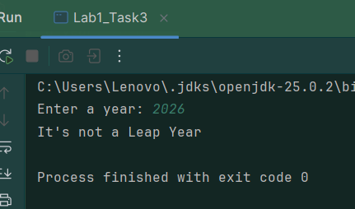
Task No. 4:

Problem:

You are interested in calculating your electricity bill of your home. You know the unit consumption of your home. Billing criteria for electric company is that it charges 5 Rs/ unit for first 100 units, next 100 units are charged at 7 Rs/unit and above that charge is 15 Rs/unit. As input, you get total_Units consumed and generate bill.

Solution:

package Tasks.Lab_1;
import java.util.*;
public class Lab1_Task4 {
static void main(String[] args) {
Scanner input = new Scanner(System.in);
float bill, units;
System.out.print("Enter a Units Consumed: ");
units = input.nextFloat();
if (units >= 0) {
if (units < 100.0f) {
bill = units * 5.0f;
}
else if (units <= 200 && units >= 100.0) {
bill = 100.0f * 5.0f + (units - 100) * 7.0f;
}
else {
bill = 100.0f * 5.0f + 100 * 7.0f + (units - 200.0f) * 15.0f;
}
System.out.println("Bill: " + bill);
}
else {
System.out.println("Negative Numbers are not allowed");
}
}
}

Result:

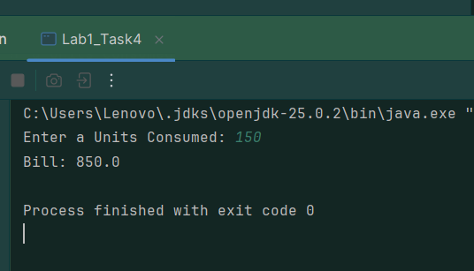

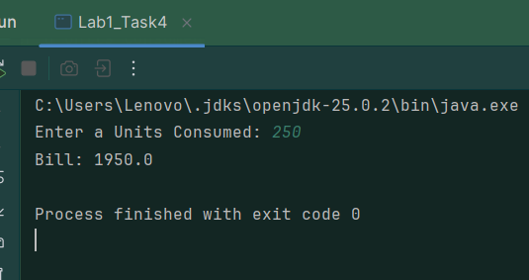

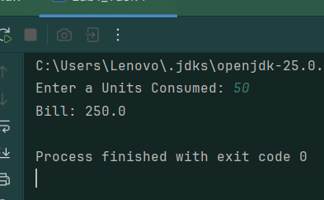
Task No. 5:

Problem:

Write a program that takes an integer n from command-line arguments and uses a while loop to compute the number of times you need to divide n by 2 until it is strictly less than 1. Print the error message “Illegal input” if n
is negative.

Code:

package Tasks.Lab_1;
import java.util.*;
public class Lab1_Task5 {
static void main(String[] args) {
Scanner input = new Scanner(System.in);
float n, temp;
int count = 0;
System.out.print("Enter a num: ");
n = input.nextFloat();
temp = n;
if (n < 1.0){
System.out.println("Illegal input");
}
while (temp >= 1){
temp = temp/2;
++count;
}
System.out.println("Div: " + count);
}
}

Result:

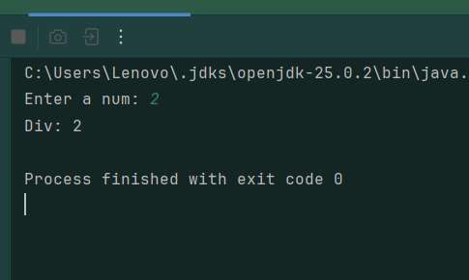
Task No. 6:

Problem:

Write a code that takes a number value from user and displays the inverse of it. Number can be of any length.

Code:

package Tasks.Lab_1;
import java.util.*;
public class Lab1_Task6 {
static int revNum(int n){
int temp = n, digit, rev = 0;
while (temp > 0){
digit = temp % 10;
rev = rev * 10 + digit;
temp /= 10;
}
return rev;
}
static void main(String[] args) {
Scanner input = new Scanner(System.in);
int num;
System.out.print("Enter a Number to Reverse: ");
num = input.nextInt();
if (num >= 0) {
System.out.println("Inverse: " + revNum(num));
}
else
{
System.out.println("Inverse: " + revNum(num * -1) * -1);
}
}

// Second Method
static int rev(int n){
return rev(n, 0);
}
private static int rev(int n, int res){
if (n <= 0){
return res;
}
return rev(n/10, res * 10 + (n % 10));
}
}

Result:

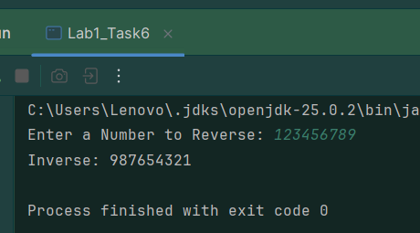

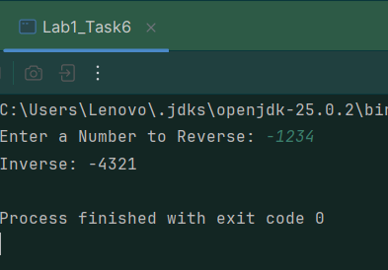

Conclusions:

This lab provided practical experience with Java programming fundamentals, including user input, conditional statements, loops, and arithmetic operations. Various real-world problems such as factorial calculation, series generation, leap year determination, electricity bill calculation, repeated division, and number reversal were implemented successfully. The lab strengthened understanding of problem-solving techniques and improved programming logic using Java control structures.

