University Of Engineering and Technology, Lahore
Computer Engineering Department

Course Name: | Course Code: CMPE-221L
Assignment Type: | Dated:
Semester: 2nd | Session: 2025 CYS FALL
Lab/Project/Assignment #: 13 | CLOs to be covered: CLO
Lab Title: Graphical User Interface (GUI) Using Java Swing | Teacher Name: Hafiz Muhammad Mubashar
Lab Evaluation:

CLO1 | Apply appropriate programming techniques to create executable programs to solve well defined problems
 | Level1 | Level2 | Level3 | Level4 | Level5 | Level6
(5)
Total |  |  |  |  |  | /5
Rubrics for Current Lab Evaluation
Scale | Marks | Level | Rubric
Excellent | 5 | L1 | Submitted all lab tasks, BONUS task, have good understanding.
Very Good | 4 | L2 | Submitted the lab tasks but have good understanding
Good | 3 | L3 | Submitted the lab tasks but have weak understanding.
Basic | 2 | L4 | Submitted the lab tasks but have no understanding.
Barely Acceptable | 1 | L5 | Submitted only one lab task.
Not Acceptable | 0 | L6 | Did not attempt
LAB No 13
Lab Goals/Objectives:
- To understand the fundamentals of Java Swing.
- To create graphical user interfaces using Swing components.
- To use labels, buttons, text fields, and panels.
- To understand event handling in Java.
- To develop interactive desktop applications.
- To validate user input using exception handling.
- To integrate object-oriented programming concepts with GUI development.
- To improve user interaction through graphical interfaces.

Equipment Required:

- IntelliJ IDEA Community Edition / NetBeans IDE

- Java Development Kit (JDK 13 or above)

- Windows Operating System

- Personal Computer or Laptop

Theory:
Introduction
A Graphical User Interface (GUI) enables users to interact with software through graphical components such as buttons, labels, text fields, menus, and windows instead of command-line instructions. Java provides the Swing library, which contains a rich collection of lightweight GUI components used to develop desktop applications.
Swing is platform-independent and follows an event-driven programming model, where user actions such as button clicks or keyboard input generate events handled by event listeners.

Java Swing
Swing is part of the javax.swing package and provides pre-built components for creating graphical applications.
Common Swing Components include:
- JFrame
- JPanel
- JLabel
- JButton
- JTextField
- JTextArea
- JComboBox
- JCheckBox
- JRadioButton
- JScrollPane

JFrame
A JFrame is the main window of a Swing application.
Example:
JFrame frame = new JFrame("Student Management");

JLabel
Displays text or images.
Example:
JLabel label = new JLabel("Enter Name");

JTextField
Allows users to enter text.
Example
JTextField txtName = new JTextField();

JButton
A clickable button used to perform actions.
Example
JButton btnCalculate = new JButton("Calculate");

Event Handling
Swing uses ActionListener to respond to button clicks.
Example
button.addActionListener(e -> {
System.out.println("Button Clicked");
});

Exception Handling in GUI
Exception handling prevents application crashes caused by invalid user input.
Example:
- Invalid numbers
- Empty fields
- Division by zero
- Percentage greater than 100

Applications of GUI
- Student Management Systems
- Banking Applications
- Hospital Management Systems
- Library Systems
- Calculator Applications
- Attendance Systems
- Inventory Management Software

Lab Work:

Task 1:
Problem Statement

Create a simple Java Swing application that displays a login form using JFrame. The form should contain labels for Username and Password along with their respective text fields. Set the frame size, layout, and default close operation, then display all components properly on the window.

Code:
package Lab_12;
import javax.swing.*;
import java.awt.*;
public class SwingWork {
static void main(String[] args) {
JFrame frame = new JFrame();
frame.setSize(1600, 800);
frame.setLocationRelativeTo(null);
frame.setLayout(null);
frame.setDefaultCloseOperation(JFrame.EXIT_ON_CLOSE);
JLabel label1 = new JLabel("Username: ");
label1.setBounds(20 , 20 , 190 , 20);
label1.setFont(new Font("Aptos ExtraBold" ,Font.BOLD , 23));
frame.add(label1);
JLabel label2 = new JLabel("Password: ");
label2.setBounds(20 , 80 , 190 , 20);
label2.setFont(new Font("Aptos ExtraBold" , Font.BOLD , 23));
frame.add(label2);
JTextField field1 = new JTextField();
field1.setBounds(190 , 20 , 80 , 20);
frame.add(field1);
JTextField field2 = new JTextField();
field2.setBounds(190 , 80 , 80 , 20);
frame.add(field2);
frame.setVisible(true);
}
}

Result:

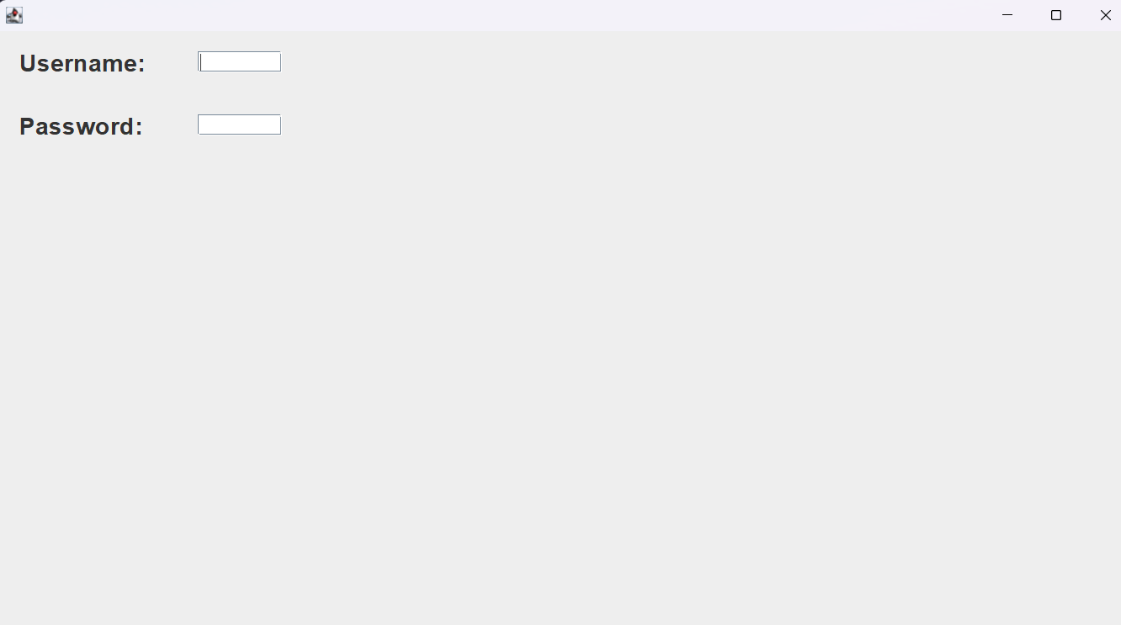

Conclusions:
This lab introduced the fundamentals of Graphical User Interface (GUI) development using Java Swing. Students learned how to create application windows using JFrame, display text using JLabel, accept user input through JTextField, and perform actions using JButton with event handling. Through practical exercises including a basic GUI window, a student information form, and a simple calculator, the lab strengthened understanding of Swing components, layout management, and event-driven programming, enabling the development of interactive and user-friendly Java desktop applications.

