University Of Engineering and Technology, Lahore
Computer Engineering Department

Course Name: | Course Code: CMPE-221L
Assignment Type: | Dated:
Semester: 2nd | Session: 2025 CYS FALL
Lab/Project/Assignment #: 1 | CLOs to be covered: CLO
Lab Title: Core Concepts of Java | Teacher Name: Hafiz Muhammad Mubashar
Lab Evaluation:

CLO1 | Apply appropriate programming techniques to create executable programs to solve well defined problems
 | Level1 | Level2 | Level3 | Level4 | Level5 | Level6
(5)
Total |  |  |  |  |  | /5
Rubrics for Current Lab Evaluation
Scale | Marks | Level | Rubric
Excellent | 5 | L1 | Submitted all lab tasks, BONUS task, have good understanding.
Very Good | 4 | L2 | Submitted the lab tasks but have good understanding
Good | 3 | L3 | Submitted the lab tasks but have weak understanding.
Basic | 2 | L4 | Submitted the lab tasks but have no understanding.
Barely Acceptable | 1 | L5 | Submitted only one lab task.
Not Acceptable | 0 | L6 | Did not attempt
LAB No 1
Lab Goals/Objectives:
- To understand the basic syntax and structure of Java programs.
- To learn how to display output using Java.
- To understand the use of comments in Java programming.
- To declare and use variables and different data types.
- To perform type casting between primitive data types.
- To use arithmetic, comparison, logical, and assignment operators.
- To manipulate strings using built-in String methods.
- To perform mathematical operations using the Math class.
- To understand and use Boolean values.
- To implement decision-making using if-else and switch statements.
- To apply these concepts by solving practical programming problems.

Equipment Required:

- IntelliJ IDEA Community Edition / NetBeans IDE

- Java Development Kit (JDK 13 or above)

- Windows Operating System

- Personal Computer or Laptop

Theory:

1. Java Syntax
Explain Java program structure, class declaration, and the main() method with an example.

2. Output Statements
Explain the difference between:
- System.out.println()
- System.out.print()
with examples.

3. Comments in Java
- Single-line comments (//)
- Multi-line comments (/* */)
- Importance of comments in programming

4. Variables
- Definition of variables
- Variable declaration
- Variable initialization
- Naming conventions
- Examples

5. Data Types
Primitive Data Types
- byte
- short
- int
- long
- float
- double
- char
- boolean
Non-Primitive Data Types
- String
- Arrays
- Classes

6. Type Casting
- Widening Casting
- Explain automatic conversion.
- Narrowing Casting
- Explain manual conversion with examples.

7. Operators
Explain:
- Arithmetic Operators
- Assignment Operators
- Comparison Operators
- Logical Operators
with examples.

8. Strings
Explain:
- String declaration
- length()
- toUpperCase()
- toLowerCase()
- indexOf()
- concat()
with examples.

9. Math Class
Explain:
- Math.max()
- Math.min()
- Math.sqrt()
- Math.abs()
- Math.random()
- Math.PI
- Math.pow()
with examples.

10. Boolean Data Type
Explain:
- true
- false
- Boolean expressions
- Practical applications

11. If...Else Statement
Explain:
- if
- if-else
- else-if ladder
with syntax and examples.

12. Switch Statement
Explain:
- switch
- case
- break
- default
with syntax and examples.

Lab Work:

Task No. 1:

The Geometry Calculator (Operators & Math).

Code:

package Tasks.Lab_2;
import java.util.Scanner;
public class Lab2_Task1 {
public static void main(String[] args) {
Scanner input = new Scanner(System.in);
double radius, area;
System.out.print("Radius of circle: ");
radius = input.nextDouble();
area = Math.PI * Math.pow(radius, 2);
System.out.printf("Area = %.4f\n", area);
System.out.println("Area (in integer) = " + (int) area);
input.close();
}
}

Result:

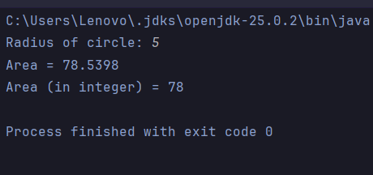
Task No. 2:

String Analysis Tool (Strings)
Code:

package Tasks.Lab_2;
import java.util.*;
public class Lab2_Task2 {
public static void main(String[] args) {
Scanner input = new Scanner(System.in);
String fullName, Capital_Name;
int len;
System.out.print("Enter Your Full Name: ");
fullName = input.nextLine().trim();
len = fullName.length();
System.out.println("Length: " + len);
Capital_Name = fullName.toUpperCase();
System.out.println(Capital_Name);
System.out.println("Space at your name is: " + fullName.indexOf(" "));
input.close();
}
}

Result:

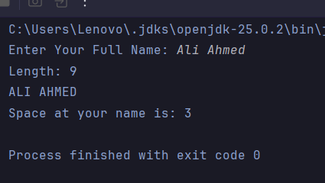

Task No.3:

Automatic Grade Converter (Type Casting).

Code:

package Tasks.Lab_2;
public class Lab2_Task3 {
public static void main(String[] args) {
double percentage = 85.99;
System.out.printf("Your raw score is: %.2f%% but your rounded grade is: %d%%", percentage, (int) percentage);
}
}

Result:

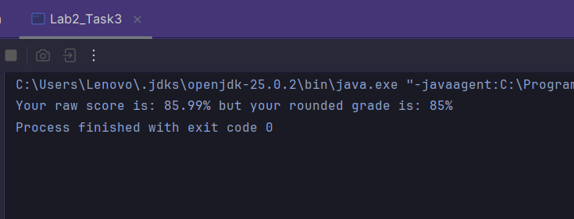
Task No. 4:

The Logical Gatekeeper (Logical Operators)

Code:

package Tasks.Lab_2;
import java.util.*;
public class Lab2_Task4 {
static Scanner input = new Scanner(System.in);
static boolean ID_check() {
System.out.print("Do you have ID? (Yes OR No) \n> ");
return input.next().equalsIgnoreCase("yes");
}
static boolean age() {
System.out.print("Are you 18 or above? (Yes OR No) \n> ");
return input.next().equalsIgnoreCase("yes");
}
public static void main(String[] args) {
boolean hasID, isOver18;
hasID = ID_check();
isOver18 = age();
if (hasID && isOver18) {
System.out.print("Access Granted");
}
else if (hasID || isOver18) {
System.out.print("Special Guest");
}
else {
System.out.print("Sorry! Not Allowed");
}
input.close();
}
}

Result:

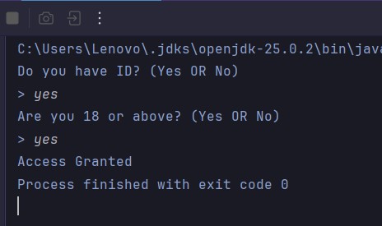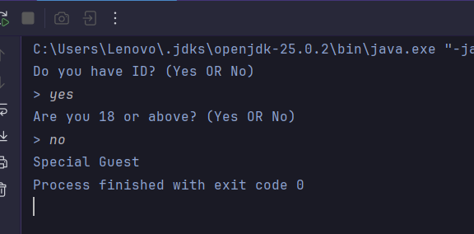
Task No. 5:

Random Number Matcher (Math & Booleans)
Code:

package Tasks.Lab_2;
public class Lab2_Task5 {
public static void main(String[] args) {
int userGuess, compGuess;
userGuess = 5;
compGuess = (int) ((Math.random() * 10) + 1); // 1-10 Random Number Assigned
System.out.print(userGuess == compGuess);
}
}

Result:

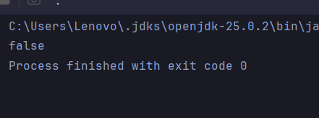
Task No. 6:

Personalized Greeting (Strings & Concatenation)
Code:

package Tasks.Lab_2;
import java.util.*;
public class Lab2_Task6 {
public static void main(String[] args) {
Scanner input = new Scanner(System.in);
int method;
String greeting = "Hello", firstName, lastName;
System.out.print("First Name: ");
firstName = input.next();
System.out.print("Last Name: ");
lastName = input.next();
method = (int) (Math.random() * 2);
switch (method){
case 0:
System.out.println("First Greeting");
System.out.println(greeting + " " + firstName + " " + lastName);
break;
case 1:
System.out.println("Second Greeting");
System.out.println(greeting.concat(" ").concat(firstName).concat(" ").concat(lastName));
break;
}
input.close();
}
}

Result:

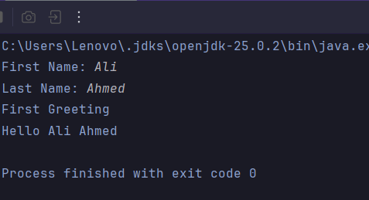

Task No. 7:

Time-of-Day Identifier (If...Else If)
Code:
package Tasks.Lab_2;
import java.util.Scanner;
public class Lab2_Task7 {
public static void main(String[] args) {
Scanner input = new Scanner(System.in);
System.out.println("Enter the current Hour: ");
int hour = input.nextInt();
if ((5 <= hour) && (hour <= 11)) {
System.out.print("Good Morning");
}
else if ((12 <= hour) && (hour <= 17)) {
System.out.println("Good Afternoon");
}
else if ((18 <= hour) && (hour <= 23)) {
System.out.println("Good Evening");
}
else {
System.out.println("Invalid Hour");
}
input.close();
}
}

Result:

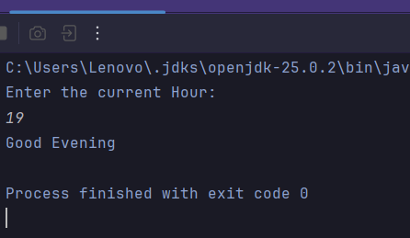

Task No. 8:

The Currency Switcher (Switch Case)
Code:

package Tasks.Lab_2;
public class Lab2_Task8 {
public static void main(String[] args) {
String currency = "USD";
switch (currency){
case "USD":
System.out.println("United States Dollar");
break;
case "GBP":
System.out.println("British Pound");
break;
case "EUR":
System.out.println("Euro");
break;
default:
System.out.println("Unknown Currency");
}
}
}

Result:

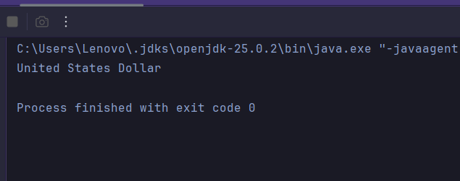

Task No. 9:

Comparison & Increment Lab (Operators)
Code:
package Tasks.Lab_2;
public class Lab2_Task9 {
public static void main(String[] args) {
int x = 10, y = 20;
System.out.println("x is not equal to y: " + (x != y));
++x;
System.out.println("Value of x: " + x);
System.out.println("Is x greater than 10: " + (x > 10));
}
}

Result:

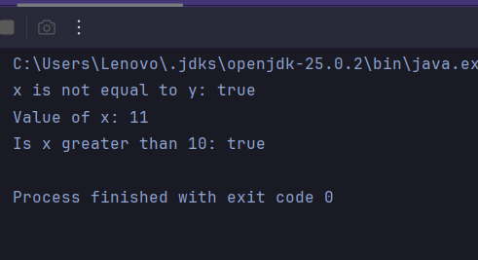

Conclusions:

Write a brief conclusion explaining that this lab helped you understand the fundamental concepts of Java programming, including syntax, variables, data types, operators, strings, type casting, mathematical functions, Boolean expressions, conditional statements, and switch statements. Mention that implementing the nine practical tasks strengthened your programming logic and improved your understanding of Java fundamentals.

