University Of Engineering and Technology, Lahore
Computer Engineering Department

Course Name: | Course Code: CMPE-221L
Assignment Type: | Dated:
Semester: 2nd | Session: 2025 CYS FALL
Lab/Project/Assignment #: 3 | CLOs to be covered: CLO
Lab Title: Getting Started with Java | Teacher Name: Hafiz Muhammad Mubashar
Lab Evaluation:

CLO1 | Apply appropriate programming techniques to create executable programs to solve well defined problems
 | Level1 | Level2 | Level3 | Level4 | Level5 | Level6
(5)
Total |  |  |  |  |  | /5
Rubrics for Current Lab Evaluation
Scale | Marks | Level | Rubric
Excellent | 5 | L1 | Submitted all lab tasks, BONUS task, have good understanding.
Very Good | 4 | L2 | Submitted the lab tasks but have good understanding
Good | 3 | L3 | Submitted the lab tasks but have weak understanding.
Basic | 2 | L4 | Submitted the lab tasks but have no understanding.
Barely Acceptable | 1 | L5 | Submitted only one lab task.
Not Acceptable | 0 | L6 | Did not attempt
LAB No 3
Lab Goals/Objectives:
- Getting started with Java programming.
- Understanding classes and objects.
- Learning abstraction and encapsulation.
- Developing reusable classes for real-world entities.
- Implementing constructors, getters, and setters.
- Practicing object-oriented programming concepts through problem-solving.
- Applying Java programming to real-life scenarios.

Equipment Required:

- IntelliJ IDEA Community Edition / NetBeans IDE

- Java Development Kit (JDK 13 or above)

- Windows Operating System

- Personal Computer or Laptop

Theory:
Introduction
Object-Oriented Programming (OOP) is a programming paradigm that organizes software around objects rather than functions. An object represents a real-world entity with attributes (data) and behaviors (methods). Java is a fully object-oriented language that supports abstraction, encapsulation, inheritance, and polymorphism. In this lab, students practice designing classes that model real-world objects and implement object-oriented solutions using Java.

1. Classes and Objects
A class is a blueprint used to create objects. It defines the attributes and methods of an object. An object is an instance of a class that occupies memory and can perform actions defined by the class.
Key Points
- Class is a user-defined data type.
- Objects store actual data.
- Multiple objects can be created from one class.
- Methods define object behavior.

2. Attributes and Methods
Attributes represent the properties of an object, while methods define the operations that the object can perform.
Example:
- Point → x, y, z coordinates
- Time → hours, minutes, seconds

3. Constructors
A constructor is a special method that initializes an object when it is created.
Characteristics:
- Same name as the class.
- No return type.
- Called automatically during object creation.

4. Encapsulation
Encapsulation is the process of hiding data by declaring variables as private and providing controlled access through getter and setter methods.
Advantages:
- Data security
- Better maintainability
- Improved code organization
- Controlled modification of data

5. Getter and Setter Methods
Getter methods retrieve private data, whereas setter methods modify private variables safely.
Example:
- getHours()
- setHours()
These methods help implement encapsulation.

6. Abstraction
Abstraction means hiding unnecessary implementation details and exposing only essential functionality to the user. It simplifies software design and improves maintainability.
Benefits include:
- Reduced complexity
- Improved readability
- Better code reusability
- Easier maintenance

7. Objects as Real-World Entities
Real-world objects can be represented using classes.
Examples:
- Point
- Time
- Bank Account
- Student
- Employee
- Car
Each object contains data members and functions that model its real-world behaviour.

8. User Input in Java
The Scanner class is used to receive input from the keyboard.
Example:
Scanner sc = new Scanner(System.in);
It allows users to enter integers, floating-point numbers, strings, and other data types.

9. Financial Calculations
Java can be used to solve practical financial problems such as savings calculations.
In this lab:
- Monthly salary
- Savings percentage
- Investment return
- Down payment
- Monthly savings
are used to calculate the number of months required to purchase a dream asset.
The calculation repeatedly updates the current savings by adding monthly savings and investment returns until the required down payment is reached.

Lab Work:

Task 1:
Modify the Point class as discussed in class: that can represent 3-D point. Modify all the existing functions such that they work for 3-D point as well
Problem
Modify the Point class so that it represents a three-dimensional point and update all existing methods accordingly.

Code:

package Tasks.Lab_3;
import java.util.Arrays;
import java.util.Scanner;
public class Lab3_Task1 {
public static void main(String[] args) {
Point p1 = new Point(1);
Point p2 = new Point(2);
Point p3;
p1.translate(5,5,5);
p3 = p1.add(p2);
System.out.println(p3);
}
}
class Point{
private int x,y,z;
int[] point = new int[3];
static Scanner input = new Scanner(System.in);
public Point(int n) {
System.out.printf("Enter Values for Point p%d: \n", n);
System.out.print("x = ");
this.setX(input.nextInt());
System.out.print("y = ");
this.setY(input.nextInt());
System.out.print("z = ");
this.setZ(input.nextInt());
}
public Point() {
}
public int getX() {
return x;
}
public void setX(int x) {
this.x = x;
point[0] = this.x;
}
public int getY() {
return y;
}
public void setY(int y) {
this.y = y;
point[1] = this.y;
}
public int getZ() {
return z;
}
public void setZ(int z) {
this.z = z;
point[2] = this.z;
}
public void translate(int x, int y, int z){
this.x += x;
this.y += y;
this.z += z;
this.point[0] = this.x;
this.point[1] = this.y;
this.point[2] = this.z;
}
public Point add(Point p){
Point result = new Point();
result.setX(this.x + p.x);
result.setY(this.y + p.y);
result.setZ(this.z + p.z);
return result;
}
@Override
public String toString() {
return Arrays.toString(point);
}
}

Result:

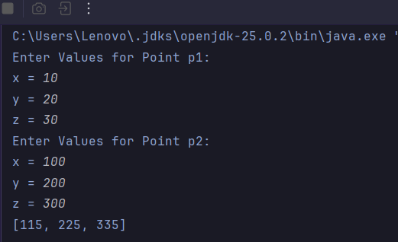
Task 2:
Think of Time as an entity. Think of attributes and functions. Implement getter setters for its attributes. And write a function whatTime( int no_of_seconds_till_noon) and sets its attributes accordingly.
Problem
Design a Time class with appropriate attributes, getter and setter methods, and implement the whatTime(int no_of_seconds_till_noon) function.

Code:

package Tasks.Lab_3;
import java.util.Scanner;
public class Lab3_Task2 {
public static void main(String[] args) {
Scanner input = new Scanner(System.in);
Time t = new Time();
System.out.print("Enter Seconds: ");
System.out.println(t.whatTime(input.nextInt()));
}
}
class Time{
private int total_seconds, s, m, h, day;
static Scanner input = new Scanner(System.in);
public int getTotal_seconds() {
return total_seconds;
}
public void setTotal_seconds(int total_seconds) {
this.total_seconds = total_seconds;
}
public int getS() {
return s;
}
public void setS(int s) {
this.s = s;
}
public int getM() {
return m;
}
public void setM(int m) {
this.m = m;
}
public int getH() {
return h;
}
public void setH(int h) {
this.h = h;
}
public int getDay() {
return day;
}
public void setDay(int day) {
this.day = day;
}
public String whatTime(int total_seconds) {
this.total_seconds = total_seconds;
convertor();
System.out.print("1) 24-Hour Format\n" +
"2) 12-Hour Format (Type Number)\n" +
">> ");
int Format = input.nextInt();
System.out.println("_______________TIME_______________");
switch (Format){
case 1:
return String.format("Day: %d\n%02d:%02d:%02d", day, h, m, s);
case 2:
if (h > 12 && h < 24){
return String.format("Day: %d\n%02d:%02d:%02d pm", day, Math.abs(h-12), m, s);
}
else if (h == 12) {
return String.format("Day: %d\n%02d:%02d:%02d pm", day, Math.abs(h), m, s);
} else if (h == 0) {
return String.format("Day: %d\n%02d:%02d:%02d am", day, 12, m, s);
} else {
return String.format("Day: %d\n%02d:%02d:%02d am", day, Math.abs(h), m, s);
}
default:
System.out.println("Enter Correct Format Option (24-Hour Format Below");
return String.format("Day: %d\n%02d:%02d:%02d", day, h, m, s);
}
}
private void convertor() {
int total_hours = total_seconds / 3600;
this.day = total_hours / 24;
this.h = total_hours % 24;
this.m = (total_seconds % 3600) / 60;
this.s = total_seconds % 60;
}
}

Result:

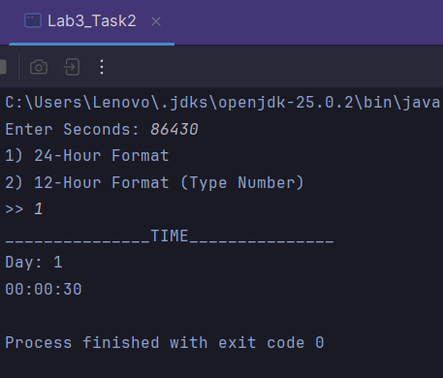

Task 3:
Write a program to calculate how many months it will take you to save up enough money for a down payment. You will want your main variables to be floats, so you should cast user inputs to floats. Your program should ask the user to enter the following variables:
1. The starting monthly salary (monthly_salary).
2. The portion of salary to be saved (portion_saved).
3. The cost of your dream home (total_cost).
Problem
Develop a savings calculator that determines the number of months required to save enough money for the down payment of a dream asset.

Code:

package Tasks.Lab_3;
import java.util.Scanner;
public class Lab3_Task3 {
static void main(String[] args) {
Scanner input = new Scanner(System.in);
float monthly_salary, portion_saved, total_cost, portion_down_payment, current_savings = 0f, r = 0.04f;
int count_months = 0;
System.out.print("Enter your monthly salary: ");
monthly_salary = input.nextFloat();
System.out.print("Enter the percent of your salary to save: ");
portion_saved = input.nextFloat()/100.0f;
System.out.print("Enter the cost of your dream home: ");
total_cost = input.nextFloat();
portion_down_payment = 0.25f * total_cost;
while (current_savings < portion_down_payment){
count_months++;
current_savings += monthly_salary * portion_saved;
current_savings += current_savings*(r/12);
}
System.out.print("Number of months: " + count_months);
}
}

Result:

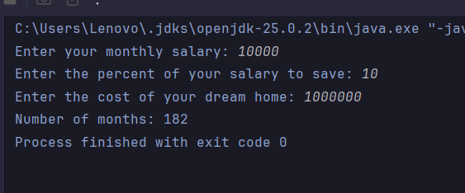

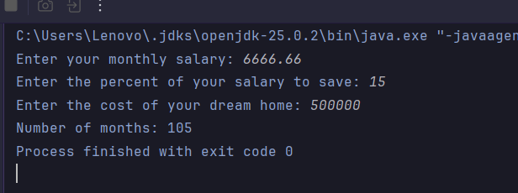

Conclusions:

This lab introduced the fundamental concepts of object-oriented programming in Java by focusing on classes, objects, abstraction, and encapsulation. Practical exercises involving a 3-D Point class, a Time class, and a savings calculator improved understanding of class design, object manipulation, getter and setter methods, and real-world problem solving. Completing these tasks strengthened programming logic and provided hands-on experience in developing reusable Java classes.

