University Of Engineering and Technology, Lahore
Computer Engineering Department

Course Name: | Course Code: CMPE-221L
Assignment Type: | Dated:
Semester: 2nd | Session: 2025 CYS FALL
Lab/Project/Assignment #: 4 | CLOs to be covered: CLO
Lab Title: Classes & Objects | Teacher Name: Hafiz Muhammad Mubashar
Lab Evaluation:

CLO1 | Apply appropriate programming techniques to create executable programs to solve well defined problems
 | Level1 | Level2 | Level3 | Level4 | Level5 | Level6
(5)
Total |  |  |  |  |  | /5
Rubrics for Current Lab Evaluation
Scale | Marks | Level | Rubric
Excellent | 5 | L1 | Submitted all lab tasks, BONUS task, have good understanding.
Very Good | 4 | L2 | Submitted the lab tasks but have good understanding
Good | 3 | L3 | Submitted the lab tasks but have weak understanding.
Basic | 2 | L4 | Submitted the lab tasks but have no understanding.
Barely Acceptable | 1 | L5 | Submitted only one lab task.
Not Acceptable | 0 | L6 | Did not attempt
LAB No 4
Lab Goals/Objectives:
- To understand the concepts of classes and objects in Java.
- To implement object-oriented programming principles using Java.
- To create and use constructors for object initialization.
- To understand the purpose of getter and setter methods.
- To learn the use of access modifiers in Java.
- To design reusable classes for real-world applications.
- To develop menu-driven applications using switch statements.
- To strengthen problem-solving skills through object-oriented programming.
Equipment Required:

- IntelliJ IDEA Community Edition / NetBeans IDE

- Java Development Kit (JDK 13 or above)

- Windows Operating System

- Personal Computer or Laptop
Theory:
Introduction
Object-Oriented Programming (OOP) is a programming paradigm that models software using objects. An object represents a real-world entity containing data (attributes) and behaviors (methods). Java is a fully object-oriented programming language that provides features such as encapsulation, abstraction, inheritance, and polymorphism. This lab focuses on designing classes, creating objects, using constructors, implementing getter and setter methods, and applying access modifiers to build reusable and maintainable software systems.

1. Classes and Objects
A class is a blueprint that defines the structure and behavior of objects, while an object is an instance of a class. Objects contain attributes to store data and methods to perform operations.
Advantages
- Code reusability
- Easy maintenance
- Better organization
- Real-world modeling

2. Constructors
A constructor is a special member of a class that initializes an object when it is created.
Types of Constructors
- Default Constructor
- Parameterized Constructor
- Copy Constructor (concept)
Features
- Same name as the class
- No return type
- Called automatically during object creation

3. Getter and Setter Methods
Getter and setter methods provide controlled access to private data members.
Getter Methods
Retrieve the values of private variables.
Example:
- getHour()
- getMinute()
Setter Methods
Modify private variables safely.
Example:
- setHour()
- setMinute()
Benefits
- Data hiding
- Controlled access
- Improved security
- Better maintainability

4. Access Modifiers
Access modifiers control the visibility of classes, methods, and variables.
- Public
Accessible from anywhere.
- Private
Accessible only within the same class.
- Protected
Accessible within the same package and subclasses.
- Default
Accessible only within the same package.
Proper use of access modifiers improves data security and supports encapsulation.

5. Encapsulation
Encapsulation is the process of combining data and methods into a single unit while restricting direct access to data through private variables.
Advantages
- Protects data
- Improves modularity
- Simplifies maintenance
- Enhances code reusability

6. Switch Statement
The switch statement allows multiple choices based on the value of an expression. It is commonly used in menu-driven applications where users select different operations.
Components
- switch
- case
- break
- default

7. Menu-Driven Programs
Menu-driven applications repeatedly display available options and allow users to perform different operations such as deposit, withdrawal, and balance inquiry.
Advantages
- User-friendly interface
- Easy navigation
- Better program organization
- Improved usability

8. Time Class
A Time class represents a timestamp using hour, minute, and second attributes. It can include constructors, getter/setter methods, and functions to calculate elapsed time or create timestamps from elapsed seconds.

9. Bank Account Class
A Bank Account class models a customer's account by maintaining the current balance and providing methods to deposit money, withdraw money, and check the account balance. This demonstrates practical implementation of classes, objects, and encapsulation.

10. Simulation Using Objects
Objects can be used to simulate real-world scenarios. In this lab, two objects (Ali and Hasan) represent independent walkers moving according to different movement rules while avoiding obstacles. Such simulations demonstrate the practical use of objects, methods, and decision-making in Java.

Lab Work:

Task 1:
Thinking of Time as an entity JTime class was created. Each object of this class represents a time-stamp (a mark in history). It has three attributes (hour, minute, second) and three constructors along with some other functions. Enhance its functionality by added following functions to it and test the functionality by updating the driver function.
Problem
Enhance the JTime class by adding methods to calculate the elapsed time between two timestamps and implement a constructor that creates a timestamp from the total number of elapsed seconds.

Code:

package Tasks.Lab_4;
import java.util.Scanner;
public class Lab4_Task1 {
public static void main(String[] args) {
Scanner input = new Scanner(System.in);
JTime t1 = new JTime(2, 15, 30);
JTime t2 = new JTime(42050);
System.out.println("Time 1: " + t1);
System.out.println("Time 2: " + t2);
int secondsDiff = t1.elapsedSeconds(t2);
System.out.println("Difference in Seconds: " + secondsDiff);
System.out.println("Do You want the time elapsed in format of another time-stamp (Yes/No): ");
String y_n = input.nextLine();
if (y_n.equalsIgnoreCase("yes")) {
System.out.println("Time Object: " + t1.Another_Format(t2));
}
}
}
class JTime {
private int h, m, s;
JTime() {
this.h = 0;
this.m = 0;
this.s = 0;
}
JTime(int h, int m, int s) {
this.h = h;
this.m = m;
this.s = s;
}
JTime(int total_seconds) {
this.h = (total_seconds / 3600) % 24;
this.m = (total_seconds % 3600) / 60;
this.s = total_seconds % 60;
}
int ConvertTotalSeconds() {
return (h * 3600) + (m * 60) + s;
}
int elapsedSeconds(JTime time_stamp_2) {
int stamp1 = this.ConvertTotalSeconds();
int stamp2 = time_stamp_2.ConvertTotalSeconds();
return Math.abs(stamp1 - stamp2);
}
JTime Another_Format(JTime time_stamp_2) {
int diff = this.elapsedSeconds(time_stamp_2);
JTime t = new JTime(diff);
return t;
}
@Override
public String toString() {
return h + ":" + m + ":" + s;
}
}

Result:

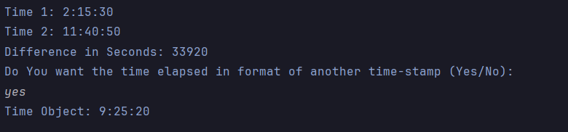

Task 2:
We are going to develop a menu-driven application to manage a simple bank account class. It supports the following operations
a. Deposit money
b. Withdraw money
c. Check balance
Problem
Develop a menu-driven Bank Account application that supports deposit, withdrawal, and balance inquiry using a switch statement.

Code:

package Tasks.Lab_4;
import java.util.Scanner;
import java.util.Random;
public class Lab4_Task2 {
public static void main(String[] args) {
Scanner input = new Scanner(System.in);
System.out.print(
"""
*-*-*-*-*-*-*-*-*-*-*-*-*-*-*-*-
Welcome to The Bank Of Punjab
*-*-*-*-*-*-*-*-*-*-*-*-*-*-*-*-
"""
);
Bank customer = new Bank();
boolean running = true;
while (running) {
System.out.println("\n========================================");
System.out.println(" MAIN MENU");
System.out.println("========================================");
System.out.println("1. Check Balance");
System.out.println("2. Deposit Money");
System.out.println("3. Withdraw Money");
System.out.println("4. Exit");
System.out.print("Enter your choice (1-4): ");
int choice = input.nextInt();
switch (choice) {
case 1:
customer.balance();
break;
case 2:
customer.deposit();
break;
case 3:
customer.withdraw();
break;
case 4:
System.out.println("Thank you for using The Bank Of Punjab. Goodbye.");
running = false;
break;
default:
System.out.println("Invalid choice. Please enter a number between 1 and 4.");
}
}
}
}
class Bank {
static Scanner input = new Scanner(System.in);
static Random ran = new Random();
// Data
private final String acc_name;
private final int acc_no;
private final int pin;
private float amount = 0.0f;
// Starting Menu
Bank(){
System.out.println(
"==========> Let's Create Your Account First <==========\n" +
"-------------------------------------------------------"
);
System.out.print("Enter Your Account Name for Your Bank Account\n" +
"> ");
acc_name = input.nextLine();
acc_no = ran.nextInt(100000,1000000);
pin = PIN();
input.nextLine();
Account_Created();
}
void Account_Created(){
System.out.println("\n====> ACCOUNT CREATED SUCCESSFULLY <====");
System.out.println("\n========================================");
System.out.println(" ACCOUNT CREATED SUCCESSFULLY");
System.out.println("========================================\n");
System.out.printf("Account Name : %s%n", acc_name);
System.out.printf("Account ID : %d%n", acc_no);
System.out.printf("Account PIN : %d%n [DON'T SHARE WITH ANYONE]", pin);
System.out.println("\n========================================");
System.out.println("⚠ Do NOT share your credentials.");
System.out.println("========================================\n");
}
int PIN(){
int pin;
while (true) {
System.out.print("Enter Four Number PIN for Your Bank Account\n" +
"> ");
pin = input.nextInt();
if (String.valueOf(pin).length() == 4) {
return pin;
}
input.nextLine();
System.out.println("---> Please Enter 4 Numbered Pin [4 NUMBERS ONLY]");
}
}
boolean pin_check(){
int pin;
for (int i = 1; i < 4; i++) {
System.out.print("Enter Pin: ");
pin = input.nextInt();
input.nextLine();
if(pin == this.pin){
return true;
}
else {
System.out.println("Wrong Pin Entered! \nEnter Pin Again.");
}
}
return false;
}
// BALANCE
void balance() {
if (pin_check()) {
System.out.println("Current Balance: " + amount + "$");
}
else {
System.out.println("Sorry You Entered Wrong Pin");
}
}
// DEPOSIT
void deposit(){
float money = 0.0f;
System.out.println("MINIMUM DEPOSIT [10$]");
while (true){
System.out.println("Enter Amount to Deposit: ");
money = input.nextFloat();
input.nextLine();
if (money >= 10.0f){
if(pin_check()) {
this.amount = this.amount + money;
break;
}
else {
System.out.println("Sorry You Entered Wrong Pin");
return;
}
}
else {
System.out.println("Please Enter a Amount of 10$ or more than 10$");
}
}
}
// WITHDRAW
void withdraw(){
float money = 0.0f;
while (true){
System.out.println("Enter Amount to Withdraw: ");
money = input.nextFloat();
input.nextLine();
if (money < 0.0f) {
System.out.println("Please Enter a valid positive amount.");
} else if (this.amount - money < 0) {
System.out.println("Insufficient Funds.");
} else {
if(pin_check()) {
this.amount = this.amount - money;
break;
}
else {
System.out.println("Sorry You Entered Wrong Pin");
return;
}
}
}
}
}

Result: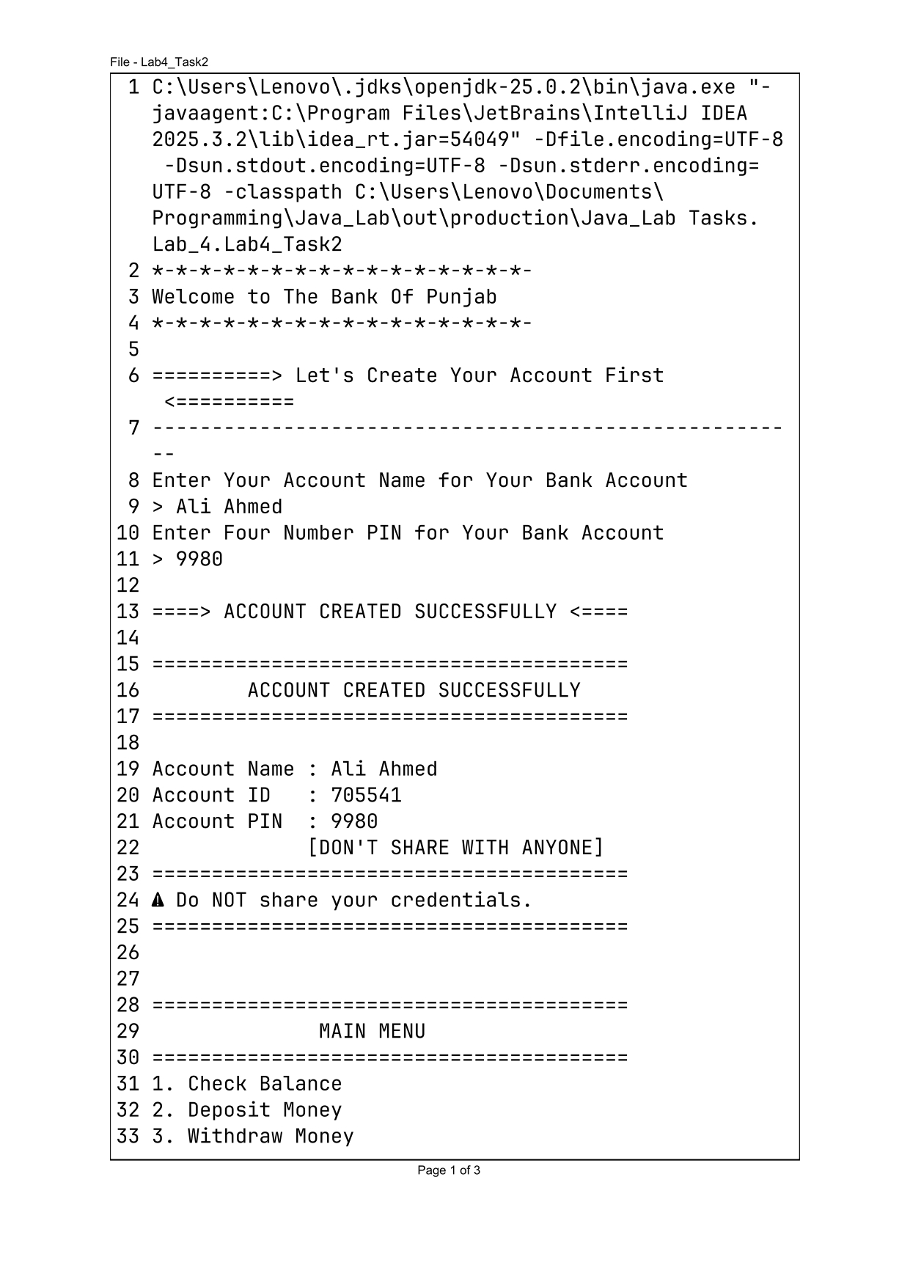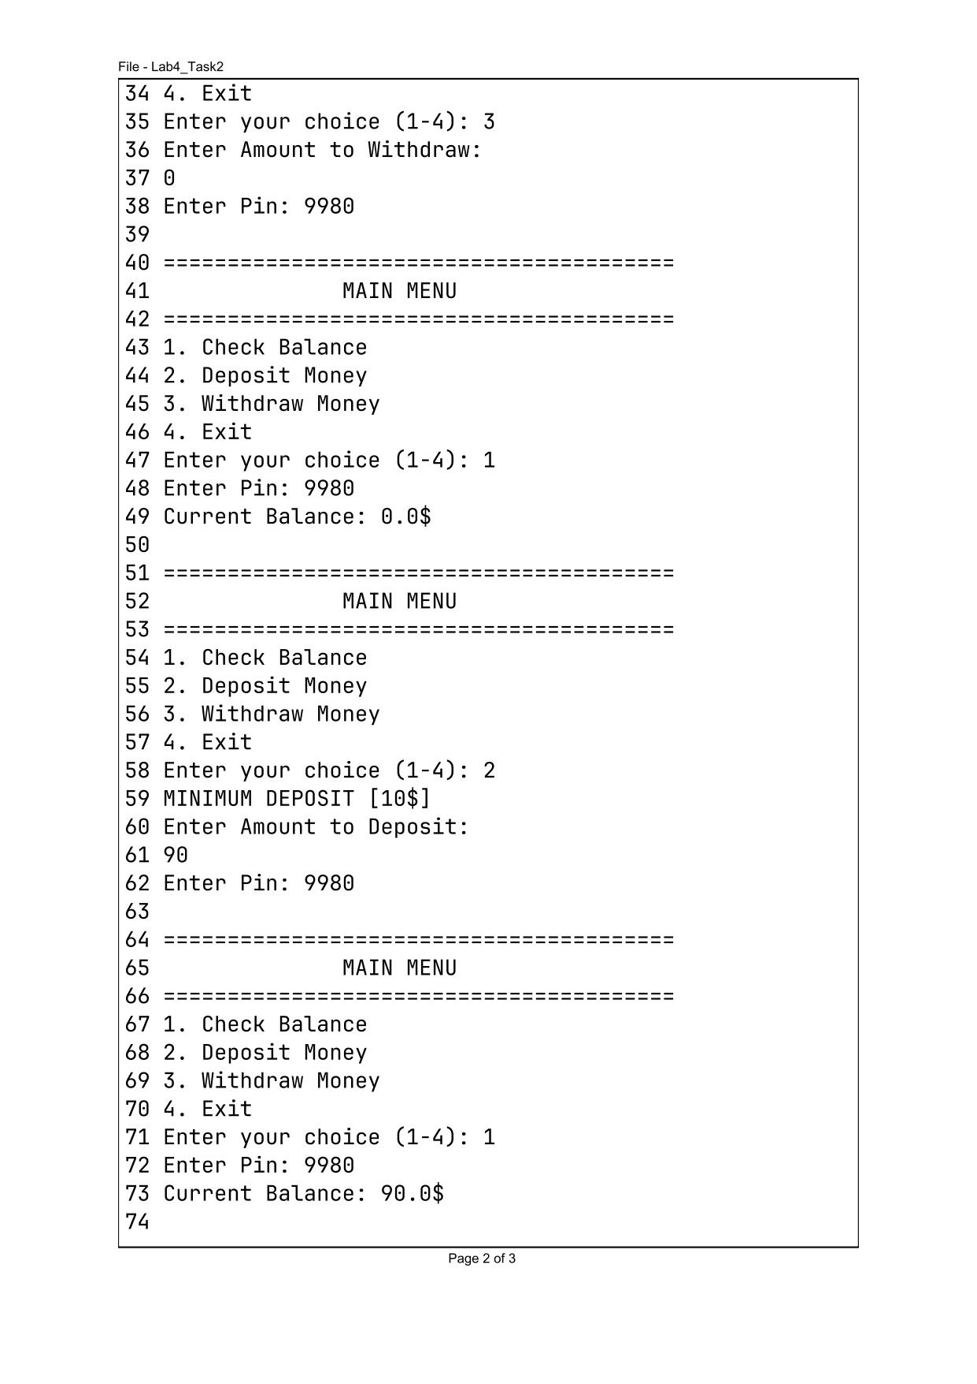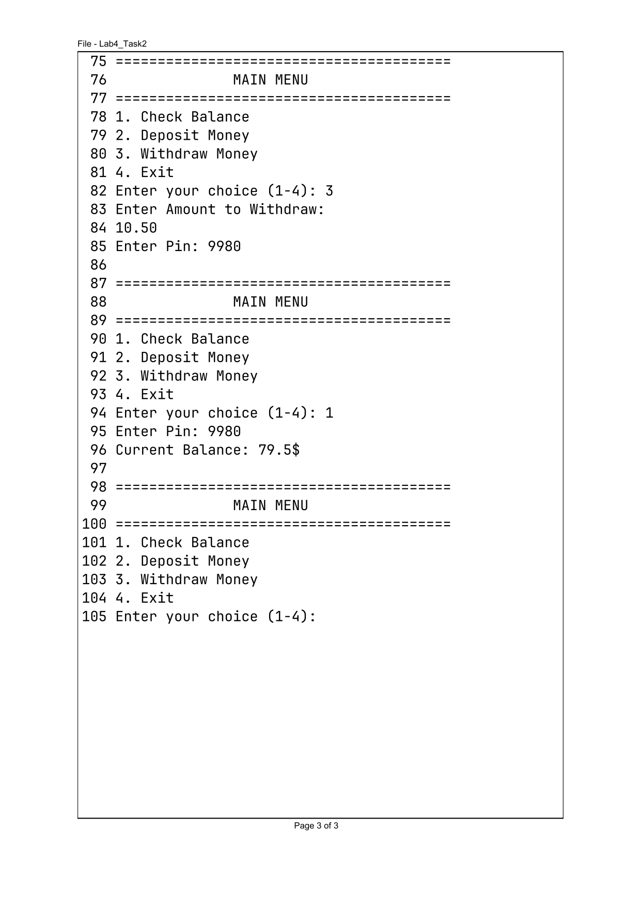

Task 3:
So lately Ali has been walking as per your instructions. Avoiding obstacles in its path. Now Hasan wants to startwalking with Ali. But Hasan will walk randomly and will avoid the same obstacles as Ali. Write a code that will simulate both the walk patterns of Ali and Hasan simultaneously.
Problem
Simulate the movement of two walkers, Ali and Hasan, where Ali follows user commands and Hasan moves randomly while avoiding obstacles.

Code:

package Tasks.Lab_4;
import java.util.Random;
import java.util.Scanner;
public class Lab4_Task3 {
public static void main(String[] args) {
Scanner input = new Scanner(System.in);
Random ran = new Random();
String arrow_Ali;
int random_Hasan;
Entity ali = new Entity();
Entity hasan = new Entity();
System.out.println("Starting Locations" +
"\nBoth Ali's and Hasan's Location is (0,0)");
System.out.println("Hasan has Random Movement, Ali follows order\n");
// HURDLES
Hurdle[] mapHurdles = {
new Hurdle(1, 2),
new Hurdle(2, 2),
new Hurdle(-1, 1),
new Hurdle(0, 3),
new Hurdle(-2, -1),
new Hurdle(3, 0),
new Hurdle(-1, -2),
new Hurdle(1, -1)
};
// ALI MOVEMENT
while (true) {
System.out.println("Where Should Ali GO");
System.out.println(" ^ [UP] ");
System.out.println(" v [DOWN] ");
System.out.println(" > [RIGHT] ");
System.out.println(" < [LEFT] ");
System.out.println(" quit [TO QUIT] ");
System.out.print("ENTER ANY FOLLOWING ARROW KEY: ");
arrow_Ali = input.nextLine();
if (arrow_Ali.equalsIgnoreCase("quit")) {
System.out.println("Game Ended! Bye...");
break;
}
System.out.println("\n\n");
switch (arrow_Ali.toLowerCase()) {
case "^":
ali.moveUp();
if (hitHurdle(ali.getX(), ali.getY(), mapHurdles)) {
System.out.println("Ali hit a hurdle.");
ali.moveDown();
}
break;
case "v":
ali.moveDown();
if (hitHurdle(ali.getX(), ali.getY(), mapHurdles)) {
System.out.println("Ali hit a hurdle.");
ali.moveUp();
}
break;
case ">":
ali.moveRight();
if (hitHurdle(ali.getX(), ali.getY(), mapHurdles)) {
System.out.println("Ali hit a hurdle.");
ali.moveLeft();
}
break;
case "<":
ali.moveLeft();
if (hitHurdle(ali.getX(), ali.getY(), mapHurdles)) {
System.out.println("Ali hit a hurdle.");
ali.moveRight();
}
break;
default:
System.out.println("Invalid input. Use ^, v, <, or >.");
continue;
}
// HASSAN MOVEMENT
random_Hasan = ran.nextInt(4);
switch (random_Hasan) {
case 0:
hasan.moveUp();
if (hitHurdle(hasan.getX(), hasan.getY(), mapHurdles)) {
System.out.println("Hasan encounters a hurdle!");
hasan.moveDown();
}
break;
case 1:
hasan.moveDown();
if (hitHurdle(hasan.getX(), hasan.getY(), mapHurdles)) {
System.out.println("Hasan encounters a hurdle!");
hasan.moveUp();
}
break;
case 2:
hasan.moveRight();
if (hitHurdle(hasan.getX(), hasan.getY(), mapHurdles)) {
System.out.println("Hasan encounters a hurdle!");
hasan.moveLeft();
}
break;
case 3:
hasan.moveLeft();
if (hitHurdle(hasan.getX(), hasan.getY(), mapHurdles)) {
System.out.println("Hasan encounters a hurdle!");
hasan.moveRight();
}
break;
}
System.out.println("\n\nHasan is at (" + hasan.getX() + ":" + hasan.getY() + ")");
System.out.println("Ali is at (" + ali.getX() + ":" + ali.getY() + ")\n");
}
}
static boolean hitHurdle(int targetX, int targetY, Hurdle[] hurdles) {
for (int i = 0; i < hurdles.length; i++) {
if (hurdles[i].getX() == targetX && hurdles[i].getY() == targetY) {
return true;
}
}
return false;
}
}
class Hurdle {
private int x, y;
Hurdle(int x, int y) {
this.x = x;
this.y = y;
}
int getX() { return x; }
int getY() { return y; }
}
class Entity {
private int x, y;
Entity() {
this.x = 0;
this.y = 0;
}
int getX() {
return x;
}
int getY() {
return y;
}
void moveUp() {
this.y++;
}
void moveDown() {
this.y--;
}
void moveRight() {
this.x++;
}
void moveLeft() {
this.x--;
}
}

Result:

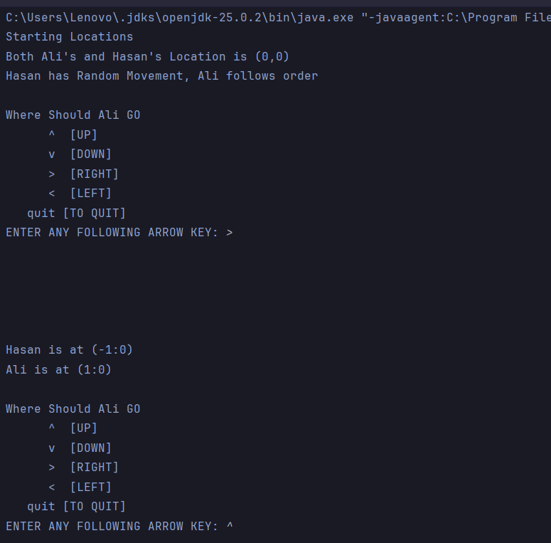
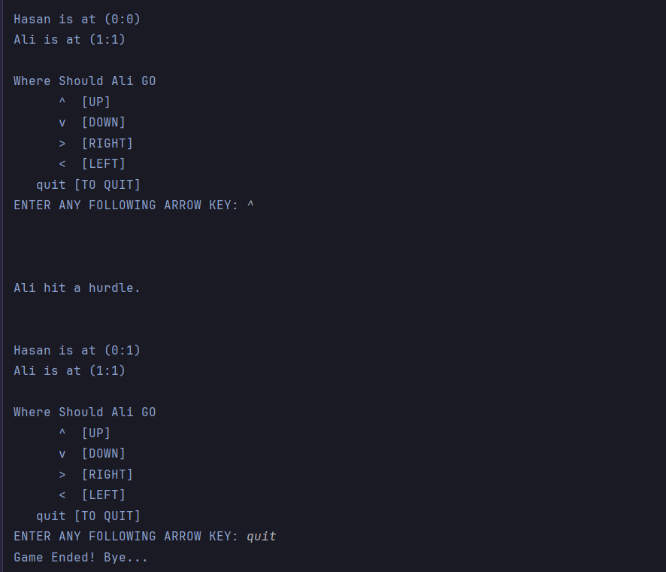

Conclusions:
This lab provided practical experience in designing classes and objects using Java. The implementation of constructors, getter and setter methods, and access modifiers strengthened the understanding of encapsulation and object-oriented design principles. Practical tasks involving the JTime class, a menu-driven Bank Account system, and a movement simulation demonstrated how Java classes can effectively model real-world problems while promoting code reusability, maintainability, and modularity.

