University Of Engineering and Technology, Lahore
Computer Engineering Department

Course Name: | Course Code: CMPE-221L
Assignment Type: | Dated:
Semester: 2nd | Session: 2025 CYS FALL
Lab/Project/Assignment #: 7 | CLOs to be covered: CLO
Lab Title: Inheritance in Java | Teacher Name: Hafiz Muhammad Mubashar
Lab Evaluation:

CLO1 | Apply appropriate programming techniques to create executable programs to solve well defined problems
 | Level1 | Level2 | Level3 | Level4 | Level5 | Level6
(5)
Total |  |  |  |  |  | /5
Rubrics for Current Lab Evaluation
Scale | Marks | Level | Rubric
Excellent | 5 | L1 | Submitted all lab tasks, BONUS task, have good understanding.
Very Good | 4 | L2 | Submitted the lab tasks but have good understanding
Good | 3 | L3 | Submitted the lab tasks but have weak understanding.
Basic | 2 | L4 | Submitted the lab tasks but have no understanding.
Barely Acceptable | 1 | L5 | Submitted only one lab task.
Not Acceptable | 0 | L6 | Did not attempt
LAB No 7
Lab Goals/Objectives:
- To understand the concept of inheritance in Java.
- To implement single inheritance using the extends keyword.
- To reuse code by inheriting methods and attributes from a parent class.
- To understand the relationship between parent and child classes.
- To access inherited methods in derived classes.
- To improve software reusability and maintainability using inheritance.
- To develop real-world applications based on inheritance.

Equipment Required:

- IntelliJ IDEA Community Edition / NetBeans IDE

- Java Development Kit (JDK 13 or above)

- Windows Operating System

- Personal Computer or Laptop

Theory:
Introduction
Inheritance is one of the fundamental concepts of Object-Oriented Programming (OOP). It allows one class to acquire the properties and behaviors of another class. The existing class is known as the parent class (superclass), while the new class is called the child class (subclass).
Inheritance promotes code reusability, reduces redundancy, and establishes an "is-a" relationship between classes. In Java, inheritance is implemented using the extends keyword.

What is Inheritance
Inheritance is the mechanism through which one class inherits the fields and methods of another class.
Syntax
class Parent{
}
class Child extends Parent{
}
Parent Class
A parent (or superclass) is the class whose members are inherited by another class.
Example:
class Animal{
public void eat(){
System.out.println("Animal is eating");
}
}

Child Class
A child (or subclass) inherits the members of the parent class and can also define its own methods.
Example
class Goat extends Animal{
public void bleat(){
System.out.println("Meh Meh");
}
}

Advantages of Inheritance
- Code Reusability
- Reduced Code Duplication
- Easier Maintenance
- Better Organization
- Extensibility
- Supports Polymorphism
- Improves Software Development Efficiency

Types of Inheritance in Java
- Single Inheritance
- Multilevel Inheritance
- Hierarchical Inheritance
(Java does not support multiple inheritance through classes but supports it using interfaces.)

The extends Keyword
The extends keyword establishes an inheritance relationship between two classes.
Example
class Goat extends Animal{
}

Method Inheritance
Child classes automatically inherit accessible methods of the parent class.
Example
Goat g = new Goat();
g.eat();

Real-World Applications
Inheritance is widely used in:
- Animal Management Systems
- Banking Systems
- Hospital Management Systems
- School Management Systems
- Vehicle Management Systems
- Employee Management Systems

Lab Work:

Task 1:
Problem
Create a parent class Animal containing a method eat(). Create a child class Goat that inherits from Animal and implements two additional methods: bleat() and graze(). Create an object of the child class and demonstrate both inherited and child-specific methods.

Code:

package Lab_6;
public class Lab6_Task3 {
public static void main(String[] args) {
Goat myGoat = new Goat();
myGoat.eat();
myGoat.bleat();
myGoat.graze();
}
}
class Animal {
public void eat() {
System.out.println("Animal is Eating");
}
}
class Goat extends Animal {
public void bleat() {
System.out.println("Meh Meh");
}
public void graze() {
System.out.println("Bakri Kah Rahi hai");
}
}

Result:

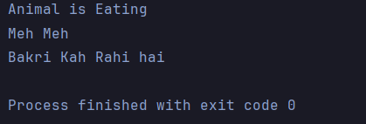

Task 2:
Problem
Create a Student class containing private attributes name and rollNo. Initialize them using a constructor and implement getter methods along with a public method to display the student's information. Create an object of the class and demonstrate the display of student details.
Code:

package Lab_7;
public class Lab7_Task1 {
static void main(String[] args) {
students st = new students("Ali", 134);
System.out.println(st.Display());
// System.out.println(st);
// System.out.println(st.get_Name());
// System.out.println(st.get_Roll_no());
}
}
class students{
private String Name;
private int Roll_no;
students(String Name, int Roll_no){
this.Name = Name;
this.Roll_no = Roll_no;
System.out.println(this.Student_Display());
//System.out.println("Name: " + Name + " Roll_No: " + Roll_no);
}
int get_Roll_no(){
return Roll_no;
}
String get_Name(){
return Name;
}
String Display(){
return Student_Display();
}
private String Student_Display(){
return "Name: " + Name + ". Roll_No: " + Roll_no;
}
// @Override
// public String toString(){
// return "Name: " + Name + ". Roll_No: " + Roll_no;
// }
}

Result:

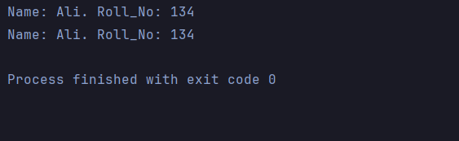

Task 3:
Problem
Create a parent class Person containing the attributes name and age along with a method displayPerson(). Create a child class Student that inherits from Person and adds a rollNo attribute and a method displayStudent(). Demonstrate inheritance by displaying both personal and student information.

Code
package Lab_7;
import java.util.Scanner;
public class Lab7_Task2 {
static void main(String[] args) {
studentsss st = new studentsss("Ali", 18, 134);
// System.out.println(st);
// st.set_Name("Hassan");
System.out.println(st.Display());
// System.out.println(st.get_Name());
// System.out.println(st.get_Roll_no());
}
}
class Person {
String Name;
int age;
Person(String Name, int age){
this.Name = Name;
this.age = age;
}
String displayPerson(){
return "Name: " + Name + ". Age: " + age;
}
}
class studentsss extends Person{
private int Roll_no;
static Scanner input = new Scanner(System.in);
studentsss(String Name, int age, int Roll_no){
super(Name, age);
this.Roll_no = Roll_no;
String choice;
System.out.println(this.displayStudent());
System.out.print("Do You want to Change your Name (yes / no): ");
choice = input.next();
if(choice.equalsIgnoreCase("yes")) set_Name();
//System.out.println("Name: " + Name + " Roll_No: " + Roll_no);
}
int get_Roll_no(){
return Roll_no;
}
String get_Name(){
return Name;
}
String Display(){
return displayStudent();
}
String displayStudent(){
return displayPerson() + ". Roll_No: " + Roll_no;
}
void set_Name(String Name){
this.Name = Name;
}
void set_Name(){
System.out.print("Name: ");
input.nextLine();
this.Name = input.nextLine();
}
// @Override
// public String toString(){
// return "Name: " + Name + ". Roll_No: " + Roll_no;
// }
}

Result:

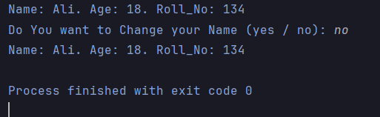

Conclusions:
This lab provided a practical understanding of Inheritance, one of the core principles of Object-Oriented Programming. By implementing parent and child classes, the concept of code reusability was effectively demonstrated. The use of the extends keyword enabled child classes to inherit methods and attributes from their parent classes while introducing additional functionality. Through the implementation of Animal–Goat, Person–Student, and Vehicle–Car examples, the lab strengthened the understanding of inheritance, class relationships, and reusable software design in Java.

