University Of Engineering and Technology, Lahore
Computer Engineering Department

Course Name: | Course Code: CMPE-221L
Assignment Type: | Dated:
Semester: | Session:
Lab/Project/Assignment #: 1 | CLOs to be covered: CLO
Lab Title: | Teacher Name: Hafiz Muhammad Mubashar
Lab Evaluation:

CLO1 | Apply appropriate programming techniques to create executable programs to solve well defined problems
 | Level1 | Level2 | Level3 | Level4 | Level5 | Level6
(5)
Total |  |  |  |  |  | /5
Rubrics for Current Lab Evaluation
Scale | Marks | Level | Rubric
Excellent | 5 | L1 | Submitted all lab tasks, BONUS task, have good understanding.
Very Good | 4 | L2 | Submitted the lab tasks but have good understanding
Good | 3 | L3 | Submitted the lab tasks but have weak understanding.
Basic | 2 | L4 | Submitted the lab tasks but have no understanding.
Barely Acceptable | 1 | L5 | Submitted only one lab task.
Not Acceptable | 0 | L6 | Did not attempt
LAB No 8
Lab Goals/Objectives:
• To understand file handling in Java.
• To create, read, write, and rename files.
• To use File, PrintWriter, FileWriter, and Files classes.
• To perform basic file operations.

Equipment Required:

• Computer/Laptop
• JDK 8+
• IntelliJ IDEA/NetBeans
• Windows OS

Theory:
Introduction
File handling is an important feature of Java that allows programs to create, read, write, rename, and manage files.
What is File Handling
File handling is the process of performing operations on files using Java.
File Class
The File class represents a file.
Example:
File file = new File("Data.txt");
Reading and Writing Files
Example:
PrintWriter writer = new PrintWriter(file);
writer.println("Hello World");
writer.close();
Advantages of File Handling
• Permanent Data Storage
• Easy Data Retrieval
• Better Data Management
Real-World Applications
• Student Management Systems
• Banking Systems
• Library Management Systems

Lab Work:

Task 1:
Problem
Create a Java program that performs basic file handling operations such as creating, renaming, writing to, and reading from a text file.
Code:
package Lab_8;
import java.io.*;
import java.nio.file.Files;
import java.nio.file.Path;
public class Lab8_Task1 {
static void main(String[] args) throws IOException {
File file = new File("Data.txt");
// Files files = new Files();
// create(file);
// file = rename(file, "Data.csv");
// System.out.println(file.getName());
write(file, "Name: Hassan\nRollNo: 166");
read(file);
}
static void create(File file) throws IOException{
if(!file.exists()) {
file.createNewFile();
System.out.println(file.exists());
}
else {
System.out.println("File Exists");
}
}
static File rename(File file, String Name){
file = null;
file = new File("C:\\Users\\Lenovo\\Documents\\Programming\\Java_Lab\\" + Name);
return file;
}
static void write(File file, String Message) throws IOException {
PrintWriter writer = new PrintWriter(file);
writer.println(Message);
writer.close();
}
static void read(File file) throws IOException {
System.out.println(Files.readString(Path.of(file.getPath())));
}
}
Result:

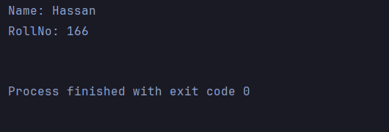

Task 2:
Problem
Create a Java program that writes data to a file using FileWriter and reads the stored data line by line using the Files class.
Code:
package Lab_8;
import java.io.*;
import java.nio.file.*;
import java.util.List;
public class Lab8_Task2 {
static String path = "Getter.txt";
static File file = new File("Getter.txt");
static void main(String[] args) throws IOException {
//create();
write(path, "Hello World..\n");
Reader(path);
}
static void Reader(String path) throws IOException {
List<String> Data = Files.readAllLines(Paths.get(path));
for(String Line : Data ){
System.out.println(Line);
}
}
// static void Read() throws IOException {
// }
static void create() throws IOException{
if(!file.exists()) {
file.createNewFile();
}
else {
System.out.println("File Exists");
}
}
static void write(String FileName, String message) throws IOException{
FileWriter fw = new FileWriter(FileName, true);
fw.write(message);
fw.close();
}
}

Result:

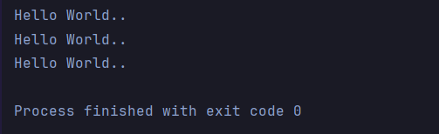

Conclusions:
In this lab, we learned the basics of file handling in Java. We performed different file operations such as creating, reading, writing, and renaming files using Java's built-in classes. We also learned how to use PrintWriter, FileWriter, File, and Files classes to manage data stored in text files. This lab strengthened our understanding of file handling and demonstrated how files can be used for permanent data storage in Java applications.

