University Of Engineering and Technology, Lahore
Computer Engineering Department

Course Name: | Course Code: CMPE-221L
Assignment Type: | Dated:
Semester: | Session:
Lab/Project/Assignment #: 1 | CLOs to be covered: CLO
Lab Title: | Teacher Name: Hafiz Muhammad Mubashar
Lab Evaluation:

CLO1 | Apply appropriate programming techniques to create executable programs to solve well defined problems
 | Level1 | Level2 | Level3 | Level4 | Level5 | Level6
(5)
Total |  |  |  |  |  | /5
Rubrics for Current Lab Evaluation
Scale | Marks | Level | Rubric
Excellent | 5 | L1 | Submitted all lab tasks, BONUS task, have good understanding.
Very Good | 4 | L2 | Submitted the lab tasks but have good understanding
Good | 3 | L3 | Submitted the lab tasks but have weak understanding.
Basic | 2 | L4 | Submitted the lab tasks but have no understanding.
Barely Acceptable | 1 | L5 | Submitted only one lab task.
Not Acceptable | 0 | L6 | Did not attempt
LAB No 9
Lab Goals/Objectives:
• To understand how to read data from an external file (CSV) into a Java program using file handling classes.
• To learn how to use the Scanner class along with File objects to read line-by-line data.
• To practice storing and organizing data using ArrayList and List collections.
• To parse and split delimited (comma-separated) string data into usable fields (name, roll number, marks).
• To perform calculations (percentage, grading) on extracted data across multiple classes.
• To apply modular programming by dividing tasks (reading data, extracting data, processing data) across separate classes/files.
• To handle exceptions such as IOException and custom RuntimeException for invalid data.

Equipment Required:

• A computer/laptop with Windows/Linux/macOS installed.
• Java Development Kit (JDK) installed (JDK 8 or later).
• An IDE or code editor (e.g., IntelliJ IDEA, Eclipse, VS Code, or NetBeans).
• A sample data file in CSV format (e.g., Book1.csv) containing student records (Name, Roll No, Marks).
• Basic knowledge of Java syntax, classes, and object-oriented programming.

Theory:
Introduction
File handling is a technique in Java that allows programs to read data from and write data to files. It helps store information permanently so that it can be accessed whenever required.
What is File Handling
File handling is the process of creating, reading, writing, and managing files using Java's built-in classes.
File Class
The File class represents a file or directory and is used to locate files on the computer.
Example:
File file = new File("Student.txt");
Scanner Class
The Scanner class is used to read data from a file line by line.
Example:
Scanner input = new Scanner(file);
Collections
ArrayList and List are commonly used to store multiple values that are read from a file.
Example:
ArrayList<String> data = new ArrayList<>();
Advantages of File Handling
• Permanent Data Storage
• Easy Data Retrieval
• Better Data Management
• Supports Modular Programming
• Efficient Data Processing
Real-World Applications
• Student Management Systems
• Employee Management Systems
• Banking Systems
• Library Management Systems
• Inventory Management Systems

File handling in Java allows a program to read from and write to external files, enabling data to be loaded from persistent storage into memory at runtime. The java.io package provides classes such as File, which represents a path to a file on the system, and Scanner, which can be used to read text data from a file line by line. In this lab, a CSV (Comma-Separated Values) file is used as a data source, where each line represents a record and individual fields within a line are separated by commas. Once read, each line can be parsed using the String.split(",") method, which breaks it into an array of substrings based on the delimiter, with specific indices corresponding to specific fields (such as name, ID, or numeric values). These extracted values can then be stored in appropriate collections (such as ArrayList or List) and used for further processing, such as performing calculations or generating formatted output. This lab also demonstrates how logic can be divided across multiple classes — separating file reading, data extraction, and computation/output — to promote modular and organized program design, along with basic exception handling for invalid or out-of-range data.

Lab Work:

Task 1:
Problem
Read student information from a file and display all records.

package Lab_9;
import java.io.*;
import java.util.ArrayList;
import java.util.Scanner;
public class Lab9_Task1 {
static File file = new File("C:\\Users\\Lenovo\\Documents\\Book1.csv");
public static ArrayList<String> Info = new ArrayList<>();
static void main(String[] args) throws IOException {
read();
for (String data : Info){
System.out.println(data);
}
}
static void read() throws IOException {
Scanner fs = new Scanner(file);
while (fs.hasNextLine()){
Info.add(fs.nextLine());
}
}
}

Result:

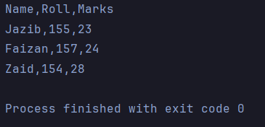

Task 2:
Problem
Extract names, roll numbers, and marks from the stored data using collections.

package Lab_9;
import java.io.IOException;
import java.util.ArrayList;
import java.util.List;
public class Lab9_Task2 {
static ArrayList<Integer> Marks = new ArrayList<>();
public static List<String> Names = new ArrayList<>();
public static List<String> Roll_No = new ArrayList<>();
static void main(String[] args) throws IOException {
Lab9_Task1.read();
Get_Marks();
Get_Name();
Get_Roll();
//System.out.println(Marks);
Perc.Percentage(Marks);
Perc.showPerc();
}
static void Average(){
}
static int Sum(){
int Sum = 0;
for (int marks : Marks){
Sum = Sum + marks;
}
return Sum;
}
static void Get_Marks(){
for(int i = 1; i < Lab9_Task1.Info.size(); i++){
Marks.add(Integer.parseInt(Lab9_Task1.Info.get(i).split(",")[2]));
}
}
static void Get_Name(){
for(int i = 1; i < Lab9_Task1.Info.size(); i++){
Names.add(Lab9_Task1.Info.get(i).split(",")[0]);
}
}
static void Get_Roll(){
for(int i = 1; i < Lab9_Task1.Info.size(); i++){
Roll_No.add(Lab9_Task1.Info.get(i).split(",")[1]);
}
}
}

Result:

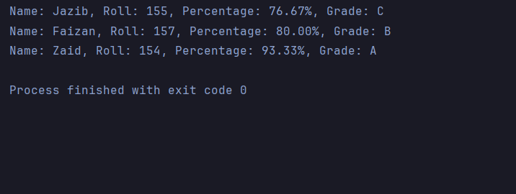

Task 3:
Problem
Calculate percentages and grades, then display the final student information.

package Lab_9;
import java.util.ArrayList;
class Perc{
static ArrayList<Double> Percentages = new ArrayList<>();
public static void Percentage(ArrayList<Integer> Marks){
for(int marks : Marks){
Percentages.add(marks/30.0 * 100);
}
}
public static void showPerc(){
for (int i = 0; i < Lab9_Task1.Info.size() - 1; i++) {
System.out.print("Name: " + Lab9_Task2.Names.get(i) + ", " + "Roll: " + Lab9_Task2.Roll_No.get(i) + ", " + "Percentage: " + String.format("%.2f", Percentages.get(i)) + "%, " + "Grade: " + Grade(Percentages.get(i)));
System.out.println();
}
}
static String Grade(double num){
if(!(num > 100)){
if (num >= 90){
return "A";
} else if (num >= 80) {
return "B";
}
else if (num >= 70) {
return "C";
} else if (num >= 60) {
return "E";
}else {
return "F";
}
}else {
throw new RuntimeException("Percentage Higher than 100.");
}
}
}

Result:

[NO OUTPUT]

Conclusions:

In this lab, we learned how to read data from a CSV file into a Java program using file handling classes, and how to store this data using appropriate collection types. We practiced parsing comma-separated data into individual fields and organizing them for further use, then used this data to perform calculations and apply conditional logic to generate meaningful output. This lab helped strengthen our understanding of file I/O, data parsing, collections, and modular programming, where responsibilities are divided across multiple classes that work together to produce a complete solution. We also gained exposure to basic exception handling for managing invalid or unexpected data values.

