# verilog 文档整理

## 入门

#### - 如何开始

欢迎来到二进制的世界,数字逻辑的入门一开始可能有难度,因为你需要学习新的概念,新的硬件描述语言(HDL -- Hardware Description Language)例如 verilog,几个新的仿真软件和一块FPGA的板子.但是这能帮你更加深刻的理解计算机的运作原理.

设计电路需要如下几个步骤:

1. 编写HDL(verilog)代码
2. 编译代码生成电路
3. 模拟电路并修复错误

下面,我们来个简单的例子,请把one的输出设为1:

* Module Declaration

module top_module(output one);

* Solution

module top_module( output one );  
  
 assign one = 1;  
  
endmodule

#### - 输出0

建立一个没有输入,输出为常数0的电路.

本系列题使用***verilog-2001 ANSI-style*** 的端口声明语法,因为它更容易阅读并减少了拼写错误.如果愿意,可以使用旧的verilog-1995语法.例如,下面的两个模块声明是可接受的和等效的:

module top_moduel(zero);  
 output zero;  
 //verilog-1995  
endmodule  
  
module top_module(output zero);  
//verilog-2001  
endmodule

* Module Declaration

module top_module(  
 output zero  
);

* Solution

module top_module(  
 output zero  
);// Module body starts after semicolon  
 assign zero=0;  
endmodule

## Verilog 语言

### 基础元素

#### - wire类型

创建一个具有一个输入和一个输出的模块,其行为想一条"线"(Wire).

与物理线不同但十分相似,Verilog中的线(和其他信号)是定向的.这意味着信息只在一个方向上流动,从(通常是一个)源流向汇点(该源通常也被称为驱动程序,将值驱动到wire上).在verilog"连续赋值"(assign left*side=right*side;)中,右侧的信号值被驱动到左侧的"线"上.请注意:赋值是"***连续的***"(Continuous Assignments),因为如果右侧的值发生更改,分配也会一直持续,因此左侧的值将随之改变.(这里与其他语言有很大区别).连续分配不是一次性事件,其产生的变化是永久的.

想要真正理解为啥会这样,你首先要明白,你并不是在编写程序,你其实是在用代码"画"电路! 因此输入端的电平高低的变化必然会影响到wire的另一端,你可以想像真的有一根电线连接两个变量.

模块(module)上的端口(port)也有一个方向(通常是输入 -- input或输出 -- output).输入端口由来自模块外部的东西驱动,而输出端口驱动外部的东西.从模块内部查看时,输入端口是驱动程序或源,而输出端口是接收器.

下图说明了电路的每个部分如何对应Verilog代码的每个部分.模块和端口声明创建电路的黑色部分.您的任务是通过添加一个assign语句来创建一条线(绿色).盒子外的部件不是您的问题,但您应该知道,通过将测试激励连接到top_module上的端口来测试电路.

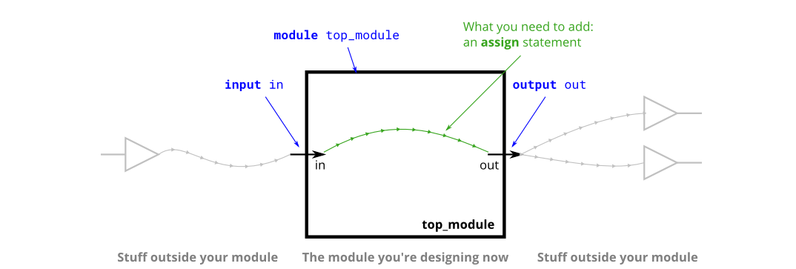

除了连续赋值之外,Verilog还有另外三种用于程序块(Procedural block)的赋值类型,其中两种是可综合的.在开始使用Procedural block之前,我们不会使用它们.

* Module Declaraction

module top_module( input in, output out );

* Solution

module top_module( input in, output out );  
 assign out = in;  
endmodule

#### - Four wires

创建一个具有3个输入和4个输出的模块,这些输入和输出的行为如下:

A ->W  
B -> X  
B -> Y  
C -> Z

下图说明了电路的每个部分如何对应Verilog代码的每个部分.模块外部有三个输入端口和四个输出端口.

当您有多个assign语句时,它们在代码中的出现顺序并不重要.与编程语言不同,assign语句("连续赋值")描述事物之间的连接,而不是将值从一个事物复制到另一个事物的操作.

可能现在应该澄清的一个潜在的困惑来源是:这里的绿色箭头表示电线之间的连接,但不是wire本身.模块本身已经声明了7条线(名为A、B、C、W、X、Y和Z).这是因为input与output被声明为了wire类型.因此,assign语句不会创建wire,而是描述了在已存在的7条线之间创建的连接.

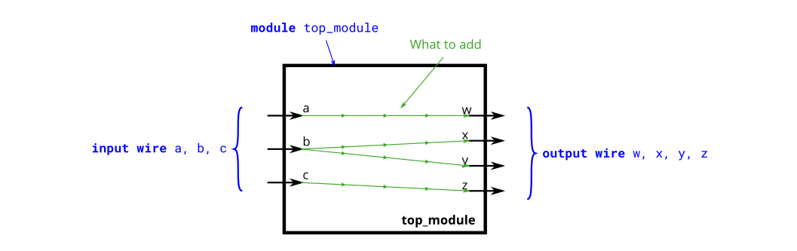

* Module Declaraction

module top_module(  
 input a,b,c;  
 output w,x,y,z  
);

* Solution

module top_module(   
 input a,b,c,  
 output w,x,y,z );  
 assign w=a;  
   
assign x=b;  
   
assign y=b;  
   
assign z=c;  
endmodule

#### - 反转器 (Inveter)

创建实现非门的模块.

这个电路和电线相似,但有点不同.当把电线从进线连接到出线时,我们要实现一个反相器(非门),而不是一根普通的线.

使用assign语句.assign语句将连续地将in取反并输出.

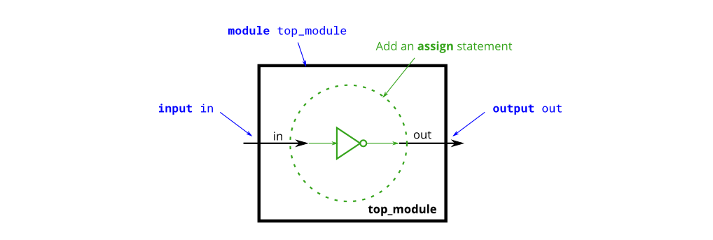

* Module

module top_module( input in, output out );

* Solution

module top_module( input in, output out );  
 assign out = !in;  
endmodule

#### - 与门 (AND gate)

创建实现和门的模块.

这个电路现在有三条线(A、B和OUT).导线A和B已经具有由输入端口驱动的值.但目前的布线并不是由任何东西驱动的.写一个赋值语句,用信号A和B的和来驱动.

输入线由模块外部的东西驱动.assign语句将把一个逻辑级别驱动信号连接到一条线上.正如您可能期望的那样,一条线不能有多个驱动信号(如果有的话,它的逻辑级别是什么?),并且没有驱动信号的导线将具有未定义的值(在合成硬件时通常被视为0,但有时候会出现奇怪的错误).

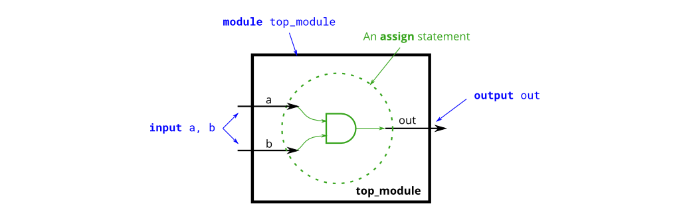

* Module Declaraction

module top_module(   
 input a,   
 input b,   
 output out );

* Solution

module top_module(   
 input a,   
 input b,   
 output out );  
assign out = a&b;  
endmodule

#### - 或非门 (NOR gate)

创建实现或非门的模块.或非门是一个输出反转的或门.

assign语句用一个值来驱动(drive)一条线(或者更正式地称为"net").这个值可以是任意复杂的函数,只要它是一个组合逻辑(即,无内存(memory-less),无隐藏状态).

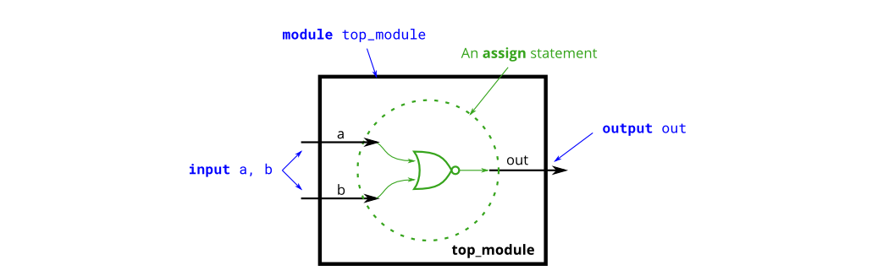

* Module Declaraction

module top_module(   
 input a,   
 input b,   
 output out );

* Solution

module top_module(   
 input a,   
 input b,   
 output out );  
 assign out = !(a|b);  
endmodule

#### - 异或非门 (XNOR gate)

实现异或非门模块.

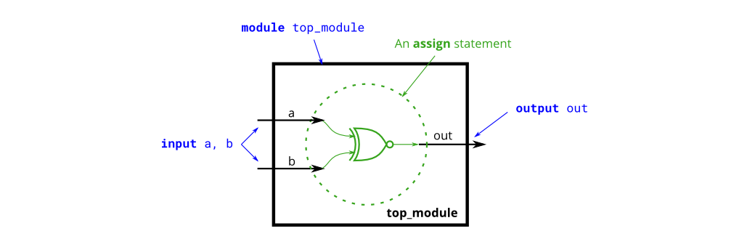

* Module Declaraction

module top_module(   
 input a,   
 input b,   
 output out );

* Solution

module top_module(   
 input a,   
 input b,   
 output out );  
 assign out = !(a^b);  
endmodule

#### - 声明wires

到目前为止,电路都十分简单.随着电路变得越来越复杂,您将需要wire将内部组件连接在一起.当您需要使用导线时,您应该在模块体中在首次使用之前的某个地方声明它.(将来,您将遇到更多类型的信号和变量,它们也以相同的方式声明,但现在,我们将从Wire类型的信号开始).

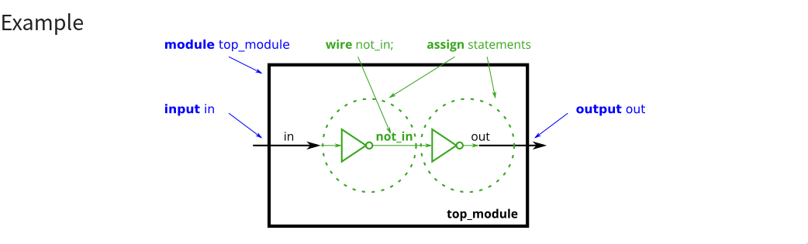

module top_module (  
 input in, // Declare an input wire named "in"  
 output out // Declare an output wire named "out"  
);  
  
 wire not_in; // Declare a wire named "not_in"  
  
 assign out = ~not_in; // Assign a value to out (create a NOT gate).  
 assign not_in = ~in; // Assign a value to not_in (create another NOT gate).  
  
endmodule // End of module "top_module"

实现以下电路.创建两个wire(命名任意)以将and/or gate连接在一起.请注意,Not gate 是输出,因此您不必在这里声明第三条线.wire可有多个输出,但只能有一个输入驱动.

如果您遵循图中的电路结构,那么应该以四个赋值语句结束,因为有四个信号需要赋值.

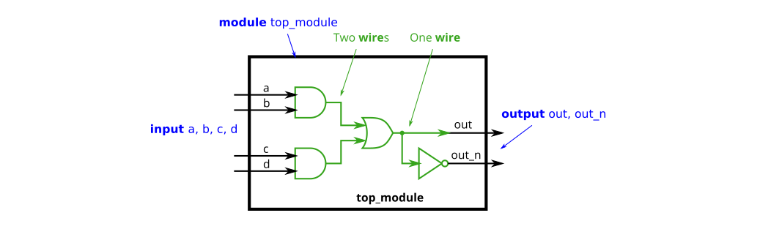

* Module Declaraction

`default_nettype none  
module top_module(  
 input a,  
 input b,  
 input c,  
 input d,  
 output out,  
 output out_n );

* Solution

`default_nettype none  
module top_module(  
 input a,  
 input b,  
 input c,  
 input d,  
 output out,  
 output out_n );   
wire inside1,inside2;  
   
assign inside1 = a&b;  
   
assign inside2 = c&d;   
   
assign out = inside1|inside2;  
   
 assign out_n = !(out);  
endmodule

#### - 7458模块

实现如下电路:

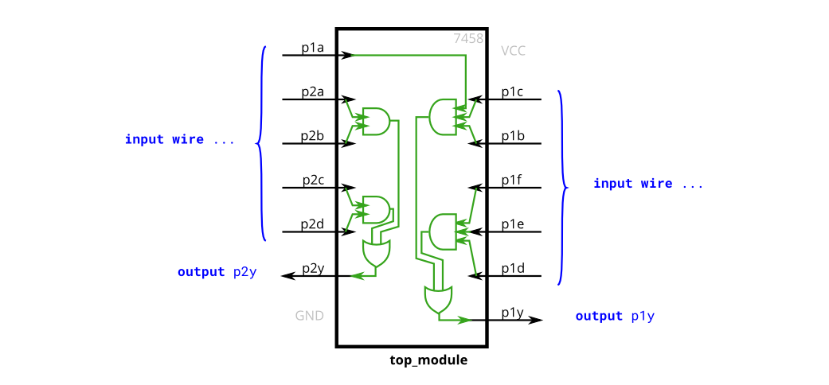

* Module Declaraction

module top_module (   
 input p1a, p1b, p1c, p1d, p1e, p1f,  
 output p1y,  
 input p2a, p2b, p2c, p2d,  
 output p2y );

* Solution

module top_module (   
 input p1a, p1b, p1c, p1d, p1e, p1f,  
 output p1y,  
 input p2a, p2b, p2c, p2d,  
 output p2y );  
wire inside1,inside2,inside3,inside4;  
   
assign inside1 = p1a&p1b&p1c;  
   
assign inside2 = p1d&p1e&p1f;  
   
assign inside3 = p2a&p2b;  
   
assign inside4 = p2c&p2d;  
   
assign p1y = inside1|inside2;  
   
assign p2y = inside3|inside4;  
  
endmodule

### 容器(Vectors)

#### - 容器介绍

vector被用来对相关的信号进行分组,以便于操作.例如,Wire[7:0]w;声明一个名为w 的 8 位数组,在功能上相当于具有8条独立的线.

请注意,vector的声明将维度(dimensions 即数组长度)放在容器名称之前,这与C语法相比不常见.

至于为什么会是如下声明,主要是采用了小端序.

Wire[99:0]my_vector；//声明一个长度为100容器  
assign out=my_vector[10]；//从数组中选择一位

构建一个具有一个3位vector输入的电路,并将其拆分为三个单独的1位输出.

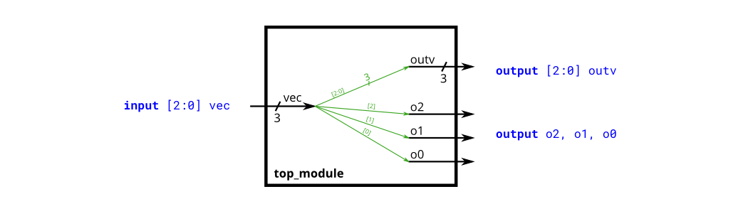

* Module Declaraction

module top_module (   
 input wire [2:0] vec,  
 output wire [2:0] outv,  
 output wire o2,  
 output wire o1,  
 output wire o0 );

* Solution

module top_module (   
 input wire [2:0] vec,  
 output wire [2:0] outv,  
 output wire o2,  
 output wire o1,  
 output wire o0 ); // Module body starts after module declaration  
 assign o0 = vec[0];  
   
 assign o1 = vec[1];  
   
 assign o2 = vec[2];  
   
assign outv = vec;  
endmodule

#### - 容器细节

vector声明如下:

type [upper:lower] vector_name; type指定了vector的类型,通常是wire或者reg.

wire [2:0] a, c; // Two vectors  
assign a = 3'b101; // a = 101  
assign b = a; // b = 1 implicitly-created wire  
assign c = b; // c = 001 <-- bug  
my_module i1 (d,e); // d and e are implicitly one-bit wide if not declared.  
 // This could be a bug if the port was intended to be a vector.

* 关于"片选"(Part Selection) 访问整个数组只需要:

assign w = a;

而访问数组的一部分,若长度在赋值时不匹配,则用0补齐例如:

reg [7:0] c;  
assign c = x[3:1];  
//此时,长度不匹配,则用0补齐  
  
w[3:0] // Only the lower 4 bits of w  
x[1] // The lowest bit of x  
x[1:1] // ...also the lowest bit of x  
z[-1:-2] // Two lowest bits of z  
b[3:0] // Illegal. Vector part-select must match the direction of the declaration.  
b[0:3] // The *upper* 4 bits of b.  
assign w[3:0] = b[0:3]; // Assign upper 4 bits of b to lower 4 bits of w. w[3]=b[0], w[2]=b[1], etc.

建立一个电路,将一个半字(16 bits,[15:0])分成高8位[15:8],与低8位[7:0]输出.

* Module Declaraction

`default_nettype none // Disable implicit nets. Reduces some types of bugs.  
module top_module(   
 input wire [15:0] in,  
 output wire [7:0] out_hi,  
 output wire [7:0] out_lo );

* Solution

`default_nettype none // Disable implicit nets. Reduces some types of bugs.  
module top_module(   
 input wire [15:0] in,  
 output wire [7:0] out_hi,  
 output wire [7:0] out_lo );  
 assign out_lo = in[7:0];  
   
 assign out_hi = in[15:8];  
endmodule

#### - 容器的片选(Vector part select)

32位矢量可以被视为包含4个字节(位[31:24]、[23:16]等).建立一个电路,使4字节字颠倒顺序.

aaaaaaaabbbbbbcccccccccddddddd=>ddddddddccccccccccbbbbbbbaaaaaaaa

此操作通常在需要交换一段数据的结束地址时使用,例如在Little Endian(小端序) x86系统和许多Internet协议中使用的Big Endian(大端序格式之间.

* Module Declaraction

module top_module(   
 input [31:0] in,  
 output [31:0] out );

* Solution

module top_module(   
 input [31:0] in,  
 output [31:0] out );//  
  
 // assign out[31:24] = ...;  
 assign out[31:24] = in[7:0];  
   
 assign out[23:16] = in[15:8];  
   
 assign out[15:8] = in[23:16];  
   
 assign out[7:0] = in[31:24];  
endmodule

#### - 位级操作(Bitwise operators)

建立一个电路,该电路有两个3-bits输入,用于计算两个vector的"基于位"的或(bitwise-OR)、两个矢量的"逻辑或"(Logical-OR)和两个矢量的非(NOT).将b的非放在out-not的高位部分(即[5:3]),将a的非放在低位部分.

看看模拟波形,看看bitwise-OR与Logical-OR的区别.

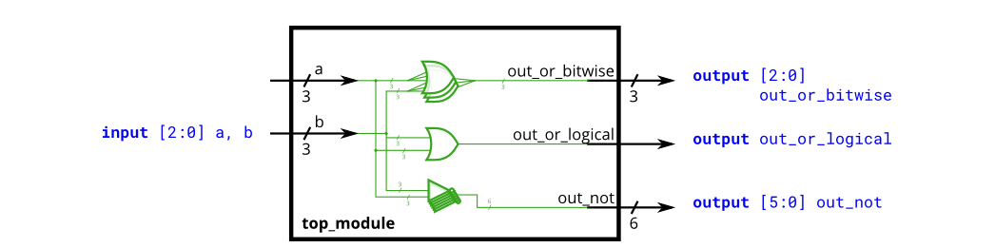

* Module Declaraction

module top_module(   
 input [2:0] a,  
 input [2:0] b,  
 output [2:0] out_or_bitwise,  
 output out_or_logical,  
 output [5:0] out_not  
);

* Solution

module top_module(  
 input [2:0] a,   
 input [2:0] b,   
 output [2:0] out_or_bitwise,  
 output out_or_logical,  
 output [5:0] out_not  
);  
   
 assign out_or_bitwise = a | b;  
 assign out_or_logical = a || b;  
  
 assign out_not[2:0] = ~a; // Part-select on left side is o.  
 assign out_not[5:3] = ~b; //Assigning to [5:3] does not conflict with [2:0]  
   
endmodule

#### - 4位Vecotr

建立一个具有4为输入的组合电路,输出要求如下:

* out_and: 输入经过 "与门" 后的结果
* out_or: 输入经过 "或门" 后的结果
* out_xor: 输入经过 "异或门" 后的结果
* Module Declaraction

module top_module(   
 input [3:0] in,  
 output out_and,  
 output out_or,  
 output out_xor  
);

* Solution

module top_module(   
 input [3:0] in,  
 output out_and,  
 output out_or,  
 output out_xor  
);  
 assign out_and = in[0]&in[1]&in[2]&in[3];  
   
 assign out_or = in[0]|in[1]|in[2]|in[3];  
   
 assign out_xor = in[0]^in[1]^in[2]^in[3];  
endmodule

#### - Vector连接操作符(Vector concatenation operator)

片选用于选择vector的部分.连接运算符{a,b,c}用于通过将vector的较小部分连接在一起来创建较大的vector.

{3'b111, 3'b000} => 6'b111000  
{1'b1, 1'b0, 3'b101} => 5'b10101  
{4'ha, 4'd10} => 8'b10101010 // 4'ha and 4'd10 are both 4'b1010 in binary

连接需要知道每个组件的宽度,因此,{1,2,3}是非法的,并导致错误消息：串联中不允许使用未经大小化的常量. 连接操作符可以在赋值的左侧和右侧使用.

input [15:0] in;  
output [23:0] out;  
assign {out[7:0], out[15:8]} = in; // Swap two bytes. Right side and left side are both 16-bit vectors.  
assign out[15:0] = {in[7:0], in[15:8]}; // This is the same thing.  
assign out = {in[7:0], in[15:8]}; // This is different. The 16-bit vector on the right is extended to  
 // match the 24-bit vector on the left, so out[23:16] are zero.  
 // In the first two examples, out[23:16] are not assigned.

连接并重新分割给定输入:

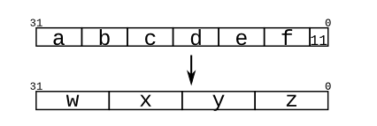

* Module Declaraction

module top_module (  
 input [4:0] a, b, c, d, e, f,  
 output [7:0] w, x, y, z );

* Solution

module top_module (  
 input [4:0] a, b, c, d, e, f,  
 output [7:0] w, x, y, z );//  
  
 // assign { ... } = { ... };  
 assign {w[7:0],x[7:0],y[7:0],z[7:0]} = {a[4:0],b[4:0],c[4:0],d[4:0],e[4:0],f[4:0],2'b11};  
endmodule

#### - 反转Vector

反转一个8位vector

* Module Declaraction

module top_module(   
 input [7:0] in,  
 output [7:0] out  
);

* Solution

module top_module(   
 input [7:0] in,  
 output [7:0] out  
);  
 assign {out[0],out[1],out[2],out[3],out[4],out[5],out[6],out[7]} = in;  
endmodule

#### - 拷贝操作符(Replication operator)

连接运算符允许将vector连接在一起以形成较大的vector.但是有时候你想把同一个东西连接在一起很多次,比如assign A = {B, B, B, B, B, B};这样的事情仍然很乏味.复制运算符允许复制vector并将它们连接在一起:

{num{vector}}

这会将vector复制num次.

例如:

{5{1'b1}} // 5'b11111 (or 5'd31 or 5'h1f)  
{2{a,b,c}} // The same as {a,b,c,a,b,c}  
{3'd5, {2{3'd6}}} // 9'b101_110_110. It's a concatenation of 101 with  
 // the second vector, which is two copies of 3'b110.

复制运算经常会用在"有符号数"的扩转运算中,假如将一个8位有符号数扩展到16位,我们需要将其符号位进行复制并填充到扩展位.即:

8'b10000001 => 16'b1111111110000001  
//这就是有符号数的扩展

* Module Declaraction

module top_module (  
 input [7:0] in,  
 output [31:0] out );

* Solution

module top_module (  
 input [7:0] in,  
 output [31:0] out );//  
  
 // assign out = { replicate-sign-bit , the-input };  
 assign out[31:0] = {{24{in[7]}},in[7:0]};  
endmodule

#### - 拷贝练习

给定5个1位的输入信号,并进行如下图的比较运算,相同的位记为1,并储存在out中.

out[24] = ~a ^ a; // a == a, so out[24] is always 1.  
out[23] = ~a ^ b;  
out[22] = ~a ^ c;  
...  
out[ 1] = ~e ^ d;  
out[ 0] = ~e ^ e;

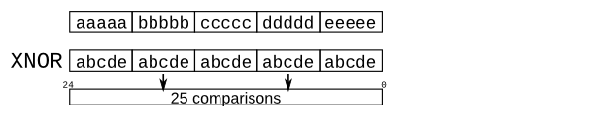

* Module Declaraction

module top_module (  
 input a, b, c, d, e,  
 output [24:0] out );

* Solution

module top_module (  
 input a, b, c, d, e,  
 output [24:0] out );//  
  
 // The output is XNOR of two vectors created by   
 // concatenating and replicating the five inputs.  
 // assign out = ~{ ... } ^ { ... };  
 assign out = ~{{5{a}},{5{b}},{5{c}},{5{d}},{5{e}}} ^ {5{a,b,c,d,e}};  
endmodule

### 模块与层级(Modules: Hierarchy)

#### - 模块

现在你已经对module很熟悉了,模块实际上就是封装起来的电路.下图显示了一个带有子模块的非常简单的电路.在本练习中,创建模块mod*a的一个实例,然后将模块的三个插脚(in1、in2和out)连接到顶级模块的三个端口(wire a、b和out).模块mod*a是为您提供的,您必须实例化它.

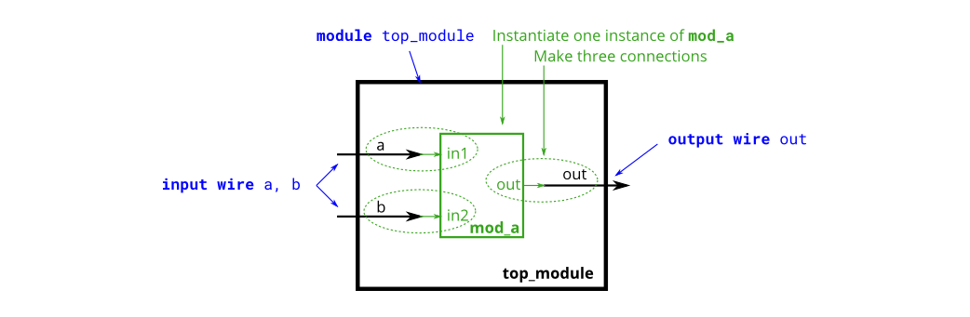

你有两种实例化模块的方式

1. 通过位置:

mod_a ins1 (wa, wb, wc);

1. 通过名称:

mod_a ins2 ( .out(wc), .in1(wa), .in2(wb) )

* Module Declaraction

module top_module ( input a, input b, output out );

* Solution

module top_module ( input a, input b, output out );  
 mod_a ins(a,b,out);  
endmodule

#### - 按位置连接端口(Connecting ports by position)

此问题与前一个问题(模块)类似.您将得到一个名为mod_a的模块,该模块按顺序具有2个输出和4个输入.您必须按位置将6个端口连接到顶级模块的端口out1、out2、A、B、C和D,顺序如下. 您将获得以下模块：

module mod_a ( output, output, input, input, input, input );

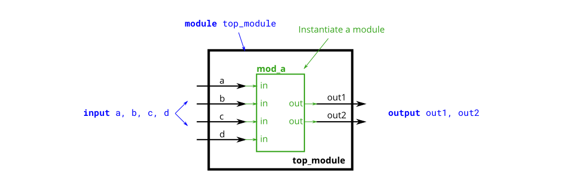

* Module Declaraction

module top_module (   
 input a,   
 input b,   
 input c,  
 input d,  
 output out1,  
 output out2  
);

* Solution

module top_module (   
 input a,   
 input b,   
 input c,  
 input d,  
 output out1,  
 output out2  
);  
 mod_a ins(out1,out2,a,b,c,d);  
endmodule

#### - 按名称连接端口(Connecting ports by name)

您将得到一个名为mod_a的模块,该模块具有2个输出和4个输入.必须按名称将6个端口连接到顶级模块的端口:

|  |  |
| --- | --- |
| Port in mod_a | Port in top_module |
| output out1 | out1 |
| output out2 | out2 |
| input in1 | a |
| input in2 | b |
| input in3 | c |
| input in4 | d |

mod*a接口如下: `module mod*a ( output out1, output out2, input in1, input in2, input in3, input in4);`

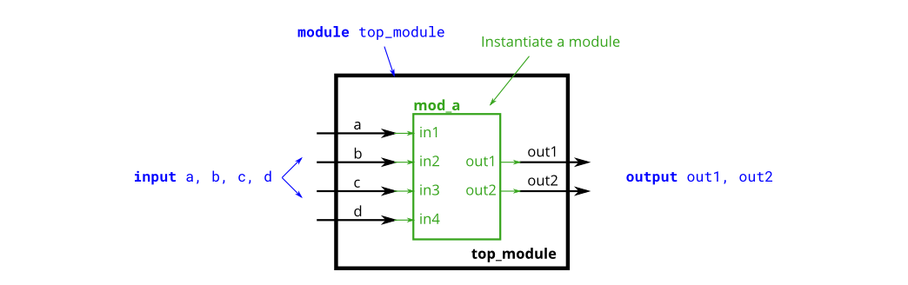

* Module Declaraction

module top_module (   
 input a,   
 input b,   
 input c,  
 input d,  
 output out1,  
 output out2  
);

* Solution

module top_module (   
 input a,   
 input b,   
 input c,  
 input d,  
 output out1,  
 output out2  
);  
 mod_a ins(.out1(out1), .out2(out2), .in1(a), .in2(b), .in3(c), .in4(d));  
endmodule

#### - 三个模块

我们为您提供了一个my_df模块,具有一个输入和一个输出(实现D触发器).实例化其中的三个,然后将它们链接在一起,形成长度为3的移位寄存器.CLK端口需要连接到所有实例.

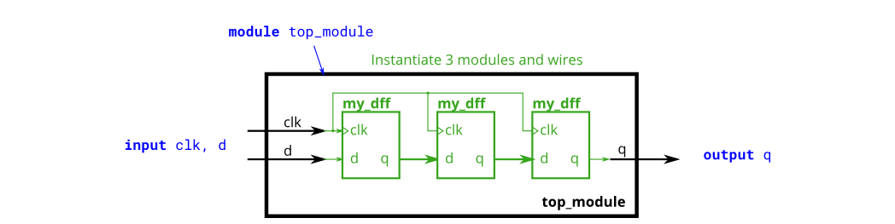

* Module Declaraction

module top_module ( input clk, input d, output q );

* Solution

module top_module ( input clk, input d, output q );  
   
wire out1,out2;  
 my_dff ins1(clk,d,out1);  
   
 my_dff ins2(clk,out1,out2);  
   
 my_dff ins3(clk,out2,q);  
endmodule

#### - 模块与容器

我们为您提供了一个模块my-dff8,它有两个输入和一个输出(实现一组8 D-触发器).实例化其中三个,然后将它们链接在一起,形成长度为3的8位宽移位寄存器.此外,创建一个4对1多路选择器,根据sel[1:0]选择输出内容.

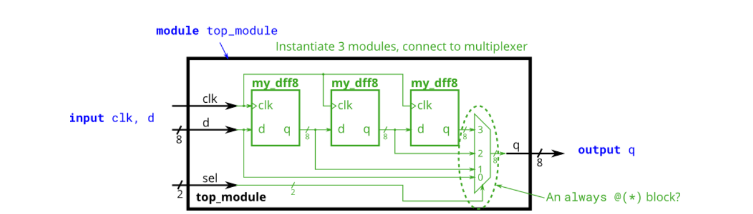

* Module Declaraction

module top_module (   
 input clk,   
 input [7:0] d,   
 input [1:0] sel,   
 output [7:0] q   
);

* Solution

module top_module (   
 input clk,   
 input [7:0] d,   
 input [1:0] sel,   
 output [7:0] q   
);  
 wire [7:0] out1, out2, out3;  
 my_dff8 ins1(clk,d,out1);  
 my_dff8 ins2(clk,out1,out2);  
 my_dff8 ins3(clk,out2,out3);  
 always @(*) begin  
 case(sel)  
   
2'b00:begin  
   
q = d;  
   
end  
 2'b01:begin  
 q[7:0] = out1[7:0];  
 end  
 2'b10:begin  
 q[7:0] = out2[7:0];  
 end  
 2'b11:begin  
 q[7:0] = out3[7:0];  
 end  
 endcase  
 end  
endmodule

#### - 加法器1

为你提供了add16模块,这是一个16位加法器,请实例化两个该模块并实现如下图32为加法器,请考虑进位.

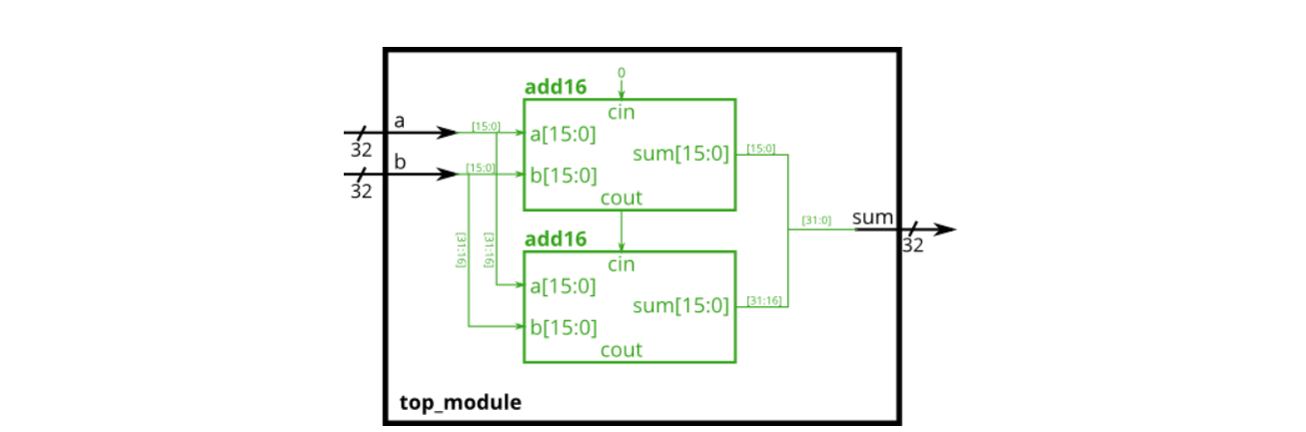

* Module Declaraction

module top_module(  
 input [31:0] a,  
 input [31:0] b,  
 output [31:0] sum  
);

* Solution

module top_module(  
 input [31:0] a,  
 input [31:0] b,  
 output [31:0] sum  
);  
 wire [15:0] sum1, sum2;  
 wire cin, cout, cout1;  
 add16 ins1(a[15:0], b[15:0], 0, sum1, cout);  
 add16 ins2(a[31:16], b[31:16], cout, sum2, cout1);  
 assign sum = {sum2,sum1};  
endmodule

#### - 加法器2

请封装一个名为add1的16位加法器模块,并用其实现一个32位加法器.

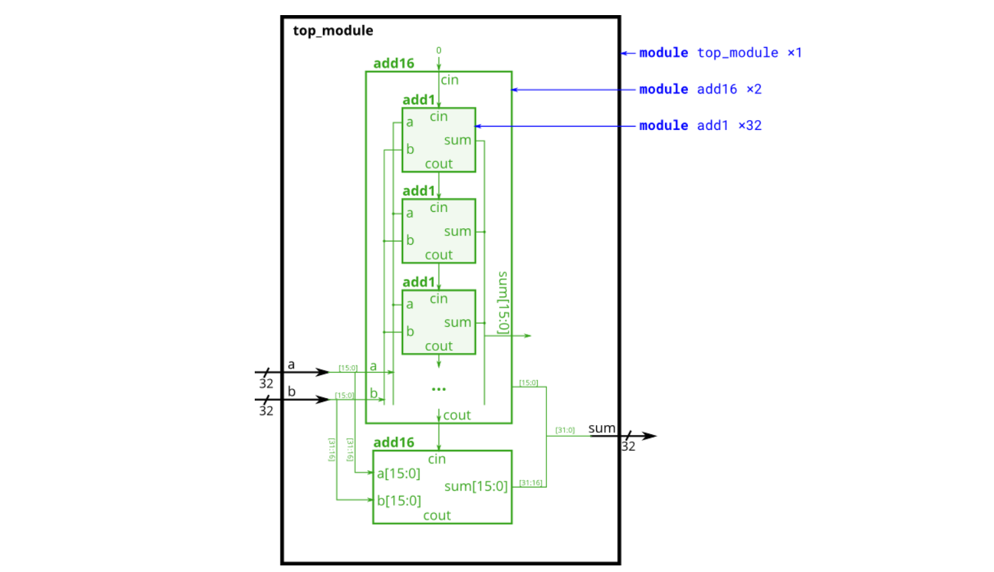

* Module Declaraction

module top_module (  
 input [31:0] a,  
 input [31:0] b,  
 output [31:0] sum  
);//  
  
endmodule  
  
module add1 ( input a, input b, input cin, output sum, output cout );  
  
// Full adder module here  
  
endmodule

* Solution

module top_module (  
 input [31:0] a,  
 input [31:0] b,  
 output [31:0] sum  
);//  
 wire cout,cout1;  
 wire [15:0] sum1, sum2;  
 add16 ins1(a[15:0],b[15:0],0,sum1,cout);  
 add16 ins2(a[31:16],b[31:16],cout,sum2,cout1);  
 assign sum = {sum2[15:0],sum1[15:0]};  
  
endmodule  
  
module add1 ( input a, input b, input cin, output sum, output cout );  
  
// Full adder module here  
 assign {cout,sum} = a+b+cin;  
endmodule

#### - 进位选择加法器

已为您提供了16位加法器add16模块,请实现如下图电路模块,即考虑第16位相加的进位.

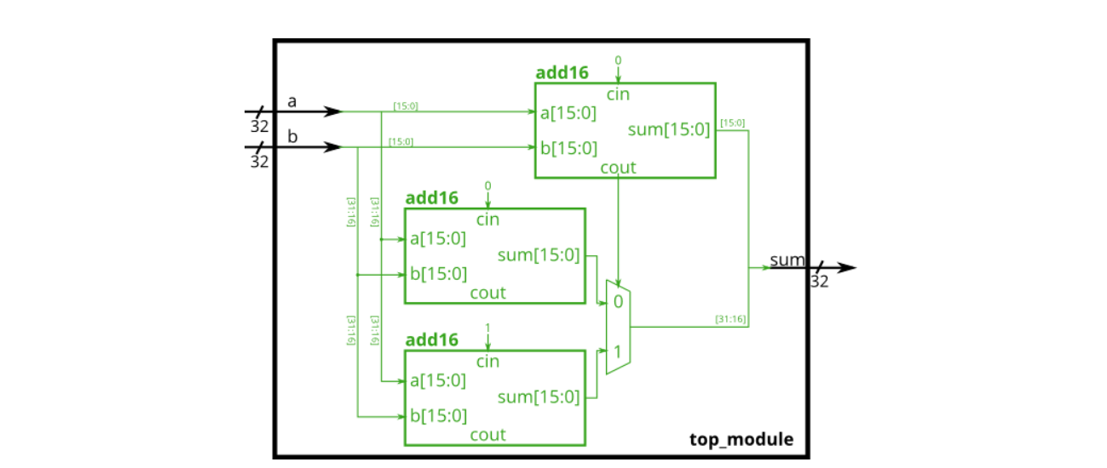

* Module Declaraction

module top_module(  
 input [31:0] a,  
 input [31:0] b,  
 output [31:0] sum  
);

* Solution

module top_module(  
 input [31:0] a,  
 input [31:0] b,  
 output [31:0] sum  
);  
 wire [15:0] sum1,sum2,sum3;  
 wire cout,cout1;  
 add16 ins1(a[15:0], b[15:0], 0, sum1, cout);  
 add16 ins2(a[31:16], b[31:16], 0, sum2, cout1);  
 add16 ins3(a[31:16], b[31:16], 1, sum3, cout1);  
 always @(*) begin  
 case (cout)  
 1'b0:begin   
 sum[31:0] = {sum2[15:0],sum1[15:0]};  
 end  
 1'b1:begin  
 sum = {sum3,sum1};  
 end  
 endcase  
 end  
endmodule

#### - 加-减法器(Adder-subtractor)

已为你提供了16位加法器add16模块,请实现如下图加法-减法器,通过一个32位"异或门"来决定加法或减法.

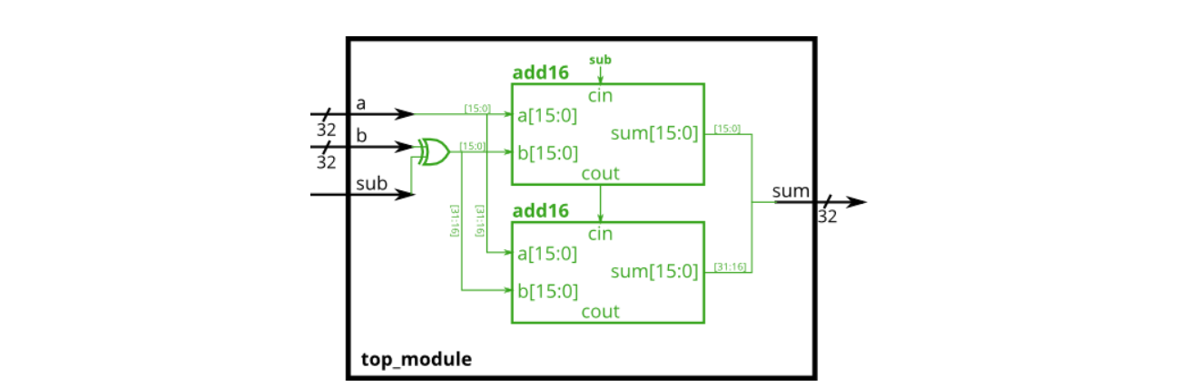

* Module Declaraction

module top_module(  
 input [31:0] a,  
 input [31:0] b,  
 input sub,  
 output [31:0] result  
);

* Solution

module top_module(  
 input [31:0] a,  
 input [31:0] b,  
 input sub,  
 output [31:0] result  
);  
   
 wire [31:0]invert;  
 wire [15:0]sum1,sum2;  
 wire cout,cout1;  
 assign invert[31:0] = b[31:0]^{32{sub}};  
 add16 ins1(a[15:0], invert[15:0], sub, sum1, cout);  
 add16 ins2(a[31:16], invert[31:16], cout, sum2, cout1);  
 assign result = {sum2,sum1};  
endmodule

### 过程(Procedures)

#### - Always块 -- 组合逻辑 (Always blocks -- Combinational)

由于数字电路是由与电线相连的逻辑门组成的,所以任何电路都可以表示为模块和赋值语句的某种组合.然而,有时这不是描述电路最方便的方法.

两种always block是十分有用的:

* 组合逻辑: always @(*)
* 时序逻辑: always @(posedge clk)

always @(*)就相当于赋值语句--assign,因此选择哪一种语法仅仅取决与方便程度.block内还有更丰富的语句集,比如if-else,case等等.但不能包含连续赋值,即不可包含assign,因为他与always @(*)冲突.

以下语句是等价的

assign out1 = a & b | c ^ d;  
always @(*) out2 = a & b | c ^ d;

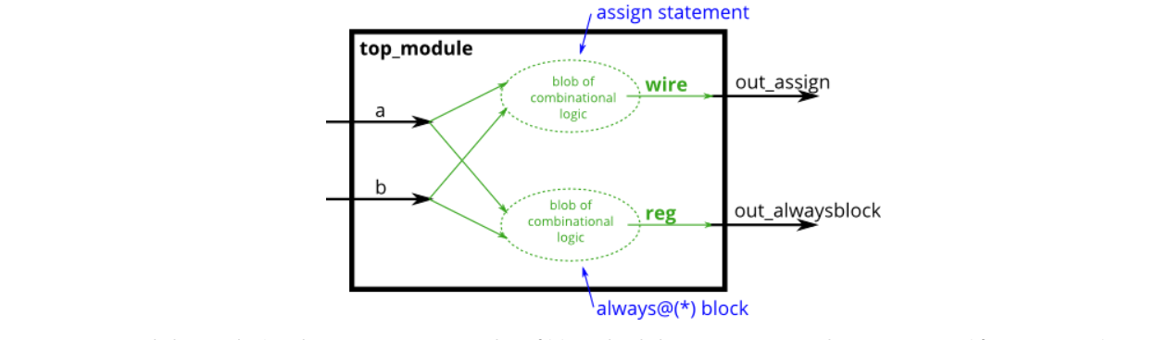

* Module Declaraction

module top_module(  
 input a,   
 input b,  
 output wire out_assign,  
 output reg out_alwaysblock  
);

* Solution

// synthesis verilog_input_version verilog_2001  
module top_module(  
 input a,   
 input b,  
 output wire out_assign,  
 output reg out_alwaysblock  
);  
 assign out_assign = a&b;  
   
 always @(*) out_alwaysblock = a&b;  
endmodule

#### - Always块 -- 时序逻辑 (Always blocks -- Clocked)

verilog中有三种赋值方式:

* 连续赋值: assign x = y; 不能在always-block内使用
* 阻塞赋值: x = y;,只能在always-block内使用
* 非阻塞赋值: x <= y,只能在always-block内使用

请在组合逻辑中使用阻塞赋值,在时序逻辑中使用非阻塞赋值 否则将产生难以发现的错误

请实现如下电路:

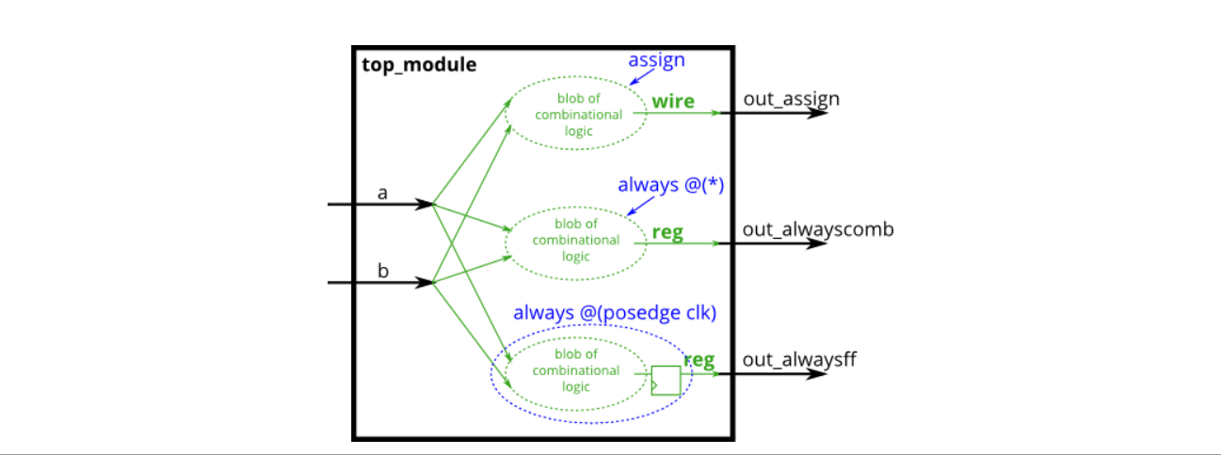

* Module Declaraction

module top_module(  
 input clk,  
 input a,  
 input b,  
 output wire out_assign,  
 output reg out_always_comb,  
 output reg out_always_ff );

* Solution

// synthesis verilog_input_version verilog_2001  
module top_module(  
 input clk,  
 input a,  
 input b,  
 output wire out_assign,  
 output reg out_always_comb,  
 output reg out_always_ff );  
assign out_assign = a^b;  
   
 always @(*) out_always_comb = a^b;  
   
 always @(posedge clk) out_always_ff <= a^b;  
endmodule

#### - If语句

if语句通常创建一个2对1的多路选择器,如果条件为真,则选择一个输入,如果条件为假,则选择另一个输入.一下两种写法是等价的:

always @(*) begin  
 if (condition) begin  
 out = x;  
 end  
 else begin  
 out = y;  
 end  
end  
  
assign out = (condition) ? x : y;

建立一个在a和b之间选择的2对1多路选择器.如果sel*b1和sel*b2都为真,则选择b.否则,选择a.执行相同的操作两次,一次使用assign语句,一次使用if语句.

* Module Declaraction

module top_module(  
 input a,  
 input b,  
 input sel_b1,  
 input sel_b2,  
 output wire out_assign,  
 output reg out_always );

* Solution

// synthesis verilog_input_version verilog_2001  
module top_module(  
 input a,  
 input b,  
 input sel_b1,  
 input sel_b2,  
 output wire out_assign,  
 output reg out_always );   
 assign out_assign = (sel_b1&sel_b2)?b:a;  
   
 always @(*) begin  
 if(sel_b1&sel_b2) begin  
 out_always = b;  
 end  
 else begin  
 out_always = a;  
 end  
 end  
endmodule

#### - If语句引发的锁存(latches)

以下代码包含锁存的错误行为.修正这些错误,这样你只有在电脑过热的时候才会关掉它,你到达目的地或者需要加油的话就停止驾驶.

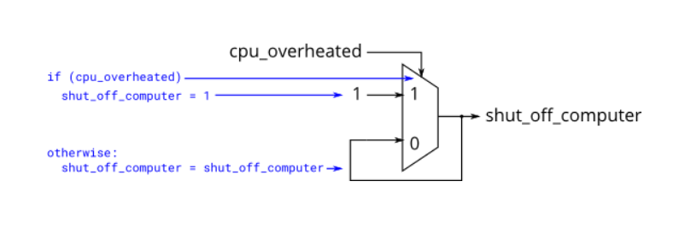

* Module Declaraction

always @(*) begin  
 if (cpu_overheated)  
 shut_off_computer = 1;  
end  
  
always @(*) begin  
 if (~arrived)  
 keep_driving = ~gas_tank_empty;  
end

* Solution

// synthesis verilog_input_version verilog_2001  
module top_module (  
 input cpu_overheated,  
 output reg shut_off_computer,  
 input arrived,  
 input gas_tank_empty,  
 output reg keep_driving ); //  
  
 always @(*) begin  
 if (cpu_overheated) begin  
 shut_off_computer = 1;  
 end  
 else begin  
 shut_off_computer = 0;  
 end  
 end  
   
 always @(*) begin  
 if (~arrived&~gas_tank_empty) begin  
 keep_driving = ~gas_tank_empty&(~arrived);  
 end  
 else begin  
 keep_driving = ~(gas_tank_empty|arrived);  
 end  
 end  
  
endmodule

#### - Case语句

verilog中的case语句几乎等同于if elseif else的序列,该序列将一个表达式与其他表达式列表进行比较.它的语法和功能与C语言中的switch语句不同.

always @(*) begin // This is a combinational circuit  
 case (in)  
 1'b1: begin   
 out = 1'b1; // begin-end if >1 statement  
 end  
 1'b0: out = 1'b0;  
 default: out = 1'bx;  
 endcase  
end

* case语句以case开头,每个"case item"以冒号结尾,没有switch
* 每个case项只能执行一条语句.这使得C中使用的“break”不必要.但这意味着如果需要多个语句,必须使用begin…end

如果有大量选项的情况,case语句比if语句更方便.因此,在本练习中,创建一个6对1的多路选择器.当sel介于0和5之间时,选择相应的数据输入,否则,输出0.数据输入和输出均为4位宽.小心锁存.

* Module Declaraction

module top_module (   
 input [2:0] sel,   
 input [3:0] data0,  
 input [3:0] data1,  
 input [3:0] data2,  
 input [3:0] data3,  
 input [3:0] data4,  
 input [3:0] data5,  
 output reg [3:0] out );

* Solution

// synthesis verilog_input_version verilog_2001  
module top_module (   
 input [2:0] sel,   
 input [3:0] data0,  
 input [3:0] data1,  
 input [3:0] data2,  
 input [3:0] data3,  
 input [3:0] data4,  
 input [3:0] data5,  
 output reg [3:0] out );//  
  
 always@(*) begin // This is a combinational circuit  
 case(sel)  
 3'b0: begin  
 out = data0;  
 end  
 3'b001: begin  
 out = data1;  
 end  
 3'b010: begin  
 out = data2;  
 end  
 3'b011: begin  
 out = data3;  
 end  
 3'b100: begin  
 out = data4;  
 end  
 3'b101: begin  
 out = data5;  
 end  
 default: begin  
 out[3:0] = 0;  
 end  
 endcase  
 end  
  
endmodule

#### - 简单编码器1

priority encoder是一种组合电路,当输入一个vector时,输出第一个'1'出现的位置.例如:输入8'b10010000,输出3'd4,因为[4]是第一个高位. 构建一个4位encoder,若全是低位则输出0.

* Module Declaraction

module top_module (  
 input [3:0] in,  
 output reg [1:0] pos );

* Solution

// synthesis verilog_input_version verilog_2001  
module top_module (  
 input [3:0] in,  
 output reg [1:0] pos );  
 always @(*) begin  
 if (in[0] == 1'b1) begin  
 pos = 2'd0;  
 end  
 else begin  
 if(in[1] == 1'b1) begin  
 pos = 2'd1;  
 end  
 else begin  
 if(in[2] == 1'b1) begin  
 pos = 2'd2;  
 end  
 else begin  
 if(in[3] == 1'b1) begin  
 pos = 2'd3;  
 end  
 else begin  
 pos = 0;  
 end  
 end  
 end  
 end  
 end  
endmodule

#### - 简单编码器2

假如现在输入是8位,那么就会有256种情况,我们可以使用casez来将item减少到9种.  
例如:

always @(*) begin  
 casez (in[3:0])  
 4'bzzz1: out = 0; // in[3:1] can be anything  
 4'bzz1z: out = 1;  
 4'bz1zz: out = 2;  
 4'b1zzz: out = 3;  
 default: out = 0;  
 endcase  
end

* Module Declaraction

module top_module (  
 input [7:0] in,  
 output reg [2:0] pos );

* Solution

// synthesis verilog_input_version verilog_2001  
module top_module (  
 input [7:0] in,  
 output reg [2:0] pos );  
always @(*) begin  
 casez (in[7:0])  
 8'bzzzzzzz1: begin  
 pos = 3'd0;  
 end  
 8'bzzzzzz1z: begin  
 pos = 3'd1;  
 end  
 8'bzzzzz1zz: begin  
 pos = 3'd2;  
 end  
 8'bzzzz1zzz: begin  
 pos = 3'd3;  
 end  
 8'bzzz1zzzz: begin  
 pos = 3'd4;  
 end  
 8'bzz1zzzzz: begin  
 pos = 3'd5;  
 end  
 8'bz1zzzzzz: begin  
 pos = 3'd6;  
 end  
 8'b1zzzzzzz: begin  
 pos = 3'd7;  
 end  
 default: begin  
 pos = 0;  
 end  
 endcase  
end  
endmodule

#### - 避免锁存

假设您正在构建一个电路来处理游戏中PS/2键盘的扫描代码.接收到的最后两个字节的扫描代码,您需要判断是否已按下键盘上的一个箭头键.这涉及到一个相当简单的映射,它可以使用一个case语句(或者如果elseif)实现,有四个case.

|  |  |
| --- | --- |
| Scancode [15:0] | Arrow key |
| 16'he06b | left arrow |
| 16'he072 | down arrow |
| 16'he074 | right arrow |
| 16'he075 | up arrow |
| Anything | else none |

为了避免创建锁存,必须在所有可能的条件下为所有输出分配一个值

* Module Declaraction

module top_module (  
 input [15:0] scancode,  
 output reg left,  
 output reg down,  
 output reg right,  
 output reg up );

* Solution

// synthesis verilog_input_version verilog_2001  
module top_module (  
 input [15:0] scancode,  
 output reg left,  
 output reg down,  
 output reg right,  
 output reg up );   
 always @(*) begin  
 left = 0;  
 down = 0;  
 left = 0;  
 right = 0;  
 case (scancode)  
 16'he06b: begin  
 left = 1;  
 end  
 16'he072: begin  
 down = 1;  
 end  
 16'he074: begin  
 right = 1;  
 end  
 16'he075: begin  
 up = 1;  
 end  
 default: begin  
 up = 0;  
 down = 0;  
 left = 0;  
 right = 0;  
 end  
 endcase  
 end  
endmodule

### 更多语法特点

verilog也有像C一样的三目算符:

condition ? true : false;

给定四个无符号数,求其最小值.

* Module Declaraction

module top_module (  
 input [7:0] a, b, c, d,  
 output [7:0] min);

* Solution

#### - 三目算符

verilog也有像C一样的三目算符:

condition ? true : false;

给定四个无符号数,求其最小值.

* Module Declaraction

module top_module (  
 input [7:0] a, b, c, d,  
 output [7:0] min);

* Solution

module top_module (  
 input [7:0] a, b, c, d,  
 output [7:0] min);//  
  
 // assign intermediate_result1 = compare? true: false;  
   
 wire [7:0]min1,min2;  
 assign min1=(a<b?a:b);  
   
 assign min2 = (min1<c?min1:c);  
   
 assign min = (min2<d?min2:d);  
endmodule

#### - 优化运算1

奇偶校验经常被用来作为一种简单的方法检测错误.创建一个电路,该电路将为一个8位字节计算一个奇偶校验位.

即计算输入8个位的异或

* Module Declaraction

module top_module (  
 input [7:0] in,  
 output parity);

* Solution

module top_module (  
 input [7:0] in,  
 output parity);   
 assign parity = ^in[7:0];  
endmodule

#### - 优化运算2

建立如下电路:

* out_and: 对输入数据求与
* out_or: 对输入数据求或
* out_xor:对输入数据求异或
* Module Declaraction

module top_module(   
 input [99:0] in,  
 output out_and,  
 output out_or,  
 output out_xor   
);

* Solution

module top_module(   
 input [99:0] in,  
 output out_and,  
 output out_or,  
 output out_xor   
);  
 assign out_and = &in[99:0];  
 assign out_or = |in[99:0];  
 assign out_xor = ^in[99:0];  
endmodule

#### - 循环 -- 组合逻辑:实现Vector反转

反转vector顺序

* Module Declaraction

module top_module(   
 input [99:0] in,  
 output [99:0] out  
);

* Solution

module top_module(   
 input [99:0] in,  
 output [99:0] out  
);  
 integer i;  
 always @(*) begin  
 for(i=0;i<=99;i=i+1)  
 out[7'd99-i] <= in[i];  
 end  
endmodule

#### - 循环 -- 组合逻辑:实现255位计数器

计算vector中1的个数

* Module Declaraction

module top_module(   
 input [254:0] in,  
 output [7:0] out );

* Solution

module top_module(   
 input [254:0] in,  
 output [7:0] out );  
 integer i;  
 reg [7:0]count;  
 always @(*) begin  
   
 count=0;  
 for(i=0;i<=254;i=i+1) begin  
 if(in[i] == 1) begin  
 count = count + 7'b1;  
 end  
 end  
 end  
 assign out = count;  
endmodule

#### - 循环:实现100位加法器

通过实例化100个全加器构建一个100位加法器.

* Module Declaraction

module top_module(   
 input [99:0] a, b,  
 input cin,  
 output [99:0] cout,  
 output [99:0] sum );

* Solution

module top_module(   
 input [99:0] a, b,  
 input cin,  
 output [99:0] cout,  
 output [99:0] sum );  
 reg [100:0]cin1;  
  
 generate  
 genvar i;  
 for(i=0;i<100;i=i+1) begin:adds  
   
 if(i==0) begin   
 add ins(a[i],b[i],cin,sum[i],cout[i]);   
 assign cin1[i+1]=cout[i];  
 end   
 else begin  
 add ins(a[i],b[i],cin1[i],sum[i],cout[i]);  
 assign cin1[i+1]=cout[i];   
 end  
 end  
 endgenerate  
endmodule  
  
module add(input a, input b, input cin, output sum, output cout);  
 assign {cout,sum}=a+b+cin;  
endmodule

#### - 循环:实现100位BCD加法器

* Module Declaraction
* Solution

## 电路 (Circuits)

### 组合逻辑 (Combinational Login)

#### **基础门电路**

#### - Wire类型

实现如下电路:

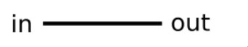

* Module Declaraction

module top_module (  
 input in,  
 output out);

* Solution

module top_module (  
 input in,  
 output out);  
   
assign out =in;  
endmodule

#### - 接地 -- GND

实现如下电路:

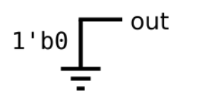

* Module Declaraction

module top_module (  
 output out);

* Solution

module top_module (  
 output out);  
assign out = 'b0;  
endmodule

#### - 或非门 (NOR)

实现如下电路:

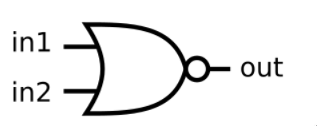

* Module Declaraction

module top_module (  
 input in1,  
 input in2,  
 output out);

* Solution

module top_module (  
 input in1,  
 input in2,  
 output out);  
 assign out = ~(in1|in2);  
endmodule

#### - 其他的门

实现如下电路:

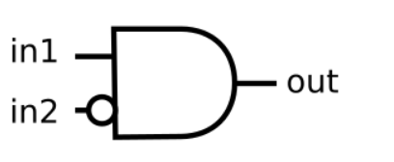

* Module Declaraction

module top_module (  
 input in1,  
 input in2,  
 output out);

* Solution

module top_module (  
 input in1,  
 input in2,  
 output out);  
assign out = in1&~in2;  
endmodule

#### - 两个门

实现如下电路:

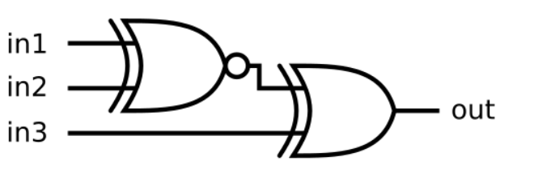

* Module Declaraction

module top_module (  
 input in1,  
 input in2,  
 input in3,  
 output out);

* Solution

module top_module (  
 input in1,  
 input in2,  
 input in3,  
 output out);  
 wire out1;  
   
 assign out1 = ~(in1^in2);  
   
assign out = in3^ out1;  
endmodule

#### - 更多的逻辑门

* Module Declaraction
* Solution

#### - 7420模块

创建如下电路:

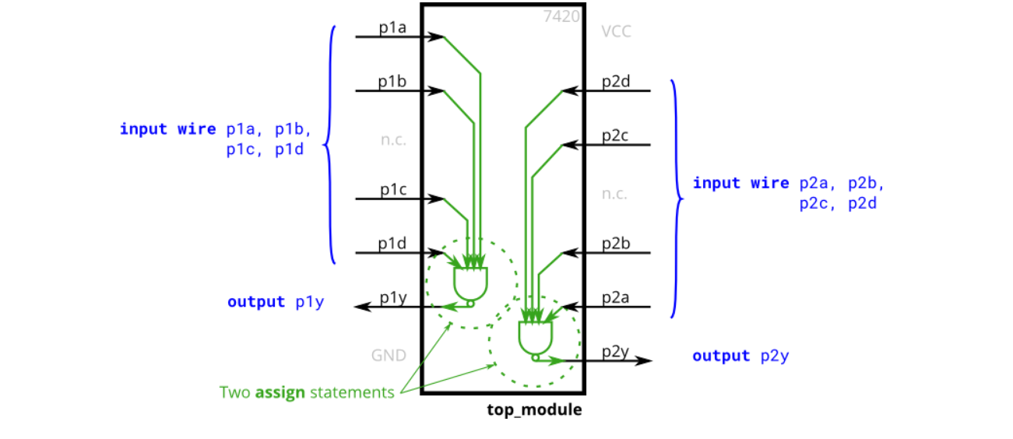

* Module Declaraction

module top_module (   
 input p1a, p1b, p1c, p1d,  
 output p1y,  
 input p2a, p2b, p2c, p2d,  
 output p2y );

* Solution

module top_module (   
 input p1a, p1b, p1c, p1d,  
 output p1y,  
 input p2a, p2b, p2c, p2d,  
 output p2y );  
 assign p1y = ~(p1a&p1b&p1c&p1d);  
 assign p2y = ~(p2a&p2b&p2c&p2d);  
endmodule

#### - 真值表

* Module Declaraction
* Solution

#### - 小练习 -- Two-bit equality

若A==B则输出1,否则输出0

* Module Declaraction

module top_module ( input [1:0] A, input [1:0] B, output z );

* Solution

module top_module ( input [1:0] A, input [1:0] B, output z );   
 assign z = ((A[1]==B[1])&&(A[0]==B[0]))?1:0;  
endmodule

#### - 简单电路A

实现一个模块,具有z = (x^y) & x功能

* Module Declaraction

module top_module (input x, input y, output z);

* Solution

module top_module (input x, input y, output z);  
 assign z = (x^y)&x;  
endmodule

#### - 简单电路B

电路B可以通过以下模拟波形来描述：

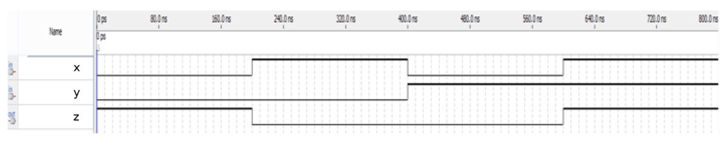

* Module Declaraction

module top_module ( input x, input y, output z );

* Solution

module top_module ( input x, input y, output z );  
 assign z = ~(x^y);  
endmodule

#### - 组合电路AB

通过电路A,B构建如下电路：

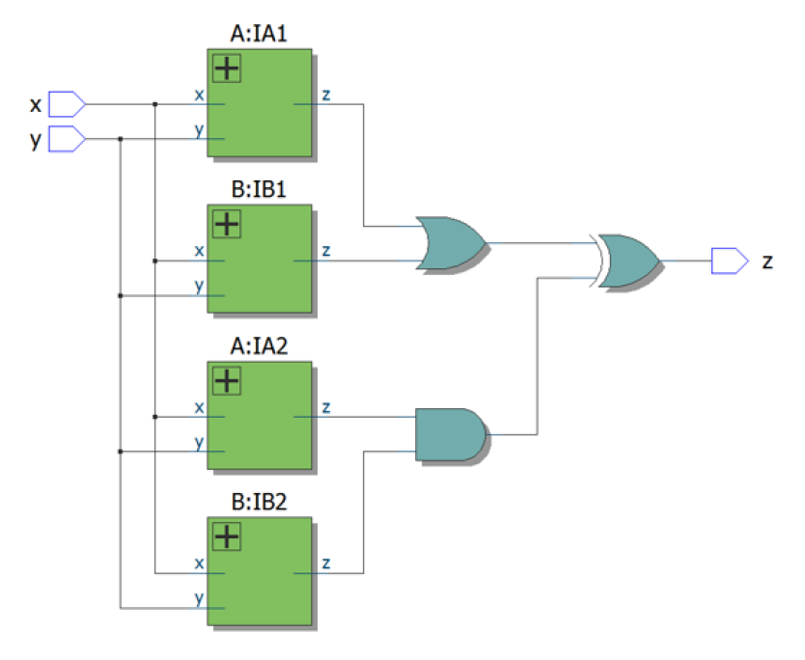

* Module Declaraction

module top_module ( input x, input y, output z );

* Solution

module top_module (input x, input y, output z);  
 wire z1,z2,z3,z4,out1,out2;  
 A ins1(x,y,z1);  
 B ins2(x,y,z2);  
 A ins3(x,y,z3);  
 B ins4(x,y,z4);  
 assign out1 = z1 | z2;  
 assign out2 = z3 & z4;  
 assign z = out1 ^ out2;  
endmodule  
  
module A(input x, input y, output z);  
 assign z = (x^y) & x;  
endmodule  
  
module B ( input x, input y, output z );  
 assign z = ~(x^y);  
endmodule

#### - 铃声与震动模式

* Module Declaraction
* Solution

#### - 恒温器

实现一个加热/冷却恒温器控制器.执行一个电路,根据需要打开和关闭加热器、空调和鼓风机风扇.

恒温器可以处于两种模式之一：加热(mode=1)和冷却(mode=0).在加热模式下,当加热器太冷(too*cold=1)时,打开加热器,但不要使用空调.在冷却模式下,当空调太热(too*hot=1)时打开空调,但不要打开加热器.当加热器或空调打开时,也打开风扇使空气循环.

此外,即使加热器和空调关闭,用户也可以请求风扇打开(fan_on=1).

尝试只使用assign语句,以查看是否可以将问题描述转换为逻辑门集合.

* Module Declaraction

module top_module (  
 input too_cold,  
 input too_hot,  
 input mode,  
 input fan_on,  
 output heater,  
 output aircon,  
 output fan  
);

* Solution

module top_module (  
 input too_cold,  
 input too_hot,  
 input mode,  
 input fan_on,  
 output heater,  
 output aircon,  
 output fan  
);   
 always @(*) begin  
 if(fan_on == 1) begin  
 fan = 1;  
 end  
 else begin  
 fan = 0;  
 end  
 if(mode == 1) begin  
 heater = mode;  
 if(too_cold) begin  
 heater = 1;  
 fan = 1;  
 aircon = 0;  
 end  
 else begin  
 heater = 0;  
 aircon = 0;  
 end  
 end  
 else begin   
 if(too_hot) begin  
 aircon = 1;  
 fan = 1;  
 heater = 0;  
 end  
 else begin  
 aircon = 0;  
 heater = 0;  
 end  
 end  
 end  
endmodule

#### - 3位计数器

计算3位vector中1的个数

* Module Declaraction

module top_module(   
 input [2:0] in,  
 output [1:0] out );

* Solution

module top_module(   
 input [2:0] in,  
 output [1:0] out );  
 reg [1:0]num;  
 integer i;  
 always @(*) begin  
 num = 0;  
 for(i=0;i<3;i=i+1) begin  
 if(in[i] == 1) begin  
 num = num + 2'b1;   
 end  
 end   
 end  
 assign out = num;  
endmodule

#### - 门与容器

给定4位vector,请给出每个位与其相临位之间的关系.

* out_both: 判断相应位与其左临位是否均为1,不考虑in[3]
* out_any: 判断相应位与其右临位是否含有'1',不考虑in[0]
* out_different: 判断相应位与其左临位是否不同,in[3[是in[0]的左临位
* Module Declaraction

module top_module(   
 input [3:0] in,  
 output [2:0] out_both,  
 output [3:1] out_any,  
 output [3:0] out_different );

* Solution

module top_module(   
 input [3:0] in,  
 output [2:0] out_both,  
 output [3:1] out_any,  
 output [3:0] out_different );  
 integer i;  
 reg [2:0]both;  
 reg [3:1]any;  
 reg [3:0]different;  
 always @(*) begin  
 both = 0;  
 any = 0;  
 different = 0;  
 for(i=0;i<3;i=i+1) begin  
 if((in[i]&in[i+1]) == 1) begin  
 both[i] = 1;  
 end  
 end  
 for(i=1;i<4;i=i+1) begin  
 if((in[i]|in[i-1]) == 1) begin  
 any[i] = 1;  
 end  
 end  
 for(i=0;i<4;i=i+1) begin  
 if(i<3) begin  
 if(in[i]^in[i+1]) begin  
 different[i] = 1;  
 end  
 end  
 else begin   
 if(in[3]^in[0]) begin  
 different[3] = 1;  
 end  
 end  
 end  
 end  
 assign out_both = both;  
 assign out_any[3:1] = any[3:1];  
 assign out_different = different;  
endmodule

#### - 更长的数组

给定4位vector,请给出每个位与其相临位之间的关系.

* out_both: 判断相应位与其左临位是否均为1,不考虑in[3]
* out_any: 判断相应位与其右临位是否含有'1',不考虑in[0]
* out_different: 判断相应位与其左临位是否不同,in[3[是in[0]的左临位
* Module Declaraction

module top_module(   
 input [99:0] in,  
 output [98:0] out_both,  
 output [99:1] out_any,  
 output [99:0] out_different );

* Solution

module top_module (  
 input [99:0] in,  
 output [98:0] out_both,  
 output [99:1] out_any,  
 output [99:0] out_different  
);  
  
 // See gatesv for explanations.  
 assign out_both = in & in[99:1];  
 assign out_any = in[99:1] | in ;  
 assign out_different = in ^ {in[0], in[99:1]};  
   
endmodule

#### **多路选择器**(Multiplexers)

#### - 2选1多路选择器

创建一个1位宽的2对1多路选择器.当sel=0时,选择a；当sel=1时,选择b.

* Module Declaraction

module top_module(   
 input a, b, sel,  
 output out );

* Solution

module top_module (  
 input a,  
 input b,  
 input sel,  
 output out  
);  
  
 assign out = (sel & b) | (~sel & a); // Mux expressed as AND and OR  
   
 // Ternary operator is easier to read, especially if vectors are used:  
 // assign out = sel ? b : a;  
   
endmodule

#### - 2选1总线选择器

创建一个100位宽的2对1多路选择器.当sel=0时,选择a；当sel=1时,选择b.

* Module Declaraction

module top_module(   
 input [99:0] a, b,  
 input sel,  
 output [99:0] out );

* Solution

module top_module (  
 input [99:0] a,  
 input [99:0] b,  
 input sel,  
 output [99:0] out  
);  
  
 assign out = sel ? b : a;  
   
 // The following doesn't work. Why?  
 // assign out = (sel & b) | (~sel & a);  
   
endmodule

#### - 9选1多路选择器

创建一个16位宽的9对1多路选择器.sel=0选择a,sel=1选择b等.对于未使用的情况(sel=9到15),将所有输出位设置为“1”.

* Module Declaraction

module top_module(   
 input [15:0] a, b, c, d, e, f, g, h, i,  
 input [3:0] sel,  
 output [15:0] out );

* Solution

module top_module (  
 input [15:0] a,  
 input [15:0] b,  
 input [15:0] c,  
 input [15:0] d,  
 input [15:0] e,  
 input [15:0] f,  
 input [15:0] g,  
 input [15:0] h,  
 input [15:0] i,  
 input [3:0] sel,  
 output logic [15:0] out  
);  
  
 // Case statements can only be used inside procedural blocks (always block)  
 // This is a combinational circuit, so use a combinational always @(*) block.  
 always @(*) begin  
 out = '1; // '1 is a special literal syntax for a number with all bits set to 1.  
 // '0, 'x, and 'z are also valid.  
 // I prefer to assign a default value to 'out' instead of using a  
 // default case.  
 case (sel)  
 4'h0: out = a;  
 4'h1: out = b;  
 4'h2: out = c;  
 4'h3: out = d;  
 4'h4: out = e;  
 4'h5: out = f;  
 4'h6: out = g;  
 4'h7: out = h;  
 4'h8: out = i;  
 endcase  
 end  
   
endmodule

#### - 256选1多路选择器

创建一个1位宽、256对1的多路选择器.256个输入全部打包成一个256位输入vector.sel=0选择in[0],sel=1选择in[1],sel=2选择in[2]等等.

* Module Declaraction

module top_module(   
 input [255:0] in,  
 input [7:0] sel,  
 output out );

* Solution

module top_module (  
 input [255:0] in,  
 input [7:0] sel,  
 output out  
);  
  
 // Select one bit from vector in[]. The bit being selected can be variable.  
 assign out = in[sel];  
   
endmodule

#### - 256选1 4位选则器

创建一个4位宽、256对1的多路选择器.sel=0应选择in[3:0],sel=1选择in[7:4],sel=2选择in[11:8]等.

* Module Declaraction

module top_module(   
 input [1023:0] in,  
 input [7:0] sel,  
 output [3:0] out );

* Solution

module top_module(   
 input [1023:0] in,  
 input [7:0] sel,  
 output [3:0] out );  
 reg [7:0]index;  
 assign out[3:0] = in[4*sel+:4];  
endmodule

#### **运算电路**

#### - 半加器

创建一个半加器,对两个位做加法并输出结果与进位.

* Module Declaraction

module top_module(   
 input a, b,  
 output cout, sum );

* Solution

module top_module(   
 input a, b,  
 output cout, sum );  
 assign {cout,sum} = a + b;  
endmodule

#### - 全加器

创建一个全加器,对两位及进位做加法,输出结果与进位

* Module Declaraction

module top_module(   
 input a, b, cin,  
 output cout, sum );

* Solution

module top_module(   
 input a, b, cin,  
 output cout, sum );  
 assign {cout,sum} = a + b + cin;  
endmodule

#### - 3位加法器

创建一个三位全加器,把每位相加的进位都输出出来.

* Module Declaraction

module top_module(   
 input [2:0] a, b,  
 input cin,  
 output [2:0] cout,  
 output [2:0] sum );

* Solution

module top_module(   
 input [2:0] a, b,  
 input cin,  
 output [2:0] cout,  
 output [2:0] sum );  
 FullAdder ins1(a[0],b[0],cin,cout[0],sum[0]);  
 FullAdder ins2(a[1],b[1],cout[0],cout[1],sum[1]);  
 FullAdder ins3(a[2],b[2],cout[1],cout[2],sum[2]);  
endmodule  
  
module FullAdder(  
 input a, b, cin,  
 output cout, sum  
);  
 assign {cout, sum} = a + b + cin;  
endmodule

#### -adder练习

实现如下电路:

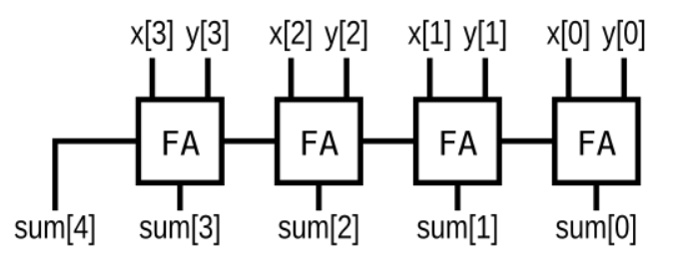

* Module Declaraction

module top_module (  
 input [3:0] x,  
 input [3:0] y,   
 output [4:0] sum);

* Solution

module top_module (  
 input [3:0] x,  
 input [3:0] y,  
 output [4:0] sum  
);  
  
 // This circuit is a 4-bit ripple-carry adder with carry-out.  
 assign sum = x+y; // Verilog addition automatically produces the carry-out bit.  
  
 // Verilog quirk: Even though the value of (x+y) includes the carry-out, (x+y) is still considered to be a 4-bit number (The max width of the two operands).  
 // This is correct:  
 // assign sum = (x+y);  
 // But this is incorrect:  
 // assign sum = {x+y}; // Concatenation operator: This discards the carry-out  
endmodule

#### - 溢出检测

假设您有两个8位的补码,A[7:0]和B[7:0].这些数字加在一起产生s[7:0].还要计算是否发生了(有符号的)溢出.

* Module Declaraction

module top_module (  
 input [7:0] a,  
 input [7:0] b,  
 output [7:0] s,  
 output overflow  
);

* Solution

module top_module (  
 input [7:0] a,  
 input [7:0] b,   
 output [7:0] s,  
 output overflow  
);  
 EightBitsAdder ins(a, b, s, overflow);  
endmodule  
  
module FullAdder(  
 input a, b, cin,  
 output sum, cout  
);  
 assign {cout, sum} = a + b + cin;  
endmodule  
  
module EightBitsAdder(  
 input [7:0] x,  
 input [7:0] y,  
 output [7:0] s,  
 output overflow  
);  
 wire [7:0] cout1;  
 FullAdder ins0(x[0],y[0],0,s[0],cout1[0]);  
 FullAdder ins1(x[1],y[1],cout1[0],s[1],cout1[1]);  
 FullAdder ins2(x[2],y[2],cout1[1],s[2],cout1[2]);  
 FullAdder ins3(x[3],y[3],cout1[2],s[3],cout1[3]);  
 FullAdder ins4(x[4],y[4],cout1[3],s[4],cout1[4]);  
 FullAdder ins5(x[5],y[5],cout1[4],s[5],cout1[5]);  
 FullAdder ins6(x[6],y[6],cout1[5],s[6],cout1[6]);  
 FullAdder ins7(x[7],y[7],cout1[6],s[7],cout1[7]);  
 always @(*) begin  
 if(cout1[7]^cout1[6]) begin  
 overflow = 1;  
 end  
 else begin  
 overflow = 0;  
 end  
 end  
endmodule

#### - 100位加法器

创建一个100位加法器.

* Module Declaraction

module top_module(   
 input [99:0] a, b,  
 input cin,  
 output cout,  
 output [99:0] sum );

* Solution

module top_module(   
 input [99:0] a, b,  
 input cin,  
 output cout,  
 output [99:0] sum );  
 assign {cout,sum} = a+b+cin;  
endmodule

#### - BCD加法器

您将获得一个BCD(二进制编码十进制)一位加法器,名为BCD_fadd,它对两个BCD数字及进位做加法,产生一个和与进位.

module bcd_fadd {  
 input [3:0] a,  
 input [3:0] b,  
 input cin,  
 output cout,  
 output [3:0] sum );

创建一个4BCD位加法器.

* Module Declaraction

module top_module(   
 input [15:0] a, b,  
 input cin,  
 output cout,  
 output [15:0] sum );

* Solution

module top_module (  
 input [15:0] a, b,  
 input cin,  
 output cout,  
 output [15:0] sum  
);  
  
 wire [3:0] inter_cout;  
  
 bcd_fadd bcd_fadd0_inst  
 (  
 .a(a[3:0]),  
 .b(b[3:0]),  
 .cin(cin),  
 .cout(inter_cout[0]),  
 .sum(sum[3:0])  
 );  
  
 genvar i;  
 generate  
 for (i = 1; i <=3; i = i + 1) begin: gen_bcd_adders  
 bcd_fadd bcd_fadd_insts  
 (  
 .a(a[4*(i+1)-1 : 4*i]),  
 .b(b[4*(i+1)-1 : 4*i]),  
 .cin(inter_cout[i-1]),  
 .cout(inter_cout[i]),  
 .sum(sum[4*(i+1)-1 : 4*i])  
 );  
 end  
 endgenerate  
  
 assign cout = inter_cout[3];  
  
endmodule

### 时序逻辑 (Sequential Login)

#### **锁存器与触发器**

#### - D-触发器(D flip-flops)

D-触发器可以存储一个bit数据并根据时钟信号周期的更新数据,一般是由正边沿触发. D-触发器由逻辑合成器(Logic synthesizer)在使用"Always block"时创建(参见AlwaysBlock2).D-触发器是"组合逻辑块之后连接触发器"的最简单形式,其中组合逻辑部分只是一个wire类型变量.

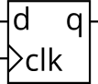

创建一个D-触发器.

* **Module Declaration**

module top_module (  
 input clk,  
 input [7:0] d,  
 output [7:0] q  
);

* **Solution**

module top_module (  
 input clk, // Clocks are used in sequential circuits  
 input d,  
 output reg q );//  
  
 // Use a clocked always block 使用Always block  
 // copy d to q at every positive edge of clk 在时钟信号上升沿时将q复制给d   
 // Clocked always blocks should use non-blocking assignments   
 /*在Always block内永远都不要使用赋值(Assignment),即assign关键字*/  
 always @(posedge clk) begin  
 q = d;  
 end  
  
endmodule

#### - D触发器组合

创建8个D触发器,所有的D触发器均由时钟上升沿触发.

* **Module Declaration**

module top_module (  
 input clk,  
 input [7:0] d,  
 output [7:0] q  
);

* **Solution**

module top_module (  
 input clk,  
 input [7:0] d,  
 output [7:0] q  
);  
 always @(posedge clk) begin  
 q = d;  
 end  
endmodule

#### - 可复位(Reset)的DFF

使用主动高位同步复位信号(Reset)创建8个D-触发器.所有的触发器均由时钟上升沿信号触发.

* **Module Declaration**

module top_module (  
 input clk,  
 input reset, // Synchronous reset  
 input [7:0] d,  
 output [7:0] q  
);

* **Solution**

module top_module (  
 input clk,  
 input reset, // Synchronous reset  
 input [7:0] d,  
 output [7:0] q  
);  
 always @(posedge clk) begin  
 q <= d & {8{~reset}};  
 end  
endmodule

#### - 可复位为特殊值的D-触发器

使用主动高位同步复位信号(Reset)创建8个D-触发器.触发器必须重置为0x34而不是零.所有DFF都应该由CLK的下降沿触发.

* **Module Declaration**

module top_module (  
 input clk,  
 input reset,  
 input [7:0] d,  
 output [7:0] q  
);

* **Solution**

module top_module (  
 input clk,  
 input reset,  
 input [7:0] d,  
 output [7:0] q  
);  
 always @(negedge clk) begin  
 if(reset) begin  
 q <= {8{6'h34}};  
 end  
 else begin  
 q <= d;  
 end  
 end  
endmodule

#### - 可异步复位的触发器(Asynchronous Reset)

使用主动高位异步复位信号创建8个D-触发器.所有DFF都应该由时钟上升沿触发.

* **Module Declaration**

module top_module (  
 input clk,  
 input areset, // active high asynchronous reset  
 input [7:0] d,  
 output [7:0] q  
);

* **Solution**

module top_module (  
 input clk,  
 input areset, // active high asynchronous reset  
 input [7:0] d,  
 output [7:0] q  
);  
 always @(posedge clk or posedge areset) begin  
 if(areset == 1) begin  
 q <= 0;  
 end  
 else begin  
 q <= d;  
 end  
 end  
endmodule

#### - 有开关的触发器

创建16个D-触发器.有时我们希望只修改触发器组的部分值.输入的***开关字节***控制16个寄存器的每个字节是否应在该循环中写入.byteena[1]控制上字节d[15:8],而byteena[0]控制下字节d[7:0]. resetn是一个同步的、主动的低重置. 所有DFF都应该由时钟的上升沿触发.

* **Module Delclaration**

module top_module (  
 input clk,  
 input resetn,  
 input [1:0] byteena,  
 input [15:0] d,  
 output [15:0] q  
);

* **Solution**

module top_module (  
 input clk,  
 input resetn,  
 input [1:0] byteena,  
 input [15:0] d,  
 output [15:0] q  
);  
 always @(posedge clk) begin  
 if(resetn == 1) begin  
 if(byteena[0] == 1) begin  
 q[7:0] <= d[7:0];  
 end  
 if(byteena[1] == 1) begin  
 q[15:8] <= d[15:8];  
 end  
 end  
 else if(resetn == 0) begin  
 q <= 0;  
 end  
 end  
endmodule

#### - D-锁存器(D Latch)

实现如下电路:  
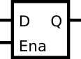

请注意,这是一个锁存器,因此Quartus会报锁存警告

* **Module Declaration**

module top_module (  
 input d,   
 input ena,  
 output q);

module top_module (  
 input d,   
 input ena,  
 output q);  
 wire in,out1,out2;  
 always @(*) begin  
 out1 = ~(out2 | (~d)&ena);  
 out2 = ~(out1 | d&ena);  
 q = out1;  
 end  
endmodule

#### - DFF练习1

请实现如下电路:  
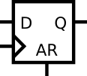

* **Module Declaration**

module top_module (  
 input clk,  
 input d,   
 input ar, // asynchronous reset  
 output q);

* **Solution**

module top_module (  
 input clk,  
 input d,   
 input ar, // asynchronous reset  
 output q);  
 wire out1,out2;  
 always @(posedge clk or posedge ar) begin  
 if(ar == 1) begin  
 q <= 0;  
 end  
 else if(ar == 0) begin  
 q <= d;  
 end  
 end  
endmodule

#### - DFF2

实现如下电路:  
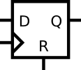

* **Module Declaration**

module top_module (  
 input clk,  
 input d,   
 input r, // synchronous reset  
 output q);

* **Solution**

module top_module (  
 input clk,  
 input d,   
 input r, // synchronous reset  
 output q);  
 always @(posedge clk) begin  
 if(r) begin  
 q <= 0;  
 end  
 else begin  
 q = d;  
 end  
 end  
endmodule

#### - DFF和gate

实现如下电路:  
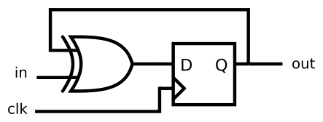

* **Module Declaration**

module top_module (  
 input clk,  
 input in,   
 output out);

* **Solution**

module top_module (  
 input clk,  
 input in,   
 output out);  
 wire out1,out2;  
 always @(posedge clk) begin  
 out1 = out2 ^ in;  
 out2 = out1;  
 out = out2;  
 end  
endmodule

#### - 多路选择器与触发器1

考虑如下时序电路:  
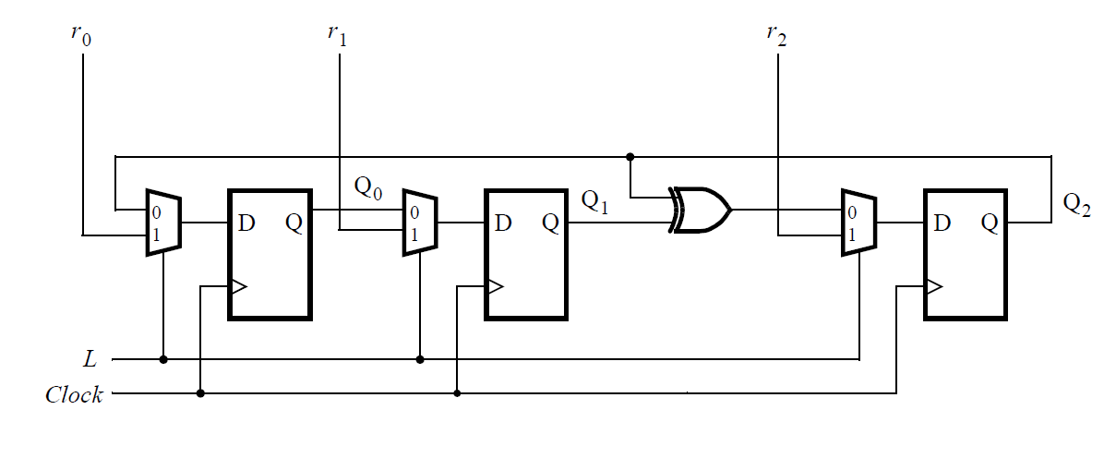

假设您想为如下电路实现层级化(Hierarchical)的代码,使用3个子级模块的实例,子级模块由触发器与多路选择器构成.您的顶级模块应当由含子级模块实现.

注: 这是一种封装的思想

* **Module Declaration**

module top_module (  
 input clk,  
 input L,  
 input r_in,  
 input q_in,  
 output reg Q);

* **Solution**

module top_module (  
 input clk,  
 input L,  
 input r_in,  
 input q_in,  
 output reg Q);  
  
 wire out1;  
 always @(*) begin  
 case (L)  
 1'b0: begin  
 out1 <= q_in;  
 end  
 1'b1: begin  
 out1 <= r_in;  
 end  
 endcase  
 end  
 always @(posedge clk) begin  
 Q <= out1;  
 end  
endmodule

#### - 多路选择器与触发器2

考虑如下n位变换寄存器电路:  
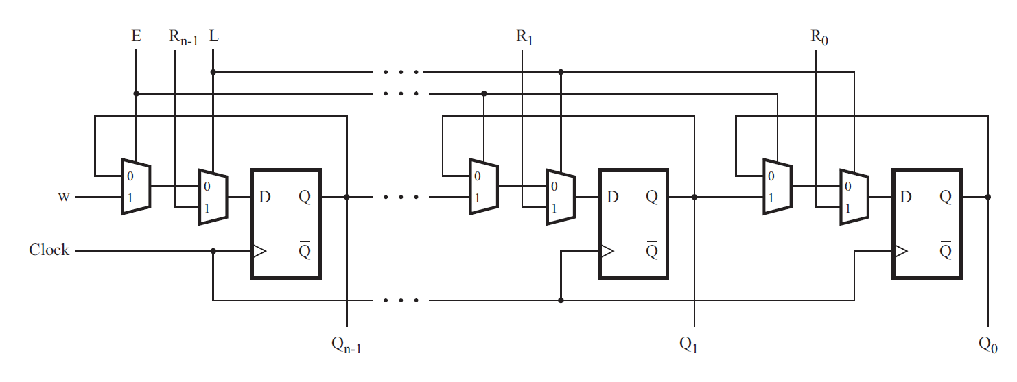

为这个电路实现一个一阶模块,并命名为top_module,可供此电路调用.你的模块应包括触发器与多路选择器.

* **Module Declaration**

module top_module (  
 input clk,  
 input w, R, E, L,  
 output Q  
);

* **Solution**

module top_module (  
 input clk,  
 input w, R, E, L,  
 output Q  
);  
 wire out1,out2;  
 always @(posedge clk) begin  
 case (E)  
 1'b0: begin  
 out1 = Q;  
 end  
 1'b1: begin  
 out1 = w;  
 end  
 endcase  
 case (L)  
 1'b0: begin  
 Q = out1;  
 end  
 1'b1: begin  
 Q = R;  
 end  
 endcase  
 end  
endmodule

#### - DFFs和gates

给定如下有限状态机电路,假设D-触发器在状态机开始前被初始化为0.

构建如下电路.  
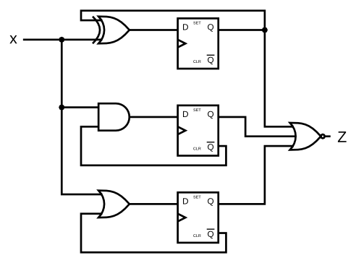

* **Module Declaration**

module top_module (  
 input clk,  
 input x,  
 output z  
);

* **Solution**

module top_module (  
 input clk,  
 input x,  
 output z  
);   
 reg out1, out2, out3;  
 initial z = 1;  
 always @(posedge clk) begin  
 out1 = x ^ out1;  
 out2 = x & ~out2;  
 out3 = x | ~out3;  
 z = ~(out1 | out2 | out3);  
 end  
endmodule

#### - 根据真值表实现电路

JK触发器有如下真值表.通过一个D-触发器和几个gate实现一个JK触发器.

注意:Qold是D-触发器在上升沿之前的输出.

|  |  |  |
| --- | --- | --- |
| J | K | Q |
| 0 | 0 | Qold |
| 0 | 1 | 0 |
| 1 | 0 | 1 |
| 1 | 1 | ~Qold |

* **Module Declaration**

module top_module (  
 input clk,  
 input j,  
 input k,  
 output Q);

* **Solution**

module top_module (  
 input clk,  
 input j,  
 input k,  
 output Q);   
 wire old = Q;  
 always @(posedge clk) begin  
 if(j^k) begin  
 Q = j;  
 end  
 else begin  
 Q = j?~old:old;  
 end  
 end  
endmodule

#### - 边缘检测(Detect an edge)

对于每一个8位容器,在一个时钟周期内,当输入信号从0,变为下个周期的1时进行检测.(类似于上升沿检测).当对应位从0变为1时应当设置输出位.

以下为波形样例,为了清楚起见,in[1]与pedge[1]被分别显示.  
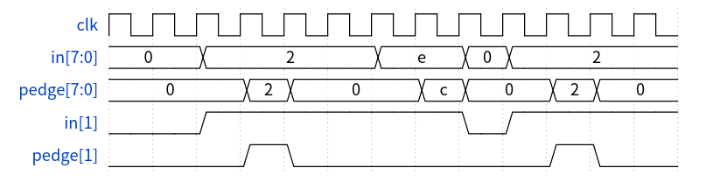

* **Module Declaration**

module top_module (  
 input clk,  
 input [7:0] in,  
 output [7:0] pedge  
);

* **Solution**

module top_module(  
 input clk,  
 input [7:0] in,  
 output reg [7:0] pedge);  
   
 reg [7:0] d_last;   
   
 always @(posedge clk) begin  
 d_last <= in; // Remember the state of the previous cycle  
 pedge <= in & ~d_last; // A positive edge occurred if input was 0 and is now 1.  
 end  
   
endmodule

#### - 边缘检测2

对于每一个8位容器,在一个时钟周期内,当输入信号从0,变为下个周期的1时进行检测.(上升沿与下降沿均触发).当对应位从0变为1时应当设置输出位.

以下为波形样例,为了清楚起见,in[1]与anyedge[1]被分别显示.  
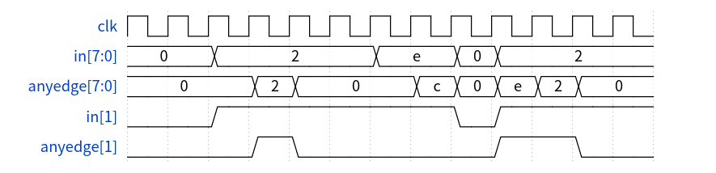

* **Module Declaration**

module top_module (  
 input clk,  
 input [7:0] in,  
 output [7:0] anyedge  
);

* **Solution**

module top_module (  
 input clk,  
 input [7:0] in,  
 output [7:0] anyedge  
);  
 reg [7:0] temp;  
 always @(posedge clk) begin  
 temp <= in;  
 anyedge <= temp ^ in;  
 end  
endmodule

#### - 边缘捕获寄存器(Edge capture register)

对于32位Vector中的每一位,当输入信号在一个时钟周期内从1变为下一个时钟周期的0时进行捕获."捕获"表示输出将保持1,直到寄存器复位(同步复位 -- Synchronous Reset).

每个输出位的行为类似于SR触发器：在发生1到0的转换之后,输出位应该被设置为1.当复位为高电平时,输出位应在上升沿复位(至0).如果上述两个事件同时发生,则重置(Reset)具有优先权.在下面示例波形的最后4个周期中,"Reset"事件比"Set"事件早一个周期,因此这里没有冲突. 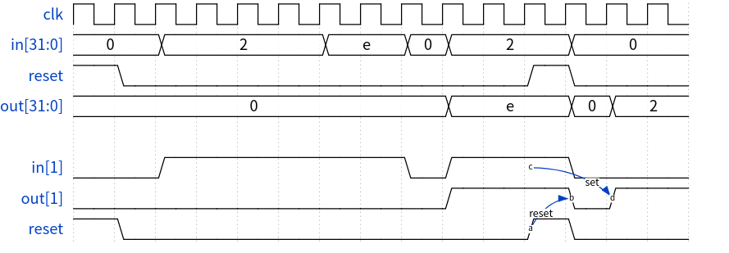

* **Module Declaration**

module top_module (  
 input clk,  
 input reset,  
 input [31:0] in,  
 output [31:0] out  
);

* **Solution**

module top_module (  
 input clk,  
 input reset,  
 input [31:0] in,  
 output [31:0] out  
);  
 reg [31:0] old,result,temp;  
 initial temp = 0;  
 always @(posedge clk) begin  
 if(reset) begin  
 old = in;  
 result = 0;  
 out = 0;  
 end  
 else begin  
 temp = (in ^ old) & old;  
 result = result | temp;  
 out = result;  
 old = in;  
 end  
 end   
endmodule

#### - 双边沿出发(Dualedge)

你现在已经比较熟悉上升沿或者下降沿出发的触发器了.而双边触发器在时钟上升沿与下降沿都会触发.但是FPGA并没有双边沿触发器,并且always @(posedge clk or negedge clk)是非法的.

构建一个电路来实现类似于双边触发器的功能:  
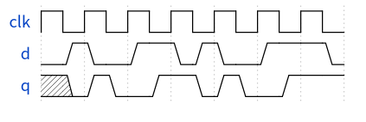

注意:并不需要完全等效:在这里触发器的输出没什么毛病,但是在更大的电路中模拟这种行为可能会有故障,我们在这里忽略这个细节.

* Hint:
  + 你不能在FPGA上创建双边沿触发器,但是组合上升沿与下降沿触发器.
  + 这个问题是一个中等难度的电路设计问题,但只需要基本的verilog语言特性.(这是一个电路设计问题,而不是编码问题.)在试图对电路进行编码之前,先用手画出电路草图可能会有所帮助.
* **Module Declaraction**

module top_module (  
 input clk,  
 input d,  
 output q  
);

* **Solution**

module top_module (  
 input clk,  
 input d,  
 output q  
);  
 reg [1:0] status;  
 always @(posedge clk) begin  
 status[0] = d;  
 end  
 always @(negedge clk) begin  
 status[1] = d;  
 end  
 assign q = clk ? status[0] : status[1];  
endmodule

#### **计数器(Counters)**

#### - **四位二进制计数器**

构建一个0-15的四位二进制计数器,句点为16.重置输入是同步的,应将计数器重置为0. 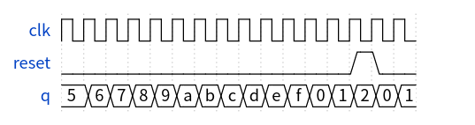

* **Module Declaration**

module top_module (  
 input clk,  
 input reset, // Synchronous active-high reset  
 output [3:0] q);

* **Solution**

module top_module (  
 input clk,  
 input reset, // Synchronous active-high reset  
 output [3:0] q);  
 always @(posedge clk) begin  
 if(!reset) begin  
 if(q == 4'hf) begin  
 q = 0;  
 end  
 else begin  
 q = q + 1;  
 end  
 end  
 else begin  
 q = 0;  
 end  
 end  
endmodule

#### - 十进制计数器

建立一个从0到9的十进制计数器,句点为10,重置输入是同步的,应该将计数器重置为0.  
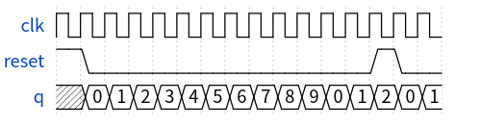

* **Module Declaration**

input clk,  
 input reset, // Synchronous active-high reset  
 output [3:0] q);

* **Solution**

module top_module (  
 input clk,  
 input reset, // Synchronous active-high reset  
 output [3:0] q);  
   
 always @(posedge clk) begin  
 if(reset) begin  
 q <= 0;  
 end  
 else begin  
 if(q = 4'd10) begin  
 q = 0;  
 end  
 else begin  
 q = q + 1;  
 end  
 end  
 end  
endmodule

#### - 十进制计数器1

建立一个从0到9的十进制计数器,句点为10,重置输入是同步的,应该将计数器重置为1.  
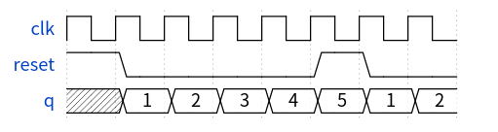

* **Module Declaration**

module top_module (  
 input clk,  
 input reset,  
 output [3:0] q);

* **Solution**

module top_module (  
 input clk,  
 input reset,  
 output [3:0] q);  
 always @(posedge clk) begin  
 if(reset) begin  
 q <= 1;  
 end  
 else begin  
 if(q == 4'ha) begin  
 q = 1;  
 end  
 else begin  
 q = q + 1;  
 end  
 end  
 end  
endmodule

#### - **慢序十进制计数器**

构建一个0到9的十进制计数器,句点为10.reset信号是同步的,将计数器置零.我们希望能够暂停计数器,而不是在每个时钟周期内增加,因此slowena控制计数器的增加.  
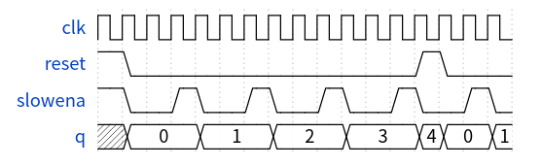

* **Module Declaration**

module top_module (  
 input clk,  
 input slowena,  
 input reset,  
 output [3:0] q);

* **Solution**

module top_module (  
 input clk,  
 input slowena,  
 input reset,  
 output [3:0] q);  
 always @(posedge clk) begin  
 if(reset) begin  
 q <= 0;  
 end  
 else begin  
 if(slowena) begin  
 if(q == 4'd9) begin   
 q = 0;  
 end  
 else begin  
 q = q + 1;  
 end  
 end  
 else begin  
 q = q + 0;  
 end  
 end  
 end  
endmodule

#### - **Counter1-12**

设计一个具有以下输入输出的Counter:

* 同步高位Reset信号将寄存器重置为0
* 当enable为高位时Counter进行工作
* 时钟信号上升沿触发
* Q[3:0] 为counter的输出
* c_enable, c_load, c_d[3:0]三个控制信号发送到所提供的4-bit Counter模块,以便检验正确操作.  
  你可以使用如下组件:

如下4位计数器,enable与load同步并行输入(load的优先级高于enable).这个count4模块提供给你,在你的模块中实例化他.

module count4(  
 input clk,  
 input enable,  
 input load,  
 input [3:0] d,  
 output reg [3:0] Q  
);

* **Module Declaration**

module top_module (  
 input clk,  
 input reset,  
 input enable,  
 output [3:0] Q,  
 output c_enable,  
 output c_load,  
 output [3:0] c_d  
);

* **Solution**

module top_module (  
 input clk,  
 input reset,  
 input enable,  
 output [3:0] Q,  
 output c_enable,  
 output c_load,  
 output [3:0] c_d  
); //  
 wire [3:0] Q_tmp;  
 assign c_enable = enable;  
 assign c_d = c_load ? 1 : 0;  
 always @(posedge clk) begin  
 if(reset) begin  
 Q <= 1;  
 Q_tmp <= 1;  
 end  
 else begin  
 if(enable) begin  
 if(Q == 12) begin  
 Q <= 1;  
 Q_tmp <= 1;  
 end  
 else begin  
 Q <= Q + 1;  
 Q_tmp <= Q_tmp + 1;  
 end  
 end  
 end  
 end  
   
 always @(*) begin  
 if(reset || (Q == 12 && c_enable)) begin  
 c_load <= 1;  
 end  
 else begin  
 c_load <= 0;  
 end  
 end  
  
 count4 the_counter (clk, c_enable, c_load, c_d, Q_tmp);  
  
endmodule

#### - 算数左右移

构建一个64为算数寄存器,具有同步load信号.这个shifter根据amount信号选择,可左右移1位或8位.  
 在算数右移时,若符号位(q[63])为1则需要复制位,而并非简单的逻辑右移.另一种考虑方式,假定被移位的数字有符号并保留符号,这样算术右移将有符号数字除以2的幂.  
 算数左移与逻辑左移没有区别.

* load: 寄存器载入数据(优先级最高)
* ena: 决定是否发生位移
* amount: 决定位移的方向
  + 2'b00: 左移一位
  + 2'b01: 左移8位
  + 2'b10: 右移一位
  + 2'b11: 右移8位
* q: shifter的内容
* **Module Declaration**

module top_module(  
 input clk,  
 input load,  
 input ena,  
 input [1:0] amount,  
 input [63:0] data,  
 output reg [63:0] q);

* **Solution**

module top_module(  
 input clk,  
 input load,  
 input ena,  
 input [1:0] amount,  
 input [63:0] data,  
 output reg [63:0] q);   
 always @(posedge clk) begin  
 if(load) begin  
 q <= data;  
 end  
 else begin  
 if(ena) begin  
 case (amount)  
 2'b00: begin   
 q <= q << 1;  
 end  
 2'b01: begin  
 q <= q << 8;  
 end  
 2'b10: begin  
 q <= q >> 1;  
 if(q[63] == 1) begin  
 q[63] <= 1;  
 end  
 end  
 2'b11: begin  
 q <= q >> 8;  
 if(q[63] == 1) begin  
 q[63:56] <= {8{1'b1}};  
 end  
 end  
 endcase  
 end  
 end  
 end  
endmodule

#### **有限状态机**

#### - 简单FSM1

实现如下简单摩尔状态机:

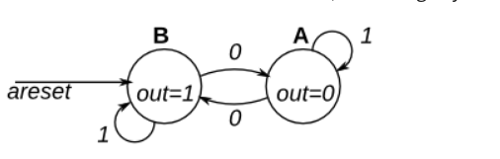

* Module Declaraction

module top_module(  
 input clk,  
 input areset, // Asynchronous reset to state B  
 input in,  
 output out);

* Solution

module top_module(  
 input clk,  
 input areset, // Asynchronous reset to state B  
 input in,  
 output out);//   
  
 parameter A=0, B=1;   
 reg state, next_state;  
  
 always @(*) begin // This is a combinational always block  
 // State transition logic  
 case (state)  
 A: next_state <= in?A:B;  
 B: next_state <= in?B:A;  
 endcase  
 end  
  
 always @(posedge clk, posedge areset) begin // This is a sequential always block  
 // State flip-flops with asynchronous reset  
 if(areset) begin  
 state <= B;  
 end  
 else begin  
 state <= next_state;  
 end  
 end  
  
 // Output logic  
 // assign out = (state == ...);  
 assign out = (state==B);  
  
  
 // always @(*) begin  
 // case (state)  
 // A: out <= 0;  
 // B: out <= 1;  
 // endcase  
 // end  
  
endmodule

#### - Fsm1s

实现如下电路:

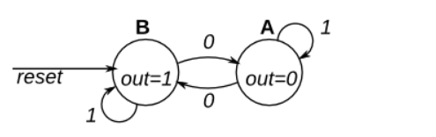

* + Module Declaraction

module top_module(clk, reset, in, out);  
 input clk;  
 input reset; // Synchronous reset to state B  
 input in;  
 output out;

* Solution

// Note the Verilog-1995 module declaration syntax here:  
module top_module(clk, reset, in, out);  
 input clk;  
 input reset; // Synchronous reset to state B  
 input in;  
 output out;//   
 reg out;  
  
 // Fill in state name declarations  
  
 reg present_state, next_state;  
 parameter A = 0, B = 1;  
 always @(posedge clk) begin  
 if (reset) begin   
 present_state <= B;  
 end else begin  
 present_state <= next_state;  
 end  
 end  
  
 always @(*) begin  
 case (present_state)  
 A: next_state <= in ? A : B;  
 B: next_state <= in ? B : A;  
 endcase  
 end  
 assign out = (present_state == B);  
endmodule

#### - fsm2

实现如下电路:

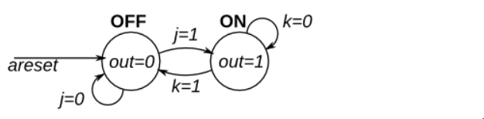

* + Module Declaraction

module top_module(  
 input clk,  
 input areset, // Asynchronous reset to OFF  
 input j,  
 input k,  
 output out);

* Solution

module top_module(  
 input clk,  
 input areset, // Asynchronous reset to OFF  
 input j,  
 input k,  
 output out); //   
  
 parameter OFF=0, ON=1;   
 reg state, next_state;  
  
 always @(*) begin  
 // State transition logic  
 case (state)  
 OFF: next_state <= j ? ON : OFF;  
 ON: next_state <= k ? OFF : ON;  
 endcase  
 end  
  
 always @(posedge clk, posedge areset) begin  
 // State flip-flops with asynchronous reset  
 if(areset) begin  
 state <= OFF;  
 end else begin  
 state <= next_state;  
 end  
 end  
  
 assign out = (state == ON);  
endmodule

#### -fsm2s

实现如下状态机:

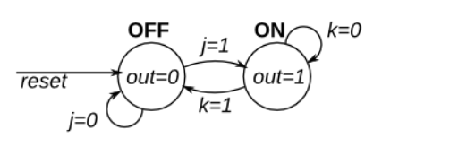

* Module Declaraction

module top_module(  
 input clk,  
 input reset, // Synchronous reset to OFF  
 input j,  
 input k,  
 output out);

* Solution

module top_module(  
 input clk,  
 input reset, // Synchronous reset to OFF  
 input j,  
 input k,  
 output out); //   
  
 parameter OFF=0, ON=1;   
 reg state, next_state;  
  
 always @(*) begin  
 // State transition logic  
 case (state)   
 OFF: next_state <= j ? ON : OFF;  
 ON: next_state <= k ? OFF : ON;  
 endcase  
 end  
  
 always @(posedge clk) begin  
 // State flip-flops with synchronous reset  
 if(reset) begin  
 state <= OFF;  
 end else begin  
 state <= next_state;  
 end  
 end  
 assign out = (state == ON);  
endmodule

#### - fsm3comb

实现如下状态机:

* Module Declaraction

module top_module(  
 input in,  
 input [1:0] state,  
 output [1:0] next_state,  
 output out);

* Solution

module top_module(  
 input in,  
 input [1:0] state,  
 output [1:0] next_state,  
 output out); //  
  
 parameter A=0, B=1, C=2, D=3;  
  
 // State transition logic: next_state = f(state, in)  
 always @(*) begin  
 case (state)  
 A: next_state <= in ? B : A;  
 B: next_state <= in ? B : C;  
 C: next_state <= in ? D : A;  
 D: next_state <= in ? B : C;  
 endcase  
 end  
  
 assign out = (state == D);  
  
 // Output logic: out = f(state) for a Moore state machine  
endmodule

#### - fsm3onehot

使用"独热码"(one-hot code)实现如下状态机:

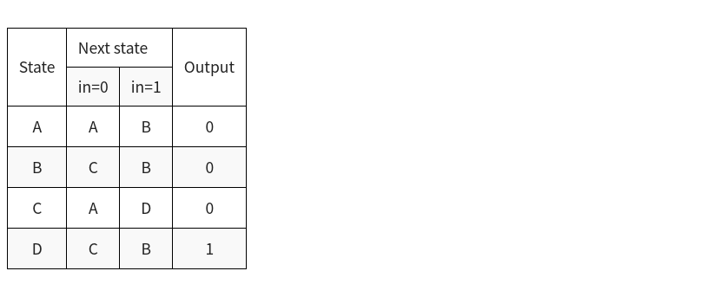

* Module Declaraction

module top_module(  
 input in,  
 input [3:0] state,  
 output [3:0] next_state,  
 output out);

* Solution

module top_module(  
 input in,  
 input [3:0] state,  
 output [3:0] next_state,  
 output out); //  
  
 parameter A=0, B=1, C=2, D=3;  
  
 // State transition logic: Derive an equation for each state flip-flop.  
 assign next_state[A] = state[0]&(~in)|state[2]&(~in);  
 assign next_state[B] = state[0]&in|state[1]&in|state[3]&in;  
 assign next_state[C] = state[1]&(~in)|state[3]&(~in);  
 assign next_state[D] = state[2]&(in);  
  
 // Output logic:   
 assign out = (state[3] == 1);  
  
endmodule

#### - fsm3

实现如下状态机:

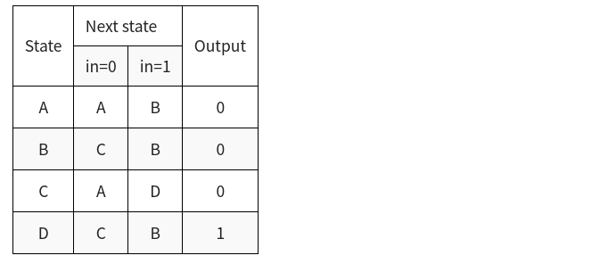

* Module Declaraction

module top_module(  
 input clk,  
 input in,  
 input areset,  
 output out);

* Solution

module top_module(  
 input clk,  
 input in,  
 input areset,  
 output out); //  
   
 reg [2:0] state, next_state;  
 parameter A=1, B=2, C=3, D=4;   
 // State transition logic  
 always @(*) begin  
 case (state)  
 A: next_state <= in ? B : A;  
 B: next_state <= in ? B : C;  
 C: next_state <= in ? D : A;  
 D: next_state <= in ? B : C;  
 endcase  
 end  
  
 // State flip-flops with asynchronous reset  
 always @(posedge clk or posedge areset) begin  
 if(areset) begin  
 state <= A;  
 end else begin  
 state <= next_state;  
 end  
 end  
  
 // Output logic  
 assign out = (state == D);  
endmodule

#### - fsm3s

实现如下状态机:

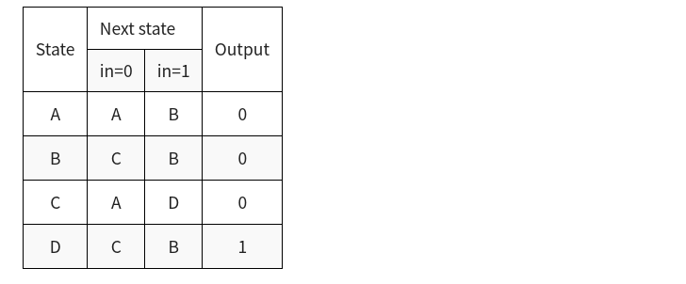

* Module Declaraction

module top_module(  
 input clk,  
 input in,  
 input reset,  
 output out);

* Solution

module top_module(  
 input clk,  
 input in,  
 input reset,  
 output out); //  
   
 reg [2:0] state, next_state;  
 parameter A=0, B=1, C=2, D=3;  
 // State transition logic  
 always @(*) begin  
 case (state)  
 A: next_state <= in ? B : A;  
 B: next_state <= in ? B : C;  
 C: next_state <= in ? D : A;  
 D: next_state <= in ? B : C;  
 endcase  
 end  
  
 // State flip-flops with synchronous reset  
 always @(posedge clk) begin  
 if(reset) begin  
 state <= A;  
 end else begin  
 state <= next_state;  
 end  
 end  
  
 // Output logic  
 assign out = (state == D);  
endmodule

#### - Fsm serial

在许多(旧的)串行通信协议中,每个数据字节与一个起始位和一个终止位一起发送,以帮助接收器从位流中分隔字节.一种常见的方案是使用一个起始位(0)、8个数据位和1个终止位(1).当没有任何东西被传输(空闲)时,输出1. 设计一个有限状态机,当给定比特流时,它将识别何时正确接收字节.它需要识别起始位,等待所有8个数据位,然后验证终止位是否正确.如果停止位没有在预期的时间出现,那么FSM必须等到收到终止位后才能尝试接收下一个字节.

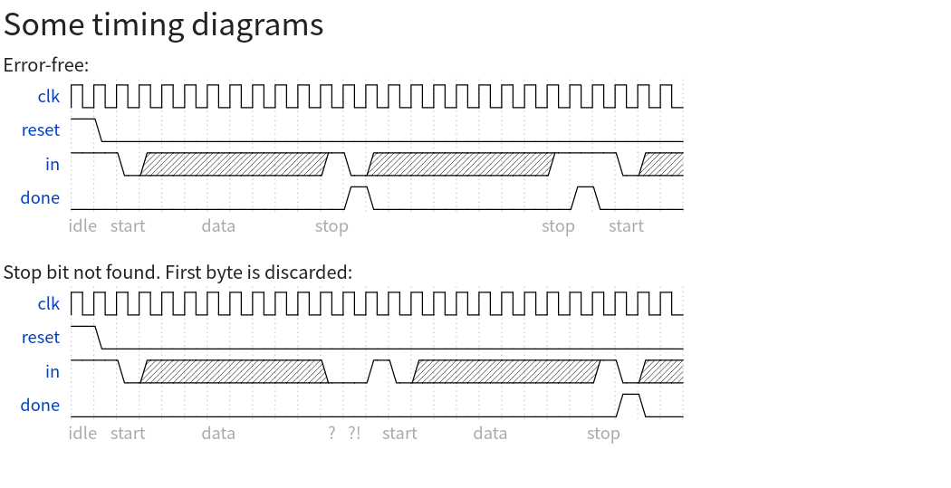

* Module Declaraction

module top_module(  
 input clk,  
 input in,  
 input reset, // Synchronous reset  
 output done  
);

* Solution

module top_module(  
 input clk,  
 input in,  
 input reset, // Synchronous reset  
 output done  
);   
 reg [3:0] i;  
 parameter RECV=0, DONE=1, READY=3, ERROR=4;  
 reg [2:0] state, next_state;  
  
 always @(*) begin  
 case (state)  
 READY: next_state <= in ? READY : RECV;  
 RECV: begin  
 if((i==8)&in) begin  
 next_state <= DONE;  
 end else if((i==8)&(~in)) begin  
 next_state <= ERROR;  
 end else begin  
 next_state <= RECV;  
 end  
 end  
 DONE: next_state <= in ? READY : RECV;  
 ERROR: next_state <= in ? READY : ERROR;  
 endcase  
 end  
  
 always @(posedge clk) begin  
 if(reset) begin  
 state <= READY;  
 i <= 0;  
 end else begin  
 if((state == RECV)&&(i!=8)) begin  
 i <= i + 1;  
 end else if(state == ERROR) begin  
 i <= 0;  
 end else if(state == DONE) begin  
 i <= 0;  
 end  
 state <= next_state;  
 end  
 end  
 assign done = (state == DONE);   
endmodule

#### - Fsm serialdata

在上题的基础上将收到的数据输出出来:

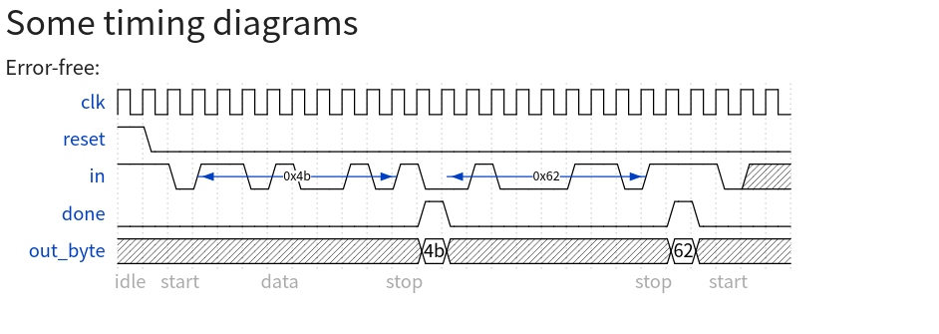

* Module Declaraction

module top_module(  
 input clk,  
 input in,  
 input reset, // Synchronous reset  
 output [7:0] out_byte,  
 output done  
);

* Solution

module top_module(  
 input clk,  
 input in,  
 input reset, // Synchronous reset  
 output [7:0] out_byte,  
 output done  
);   
 reg [3:0] i;  
 parameter RECV=0, DONE=1, READY=3, ERROR=4;  
 reg [2:0] state, next_state;  
 reg [7:0] data;  
  
 always @(*) begin  
 case (state)  
 READY: next_state <= in ? READY : RECV;  
 RECV: begin  
 if((i==8)&in) begin  
 next_state <= DONE;  
 end else if((i==8)&(~in)) begin  
 next_state <= ERROR;  
 end else begin  
 next_state <= RECV;  
 data[i] <= in;  
 end  
 end  
 DONE: begin  
 next_state <= in ? READY : RECV;  
 out_byte <= data;  
 end  
 ERROR: next_state <= in ? READY : ERROR;  
 endcase  
 end  
  
 always @(posedge clk) begin  
 if(reset) begin  
 state <= READY;  
 i <= 0;  
 end else begin  
 if((state == RECV)&&(i!=8)) begin  
 i <= i + 1;  
 end else if(state == ERROR) begin  
 i <= 0;  
 end else if(state == DONE) begin  
 i <= 0;  
 end  
 state <= next_state;  
 end  
 end  
 assign done = (state == DONE);  
endmodule

#### - 旅鼠

旅鼠是一种头脑简单的动物.非常简单,我们将用一个有限状态机对它进行建模.

在旅鼠的二维世界中,旅鼠可以处于两种状态之一：向左行走或向右行走.如果碰到障碍物,它会改变方向.尤其是,如果一只旅鼠在左边撞了,它就会向右走.如果它撞到右边,它就会向左走.如果它在两侧同时发生碰撞,它仍然会改变方向. 实现一个具有两个状态、两个输入和一个输出的摩尔状态机来模拟这种行为.

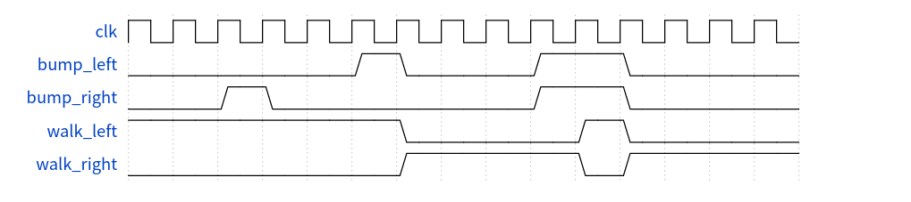

* Module Declaraction

module top_module(  
 input clk,  
 input areset, // Freshly brainwashed Lemmings walk left.  
 input bump_left,  
 input bump_right,  
 output walk_left,  
 output walk_right);

* Solution

module top_module(  
 input clk,  
 input areset, // Freshly brainwashed Lemmings walk left.  
 input bump_left,  
 input bump_right,  
 output walk_left,  
 output walk_right); //   
  
 parameter LEFT=0, RIGHT=1;  
 reg state, next_state;  
  
 always @(*) begin  
 // State transition logic  
 case (state)  
 LEFT: next_state <= bump_left ? RIGHT : LEFT;  
 RIGHT: next_state <= bump_right ? LEFT : RIGHT;  
 endcase  
 end  
  
 always @(posedge clk, posedge areset) begin  
 // State flip-flops with asynchronous reset  
 if(areset) begin  
 state <= LEFT;  
 end else begin  
 state <= next_state;  
 end  
 end  
  
 // Output logic  
 assign walk_left = (state == LEFT);  
 assign walk_right = (state == RIGHT);  
  
endmodule

#### - 旅鼠2

除了向左和向右走,如果地面消失了旅鼠会下落并大喊aaah!.

当ground=0时,除了左右行走和改变方向外,旅鼠还会跌倒并说“aaah！”.当地面重新出现(ground=1)时,旅鼠将恢复以与坠落前相同的方向行走.下落时被撞击不影响行走方向,与地面消失同一周期被撞击(但尚未坠落),或下落时地面再次出现,也不影响行走方向.

建立一个模拟这种行为的有限状态机.

* Module Declaraction

module top_module(  
 input clk,  
 input areset, // Freshly brainwashed Lemmings walk left.  
 input bump_left,  
 input bump_right,  
 input ground,  
 output walk_left,  
 output walk_right,  
 output aaah );

* Solution

module top_module(  
 input clk,  
 input areset,  
 input bump_left,  
 input bump_right,  
 input ground,  
 output walk_left,  
 output walk_right,  
 output aaah  
);  
  
 parameter LEFT = 2'd0, LEFT_GROUND = 2'd1, RIGHT = 2'd2, RIGHT_GROUND = 2'd3;  
  
 reg [1:0] curr_dir, next_dir;  
  
 always @(posedge clk or posedge areset) begin  
 // Freshly brainwashed Lemmings walk left.  
 if (areset) begin  
 curr_dir <= LEFT;  
 end  
 else begin  
 curr_dir <= next_dir;  
 end  
 end  
  
 always @(*) begin  
 case (curr_dir)  
 LEFT: begin  
 if (ground) begin  
 next_dir = bump_left ? RIGHT : LEFT;  
 end  
 else begin  
 next_dir = LEFT_GROUND;  
 end  
 end  
 RIGHT: begin  
 if (ground) begin  
 next_dir = bump_right ? LEFT : RIGHT;  
 end  
 else begin  
 next_dir = RIGHT_GROUND;  
 end  
 end  
 LEFT_GROUND: begin  
 if (ground) begin  
 next_dir = LEFT;  
 end  
 else begin  
 next_dir = LEFT_GROUND;  
 end  
 end  
 RIGHT_GROUND: begin  
 if (ground) begin  
 next_dir = RIGHT;  
 end  
 else begin  
 next_dir = RIGHT_GROUND;  
 end  
 end  
 endcase  
 end  
  
 assign walk_left = curr_dir == LEFT;  
 assign walk_right = curr_dir == RIGHT;  
 assign aaah = (curr_dir == LEFT_GROUND) || (curr_dir == RIGHT_GROUND);  
  
endmodule

#### - 旅鼠3

除了行走和摔倒之外,有时还可以告诉旅鼠做一些有用的事情,比如挖洞(dig=1时开始挖洞).如果一只旅鼠正在地面上行走(ground=1),它可以继续挖掘直到到达另一边(ground=0).在那一点上,由于没有地面,它会掉下来(aaah!),然后在它再次落地后继续沿着它原来的方向行走.和坠落一样,在挖掘时被撞击没有效果,在坠落或没有地面时被告知挖掘是被忽略的.

换言之,一个行尸走肉的旅鼠可能会摔倒、dig或改变方向.如果满足这些条件中的一个以上,则fall的优先级高于dig,dig的优先级高于切换方向.

扩展有限状态机来模拟这种行为.

* Module Declaration

module top_module(  
 input clk,  
 input areset, // Freshly brainwashed Lemmings walk left.  
 input bump_left,  
 input bump_right,  
 input ground,  
 input dig,  
 output walk_left,  
 output walk_right,  
 output aaah,  
 output digging );

* Solution

module top_module(  
 input clk,  
 input areset, // Freshly brainwashed Lemmings walk left.  
 input bump_left,  
 input bump_right,  
 input ground,  
 input dig,  
 output walk_left,  
 output walk_right,  
 output aaah,  
 output digging );  
  
 reg [2:0] state, next_state;  
 parameter LEFT=0, RIGHT=1, LEFT_GROUND=3, RIGHT_GROUND=4, DIG_LEFT=5, DIG_RIGHT=6;  
 always @(*) begin  
 case (state)  
 LEFT: begin  
 if(ground) begin  
 if(dig) begin  
 next_state <= DIG_LEFT;  
 end else begin  
 next_state <= bump_left ? RIGHT : LEFT;  
 end  
 end else begin  
 next_state <= LEFT_GROUND;  
 end  
 end  
 RIGHT: begin  
 if(ground) begin  
 if(dig) begin  
 next_state <= DIG_RIGHT;   
 end else begin  
 next_state <= bump_right ? LEFT : RIGHT;  
 end  
 end else begin  
 next_state <= RIGHT_GROUND;  
 end  
 end  
 LEFT_GROUND: begin  
 if(ground) begin  
 next_state <= LEFT;  
 end else begin  
 next_state <= LEFT_GROUND;  
 end  
 end  
 RIGHT_GROUND: begin  
 if(ground) begin  
 next_state <= RIGHT;  
 end else begin  
 next_state <= RIGHT_GROUND;  
 end  
 end  
 DIG_LEFT: begin  
 if(ground) begin  
 next_state <= DIG_LEFT;  
 end else begin  
 next_state <= LEFT_GROUND;  
 end  
 end  
 DIG_RIGHT: begin  
 if(ground) begin  
 next_state <= DIG_RIGHT;  
 end else begin  
 next_state <= RIGHT_GROUND;  
 end  
 end  
 endcase  
 end  
  
 always @(posedge clk or posedge areset) begin  
 if( areset) begin  
 state <= LEFT;  
 end else begin  
 state <= next_state;  
 end  
 end  
   
 assign walk_left = (state == LEFT);  
 assign walk_right = (state == RIGHT);  
 assign aaah = (state == RIGHT_GROUND)||(state == LEFT_GROUND);  
 assign digging = (state == DIG_LEFT)||(state == DIG_RIGHT);  
endmodule