## 

## G H RAISONI COLLEGE OF ENGINEERING & MANAGEMENT, WAGHOLI, PUNE

**(**An Empowered Autonomous Institute, Affiliated to Savitribai Phule Pune University,

Approved by AICT. New Delhi and Recognized by Govt. of Maharashtra.

NAAC ACCREDIATED A+ Grade)

**Department of Information Technology**

**Subject: Python Programming [23UQCMDP2302]**

Mini Project Report On

# “Randomized Password Generator”

### Academic Year 2024-25 Semester-III

**G H RAISONI COLLEGE OF ENGINEERING & MANAGEMENT, WAGHOLI, PUNE**

**(**An Empowered Autonomous Institute, Affiliated to Savitribai Phule Pune University,

Approved by AICT. New Delhi and Recognized by Govt. of Maharashtra.

NAAC ACCREDIATED A+ Grade)

**Department of Information Technology Academic Year 2024-25**

### Semester-III

**Guided By:-**

**Mrs. Archana Dongardive**

**Submitted by:**

1. SITB53 Panchakshari Chakor
2. SITB43 Prem Bonde
3. SITB31 Palak Singh
4. SITB54 Mahesh Salunke
5. SITB52 Raman Bhise



**CERTIFICATE**

This is to certify that **“Randomized Password Generator”** embodies the original work done by  **Mr. Panchakshari Chakor , Mr. Prem Bonde , Ms. Palak Singh , Mr. Mahesh Salunke , Mr. Raman Bhise** this project submission as a partial fulfilment of the requirement for the Mini Project using Python Programming subjects of Second Year B. Tech. Degree, III Semester, of Pune University during the academic year 2024-2025.

**Date:**

**Place:** Pune

**(Mrs. Archana Dongardive (Dr. Poonam Gupta)**

**Project Guide Head of Department**

### ACKNOWLEDGEMENT

We would like to express our sincere thanks to **Mrs. Archana Dongardive** under whose valuable guidance and light of knowledge, we could complete this project.

We take this opportunity to thank all the staff members of Department Of Information Technology Engineering for their help whenever required. Finally we express sincere thanks to all those who have helped us directly or indirectly in many ways in completion of this project work and I would like to extend my Deep appreciation to all my group members, without their support and Coordination we would not have been able to complete this Project.

**INDEX**

|  |  |  |
| --- | --- | --- |
| Sr.No | TITLE | Page No |
| 1. | Randomized Password generator using Numbers, Symbols, Uppercase and Lowercase Letters. | 1 |

**Project Statement: Random Password Generator**

This Python program generates a randomized password based on user input for the length and the number of uppercase, lowercase, digit, and special characters. The program ensures that the password meets the required constraints and includes error handling for input validation.

**Features of the Program:**

1. **Password Generation Function:**
   * **Purpose:** Generates a random password containing a specific number of uppercase letters, lowercase letters, digits, and special characters.
   * **Method: generate(len, up, lo, n, sp)**
     + Takes inputs such as the total password length, number of uppercase, lowercase, digits, and special characters.
     + Returns a password by combining random characters and ensuring the desired length is achieved.
2. **Character Pool:**
   * **Uppercase Letters:** Extracts a random selection from 'A-Z'.
   * **Lowercase Letters:** Extracts a random selection from 'a-z'.
   * **Digits:** Extracts a random selection from '0-9'.
   * **Special Characters:** Extracts a random selection from punctuation characters like '!@#$%&...'.
3. **Error Handling:**
   * Ensures that the total number of specified character types (uppercase, lowercase, digits, special) does not exceed the overall password length.
   * Raises an error if the user input violates this rule, prompting for correction.
4. **Main Functionality:**
   * **Purpose:** Manages user input for password criteria, generates the password, and displays it.
   * **Loop:** Continually asks the user to input the criteria for generating the password, with an option to exit the program.
5. **User Input:**
   * Asks for:
     + Total length of the password.
     + Number of uppercase letters, lowercase letters, digits, and special characters.
   * The program prompts until the user chooses to exit.

CODE

*# random password generator*

import random

import string

def *generate*(*len*=12, *up*=3, *lo*=3, *n*=3, *sp*=3): *#default set to 12*

    low = ''.*join*(random.choice(string.ascii_lowercase) for i in *range*(*lo*))

*#chooses lo numner of characters from : abcdefghijklmnopqrstuvwxyz*

    upr = ''.*join*(random.choice(string.ascii_uppercase) for i in *range*(*up*))

*#ABCDEFGHIJKLMNOPQRSTUVWXYZ*

    num = ''.*join*(random.choice(string.digits) for i in *range*(*n*))

*#0123456789*

    spe_ch = ''.*join*(random.choice(string.punctuation) for i in *range*(*sp*))

*#!"#$%&'()*+,-./:;<=>?@[\]^_`{|}~*

    temp = low + upr + num + spe_ch

*#to resolve error generated when characters are less or more,*

    if *len* < (*up* + *lo* + *n* + *sp*):

        raise *ValueError*("Total character types exceed password length.")

*# raises an error*

*#add random characters to meet the total length*

    pswd = ''.*join*(random.sample(temp, *len*))

    return pswd

while True:

*print*("Randomised Password Generator:")

    l = *int*(*input*("Enter Length of Password: "))

    u = *int*(*input*("Enter no. of Uppercase characters: "))

    lo = *int*(*input*("Enter no. of Lowercase characters: "))

    d = *int*(*input*("Enter number of digits: "))

    s = *int*(*input*("Enter no. of Special characters: "))

*print*("Password: ", *generate*(l,u,lo,d,s))

    e = *input*("Want to Exit(x) Or Continue(c)")

    if(e == 'x'):

        break

OUTPUT

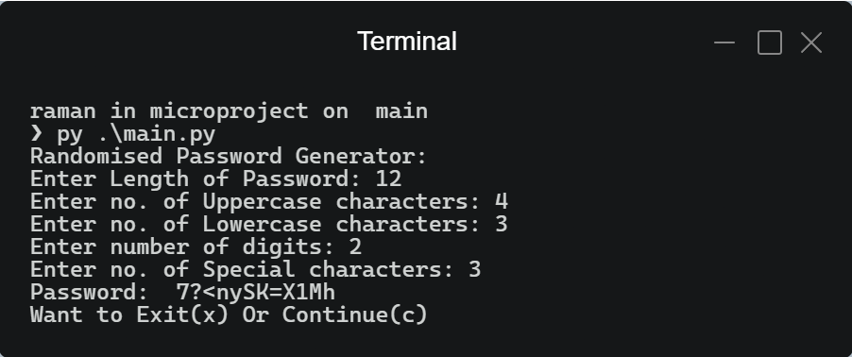

Thankyou