Task 10: Continuous Testing in Jenkins
Field | Details
Project | CI/CD Pipeline for a Parcel Tracking Portal
Name | Shravani Chavan
Roll No | 23102A0055
Class | CMPN A
Branch | task/10-continuous-testing
Date | 12 October 2026

1. Objective
Integrate the Selenium user-journey suite into Jenkins, publish Maven Surefire results, stop deployment when tests fail, correct a deliberately introduced defect and verify a successful rerun.

2. Pipeline Changes
Stage or setting | Implementation
Build | mvn -B clean compile
Selenium Tests | mvn -B test -Dselenium.baseUrl=http://localhost:8081/parcel-tracking-portal
Test report publisher | junit target/surefire-reports/*.xml
Package | mvn -B package -DskipTests
Deployment gate | Package and Deploy stages execute only after tests pass

3. Failure and Recovery
A deliberately failing Selenium assertion is introduced on the test branch and causes the Jenkins Selenium Tests stage to fail. Jenkins publishes the Surefire result and skips Package and Deploy. The assertion is then corrected in a follow-up commit, and the pipeline is rerun successfully.

4. Verification
- Failed pipeline evidence shows a red Selenium Tests stage and no deployment.
- Jenkins displays the published Surefire test report.
- The defect correction commit restores the intended assertion.
- The successful rerun completes Selenium Tests, Package and Deploy.
- The deployed application remains available at http://localhost:8081/parcel-tracking-portal/.

5. Screenshots
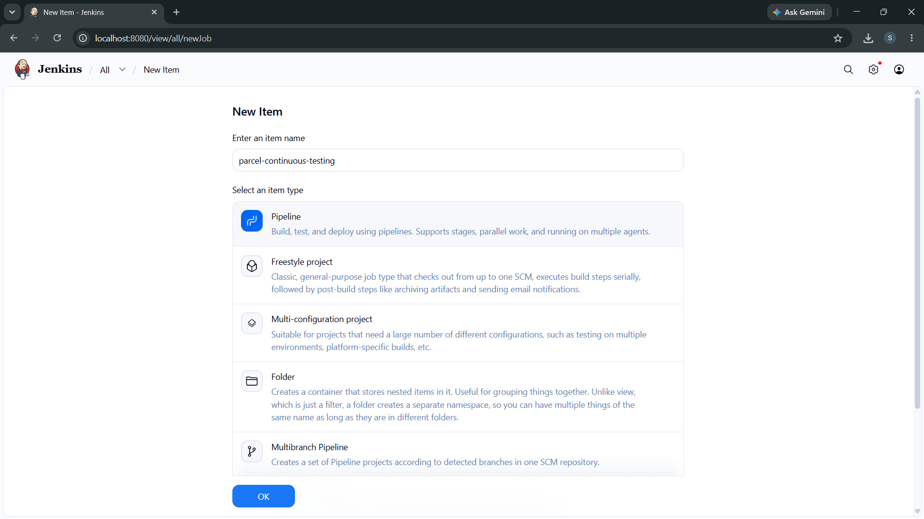
Figure 1: Screenshot 2026-10-12 165225.png
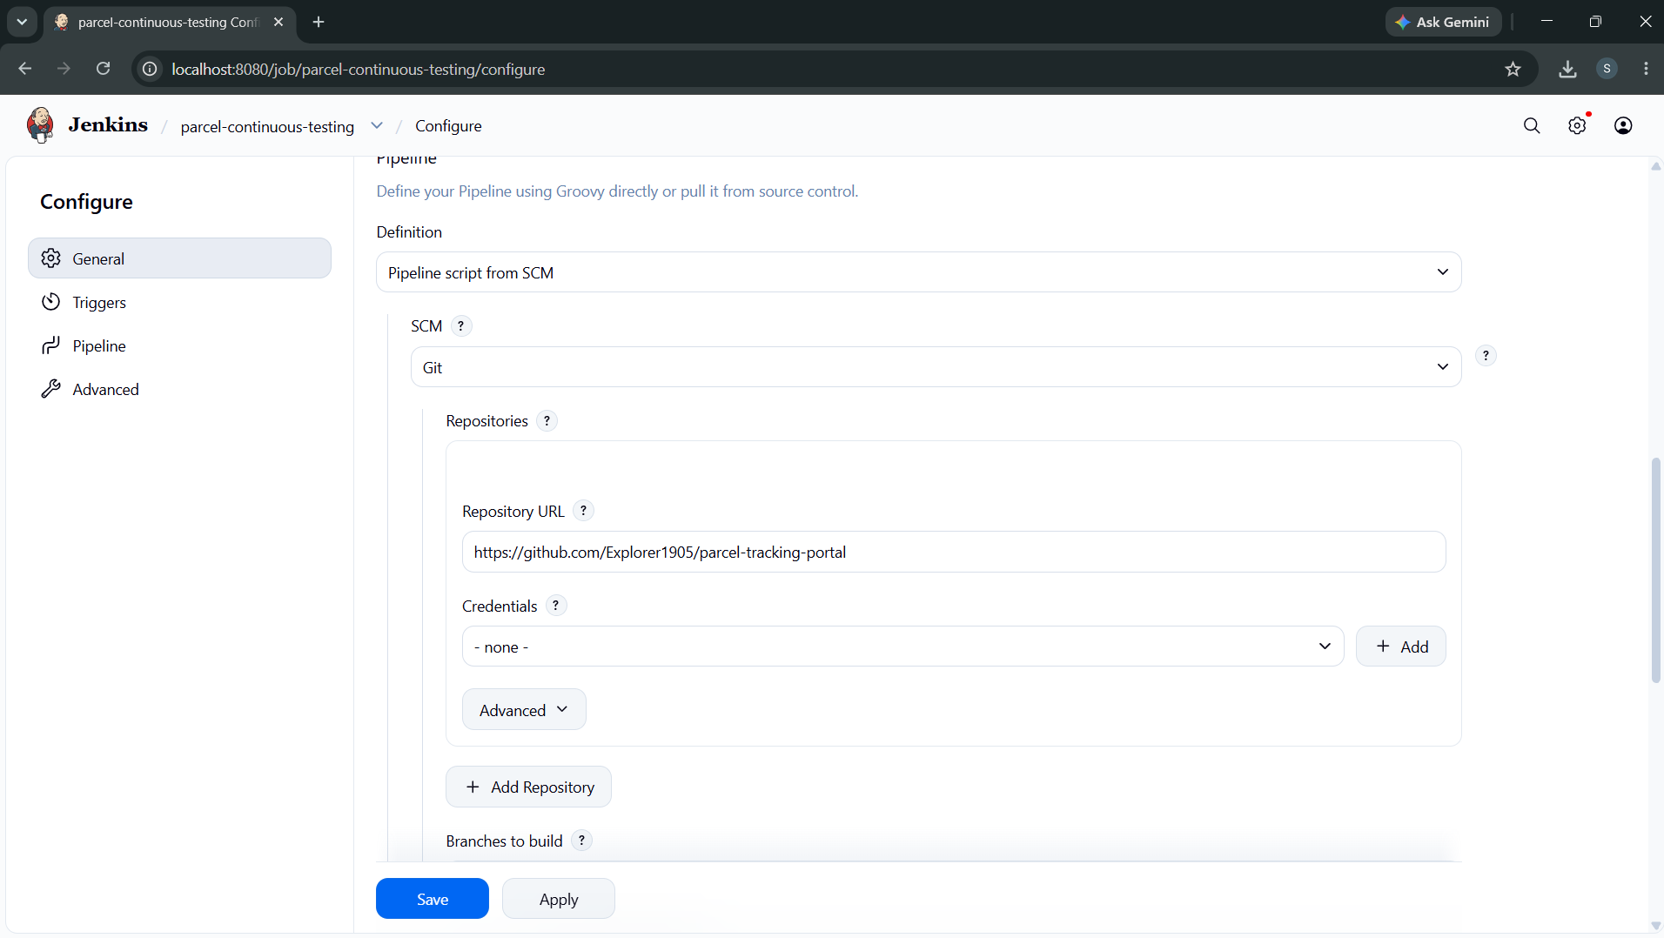
Figure 2: Screenshot 2026-10-12 165357.png
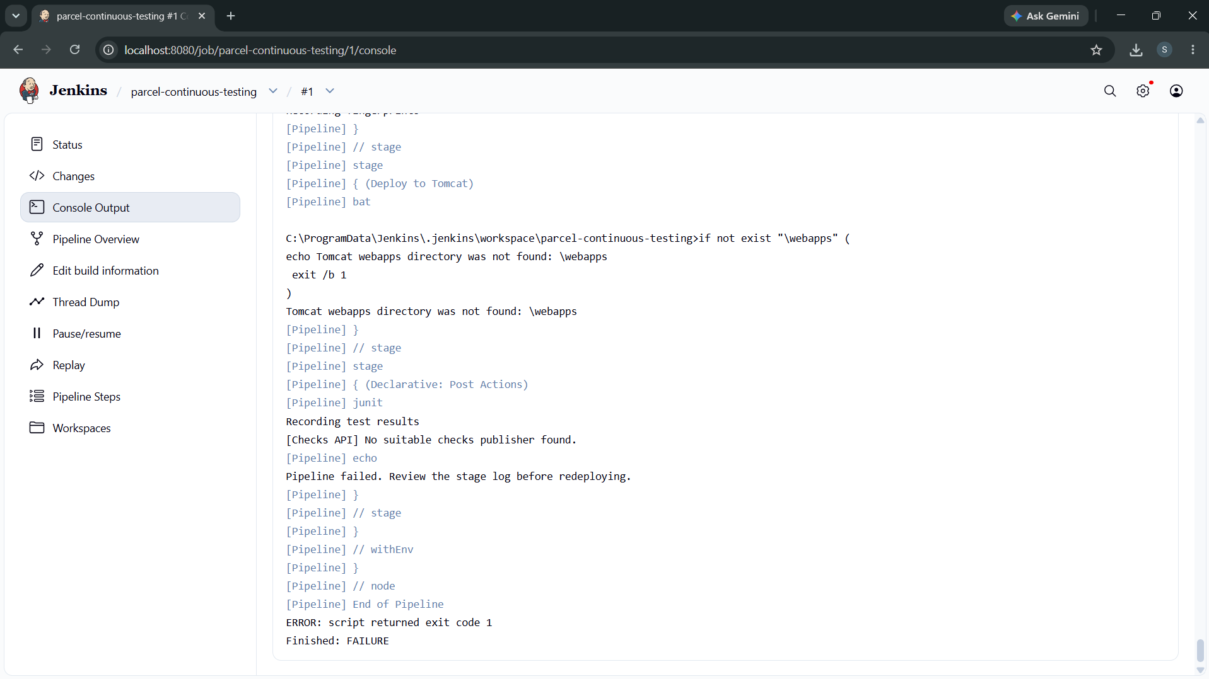
Figure 3: Screenshot 2026-10-12 165735.png

6. Deliverables Checklist
☑ Selenium suite integrated into Jenkins
☑ Surefire test report published
☑ Failed tests prevent deployment
☑ Deliberate defect and correction commit recorded
☑ Successful pipeline rerun captured
☑ Task 10 backlog item moved to Done

7. Conclusion
Jenkins now treats the Selenium suite as a deployment gate. Test results are published for every run, failures stop the release flow, and the corrected pipeline provides evidence of failure detection and recovery.

