Task 5: Application Deployment and Testing
Field | Details
Project | CI/CD Pipeline for a Parcel Tracking Portal
Name | Shravani Chavan
Roll No | 23102A0055
Class | CMPN A
Branch | develop
Date | 11 October 2026

1. Objective
To build the Parcel Tracking Portal, deploy the generated WAR file to Apache Tomcat, verify the application in a browser and confirm the health-check endpoint responds successfully.

2. Environment
Item | Value
Operating system | Windows
Java | JDK 22
Build tool | Apache Maven
Application server | Apache Tomcat 10.1.60
Tomcat port | 8081
Application URL | http://localhost:8081/parcel-tracking-portal/

3. Build and Deployment
- Updated the local develop branch after merging the parcel-entry feature.
- Ran mvn clean package successfully.
- Verified that target/parcel-tracking-portal.war was generated.
- Copied the WAR file into Tomcat's webapps directory.
- Configured Tomcat to use port 8081 because Jenkins was already using port 8080.
- Set JAVA_HOME to the installed JDK 22 directory and started Tomcat.

4. Functional Verification
Test | Result
Tomcat listener on port 8081 | Pass
Portal home page | HTTP 200
Health endpoint /health | HTTP 200; response OK
Parcel management link | Available from the home page

5. Commands Used
git checkout develop
git pull origin develop
mvn clean package
Copy-Item target\parcel-tracking-portal.war <tomcat>\webapps\ -Force
$env:JAVA_HOME = 'C:\Program Files\Java\jdk-22'
.\startup.bat
http://localhost:8081/parcel-tracking-portal/
http://localhost:8081/parcel-tracking-portal/health

6. Issues Faced and Fixes
- Tomcat initially could not start because JAVA_HOME was not defined; fixed by setting JAVA_HOME to C:\Program Files\Java\jdk-22.
- Port 8080 was already occupied by Jenkins, so the Tomcat HTTP connector was changed to port 8081.
- Requests sent to port 8080 returned Jenkins responses and 404 errors; testing the configured Tomcat port 8081 returned the application successfully.

7. Screenshots
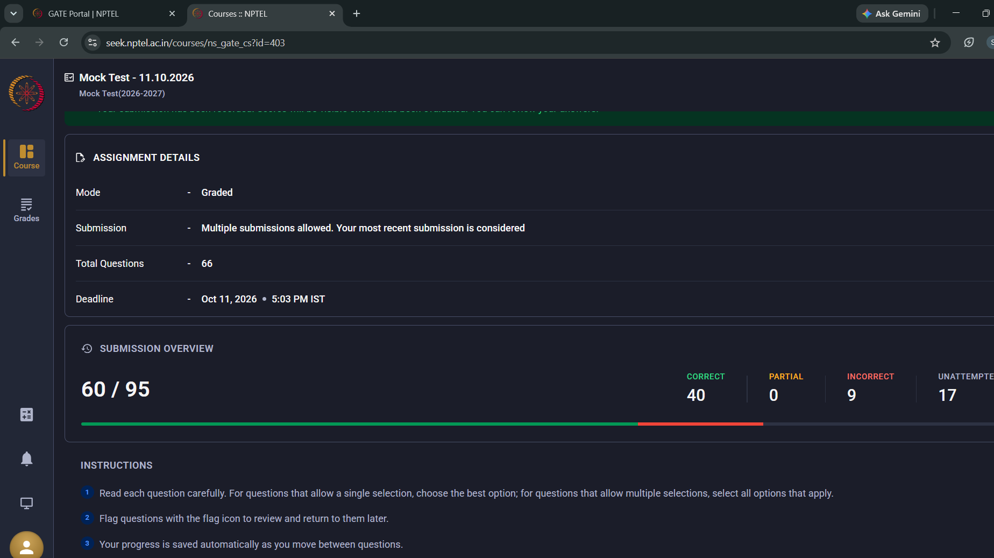
Figure 1: Screenshot 2026-10-11 170846.png
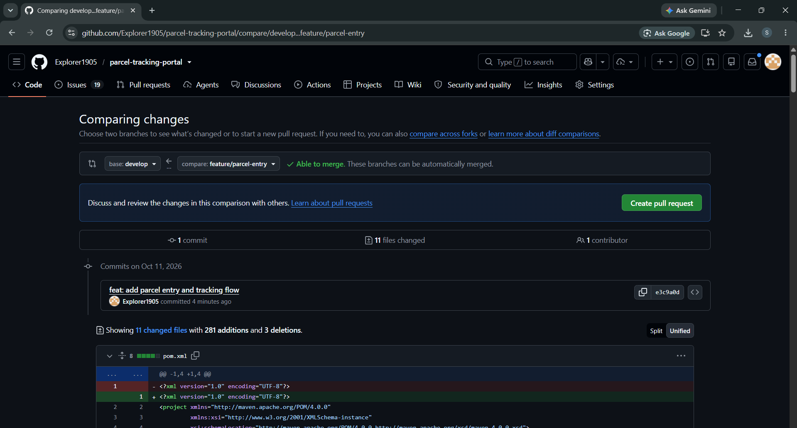
Figure 2: Screenshot 2026-10-11 232706.png
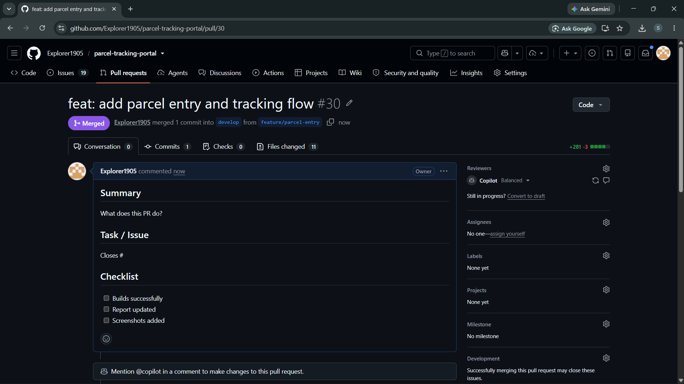
Figure 3: Screenshot 2026-10-11 232826.png
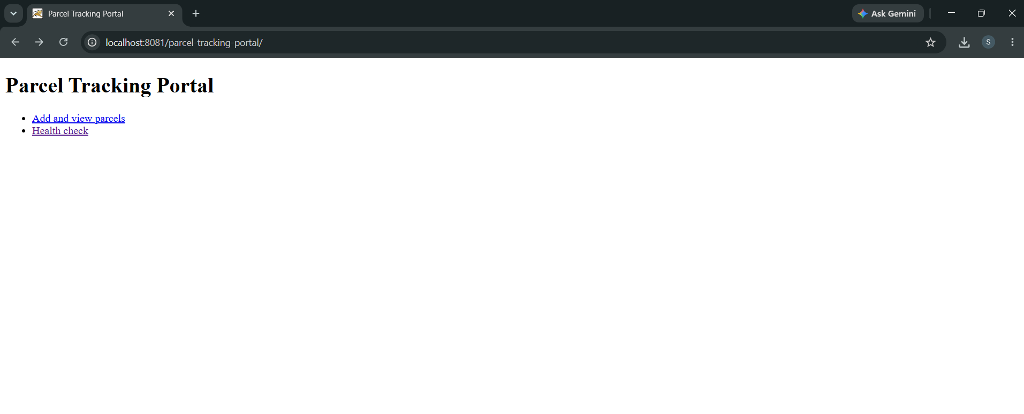
Figure 4: Screenshot 2026-10-11 234450.png
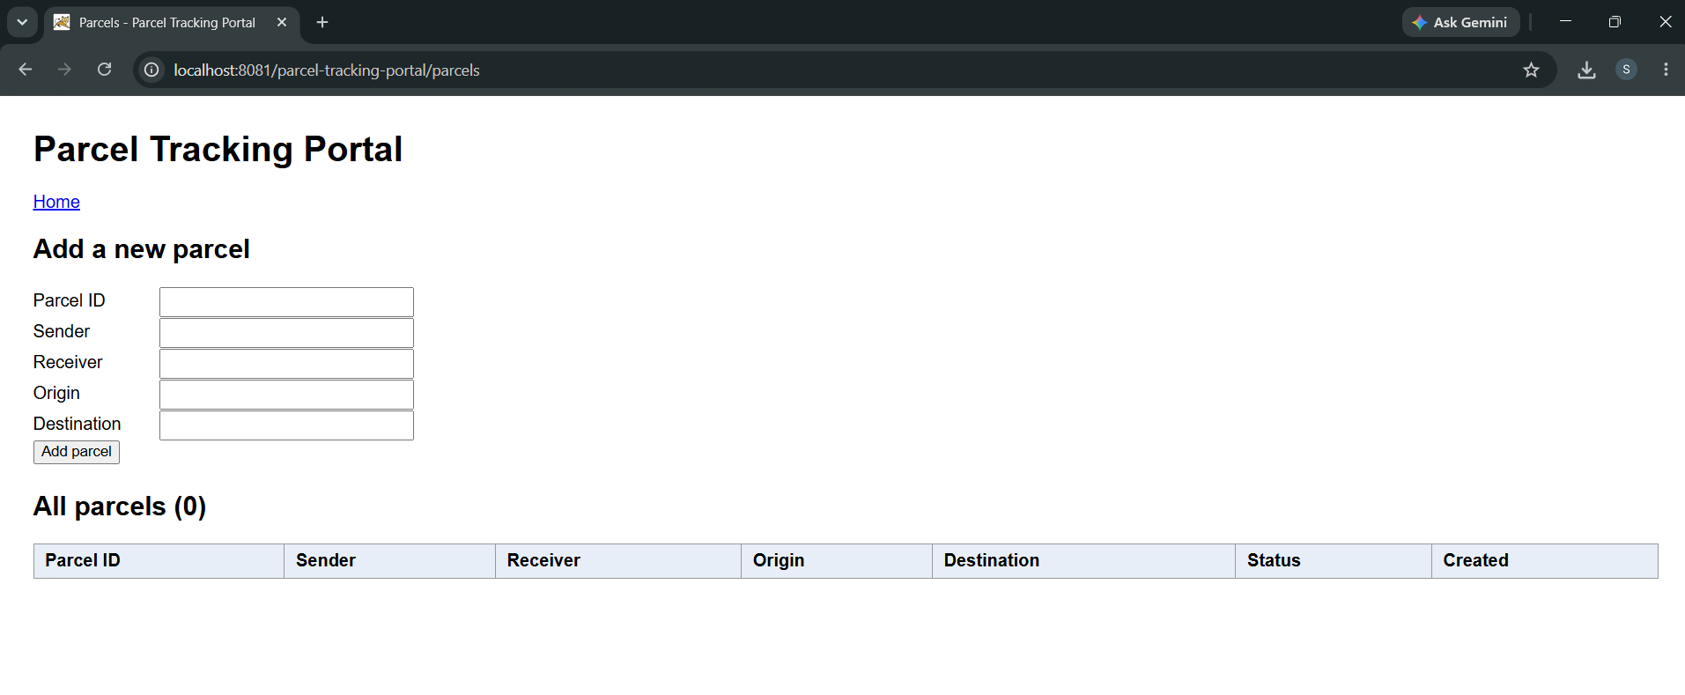
Figure 5: Screenshot 2026-10-11 234534.png
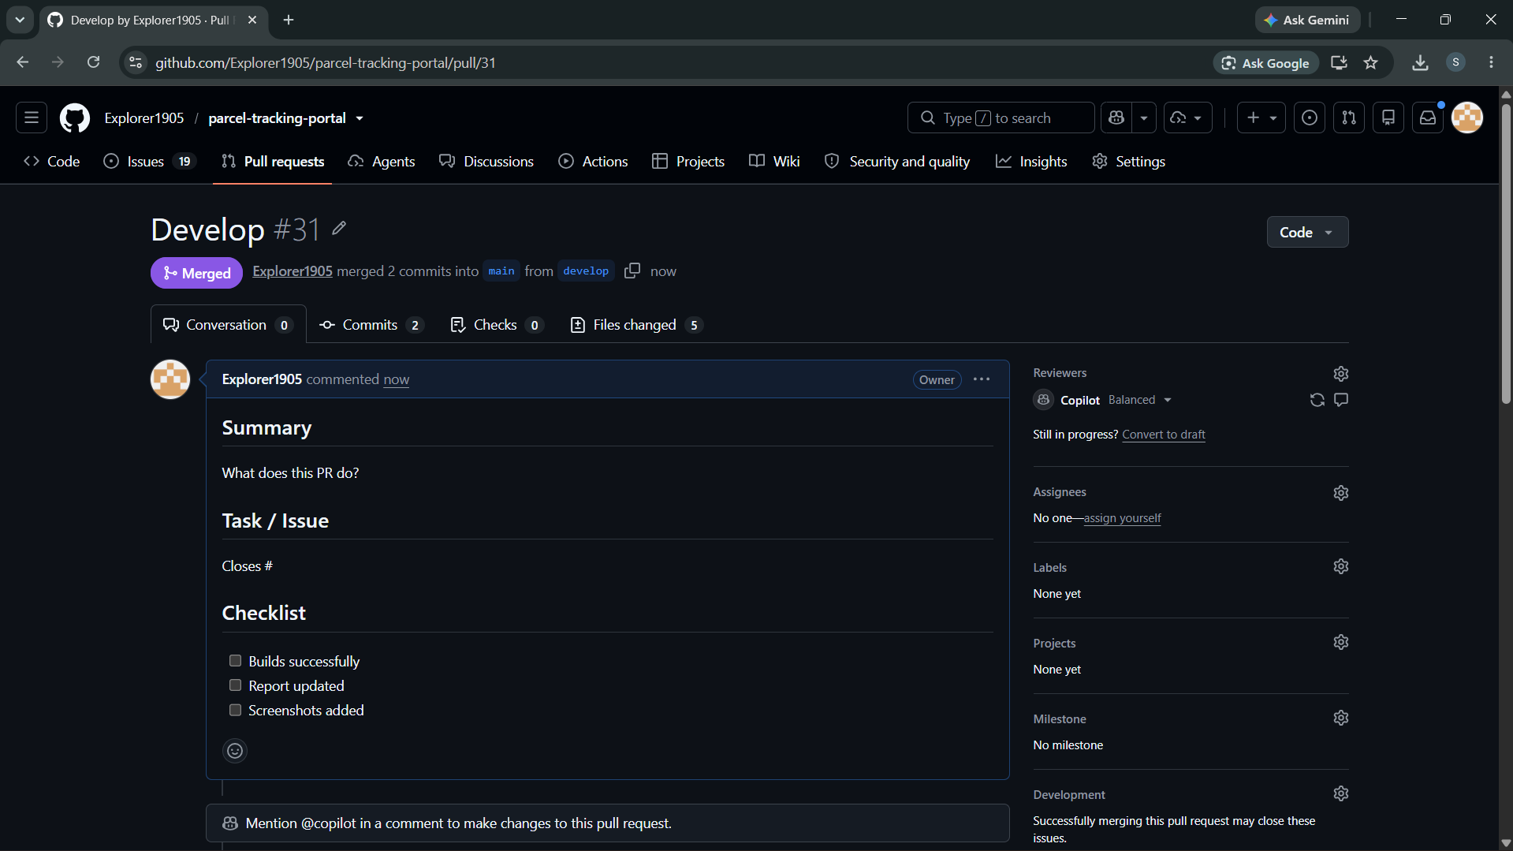
Figure 6: Screenshot 2026-10-11 234914.png

8. Deliverables Checklist
☑ Maven build completed successfully
☑ WAR file generated
☑ WAR deployed to Apache Tomcat
☑ Portal home page verified
☑ Health endpoint verified with response OK
☑ Deployment screenshots added to the repository

9. Conclusion
The Parcel Tracking Portal was built successfully, deployed to Apache Tomcat 10.1.60 and tested on port 8081. The home page returned HTTP 200 and the health endpoint returned OK, confirming that the application was running correctly.

