Task 15: Final End-to-End Release, Documentation and Viva
Field | Details
Project | CI/CD Pipeline for a Parcel Tracking Portal
Name | Shravani Chavan
Roll No | 23102A0055
Class | CMPN A
Branch | task/15-final-release-viva
Date | 12 October 2026

1. Objective
Run and document the complete Parcel Tracking Portal workflow from Git commit through Jenkins, Maven, Selenium, Docker deployment and Ansible provisioning. Prepare the final technical report, evidence and viva material.

2. Architecture and Release Flow
A Java 17 Jakarta Servlet/JSP WAR is built with Maven, tested with Selenium in Jenkins, packaged into a versioned Docker image, published to a local registry and deployed as parcel-portal-cd. Ansible provisions the target and validates the health endpoint.
Stage | Evidence
Source control | Final commit, branch and merged pull request
Continuous integration | Jenkins checkout, Maven build and WAR archive
Quality gate | Selenium journeys and published Surefire results
Continuous delivery | Versioned registry image and running container
Operations | Ansible provisioning, idempotence, health check and rollback

3. Demonstration Commands
mvn -B clean package
curl.exe http://localhost:8082/parcel-tracking-portal/health
cd ansible
sudo ansible-playbook -i inventory.ini site.yml -e ansible_become=false
sudo ansible-playbook -i inventory.ini deploy.yml -e ansible_become=false -e release_tag=1.0.7
sudo ansible-playbook -i inventory.ini deploy.yml -e ansible_become=false -e release_tag=1.0.7
sudo ansible-playbook -i inventory.ini rollback.yml -e ansible_become=false -e rollback_tag=1.0.7

4. Troubleshooting, Limitations and Future Work
The final runbook documents Jenkins Docker path issues, delayed Tomcat startup, Selenium connectivity, WSL Docker service limitations, registry tag failures and port conflicts. It also records the single-container, local-registry and non-production security limitations and proposes artifact signing, scanning, observability, replicas and production TLS.

5. Evidence
Save final screenshots under docs/screenshots/task-15 and record the Jenkins run, Selenium gate, registry image, container health, Ansible idempotence and rollback recovery. Keep large video files outside the repository unless the submission rules permit them.

6. Screenshots
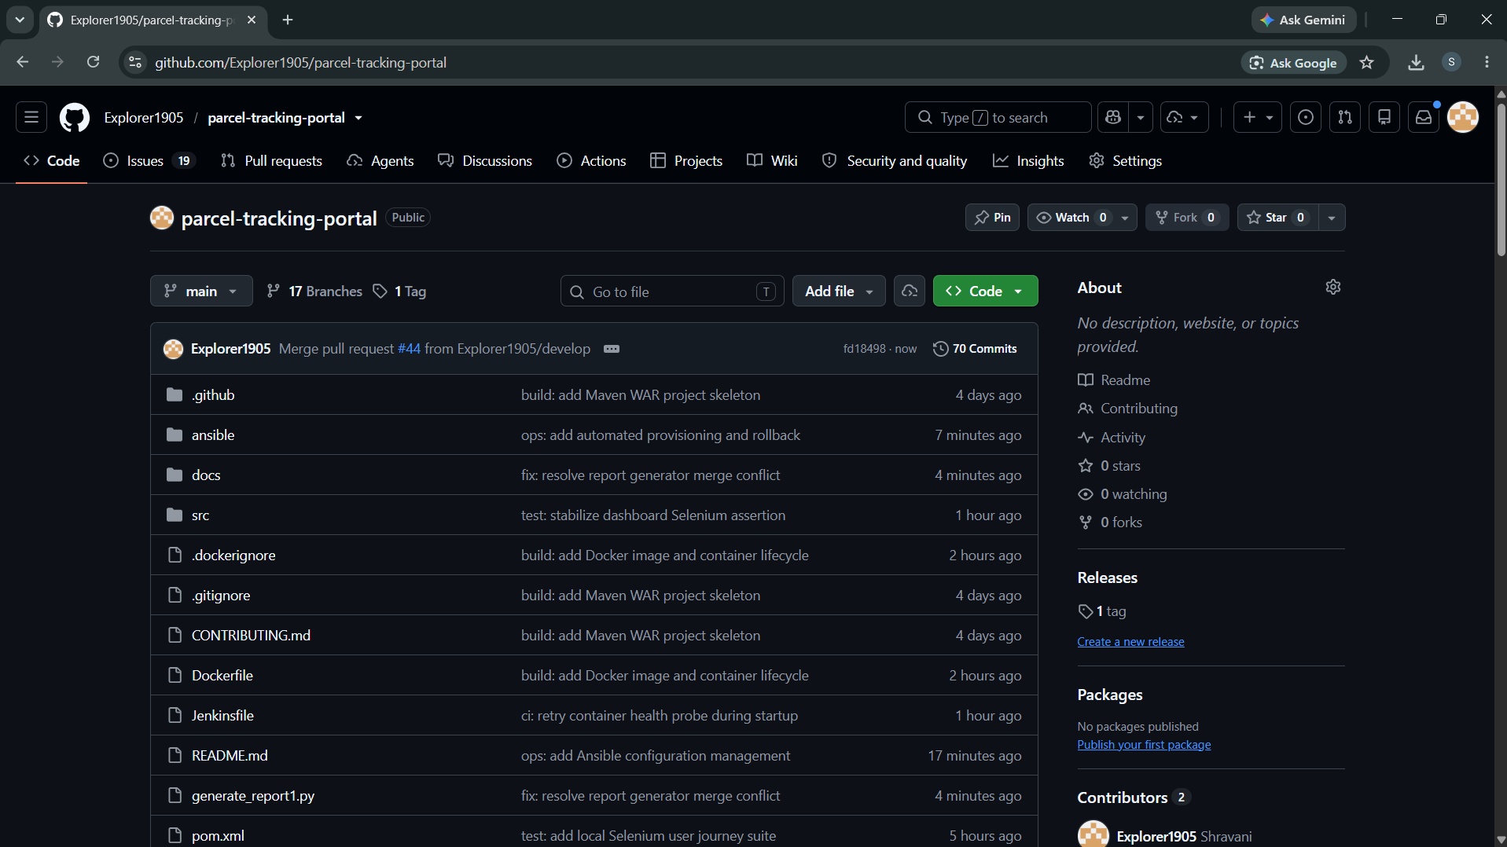
Figure 1: Screenshot 2026-10-12 214106.png
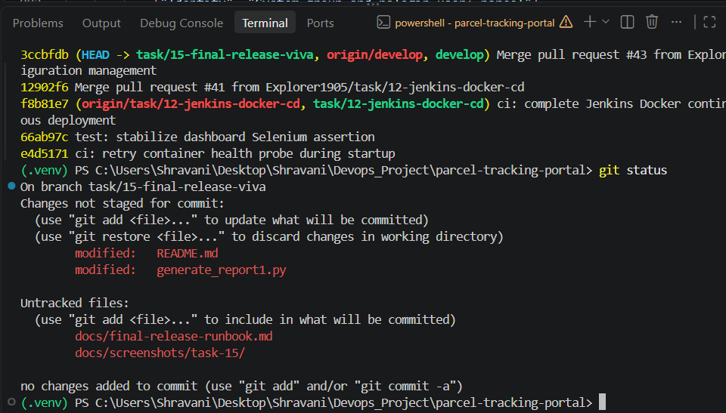
Figure 2: Screenshot 2026-10-12 214416.png
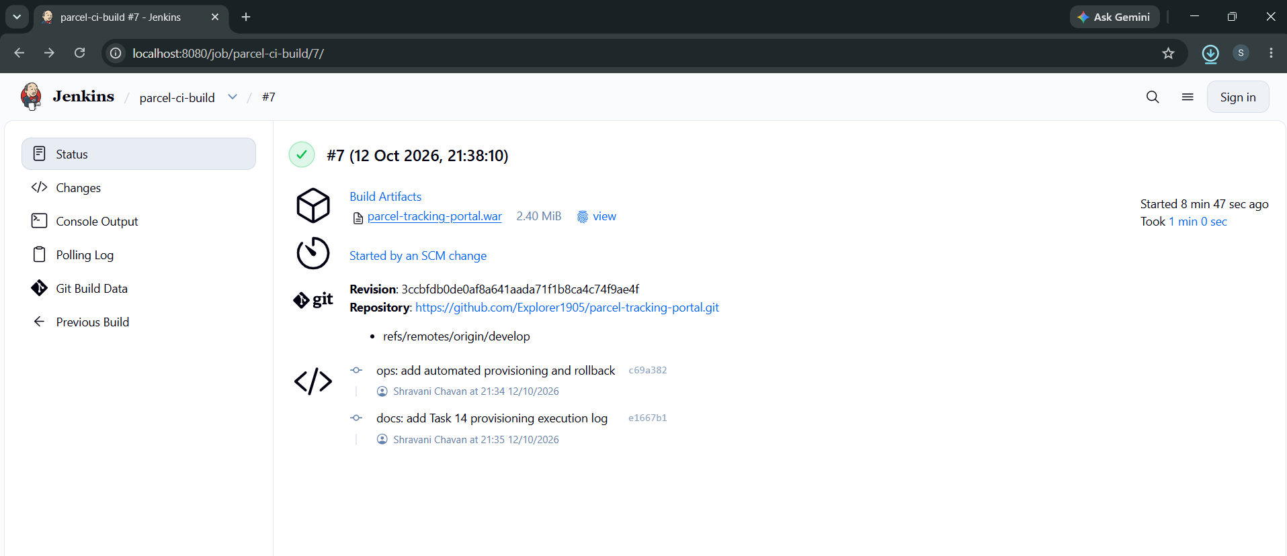
Figure 3: Screenshot 2026-10-12 214705.png
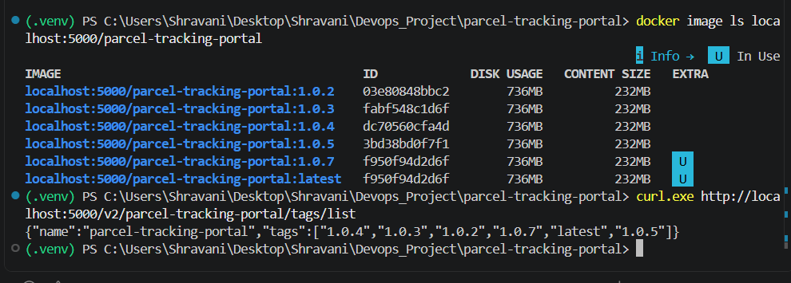
Figure 4: Screenshot 2026-10-12 214755.png
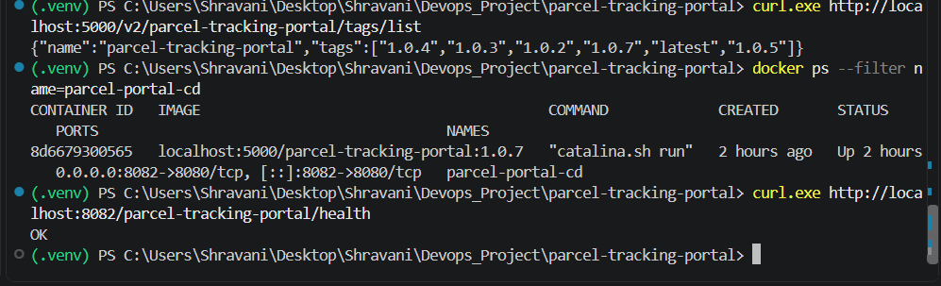
Figure 5: Screenshot 2026-10-12 214828.png
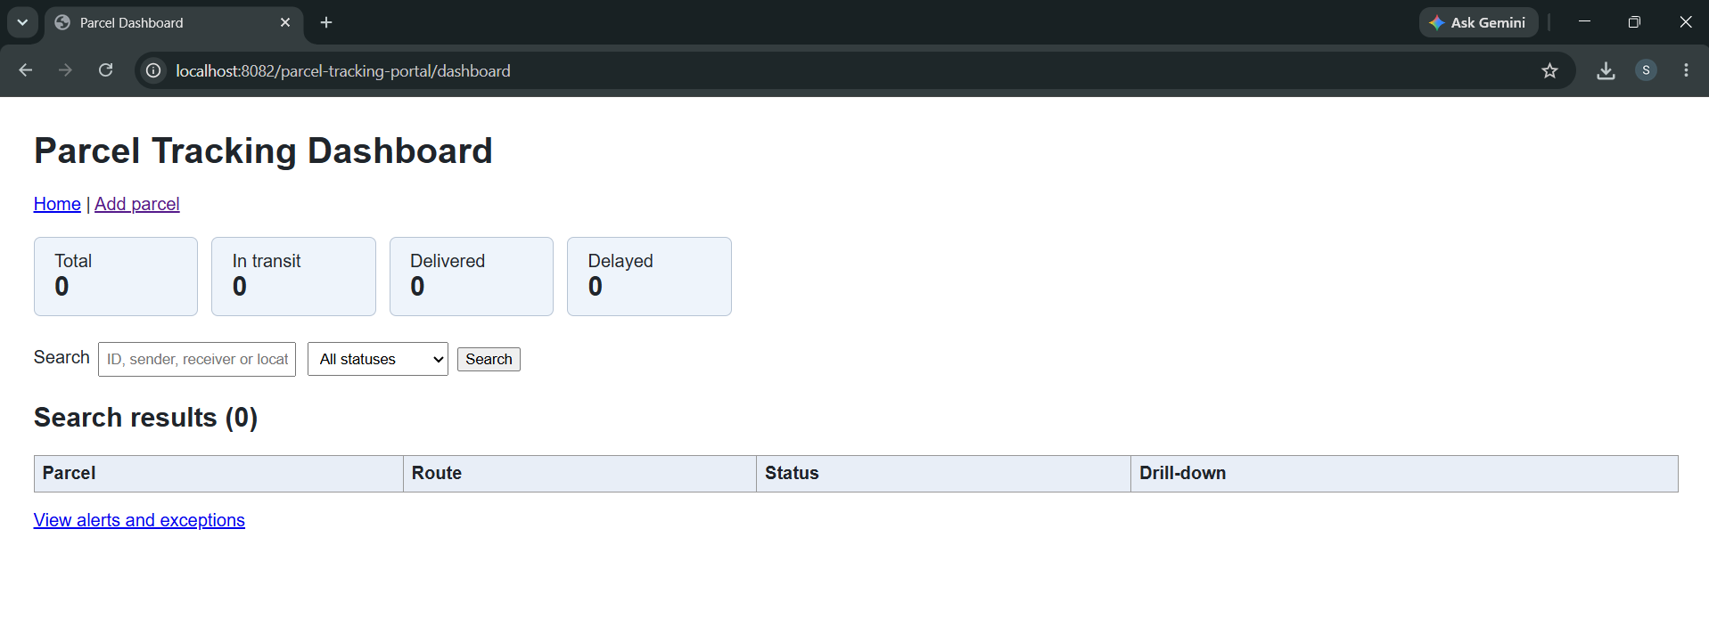
Figure 6: Screenshot 2026-10-12 214857.png
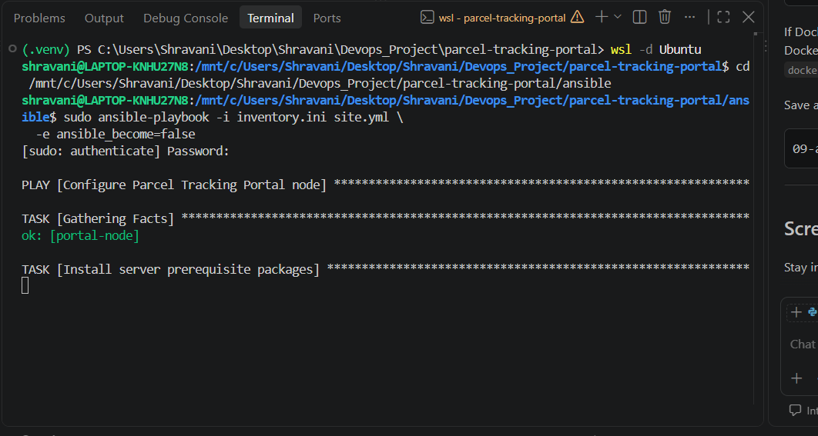
Figure 7: Screenshot 2026-10-12 215211.png
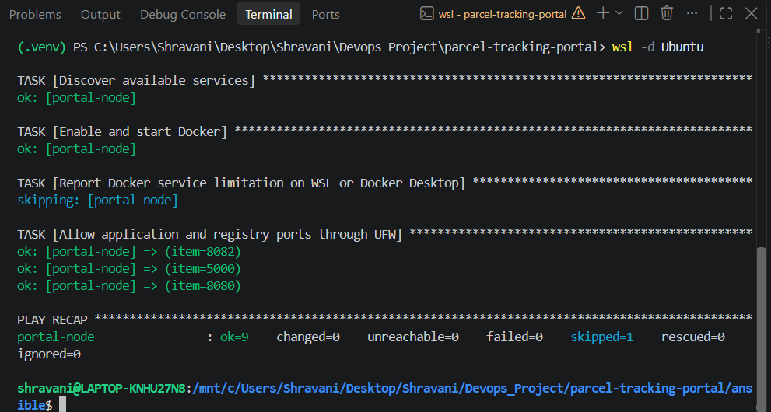
Figure 8: Screenshot 2026-10-12 215236.png
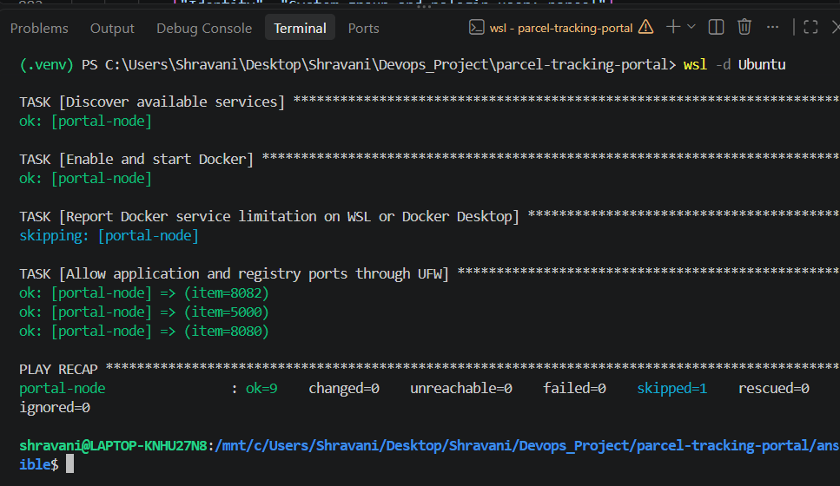
Figure 9: Screenshot 2026-10-12 215301.png

7. Viva Preparation
☑ Final repository and merged history shown
☑ Jenkins end-to-end pipeline demonstrated
☑ Selenium quality gate explained
☑ Versioned Docker deployment verified
☑ Ansible provisioning and idempotence explained
☑ Rollback and health recovery demonstrated
☑ Troubleshooting, limitations and future plan reviewed
☑ Final presentation and viva questions prepared

8. Conclusion
The project demonstrates a traceable DevOps release path with automated quality validation, versioned deployment, infrastructure configuration, health gating and recovery evidence.

