Task 13: Configuration Management Script
Field | Details
Project | CI/CD Pipeline for a Parcel Tracking Portal
Name | Shravani Chavan
Roll No | 23102A0055
Class | CMPN A
Branch | task/13-configuration-management
Date | 12 October 2026

1. Objective
Identify the Parcel Tracking Portal server prerequisites and configure an Ubuntu/Debian target node with an idempotent Ansible playbook.

2. Configuration Specification
Category | Required state
Packages | ca-certificates, curl, docker.io, maven, openjdk-17-jre-headless
Identity | System group and nologin user: parcel
Folders | /opt/parcel-tracking-portal, /etc/parcel-tracking-portal, /var/lib/parcel-tracking-portal
Files | Managed application.properties with ownership and mode 0640
Ports | 8082 application, 8080 Tomcat, 5000 registry
Service | Docker enabled and started
Firewall | Required TCP ports allowed on Debian-family targets

3. Ansible Inventory and Playbook
ansible/inventory.ini targets the local Ubuntu/WSL node for a reproducible first execution. ansible/site.yml installs packages, creates the service identity and directories, writes configuration, starts Docker and configures firewall ports.
cd ansible
ansible-playbook -i inventory.ini site.yml --check --diff
ansible-playbook -i inventory.ini site.yml
ansible-playbook -i inventory.ini site.yml

4. First Execution and Idempotence
The first normal execution log is saved as docs/reports/task-13-ansible-first-execution.log. A second normal execution is run to demonstrate idempotence; resources remain present and no unnecessary changes are made.

5. Screenshots
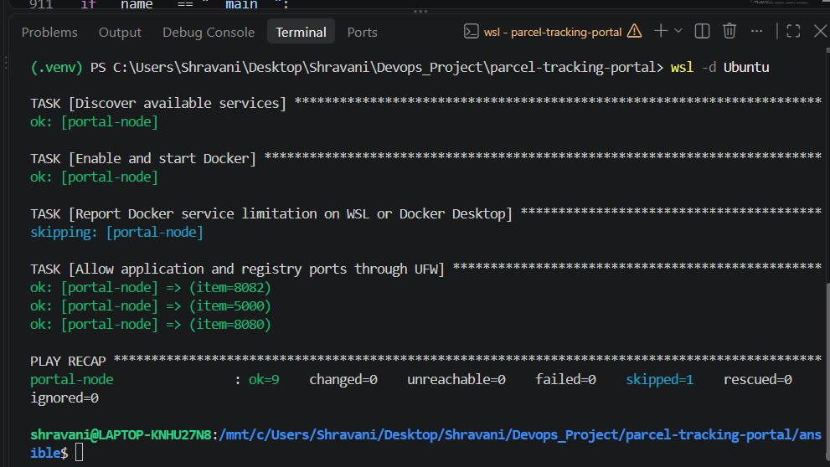
Figure 1: Screenshot 2026-10-12 211636.png
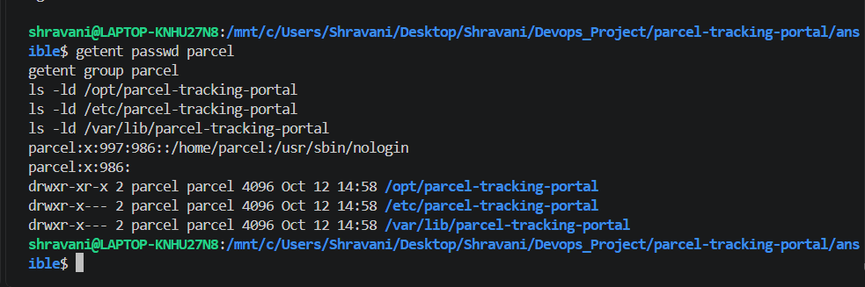
Figure 2: Screenshot 2026-10-12 211648.png
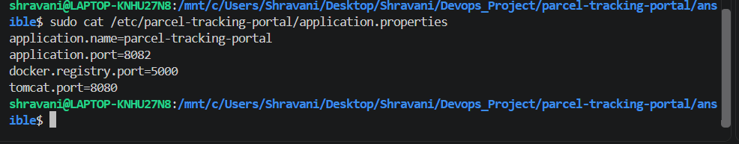
Figure 3: Screenshot 2026-10-12 211700.png
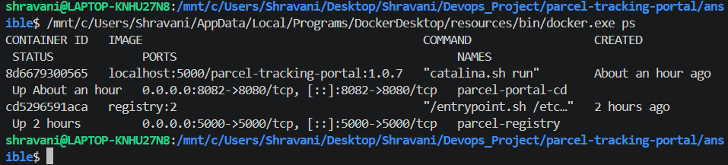
Figure 4: Screenshot 2026-10-12 211730.png
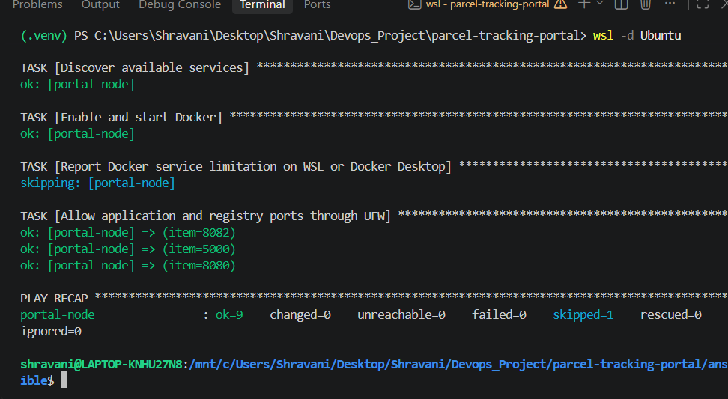
Figure 5: Screenshot 2026-10-12 211759.png

6. Deliverables Checklist
☑ Configuration specification added
☑ Ansible inventory added
☑ Ansible playbook configures packages, identity, folders, files, ports and service
☑ First execution log captured
☑ Idempotent second execution verified
☑ Task 13 backlog item moved to Done

7. Conclusion
The target node prerequisites are expressed as repeatable Ansible resources rather than manual setup steps. The inventory supports local WSL demonstration and can be changed to an SSH target without changing the playbook.

