Task 8: Pipeline as Code and Server Deployment
Field | Details
Project | CI/CD Pipeline for a Parcel Tracking Portal
Name | Shravani Chavan
Roll No | 23102A0055
Class | CMPN A
Branch | task/08-pipeline-as-code
Date | 12 October 2026

1. Objective
Create a Jenkins pipeline as code for the Parcel Tracking Portal. The pipeline checks out the repository, builds and packages the WAR, archives the artifact, and deploys it to Apache Tomcat using a parameterized environment setting.

2. Jenkinsfile
The repository root contains a declarative Jenkinsfile with Checkout, Build, Package and Deploy to Tomcat stages. The pipeline uses the DEPLOY_ENV choice and TOMCAT_HOME string parameters so the deployment target is configurable without editing the pipeline.
pipeline {
agent any
parameters {
choice(name: 'DEPLOY_ENV', choices: ['local-tomcat', 'staging-tomcat'])
string(name: 'TOMCAT_HOME', defaultValue: '<Tomcat installation>')
}
stages {
stage('Checkout') { steps { checkout scm } }
stage('Build') { steps { bat 'mvn -B clean test' } }
stage('Package') {
steps {
bat 'mvn -B package -DskipTests'
archiveArtifacts artifacts: 'target/*.war', fingerprint: true
}
}
stage('Deploy to Tomcat') {
steps {
bat 'copy /Y target\\parcel-tracking-portal.war %TOMCAT_HOME%\\webapps\\'
}
}
}
}

3. Pipeline Configuration
Item | Value
Pipeline definition | Pipeline script from SCM
Jenkinsfile location | Jenkinsfile
Build tool | Maven
Deployment server | Apache Tomcat 10.1.60
Application URL | http://localhost:8081/parcel-tracking-portal/
Health URL | http://localhost:8081/parcel-tracking-portal/health
Parameterized settings | DEPLOY_ENV and TOMCAT_HOME

4. Verification
- The Jenkins pipeline run completes successfully through Checkout, Build, Package and Deploy to Tomcat.
- The generated parcel-tracking-portal.war is archived by the pipeline.
- The WAR is copied into Tomcat's webapps directory.
- The deployed home page returns HTTP 200 at the application URL.
- The health endpoint returns OK after deployment.

5. Screenshots
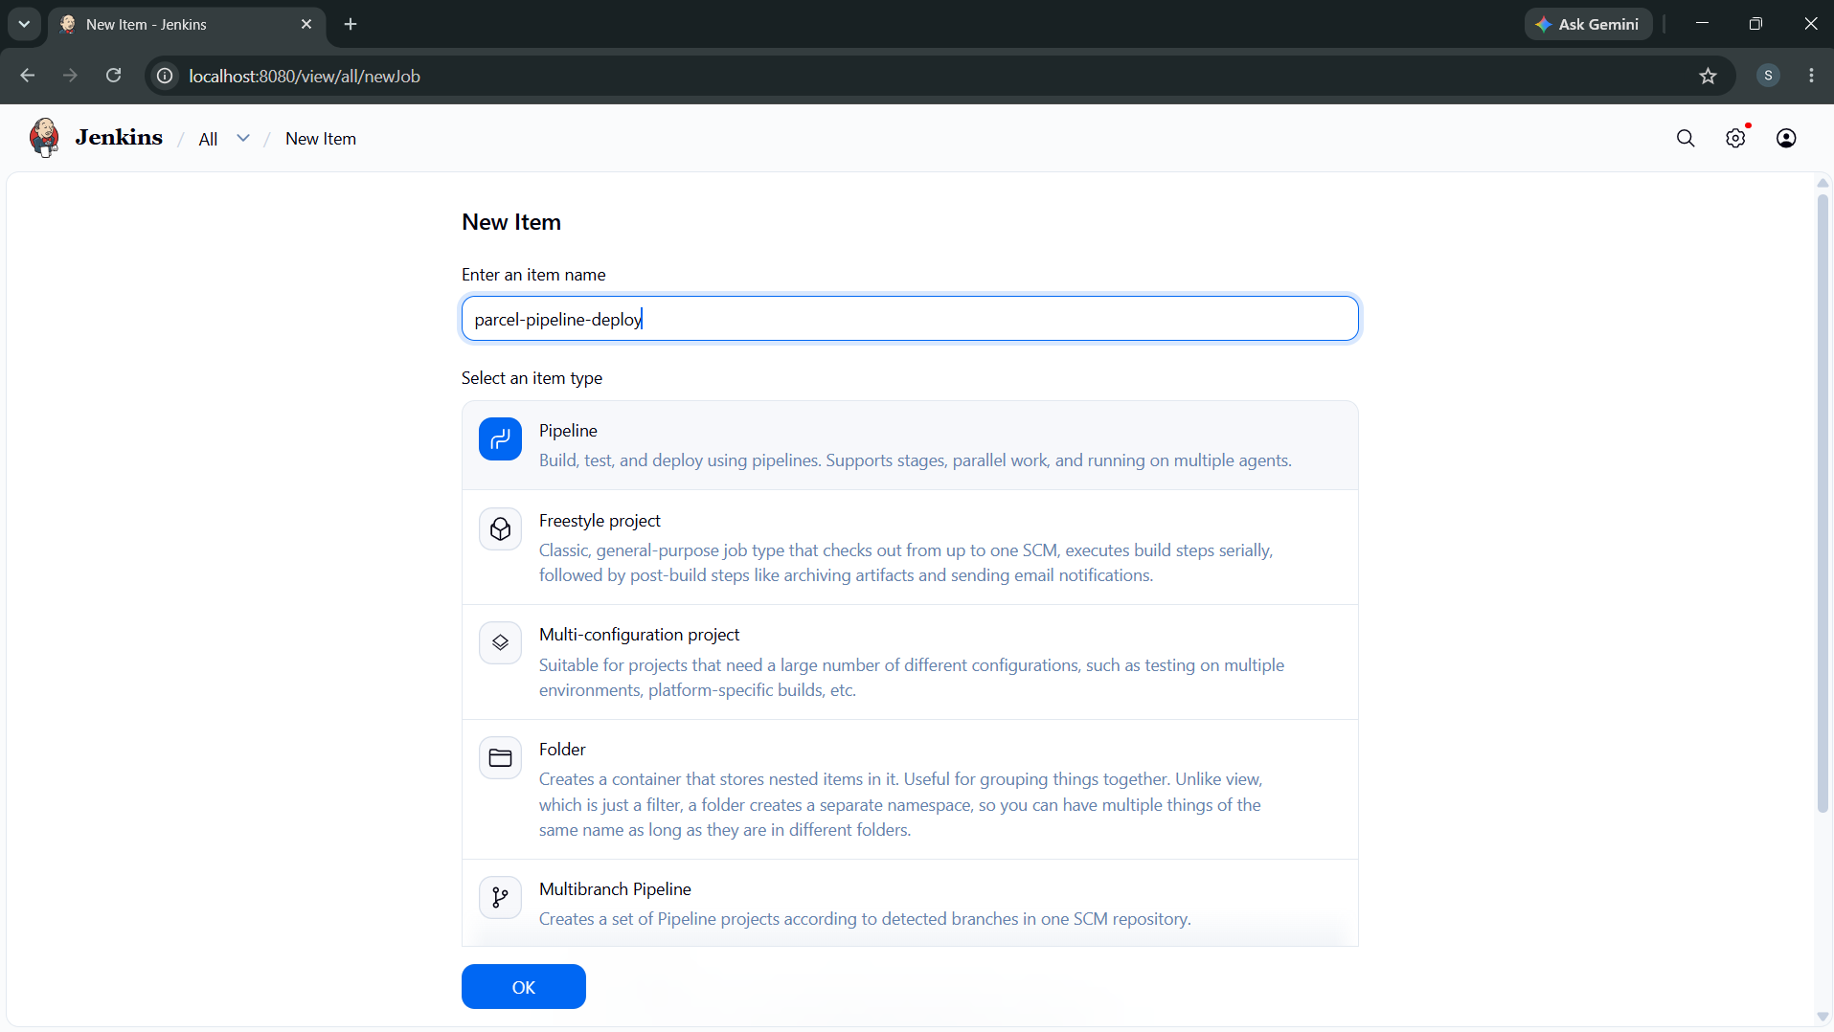
Figure 1: Screenshot 2026-10-12 162028.png
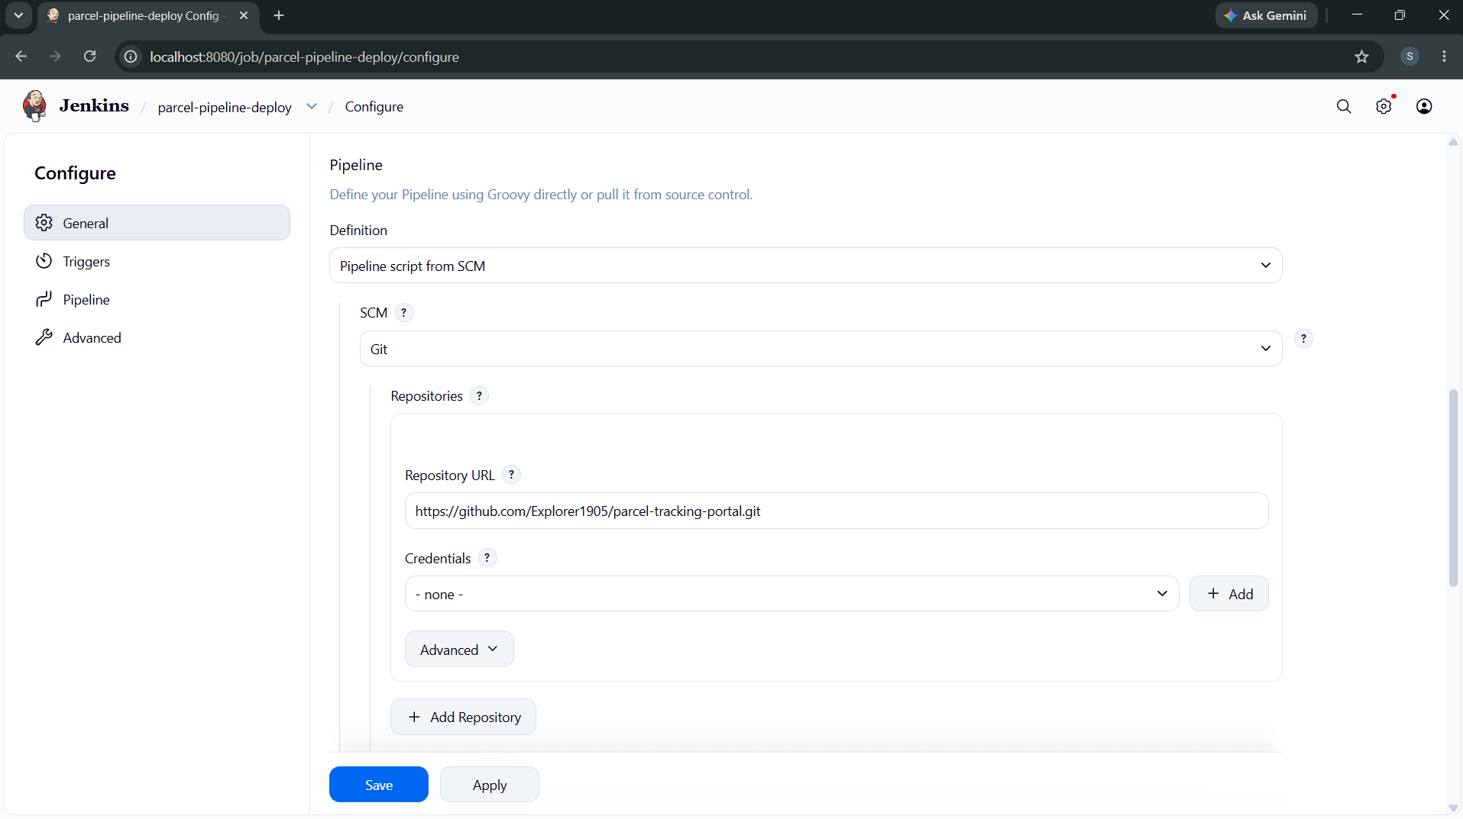
Figure 2: Screenshot 2026-10-12 162246.png
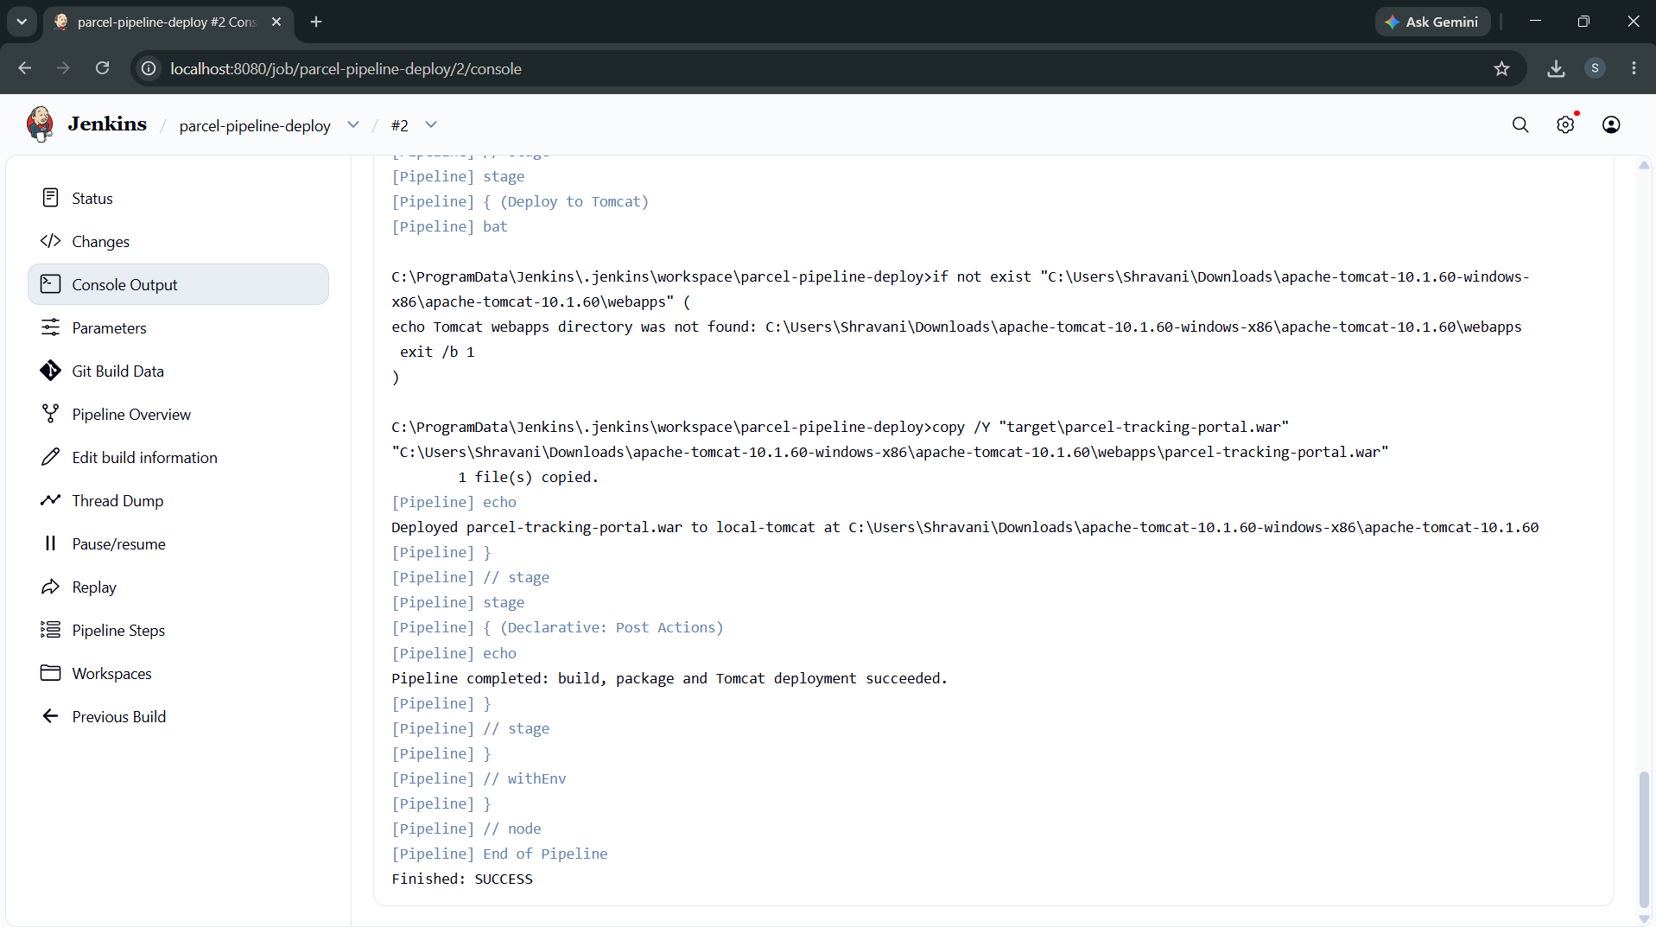
Figure 3: Screenshot 2026-10-12 162717.png
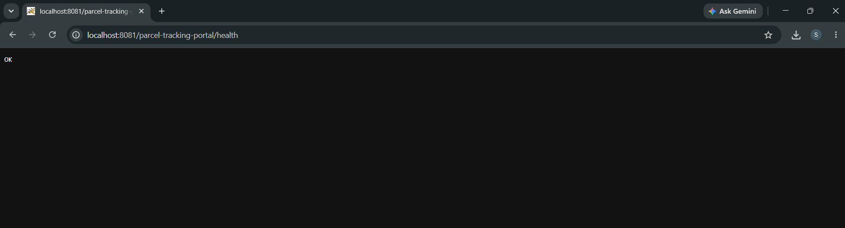
Figure 4: Screenshot 2026-10-12 163023.png

6. Deliverables Checklist
☑ Jenkinsfile committed to the repository
☑ Checkout, build, package and deploy stages visible
☑ At least one deployment parameter configured
☑ Successful pipeline run captured
☑ WAR artifact archived
☑ Deployed application URL and health check verified
☑ Task 8 backlog item moved to Done

7. Conclusion
The Jenkinsfile makes the build and Tomcat deployment repeatable from source control. A successful pipeline run produces and archives the WAR, deploys it to Tomcat and verifies the running Parcel Tracking Portal.

