Task 1: Problem Definition and Scope
Field | Details
Project | CI/CD Pipeline for a Parcel Tracking Portal
Name | Shravani Chavan
Roll No | 23102A0055
Class | CMPN A
Branch | task/01-problem-definition
Date | 07 October 2026

1. Objective
To study the real-time need for a Parcel Tracking Portal, identify its users, pain points, stakeholders, constraints and measurable success criteria, and freeze a small 15-task MVP scope that will be delivered through a complete CI/CD pipeline.

2. Problem Statement
Customers and courier staff often have no single, reliable place to see the live status of a parcel. Customers repeatedly contact support to ask where their parcel is, while staff update statuses manually in scattered sheets or messages. Delayed, stuck or failed deliveries are noticed late, which leads to poor customer experience and extra support workload.
The Parcel Tracking Portal solves this by giving one web application where parcel events are recorded, searched and monitored, with delayed or exceptional parcels flagged automatically.

3. Target Users
User | Need
Customer | Check the current status and history of a parcel quickly
Delivery agent | Update parcel events (picked up, in transit, delivered, failed)
Warehouse staff | Record arrival and dispatch of parcels
Admin / support team | Monitor all parcels, see delays and handle exceptions

3.1 Existing Pain Points
- No real-time visibility of parcel status.
- Status updates are manual and inconsistent.
- No automatic alert for delayed or failed deliveries.
- Parcel data is scattered across sheets, messages and calls.
- High number of repeated status queries to support.
- No quick summary of delivered, in-transit and delayed parcels.

4. Stakeholders
- Customers (end users of tracking)
- Courier company management
- Warehouse and delivery teams
- Customer support team
- Developers / DevOps team (project team)
- Course instructor / evaluator

5. Constraints
- Academic timeline: 15 tasks to be completed in sequence.
- Only free and open-source tools (Git, GitHub, Maven, Jenkins, Docker, Selenium, Ansible).
- Development and testing on a single laptop environment.
- No integration with a real courier API or live GPS; data is entered manually or simulated.
- Small MVP: the focus is on the DevOps pipeline, not on a large application.

6. Measurable Success Criteria
# | Criterion | How it is measured
1 | Parcel search returns a result in under 2 seconds | Manual timing / Selenium test
2 | Full event history of a parcel visible on one screen | Status drill-down page check
3 | Delayed or failed parcels flagged on the dashboard automatically | Alert/exception view check
4 | Build, test and deploy run automatically on every commit | Jenkins pipeline run
5 | At least 80% of Selenium tests pass on each build | Jenkins test report
6 | Application runs identically in a Docker container | Container run and health check
7 | Environment can be rebuilt using an Ansible/Puppet script | Re-run shows idempotent result

7. Frozen MVP Scope

In scope
- Parcel data / event entry
- Searchable dashboard
- Summary indicators (total, in transit, delivered, delayed)
- Status drill-down (event history per parcel)
- Alert / exception view for delayed or failed parcels

Out of scope
- Real GPS or live map tracking
- Payments and billing
- Mobile application
- Real courier API integration
- Email/SMS notifications

8. Technology Stack (planned)
Area | Tool
Application | Java Servlets/JSP
Build | Maven
Version control | Git and GitHub
CI / CD | Jenkins (Jenkinsfile)
Server | Apache Tomcat
Testing | Selenium WebDriver with JUnit
Containers | Docker
Configuration management | Ansible

9. 15-Task Plan
Task | Title | Branch
1 | Problem Definition and Scope | task/01-problem-definition
2 | Agile Planning and DevOps Workflow | task/02-agile-planning
3 | Requirements, Architecture and Technology Setup | task/03-architecture-setup
4 | Git and GitHub Repository Initialization | task/04-repo-init
5 | Feature Development with Branching | task/05-feature-branching
6 | MVP Completion and Git Collaboration | task/06-mvp-completion
7 | Jenkins Installation and Continuous Integration Job | task/07-jenkins-ci
8 | Pipeline as Code and Server Deployment | task/08-pipeline-as-code
9 | Selenium Test Design and Local Execution | task/09-selenium-tests
10 | Continuous Testing in Jenkins | task/10-continuous-testing
11 | Docker Image and Container Lifecycle | task/11-docker
12 | Jenkins-Docker Continuous Deployment | task/12-jenkins-docker-cd
13 | Configuration Management Script | task/13-config-management
14 | Automated Provisioning and Reliability Validation | task/14-provisioning
15 | Final End-to-End Release, Documentation and Viva | task/15-final-release

10. Steps Performed
- Studied the real-time tracking need and listed users and pain points.
- Identified stakeholders and constraints.
- Defined measurable success criteria.
- Froze the MVP scope and the 15-task plan.
- Created branch task/01-problem-definition from develop.
- Wrote the report, committed it and raised a pull request into develop.

11. Git Commands Used
git checkout develop
git checkout -b task/01-problem-definition
git add docs
git commit -m "docs: add Task 1 problem definition and scope report"
git push -u origin task/01-problem-definition

12. Screenshots
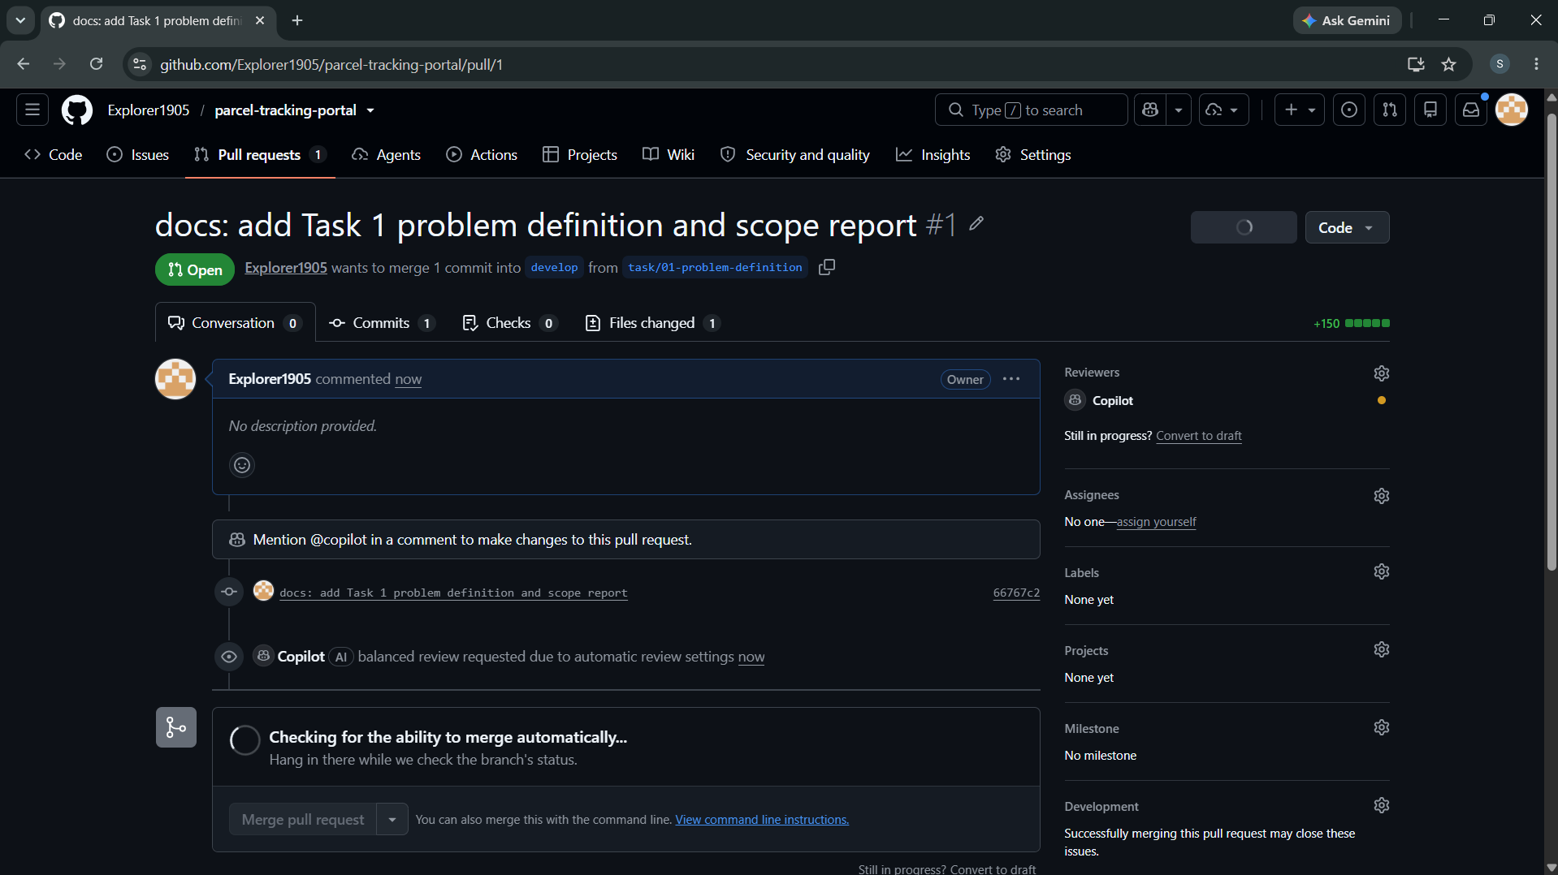
Figure 1: Screenshot 2026-10-07 213612.png
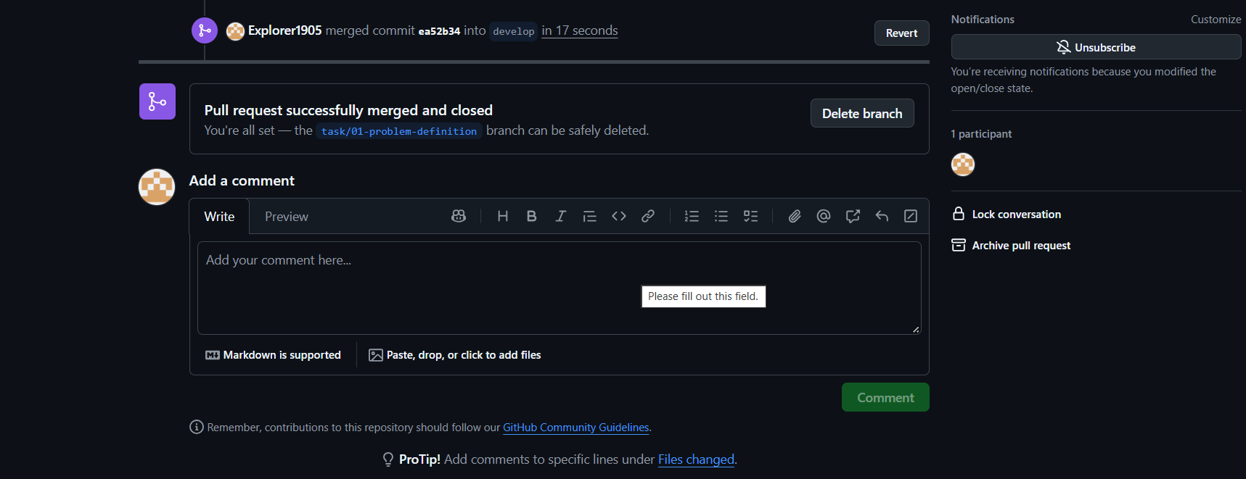
Figure 2: Screenshot 2026-10-07 213641.png

13. Deliverables Checklist
☑ Problem statement
☑ Target users and pain points
☑ Stakeholders and constraints
☑ Measurable success criteria
☑ Frozen 15-task MVP scope

14. Issues Faced and Fixes
- Linux-style mkdir -p failed in Windows PowerShell; used mkdir docs\reports instead.
- Clone command was entered with a placeholder username; corrected with the real GitHub username.

15. Conclusion
The problem, users, scope and success criteria of the Parcel Tracking Portal are now clearly defined and frozen. This gives a stable base for Agile planning in Task 2 and for building the CI/CD pipeline in the later tasks.

