Task 6: MVP Completion and Git Collaboration
Field | Details
Project | CI/CD Pipeline for a Parcel Tracking Portal
Name | Shravani Chavan
Roll No | 23102A0055
Class | CMPN A
Branch | task/06-mvp-completion
Date | 12 October 2026

1. Objective
To complete the essential Parcel Tracking Portal MVP functions: event entry, searchable dashboard, summary indicators, status drill-down and alert/exception view, while demonstrating feature branches, conflict resolution, tagging and a release-ready source baseline.

2. Features Delivered
- Event entry supports Picked Up, In Transit, Out for Delivery, Delivered and Failed statuses.
- Events include location, optional remarks and an optional event time for backdated testing.
- The dashboard supports parcel search and status filtering with total, in-transit, delivered and delayed indicators.
- The parcel detail page at /parcel?id=... shows the full event history.
- The alerts page lists Failed parcels and parcels whose latest non-delivered event is more than 48 hours old.

3. HTML Test ID Contract
Page | IDs
Add parcel | parcelId, sender, receiver, origin, destination, addBtn, successMsg, errorMsg, parcelTable
Dashboard | searchBox, statusFilter, searchBtn, parcelTable, sumTotal, sumTransit, sumDelivered, sumDelayed
Parcel detail | eventStatus, eventLocation, eventTime, addEventBtn, eventTable
Alerts | alertTable

4. Git Collaboration
- Created feature/event-entry and feature/dashboard from the develop baseline.
- Merged the event-entry feature into develop.
- Created the required conflict when the dashboard branch changed the same index.jsp navigation line.
- Resolved the conflict by retaining both parcel registration and dashboard navigation.
- Committed the resolution with a merge-specific commit message.

5. Validation
Check | Result
Maven build | BUILD SUCCESS
Compiled sources | 11 Java source files
WAR artifact | target/parcel-tracking-portal.war
Release tag | v1.0.0-mvp

6. Commands Used
git checkout develop
git checkout -b feature/event-entry
git checkout -b feature/dashboard
git merge feature/event-entry
git merge feature/dashboard
git add src/main/webapp/index.jsp
git commit -m "merge: resolve index.jsp conflict between event-entry and dashboard"
mvn clean package
git tag -a v1.0.0-mvp -m "Release-ready Parcel Tracking Portal MVP"
git log --oneline --graph --all -15

7. Screenshots
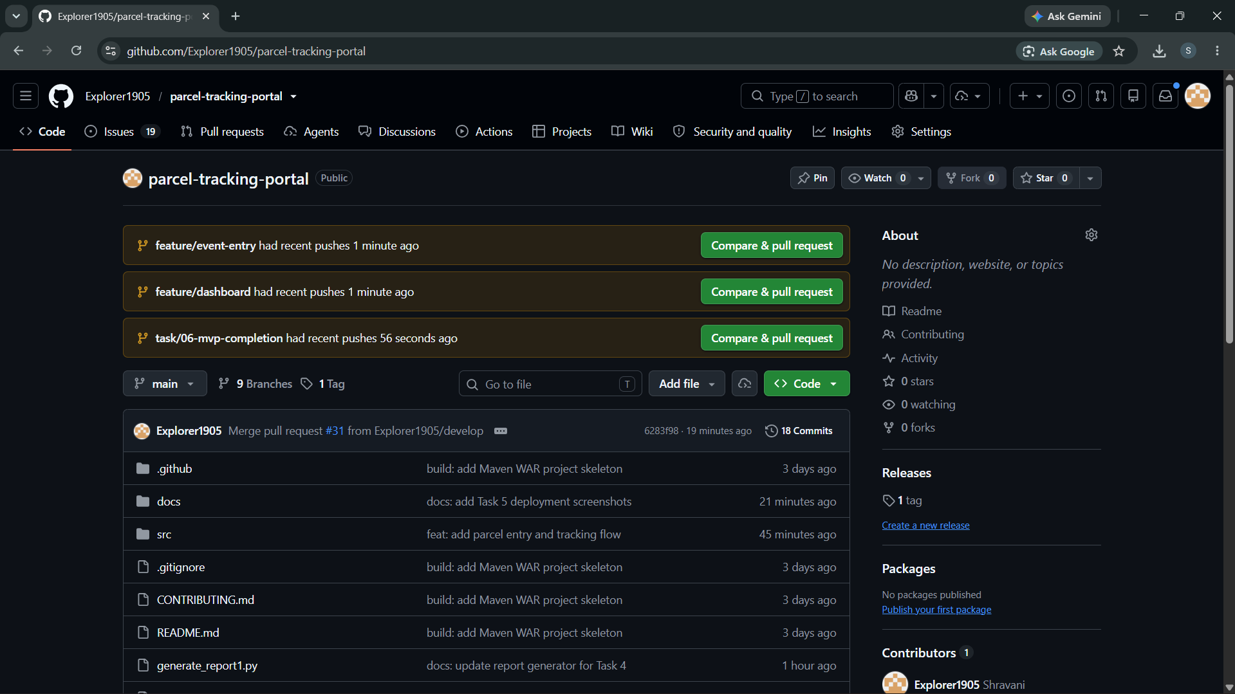
Figure 1: Screenshot 2026-10-12 000847.png
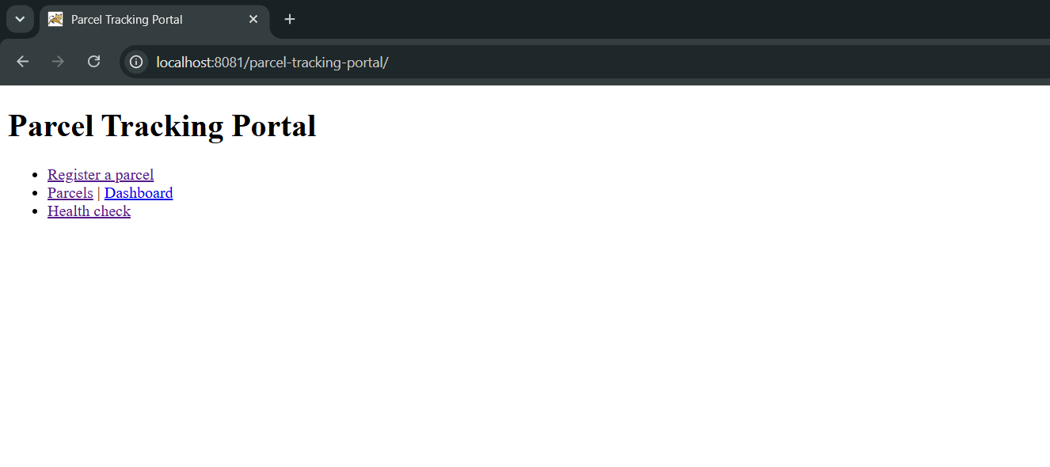
Figure 2: Screenshot 2026-10-12 001212.png
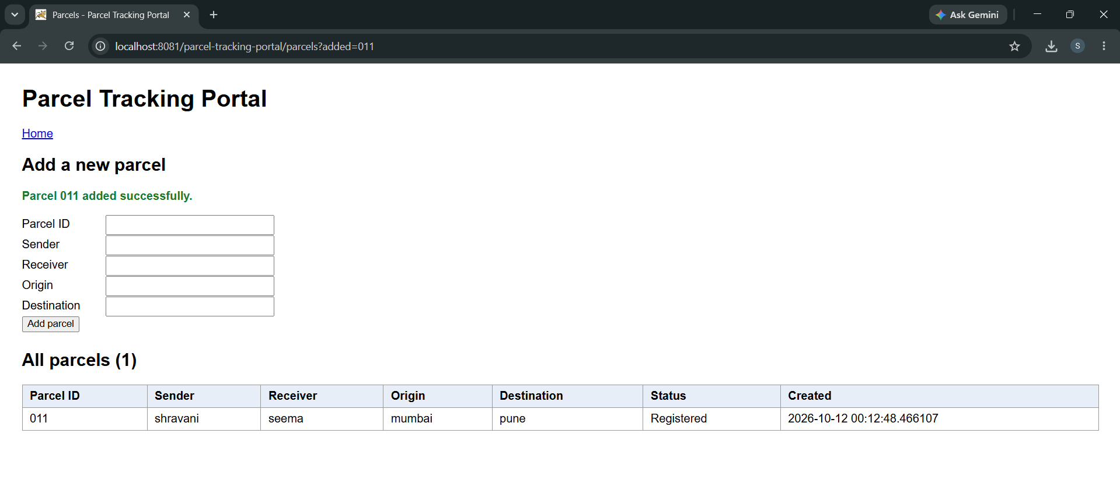
Figure 3: Screenshot 2026-10-12 001253.png
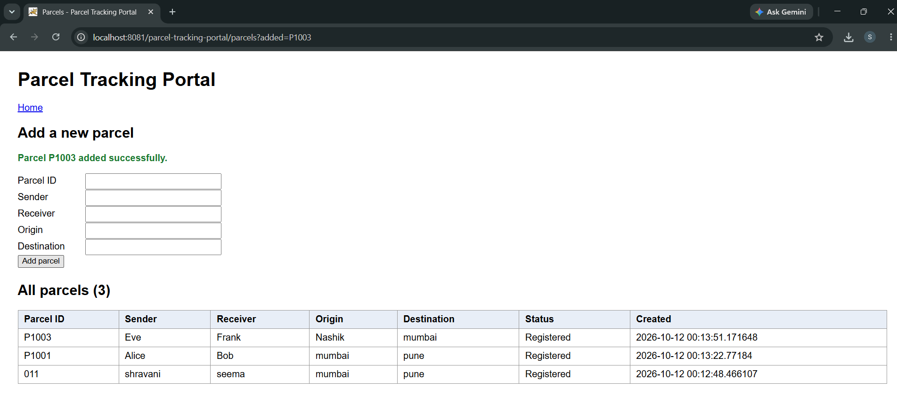
Figure 4: Screenshot 2026-10-12 001354.png
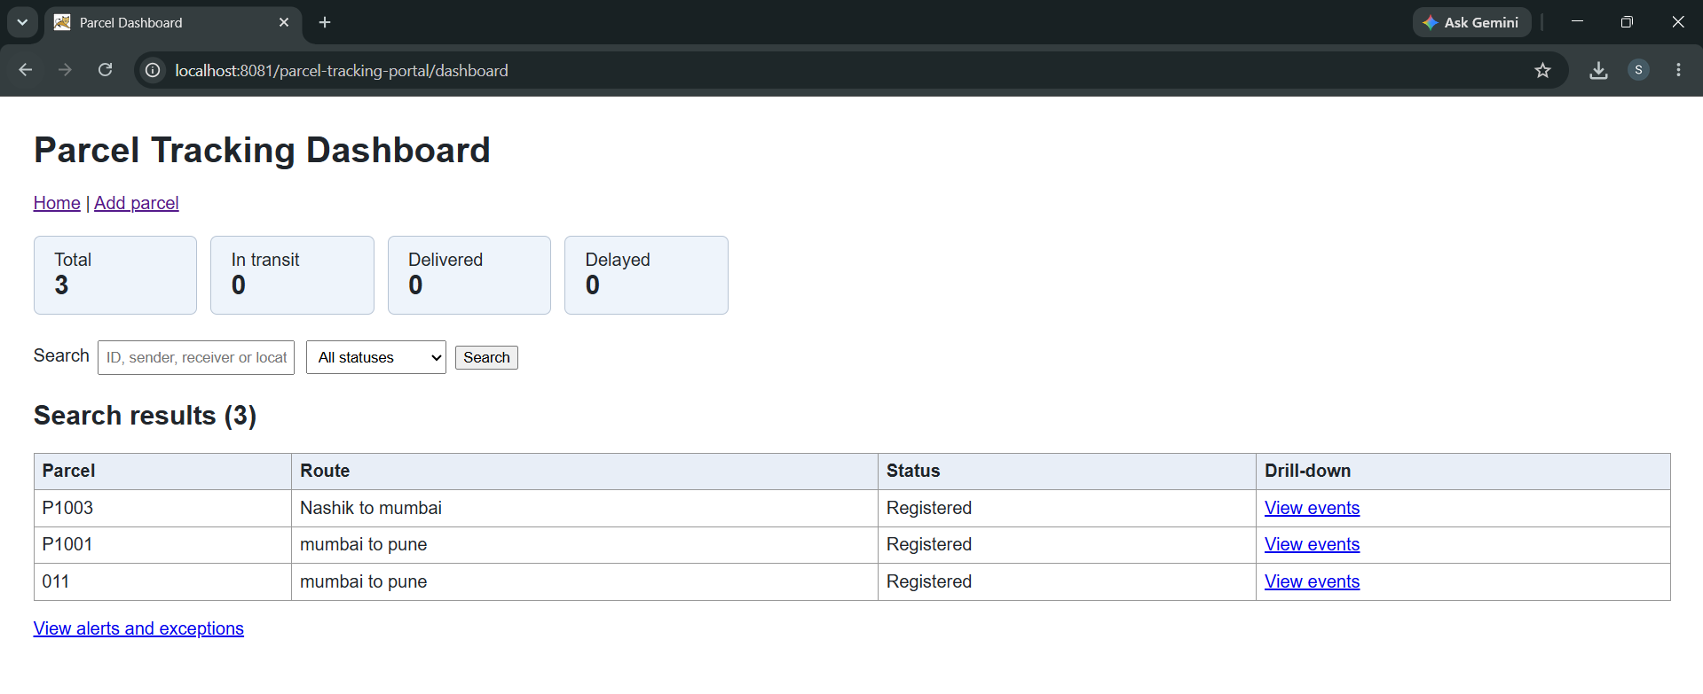
Figure 5: Screenshot 2026-10-12 001424.png

8. Deliverables Checklist
☑ Functional MVP completed
☑ Second feature branch demonstrated
☑ Merge conflict created and resolved
☑ Collaboration graph and blame evidence captured
☑ Release-ready source baseline tagged
☑ Task 6 backlog item moved to Done

9. Conclusion
The Parcel Tracking Portal MVP is complete and release-ready. The application supports event capture, search, status summaries, drill-down history and operational alerts. The Git history demonstrates parallel feature work, conflict resolution and a tagged release baseline.

