Task 2: Agile Planning and DevOps Workflow
Field | Details
Project | CI/CD Pipeline for a Parcel Tracking Portal
Name | Shravani Chavan
Roll No | 23102A0055
Class | CMPN A
Branch | task/02-agile-planning
Date | 08 October 2026

1. Objective
To create user stories and acceptance criteria for the Parcel Tracking Portal, prepare a product backlog, define a 15-task Kanban plan and a Definition of Done, and show the DevOps lifecycle from development to operations.

2. Agile Approach
Kanban is used because the project is a fixed sequence of 15 tasks delivered by one person. Work is visualised on a GitHub Projects board with the columns Backlog, To Do, In Progress, In Review and Done. A work-in-progress (WIP) limit of one task In Progress at a time keeps the flow steady.

3. User Stories and Acceptance Criteria
ID | User story | Acceptance criteria
US-01 | As a warehouse staff member, I want to add a new parcel so that it can be tracked. | Form accepts parcel ID, sender, receiver, origin and destination. Duplicate parcel IDs are rejected. A success message is shown after saving.
US-02 | As a delivery agent, I want to add a status event to a parcel so that its progress is recorded. | Status can be Picked Up, In Transit, Out for Delivery, Delivered or Failed. Each event stores a timestamp and location. The latest status updates on the dashboard.
US-03 | As a customer, I want to search a parcel by ID so that I can see its current status. | Search returns the result in under 2 seconds. An unknown ID shows a clear 'not found' message.
US-04 | As a support agent, I want a dashboard listing all parcels so that I can monitor them. | Dashboard lists all parcels with ID, status and last update. The list can be filtered by status.
US-05 | As a manager, I want summary indicators so that I can see overall performance. | Counts of total, in transit, delivered and delayed parcels are shown and match the stored data.
US-06 | As a customer, I want to open a parcel and see its full history so that I know what happened. | Drill-down page shows all events in time order on one screen.
US-07 | As a support agent, I want delayed or failed parcels flagged so that I can act quickly. | A parcel with no update beyond the set limit, or with status Failed, appears in the alert view.
US-08 | As a developer, I want every commit built and tested automatically so that defects are found early. | A Jenkins build is triggered on commit. A failed test stops deployment. Reports are archived.
US-09 | As an operations engineer, I want the portal deployed in a container and provisioned by script so that environments are repeatable. | The Docker image runs the portal. The Ansible/Puppet script builds the environment and a second run changes nothing.

4. Product Backlog
ID | Backlog item | Priority | Effort | Linked task
B-01 | Problem definition and scope | High | S | Task 1
B-02 | Agile plan, backlog and workflow | High | S | Task 2
B-03 | Architecture and technology setup | High | M | Task 3
B-04 | Repository initialization and conventions | High | S | Task 4
B-05 | Parcel entry and event entry (US-01, US-02) | High | M | Task 5
B-06 | Search, dashboard, summary, drill-down, alerts (US-03 to US-07) | High | L | Task 6
B-07 | Jenkins installation and CI job (US-08) | High | M | Task 7
B-08 | Jenkinsfile and deployment to Tomcat | High | M | Task 8
B-09 | Selenium test cases for three user journeys | High | M | Task 9
B-10 | Selenium tests integrated in Jenkins | Medium | M | Task 10
B-11 | Dockerfile and container lifecycle (US-09) | Medium | M | Task 11
B-12 | Jenkins to Docker continuous deployment | Medium | L | Task 12
B-13 | Ansible/Puppet configuration script | Medium | M | Task 13
B-14 | Automated provisioning and health check | Medium | M | Task 14
B-15 | Final release, documentation and viva | High | M | Task 15

Effort key: S = small, M = medium, L = large.

5. 15-Task Kanban Plan
Task | Title | Phase | Board column (at start)
1 | Problem Definition and Scope | Plan | Done
2 | Agile Planning and DevOps Workflow | Plan | In Progress
3 | Requirements, Architecture and Technology Setup | Plan | To Do
4 | Git and GitHub Repository Initialization | Code | To Do
5 | Feature Development with Branching | Code | Backlog
6 | MVP Completion and Git Collaboration | Code | Backlog
7 | Jenkins Installation and CI Job | Build | Backlog
8 | Pipeline as Code and Server Deployment | Build / Deploy | Backlog
9 | Selenium Test Design and Local Execution | Test | Backlog
10 | Continuous Testing in Jenkins | Test | Backlog
11 | Docker Image and Container Lifecycle | Release | Backlog
12 | Jenkins-Docker Continuous Deployment | Deploy | Backlog
13 | Configuration Management Script | Operate | Backlog
14 | Automated Provisioning and Reliability Validation | Operate / Monitor | Backlog
15 | Final End-to-End Release, Documentation and Viva | Release / Monitor | Backlog

Kanban rules
- Only one task is In Progress at a time (WIP limit = 1).
- A task moves to In Review when its pull request is opened.
- A task moves to Done only when it meets the Definition of Done.
- Each task has its own branch and its own report.

6. Definition of Done
A task is Done only when all of the following are true:
☑ Work is committed on its own task branch with meaningful commit messages.
☑ Code or configuration builds and runs without errors.
☑ Acceptance criteria of the related user stories are met.
☑ Tests (where applicable) pass.
☑ Pull request is raised, reviewed and merged into develop.
☑ The branch is kept for evidence and not deleted.
☑ Task report (Word) is written with commands, output and screenshots.
☑ The Kanban card is moved to Done.

7. DevOps Lifecycle: Development to Operations
The Parcel Tracking Portal follows a continuous loop. Code changes flow from planning through build, test, release and deployment into operations, and monitoring feedback returns to planning.
Stage | Activity in this project | Tool
1. Plan | User stories, backlog, Kanban board | GitHub Projects, Issues
2. Code | Feature branches, commits, pull requests | Git, GitHub, VS Code
3. Build | Compile and package the WAR file | Maven, Jenkins
4. Test | Automated UI tests on every build | Selenium, JUnit, Jenkins
5. Release | Versioned Docker image | Docker, Docker Hub
6. Deploy | Automatic deployment to Tomcat or container | Jenkins, Docker
7. Operate | Provision and configure servers | Ansible / Puppet
8. Monitor | Health check, test reports, feedback to Plan | Jenkins reports, curl health check

PLAN -> CODE -> BUILD -> TEST -> RELEASE -> DEPLOY -> OPERATE -> MONITOR
^ |
+------------------------- feedback loop ------------------------+

8. Steps Performed
- Created branch task/02-agile-planning from develop.
- Wrote user stories with acceptance criteria.
- Prepared the product backlog and mapped it to the 15 tasks.
- Created the Kanban board on GitHub Projects with five columns.
- Defined the Definition of Done and the DevOps lifecycle.
- Committed the report, raised a pull request into develop and merged it.

9. Git Commands Used
git checkout develop
git pull origin develop
git checkout -b task/02-agile-planning
git add docs
git commit -m "docs: add Task 2 agile planning report"
git push -u origin task/02-agile-planning

10. Screenshots
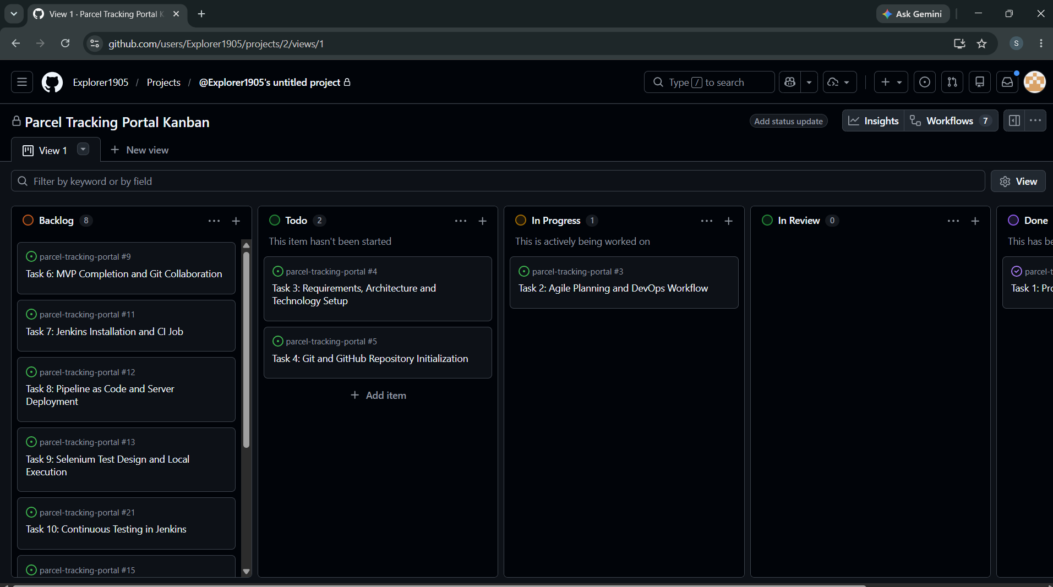
Figure 1: Screenshot 2026-10-07 215706.png
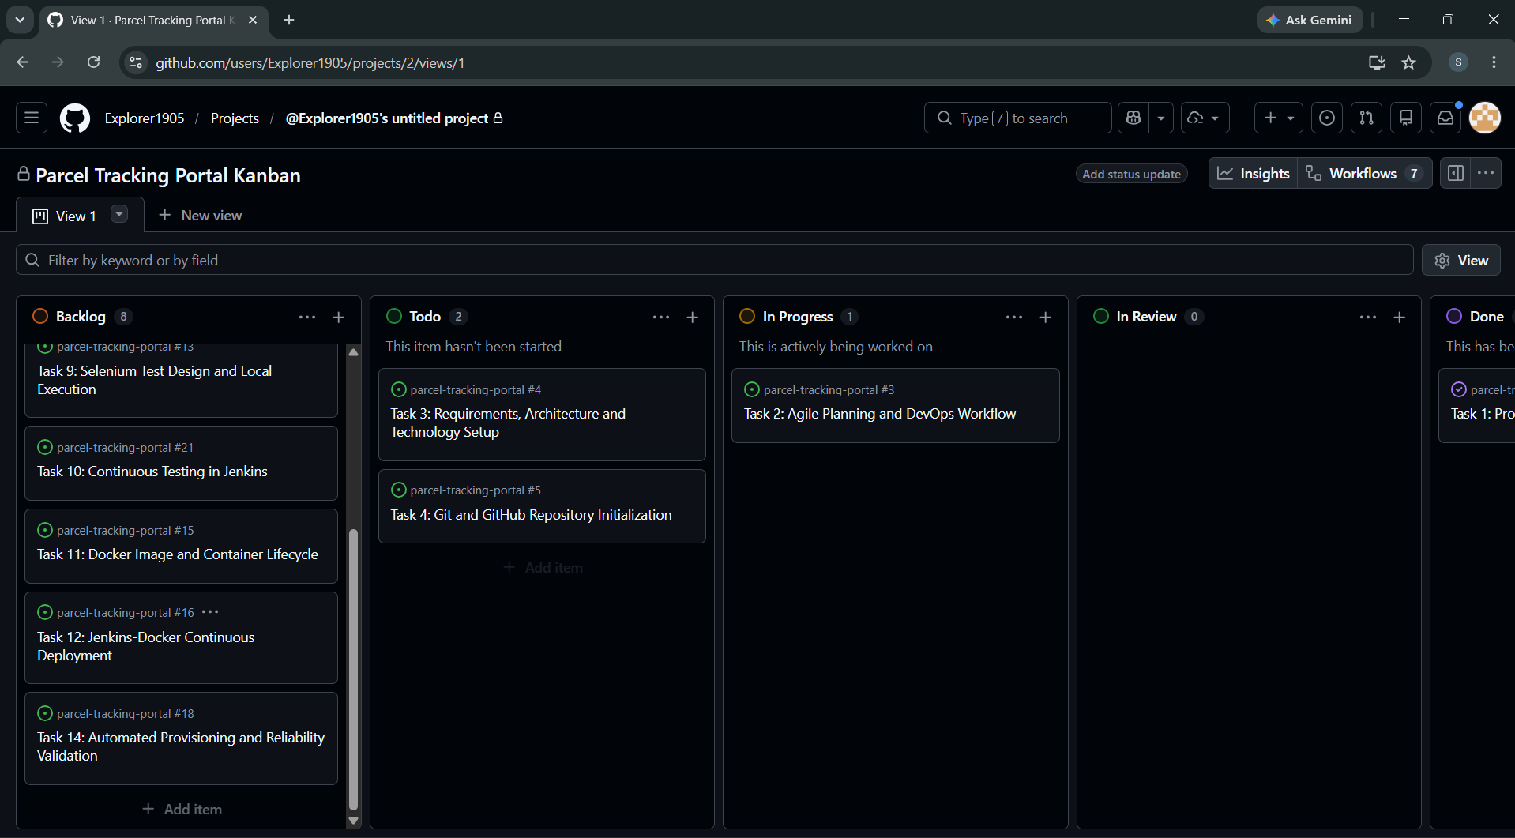
Figure 2: Screenshot 2026-10-07 215710.png
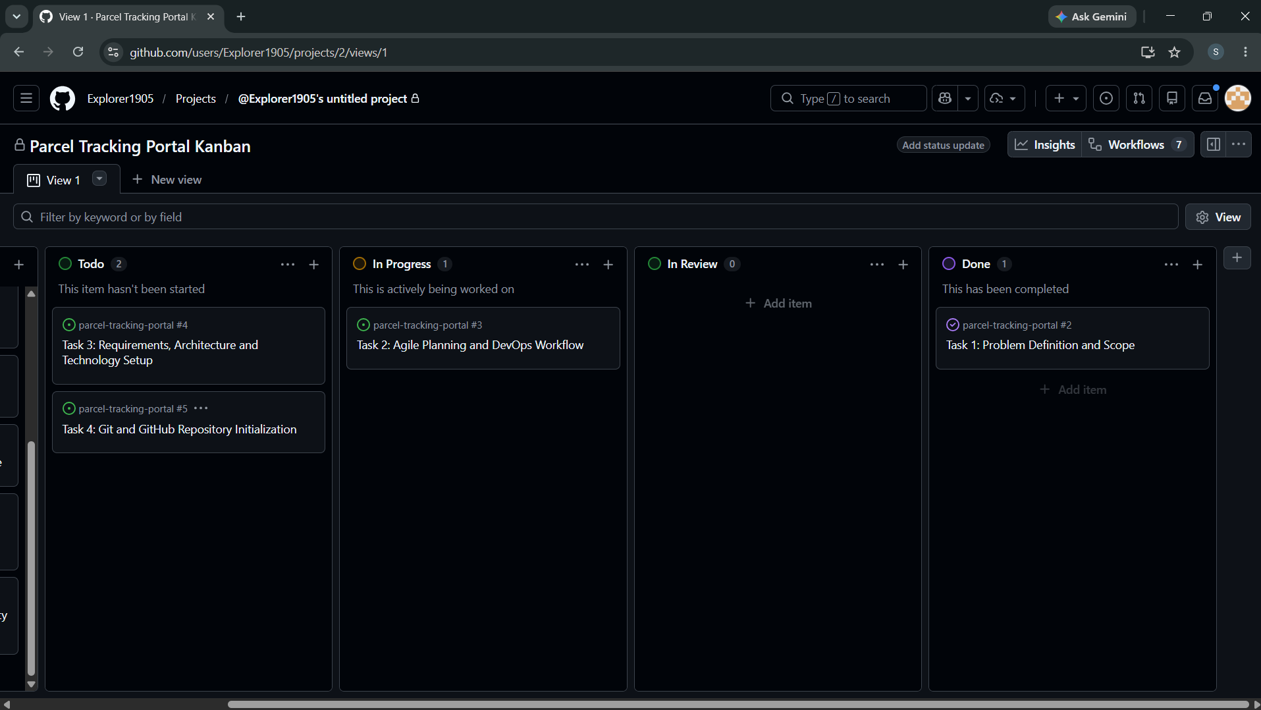
Figure 3: Screenshot 2026-10-07 215716.png
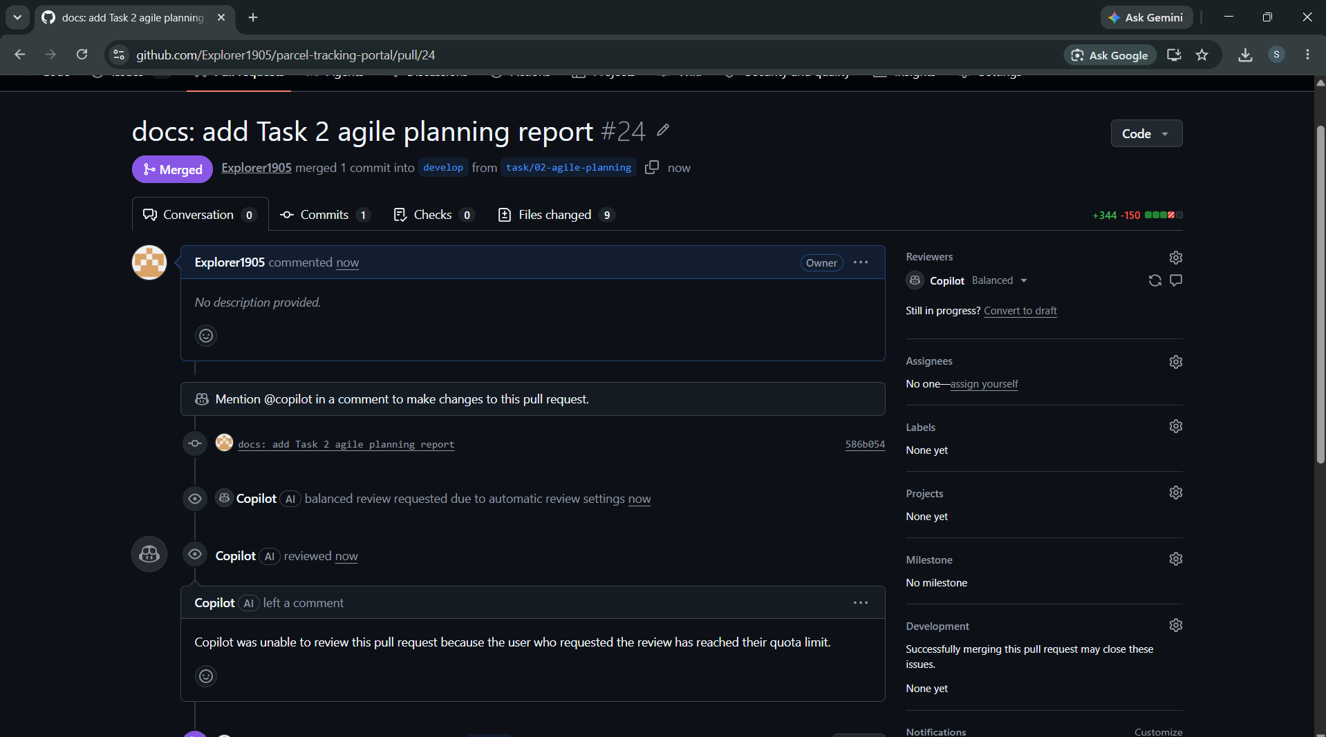
Figure 4: Screenshot 2026-10-08 222427.png

11. Deliverables Checklist
☑ User stories with acceptance criteria
☑ Product backlog
☑ 15-task Kanban plan
☑ Definition of Done
☑ DevOps lifecycle diagram

12. Issues Faced and Fixes
- Script initially run from the wrong folder; fixed by running it inside the repository.
- Report file was open in Word and caused a permission error; closed it before regenerating.

13. Conclusion
Agile planning for the Parcel Tracking Portal is complete. The user stories, backlog, Kanban board, Definition of Done and DevOps lifecycle give a clear path for building the application and its CI/CD pipeline in the next tasks.

