Task 3: Requirements, Architecture and Technology Setup
Field | Details
Project | CI/CD Pipeline for a Parcel Tracking Portal
Name | Shravani Chavan
Roll No | 23102A0055
Class | CMPN A
Branch | task/03-architecture-setup
Date | 08 October 2026

1. Objective
To define the requirements of the Parcel Tracking Portal, design the minimum application architecture for the MVP, select the technology stack and verify that the required tools are installed.

2. Functional Requirements
ID | Requirement | User story
FR-01 | Add a new parcel with ID, sender, receiver, origin and destination | US-01
FR-02 | Add a status event (Picked Up, In Transit, Out for Delivery, Delivered, Failed) with timestamp and location | US-02
FR-03 | Search a parcel by ID | US-03
FR-04 | Dashboard listing all parcels with status filter | US-04
FR-05 | Summary indicators: total, in transit, delivered, delayed | US-05
FR-06 | Status drill-down showing the full event history of a parcel | US-06
FR-07 | Alert view listing delayed or failed parcels | US-07

3. Non-Functional Requirements
ID | Requirement | Target
NFR-01 | Performance | Search result in under 2 seconds
NFR-02 | Reliability | Build, test and deploy run automatically without manual steps
NFR-03 | Portability | Same application runs on Tomcat and inside a Docker container
NFR-04 | Maintainability | Layered code structure and Maven standard layout
NFR-05 | Testability | Core user journeys covered by Selenium tests
NFR-06 | Cost | Only free and open-source tools

4. Minimum Application Architecture
The portal is a layered Java web application. The browser sends requests to servlets running on Apache Tomcat. Servlets call a service layer that holds the business rules, and the service layer uses a DAO layer to read and write an embedded H2 database. JSP pages render the results.
Layer | Responsibility | Components
Presentation | Display pages and forms | JSP: add parcel, dashboard, parcel details, alerts
Controller | Handle HTTP requests and choose the view | ParcelServlet, EventServlet, SearchServlet, DashboardServlet
Service | Business rules such as delay detection and summary counts | ParcelService, EventService
Data access | Database operations through JDBC | ParcelDao, EventDao
Storage | Persist parcels and events | H2 embedded database

Architecture diagram
Browser
|
v
JSP Views
|
v
Servlets (Controllers)
|
v
Service Layer
|
v
DAO Layer (JDBC)
|
v
H2 Database
All components run inside Apache Tomcat and are built by Maven.
A drawn version of this diagram is included in the Screenshots section.

Data model
Table | Columns
parcels | parcel_id (PK), sender, receiver, origin, destination, created_at
events | event_id (PK), parcel_id (FK), status, location, event_time, remarks

Delay rule
A parcel is flagged as delayed when its latest status is not Delivered and no event has been recorded for more than 48 hours. A parcel whose latest status is Failed is always shown in the alert view.

Planned project structure
parcel-tracking-portal/
pom.xml
src/main/java/.../controller
src/main/java/.../service
src/main/java/.../dao
src/main/java/.../model
src/main/webapp/*.jsp
src/test/java/.../selenium
Jenkinsfile
Dockerfile
config-management/
docs/

5. Technology Selection
Area | Choice | Reason
Language | Java (compiled for Java 17) | Matches Maven, Tomcat and Jenkins tooling
Web layer | Servlets and JSP (Jakarta) | Simple, lightweight, ideal for a WAR deployment
Database | H2 embedded | No separate database server needed
Build | Maven | Standard build, dependency and test management
Server | Apache Tomcat 10.1 | Supports Jakarta Servlet 6
Version control | Git and GitHub | Branching and pull requests
CI / CD | Jenkins | Pipeline as code with a Jenkinsfile
Testing | Selenium WebDriver with JUnit 5 | Browser-level automated tests
Containers | Docker | Repeatable runtime environment
Configuration management | Ansible (through WSL) | Agentless and simple YAML playbooks

6. Tool Verification
Tool | Version found | Status
Java JDK | 22.0.2 (target release 17) | Installed
Apache Maven | 3.9.16 | Installed
Git | 2.46.2.windows.1 | Installed
Operating system | Windows 11 (amd64) | Ready
Apache Tomcat | 10.1.x | Installed and welcome page verified
Jenkins, Docker, Selenium, Ansible | To be installed in their own tasks | Planned

7. Steps Performed
- Created branch task/03-architecture-setup from develop.
- Wrote functional and non-functional requirements.
- Designed the layered architecture and the data model.
- Selected the technology stack.
- Verified Java, Maven and Git with version commands.
- Downloaded Apache Tomcat 10.1, started it and opened http://localhost:8080.
- Committed the report, raised a pull request into develop and merged it.

8. Commands Used
java -version
mvn -v
git --version
startup.bat
git add docs
git commit -m "docs: add Task 3 requirements, architecture and setup report"
git push -u origin task/03-architecture-setup

9. Screenshots
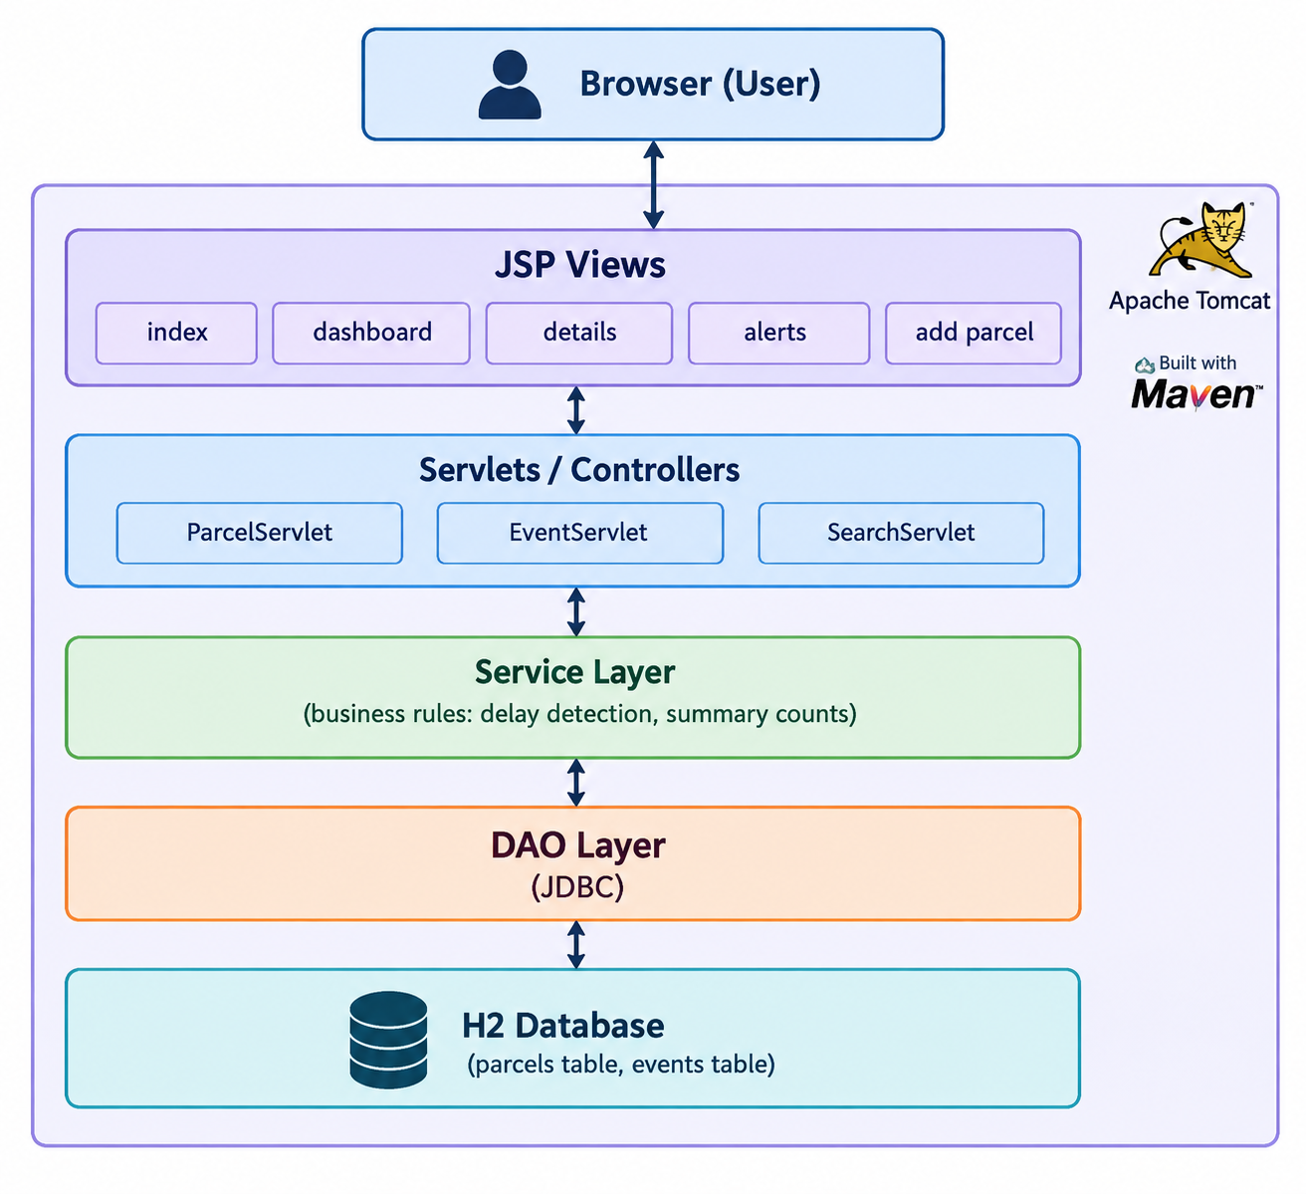
Figure 1: Layered Java Web Application Architecture.png
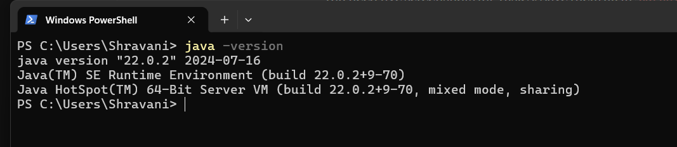
Figure 2: Screenshot 2026-10-08 221235.png
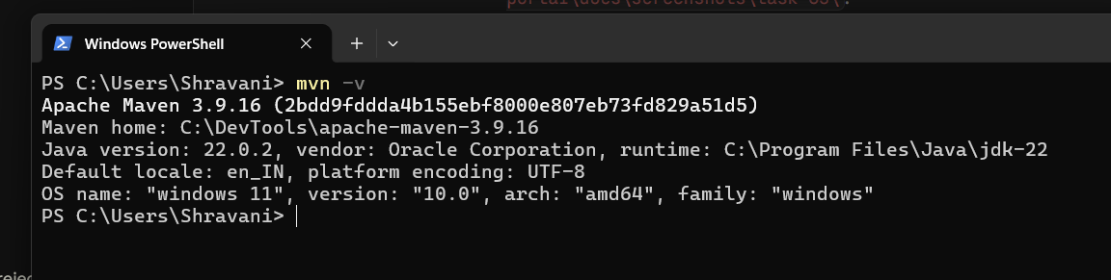
Figure 3: Screenshot 2026-10-08 223214.png
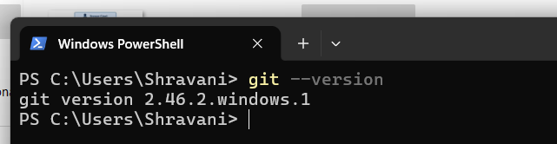
Figure 4: Screenshot 2026-10-08 223240.png

10. Deliverables Checklist
☑ Functional and non-functional requirements
☑ Minimum application architecture and data model
☑ Technology stack selected
☑ Tools verified

11. Issues Faced and Fixes
- Installed JDK is version 22. The project compiles for Java 17, and Jenkins runs on its own Java 21 runtime.
- Jenkins and Tomcat both use port 8080, so Tomcat was moved to port 8081.
- Ansible does not run natively on Windows, so WSL will be used in the configuration management task.

12. Conclusion
The requirements, architecture and technology stack for the Parcel Tracking Portal are defined and the required tools are verified. The next task creates the Git and GitHub repository structure and the initial application skeleton.

