Task 4: Git and GitHub Repository Initialization
Field | Details
Project | CI/CD Pipeline for a Parcel Tracking Portal
Name | Shravani Chavan
Roll No | 23102A0055
Class | CMPN A
Branch | task/04-repo-init
Date | 08 October 2026

1. Objective
To initialise the GitHub repository for the Parcel Tracking Portal with a README, .gitignore, folder structure, issue templates and branch naming rules, and to commit the initial application skeleton using meaningful commit messages.

2. Repository Details
Item | Value
Repository | parcel-tracking-portal
Owner | Explorer1905
Visibility | Public
Default branch | main
Integration branch | develop

3. Folder Structure
parcel-tracking-portal/
pom.xml
README.md
CONTRIBUTING.md
.gitignore
generate_report1.py
.github/
ISSUE_TEMPLATE/ (bug_report, feature_request, task)
pull_request_template.md
src/main/java/com/parcel/{controller,service,dao,model}
src/main/webapp/index.jsp
src/test/java/com/parcel
docs/reports
docs/screenshots

4. Branch Naming Rules
Branch type | Pattern | Example
Stable | main | main
Integration | develop | develop
Task | task/NN-short-name | task/04-repo-init
Feature | feature/short-name | feature/parcel-entry
Fix | fix/short-name | fix/search-error

5. Commit Message Convention
Commits use the format type: summary, where type is one of feat, fix, docs, test, build, ci or chore. Each commit contains one logical change.

6. Initial Application Skeleton
- Maven WAR project compiled for Java 17 with the Jakarta Servlet 6.0 API.
- Layered package structure: controller, service, dao and model.
- index.jsp landing page and a /health servlet returning OK.
- Build verified with mvn clean package, producing parcel-tracking-portal.war.

7. Templates Added
- Issue templates: bug report, feature request and task.
- Pull request template with a checklist.
- CONTRIBUTING.md with branching and commit rules.

8. Steps Performed
- Created branch task/04-repo-init from develop.
- Created the Maven project skeleton and verified the build.
- Added README, CONTRIBUTING.md and the .github templates.
- Extended .gitignore for Maven and IDE files.
- Made separate commits with meaningful messages.
- Pushed the branch, raised a pull request into develop and merged it.

9. Commands Used
git checkout -b task/04-repo-init
mvn clean package
git add pom.xml src
git commit -m "build: add Maven WAR project skeleton"
git commit -m "feat: add health check servlet"
git commit -m "docs: add branch naming and commit message rules"
git commit -m "chore: add issue and pull request templates"
git push -u origin task/04-repo-init
git log --oneline

10. Screenshots
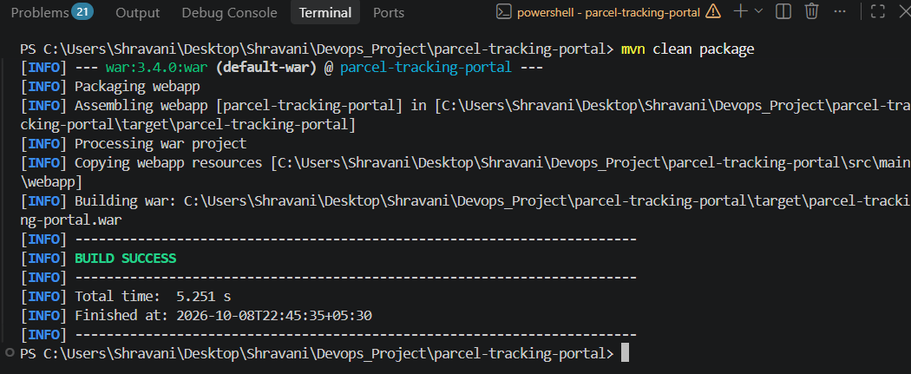
Figure 1: Screenshot 2026-10-08 224543.png

11. Deliverables Checklist
☑ GitHub repository created
☑ README and .gitignore added
☑ Folder structure created
☑ Issue templates added
☑ Branch naming rules documented
☑ Initial skeleton committed with meaningful messages

12. Issues Faced and Fixes
- Git commands were first run in the wrong folder and used a stray repository; fixed by running them inside the project folder and verifying with git rev-parse --show-toplevel.
- The Task 2 pull request had not been merged; merged it before starting later tasks.

13. Conclusion
The repository is fully initialised with documentation, templates, branching rules and a building application skeleton. The next task develops the first feature on a feature branch using the pull request workflow.

