Task 11: Docker Image and Container Lifecycle
Field | Details
Project | CI/CD Pipeline for a Parcel Tracking Portal
Name | Shravani Chavan
Roll No | 23102A0055
Class | CMPN A
Branch | task/11-docker
Date | 12 October 2026

1. Objective
Create a Docker image for the Parcel Tracking Portal, run it as a container, map the application port, inspect image and runtime details, and document the complete container lifecycle.

2. Dockerfile
The Dockerfile uses Apache Tomcat 10.1 with JDK 17, removes the default web applications, copies the Maven WAR into the application context and starts Tomcat in the foreground.
FROM tomcat:10.1-jdk17-temurin
ENV CATALINA_OPTS="-Dfile.encoding=UTF-8"
RUN rm -rf /usr/local/tomcat/webapps/*
COPY target/parcel-tracking-portal.war /usr/local/tomcat/webapps/parcel-tracking-portal.war
EXPOSE 8080
CMD ["catalina.sh", "run"]

3. Image and Container Commands
mvn -B clean package -DskipTests
docker build -t parcel-tracking-portal:1.0.0 .
docker images parcel-tracking-portal
docker run -d --name parcel-portal -p 8082:8080 parcel-tracking-portal:1.0.0
docker ps
docker logs parcel-portal
docker inspect parcel-portal
docker stop parcel-portal
docker start parcel-portal
docker rm -f parcel-portal

4. Verification
Check | Expected result
Image tag | parcel-tracking-portal:1.0.0
Container mapping | Host 8082 to container 8080
Application URL | http://localhost:8082/parcel-tracking-portal/
Health URL | http://localhost:8082/parcel-tracking-portal/health
Health response | OK
Lifecycle | Run, inspect, stop, restart and remove demonstrated

5. Screenshots
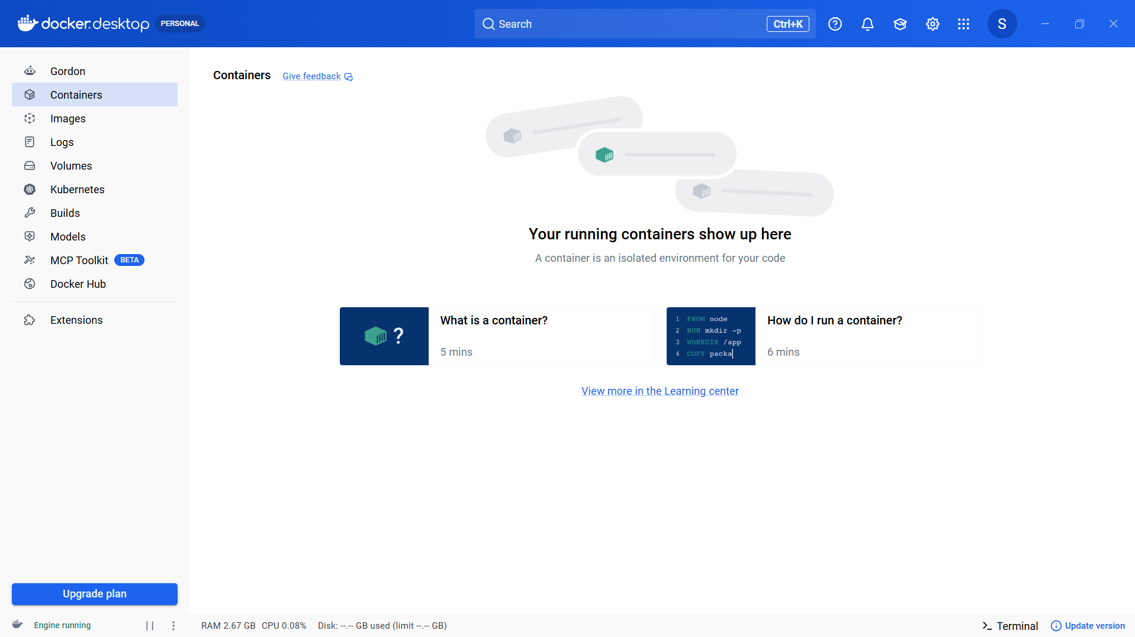
Figure 1: Screenshot 2026-10-12 185849.png
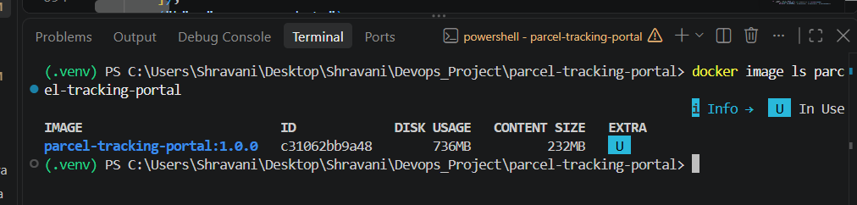
Figure 2: Screenshot 2026-10-12 190317.png
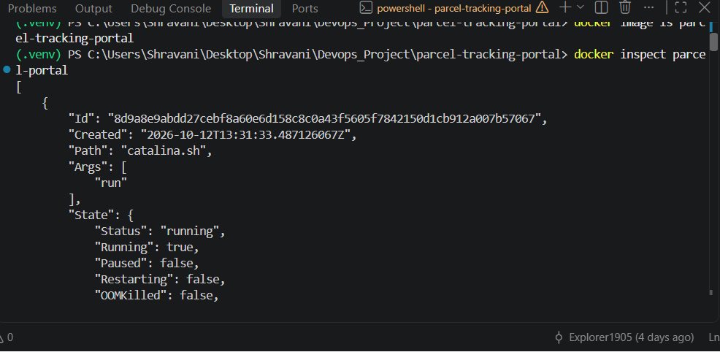
Figure 3: Screenshot 2026-10-12 190336.png
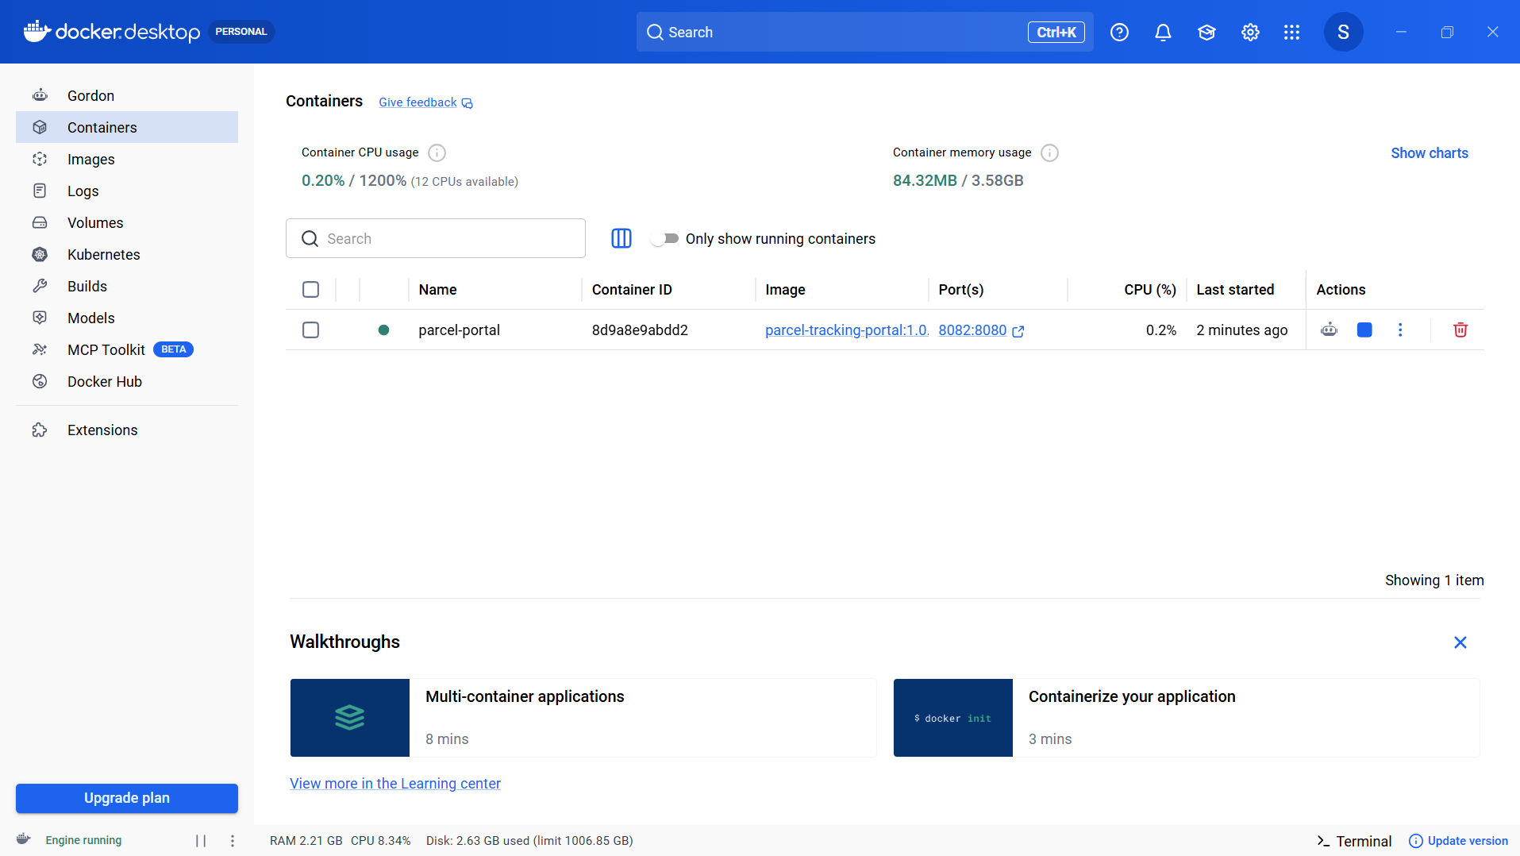
Figure 4: Screenshot 2026-10-12 190345.png
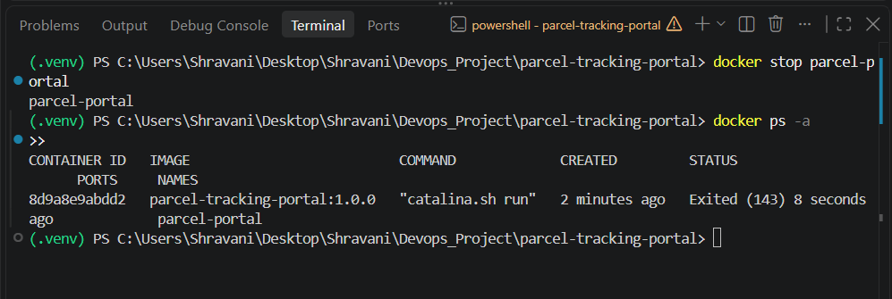
Figure 5: Screenshot 2026-10-12 190409.png
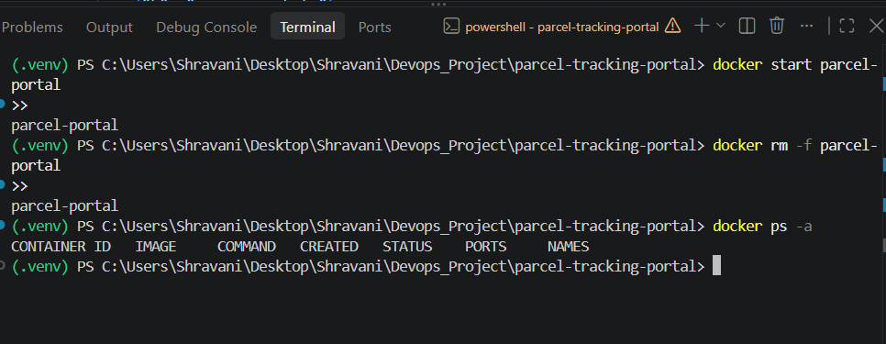
Figure 6: Screenshot 2026-10-12 190447.png

6. Deliverables Checklist
☑ Dockerfile committed
☑ Docker image built and tagged
☑ Container started with mapped port
☑ Image details and container logs inspected
☑ Container stopped and restarted
☑ Container removed after verification
☑ Running container and health endpoint captured
☑ Task 11 backlog item moved to Done

7. Conclusion
The Parcel Tracking Portal is packaged as a reproducible Tomcat container. The recorded commands demonstrate image creation, runtime verification and the full container lifecycle from start through removal.

