Task 14: Automated Provisioning and Reliability Validation
Field | Details
Project | CI/CD Pipeline for a Parcel Tracking Portal
Name | Shravani Chavan
Roll No | 23102A0055
Class | CMPN A
Branch | task/14-provisioning-reliability
Date | 12 October 2026

1. Objective
Provision a clean target with Ansible, deploy a known release, rerun automation to demonstrate repeatability, verify application health and recover by rolling back to a previous stable image.

2. Provisioning and Deployment Design
Area | Automation
Prerequisites | site.yml installs packages and creates the service identity and directories
Release deployment | deploy.yml pulls an exact image tag and reconciles parcel-portal-cd
Health gate | Ansible URI retries until HTTP 200 and body OK
Idempotence | A repeat deployment skips container replacement when the requested tag is already running
Rollback | rollback.yml restores a known stable image and repeats the health check

3. Execution Commands
sudo ansible-playbook -i inventory.ini site.yml -e ansible_become=false
sudo ansible-playbook -i inventory.ini deploy.yml -e ansible_become=false -e release_tag=1.0.7
sudo ansible-playbook -i inventory.ini deploy.yml -e ansible_become=false -e release_tag=1.0.7
sudo ansible-playbook -i inventory.ini rollback.yml -e ansible_become=false -e rollback_tag=1.0.7

4. Reliability Verification
docker ps --filter name=parcel-portal-cd
cat /etc/parcel-tracking-portal/active-release
curl http://127.0.0.1:8082/parcel-tracking-portal/health

5. Evidence
Capture the provisioning recap, repeat execution recap, deployed version and health response, then capture the rollback container and recovered health response. Save the first execution output as docs/reports/task-14-provisioning-first-execution.log.

6. Screenshots
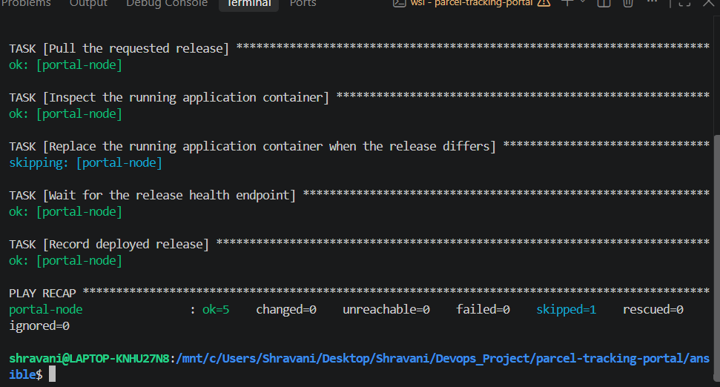
Figure 1: Screenshot 2026-10-12 213112.png
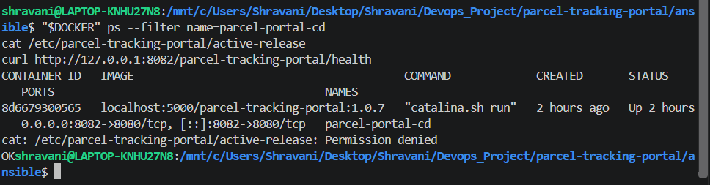
Figure 2: Screenshot 2026-10-12 213122.png
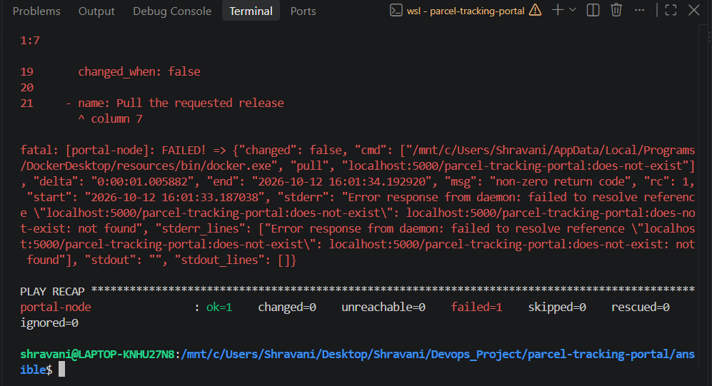
Figure 3: Screenshot 2026-10-12 213143.png
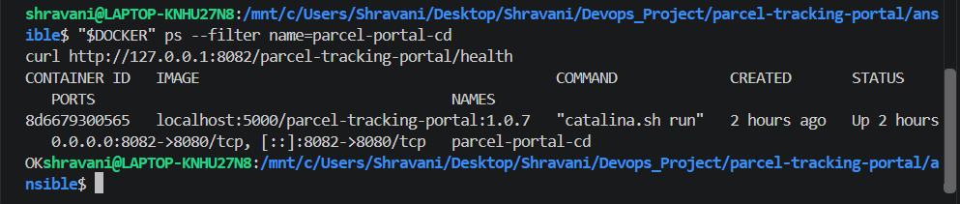
Figure 4: Screenshot 2026-10-12 213152.png

7. Deliverables Checklist
☑ Clean target provisioned with Ansible
☑ Release container deployed from an exact versioned image
☑ Automation rerun successfully
☑ Health endpoint returned OK
☑ Rollback to the previous stable release completed
☑ Recovery health check returned OK
☑ Task 14 backlog item moved to Done

8. Conclusion
The portal environment can be provisioned and recovered through repeatable automation. Exact image tags, health gating and an explicit stable rollback make the container deployment auditable and recoverable.

