[1]

DL-AMP and DBTO: An Automatic Merge Planning and Trajectory Optimization and its Application in Autonomous Driving

Yuncheng Jiang, Qi Lin

*Abstract*— This paper presents an automatic merging algorithm for autonomous driving vehicle, which decouples the specific motion planning problem into a Dual-Layer Automatic Merge Planning (DL-AMP) and a Descent-Based Trajectory Optimization (DBTO). This work leads to great improvements in finding the best merging opportunity, lateral and longitudinal merging control, trajectory postprocessing and driving comfort. Our algorithm’s efficiency, adaptiveness and robustness have been tested and validated both in simulations and on-road tests.

# INTRODUCTION

In the past several decades, autonomous driving has made a great process extending the ability of autonomous vehicle from Adaptive Cruise Control (ACC) and Lane Keeping Assistance (LKA) to more complex functions such as automatic lane changing, off-road navigation, stopping at traffic light, etc. [1][2]. In merging scenarios, human can predict other vehicles intentions and react intelligently to make the best merge choice. To deal with such scenario, prediction and planning should be well coupled considering driving efficiency, safety, and comfort. Therefore, a robust and intelligent algorithm that can interact with human-operated traffic on freeways is still under research and development. There are mainly two approaches in dealing with automatic merge problem:

One category is prediction and planning coupled method which convert the prediction and planning problem into a convex optimization form, and prediction information is transferred into inequality constraints [3]. Mixed Logical Dynamics (DML) [4][5] is also applied in solving this optimization problem. [6] uses quintic polynomials in merge planning, while polynomial parameters are chosen as optimization targets. This approach usually lacks computational efficiency, and its robustness is not well guaranteed. The other category is prediction and planning decoupled method which first find the best merging opportunity, and then plan a merge maneuver. [7] uses Prediction and Cost Function Based (PCB) method to find the best merge opportunity, while this planner must run continuously throughout the whole merge process, and its acceleration and velocity outputs are discontinuous. [8] uses a rule-based planner to decide when to merge based on its fixed definition of environment safety, but it may fail when faced with complex traffic scenarios.

In terms of merge planning, there are also two major approaches: path/speed decoupled method and path/speed coupled method. In decoupled method, polynomial curvature spiral is generated, and spatial trajectory is solved by using Lagragian method [xx][xx][xx]. Cubic polynomial is also used to generate spatial trajectory [xx][xx]. In the two methods, piece -wise velocity profile is then generated satisfying some road and trajectory constraints. In merge problem, path/speed decoupled methods do not work well since merging maneuver require that the vehicle reaches some position at some specific time stamp (position/time strictly coupled). In coupled method, quintic polynomials are generated longitudinally and laterally, and they are combined to generate spatial and temporal trajectories [xx][xx]. Such method, however, does not consider comfort and merge opportunity when deal with merge problem. Therefore, it may lead to uncomfortable lateral acceleration in lane changing, and even lead to danger if unreasonable merge opportunity is selected.

In trajectory postprocessing, gradient descent method is used in [xx] to optimize trajectory curvature, but it fails to do collision checking after smoothing. A Dual-Loop Iterative Anchoring Path Smoothing (DL-IAPS) is used to smooth trajectory generated by hybrid A* algorithm, by converting the smoothing problem into a convex optimization problem. The algorithm has an average running time about 0.18s- 0.21s [xx]. However, in merging problem, where vehicles usually move at high speed, optimization-based algorithm may degrade system instantaneity.

In this paper, we propose a novel path/speed coupled method for automatic merge planning. More specifically, we decoupled the method into two hierarchical steps, including, Dual-Layer Automatic Merge Planning (DL-AMP) and a Descent-Based Trajectory Optimization (DBTO). Our method addresses above mentioned issues with the following advantages:

1) **The Best Merging Opportunity**: In our DL-AMP, the first layer is a prediction and cost function-based algorithm which can find the best merging opportunity. The difference between our method and that in [xxx] are: 1) our method is only used in find the best merging opportunity, when the autonomous vehicle begins to merge, the second layer algorithm will be trigger. Therefore, the output continuity is guaranteed by the second layer algorithm. Meanwhile, since the task is much easier for the first layer algorithm, it has less cost function parameters to tune. In our method, candidate ego vehicle acceleration and time are sampled in some ranges. Based on the sampled acceleration and time, constant acceleration prediction model is used to predict the relative distance and velocity between ego vehicle and other traffics. Cost function that emphasis driving efficiency and comfort is designed, and the maneuver that satisfies safety hard constraints with the minimum cost is chosen.

2) **Sampling Reasonability**: although quintic polynomial sampling method has been used in [], it does not well deal with merge scenario motion planning. In our DL-AMP, the second layer algorithm is based on path/speed quintic polynomial sampling method. The longitudinal planning is divided into distance control and velocity control to adapt to difference merge scenarios. In lateral planning, we divide the scenarios into four categories, and different desired distance is selected under different scenarios. To improve sampling efficiency, the sampling dimension desired distance in lateral planning and desired velocity in longitudinal planning are constrained in reasonable ranges which are calculated in prior. Vehicle dynamic constraints are considered to calculate the constraints for the sampling range so that the sampling is warm started from some suboptimal point, and it can quickly find the global optima which is usually near the suboptimal point.

3) **Driving Comfort and Control Feasibility**: To improve driving comfort and control feasibility. We do trajectory smoothing after optimal trajectory is generated. A gradient based method that considers trajectory smoothness and curvature is us ed to reduce trajectory discontinuity and turning radius which results in reduced lateral acceleration and wheel turning angles in control. Since we use DL-AMP to find the best merge opportunity, free space is ensured at the very beginning, and collision checking is not necessary after smoothing. Unlike [xx], we also modify our gradient based method to deal with exploding and vanishing gradient problems.

This paper is organized as follows: the problem statement is presented in Section II, DL-AMP and DBTO are illustrated in Section III and IV, respectively. The simulation and on-road tests results are shown in Section V.

# algorithm framework

PLEASE FILL IN THE FRAMEWORK DESIGN

# Dual-Layer Automatic Merge Planning

In this section, we introduce the two parts of DL-AMP: In III-A we introduce how to find the best merging opportunity and in III-B we introduce merging trajectory generation. The overall algorithm is shown in 1.

## A. finding the best merging opportunity

In this section we introduce our design of how to find the best merge opportunity.

PLEASE FILL IN THE PLANNER DESIGN

## B. merging trajectory generation

We use sampling-based method to generate quintic polynomials longitudinally and laterally and evaluate the candidate trajectories using cost function considering driving efficiency, comfort, and safety. To make merge maneuver more like human behaviors, we calculate in prior a reasonable sampling time range that satisfies comfortable lateral acceleration and curvature limits. It affects the sampling range of desired longitudinal distance in longitudinal distance planning and the sampling range of velocity in longitudinal velocity planning. More details in shown in 1). We divide merging scenarios into four categories, which is shown in Fig.1. under different scenarios, desired longitudinal distance is calculated differently.

*1) lateral planning:* according to human driving statistics, we limit sampling time in a reasonable range to improve sampling efficiency. Lateral acceleration is the most critical factor that affect driver comfort, and trajectory curvature is also an important factor that affect the performance of lateral controller. Based on the feature of quintic polynomial, we calculate a reasonable time range that satisfy both which is shown in Fig. x. the sampling time range is constrained between 3.5s and 6.0s.

Fig. x:

We calculate the maximum lateral acceleration a quintic polynomial can generate with a constant lateral offset (in China, standard road width 3.75m) and longitudinal velocity varying from 36km/h to 108 km/h. We find that the lateral acceleration profile is like a saddle with its peak values (time fixed) ranging between 68km/h and 76km/h. According to driver statistics, we find that lateral acceleration should be less than 0.15g, the minimum time is therefore limited at 4.0s. The curvature graph is then used to check if the maximum curvature is too aggressive with time equaling 4.0s. To ensure merging efficiency, we limit maximum time at 6.0s which is like human drivers’ behavior.

In lateral direction, we define the initial state = [,, ,] where is ego vehicle’s lateral offset with respect to reference line. is ego vehicle’s lateral velocity, is ego vehicle’s lateral acceleration, and is current time. The terminal state is defined as = [,, , ] where is terminal sampling lateral offset and is terminal sampling time. We let  *= = 0*, as we always want the terminal lateral velocity and lateral acceleration equal to zero. The cost function is denoted by:

,

where ,, and is respective penalty weights on different parameters. is the mean value along the planned trajectory, T is planning time T, and is mean value of squared lateral offset of the planned trajectory along the reference line. Unlike [], we want to select cost function terms as less as possible, as parameter calibration is always time consuming. In terms of comfort, we find that jerk is the most direct factor that affect driver comfort; thus, we only keep jerk term, neglecting lateral velocity and acceleration terms. The curvature-related terms are also neglected since we not only calculate in priori a reasonable sampling time range that ensures proper trajectory curvature, but also do trajectory smoothing in DBTO to optimize curvature. The consecutivity term is neglected in merge scenarios where there exists no symmetry. Less cost function terms can improve computation efficiency and reduce parameter calibration burden. With initial and terminal states, lateral quintic polynomials can be generated, with more details in Appendix I.

*2) longitudinal planning:* longitudinal planning is divided into distance planning and velocity planning. Similar with lateral planning, we use quintic polynomial in distance planning and quantic polynomial in velocity planning. In distance planning, we define the initial state = [,, ,] where is ego vehicle’s longitudinal distance with respect to reference line. is ego vehicle’s longitudinal velocity, is ego vehicle’s longitudinal acceleration, and is current time. The terminal state is defined as = [,, ,] where ,, are terminal longitudinal distance, velocity, and acceleration. is the same as that in lateral planning. In velocity planning, the terminal states are a little bit different: = [, ,], we leave a degree of freedom in , and therefore, velocity planning becomes quantic polynomial profiles. The cost functions for distance planning and velocity planning are denoted, respectively, by:

where ,, and are respective penalty weights on different parameters. is the mean value along the planned trajectory, T is planning time T, is squared longitudinal offset between desired distance and sampling terminal distance, and is squared longitudinal velocity offset between set speed and sampling terminal speed.

Distance planning is further divided into four categories shown in Fig. X. In different categories, the desired longitudinal distance is calculated differently, we use Case I as an example for our following contents, and the other deduction can be seen in Appendix II. We use an exponentially decreasing acceleration model to predict the vehicle kinematics, :

with boundary conditions:

solving the boundary condition problem yield:

,

where

, , ,

The two vehicles’ longitudinal velocity and distance are as follows:

,

,

with boundary conditions:

,

solving the boundary condition problem yield:

where

,

with boundary conditions:

,

solving the boundary condition problem yield:

where

,

In real traffic, human drivers are more likely to move closer to the front vehicle when merging, therefore we define:

.

The first order and second order derivatives of are as follows:

With initial and terminal states, longitudinal quintic polynomials can be solved using the same method as that in lateral planning.

In longitudinal velocity planning, we constrain longitudinal acceleration between -0.15g ~ 0.1g, and the velocity sampling is defined as a function of time . Therefore, a reasonable velocity sampling range is calculated in priori to improve sampling efficiency:

where

The details of solving quantic polynomial are also shown in Appendix I.

# Descent based trajectory optimization

In this section, to further reduce the curvature and heading angle of the optimal quintic polynomial, we introduce our descent-based trajectory optimization, and the overall algorithm is shown in 1. Our method is a post-processing of trajectory generated by DL-AMP. It is based on gradient descent which is an iterative optimization algorithm. The coordinate of each point is updated iteratively in direction of the negative derivative of objective function. In our method the objective function is weighted sum of three terms: curvature, smoothness, and straightness which is given by:

, , and are three penalty weights on different terms. The first term is penalty on curvature. The second term is penalty on straightness, and the third term is penalty on smoothness where is defined as . Post-processing of trajectory generated by Hybrid A* is introduced in [][], but quintic polynomial has less noise than trajectory generated by Hybrid A* algorithm, therefore, in real tests, we have not seen expected gradient descent from the smoothness term. Therefore, we introduce another straightness term to deal with vanishing gradient problem. We also introduced a buffer band which is close to original quintic polynomial to avoid bad effect of exploding gradient. To prevent trajectory points’ heading angles that are close to initial and terminal locations from moving considerably, variable penalty weights which have Gaussian distribution are introduced. To guarantee the robustness of the trajectory optimization algorithm, we set three stopping criteria: 1). Maximum iteration number; 2). Buffer band; 3) Minimum curvature. The maximum iteration number ensures that the optimization algorithm is forced to stop at fixed maximum allowed running period. The buffer band ensures that the optimized trajectory is near the original trajectory. It can not only check the explode gradient problem, but also keep the validity of collision free status. Minimum curvature criteria stop the algorithm once the trajectory is smooth enough for controller.

## Vanishing Gradient Problem

In objective function, we introduce smooth term. While in merge scenarios, longitudinal distance change is much longer than lateral distance change, making gradient descent in smooth term very small and the smoothing algorithm very inefficient. Even though we can use bigger descent step, but it has to adapt to different merge scenarios, and sometimes bad step may cause explode descent problem. To ensure obvious gradient descent in trajectory smoothing, we introduce another term . Although it means stretch the trajectory to a straight line, in merge scenarios, it has the same meaning as smoothness. Human driver intends to turn steering wheel as slowly and less as possible, which indicating that the merge trajectory becomes smoother and straighter. We use a simple merge scenario to show the effect of straightness term. In this case, DL-AMP generates an optimal trajectory with maximum lateral offset 3.5m and longitudinal offset 6.5m. if we only use smoothness term for trajectory optimization with descent step size 0.15 and allow 400 iterations. The result is shown in Fig. x and Fig. x. the gradient with term is at least twenty times bigger than that without term. In this case test, the iteration is much more efficient and stops at the 191 iteration saving at least a half computational time.

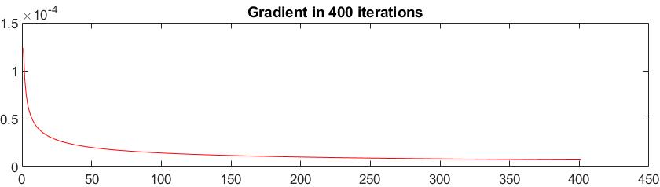

Fig.x Gradient descent without straightness term

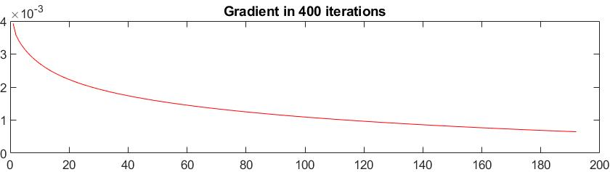

Fig.x Gradient descent with straightness term

## B. Buffer Band

Buffer band is introduced to avoid explode gradient problem and keep the validity of collision free status. As is shown in Fig. x, gradient of smoothness term explodes if a big step size is selected, thus the optimized trajectory becomes unreasonable. We use buffer band to avoid gradient explode. As is shown in Fig. x, algorithm is stopped if the points of optimized trajectory move out of the range of buffer band.

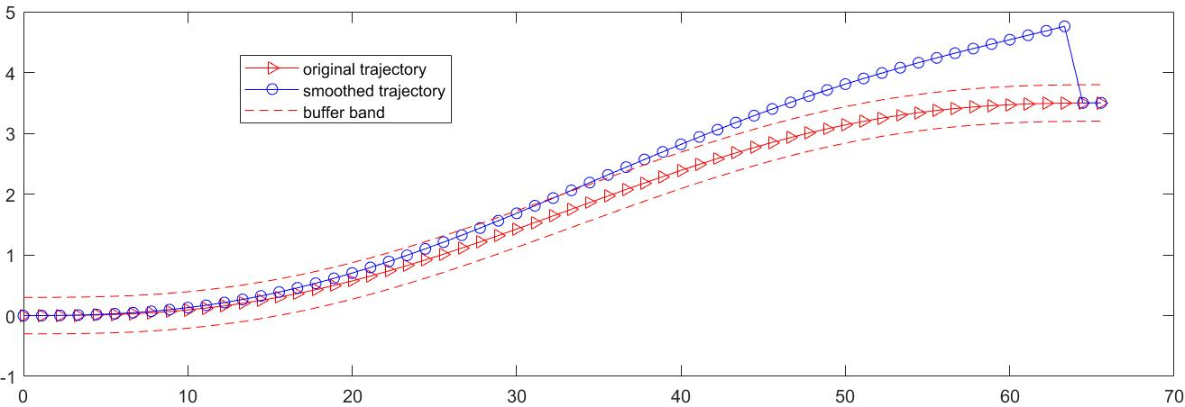

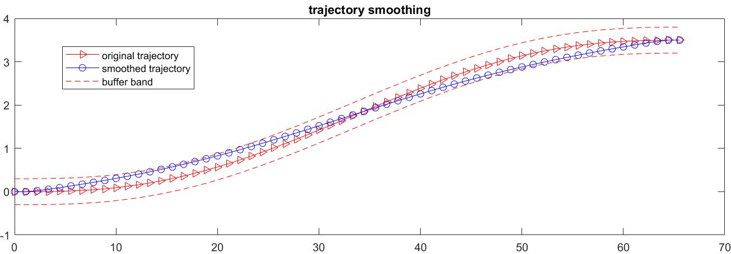

Fig.x:

## C. Variable Penalty Weights

To overcome the problem of abrupt different of heading angle close to the initial and terminal points, we prevent points close to the initial and terminal locations of the trajectory from moving considerably. The gradient descent step size is modified as a variable parameter with Gaussian distribution. This variable parameter controls the step size with respect to the point index. As a result, points near the initial and terminal points have smaller gradient descent step size, thus moving less compared to those points far from the initial and terminal points. The Gaussian distribution is shown in Fig. x.

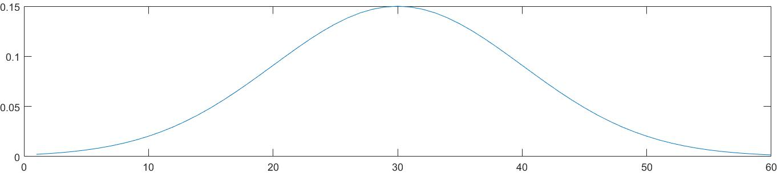

Fig. x: step size with Gaussian distribution

## D. Gradient Descent

The gradient of each term is as follows:

1). **The derivative of smoothness term**

2). **The derivative of straightness term**

**3). The derivative of curvature term**

The partial derivative of with respect to is

Where is the angle between and

The detail of derivation of can be find in [xxx].

|  |  |
| --- | --- |
| **Algorithm 1**: Gradient Descent Algorithm | |
| **Variable:** | |
| id: trajectory index.  : gradient of trajectory points.  : the maximum absolute value of trajectory curvature  : the maximum absolute value of offset between original trajectory and smoothed trajectory | |
| **Parameters:** | |
| : gradient descent step size of smoothness term.  : gradient descent step size of straightness term.  : gradient descent step size of curvature term.  : the standard deviation of Gaussian distribution.  *L*: the length of trajectory points.  *P*: original trajectory points [].  MAX_ITER: maximum iteration number  *B*: buffer band.  : satisfactory curvature. | |
| 1 | *COND 1* |
| 2 | **While** *COND = 1* **do** |
| 3 | **for** all **do** |
| 4 |  |
| 5 | *GaussianDistribution (id, , L)* |
| 6 |  |
| 7 |  |
| 8 |  |
| 9 |  |
| 10 |  |
| 11 | **end for** |
| 12 |  |
| 13 | **if**  *MAX_ITER* **then** |
| 14 | *COND 2* |
| 15 | **break** |
| 16 | **if** **then** |
| 17 | *COND 3* |
| 18 | **break** |
| 19 | **if** *B* **then** |
| 20 | *COND 4* |
| 21 | **break** |
| 22 | **end while** |

## E. Smoothing results

We use the same test parameters as section A to see the performance of DBTO. In Fig. x, the optimized trajectory is well improved in terms of heading angle and curvature. The maximum heading angle is reduced from 5.618 deg to 4.194 deg, and the maximum curvature is reduced from 0.004528 to 0.002 .

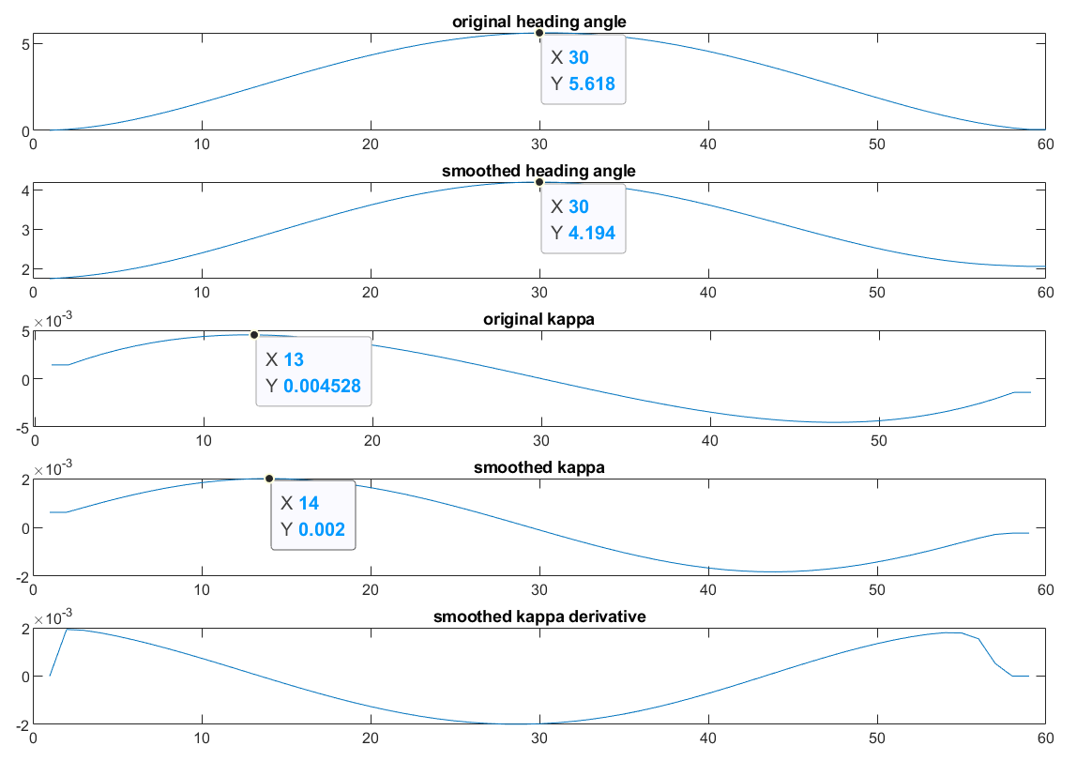

Fig. x: variable step size with Gaussian distribution ensures the continuity of optimized heading angle close to initial and terminal positions of original trajectory. The continuity of change rate of curvature is still guaranteed after trajectory smoothing.

# experimental results

After the text edit has been completed, the paper is ready for the template. Duplicate the template file by using the Save As command, and use the naming convention prescribed by your conference for the name of your paper. In this newly created file, highlight all the contents and import your prepared text file. You are now ready to style your paper; use the scroll down window on the left of the MS Word Formatting toolbar.

## A. Authors and Affiliations

The template is designed so that author affiliations are not repeated each time for multiple authors of the same affiliation.

## B. Identify the Headings

Headings, or heads, are organizational devices that guide the reader through your paper. There are two types: component heads and text heads.

Text heads organize the topics on a relational, hierarchical basis. For example, the paper title is the primary text head because all subsequent material relates and elaborates on this one topic. If there are two or more sub-topics, the next level head (uppercase Roman numerals) should be used and, conversely, if there are not at least two sub-topics, then no subheads should be introduced. Styles named “Heading 1”, “Heading 2”, “Heading 3”, and “Heading 4” are prescribed.

## C. Figures and Tables

### Positioning Figures and Tables: Place figures and tables at the top and bottom of columns. Avoid placing them in the middle of columns. Large figures and tables may span across both columns. Figure captions should be below the figures; table heads should appear above the tables. Insert figures and tables after they are cited in the text. Use the abbreviation “Fig. 1”, even at the beginning of a sentence.

1. Table Type Styles

| Table Head | Table Column Head | | |
| --- | --- | --- | --- |
| Table column subhead | Subhead | Subhead |
| copy | More table copya |  |  |

a. Sample of a Table footnote. (Table footnote)

1. Example of a figure caption. *(figure caption)*

# Conclusion

A conclusion section is not required. Although a conclusion may review the main points of the paper, do not replicate the abstract as the conclusion. A conclusion might elaborate on the importance of the work or suggest applications and extensions.

Appendix I

For any combination of and , the quintic polynomial constraints are defined as: = [,, , ] and [], we can get a close form solution for the polynomial parameters. At the starting point , we have:

At the end point , we have:

For convenience, let us always assume that . The six parameters can be solved as follow:

,,and can be calculated by solving the following matrix function:

where

.

For any combination of and , the quantic polynomial constraints are defined as: = [,, , ] and [], we can get a close form solution for the polynomial parameters. At the starting point , we have:

At the end point , we have:

For convenience, let us always assume that . The five parameters can be solved as follow:

where

.

Appendix I

References

1. G. O. Young, “Synthetic structure of industrial plastics (Book style with paper title and editor),” in *Plastics*, 2nd ed. vol. 3, J. Peters, Ed. New York: McGraw-Hill, 1964, pp. 15–64.
2. W.-K. Chen, *Linear Networks and Systems* (Book style)*.* Belmont, CA: Wadsworth, 1993, pp. 123–135.
3. H. Poor, *An Introduction to Signal Detection and Estimation*. New York: Springer-Verlag, 1985, ch. 4.
4. B. Smith, “An approach to graphs of linear forms (Unpublished work style),” unpublished.
5. E. H. Miller, “A note on reflector arrays (Periodical style—Accepted for publication),” *IEEE Trans. Antennas Propagat.*, to be published.
6. J. Wang, “Fundamentals of erbium-doped fiber amplifiers arrays (Periodical style—Submitted for publication),” *IEEE J. Quantum Electron.*, submitted for publication.
7. C. J. Kaufman, Rocky Mountain Research Lab., Boulder, CO, private communication, May 1995.

We suggest that you use a text box to insert a graphic (which is ideally a 300 dpi TIFF or EPS file, with all fonts embedded) because, in an MSW document, this method is somewhat more stable than directly inserting a picture.

To have non-visible rules on your frame, use the MSWord “Format” pull-down menu, select Text Box > Colors and Lines to choose No Fill and No Line.

1. Y. Yorozu, M. Hirano, K. Oka, and Y. Tagawa, “Electron spectroscopy studies on magneto-optical media and plastic substrate interfaces(Translation Journals style),” *IEEE Transl. J. Magn.Jpn.*, vol. 2, Aug. 1987, pp. 740–741 [*Dig. 9th Annu. Conf. Magnetics* Japan, 1982, p. 301].
2. M. Young, *The Techincal Writers Handbook.* Mill Valley, CA: University Science, 1989.
3. J. U. Duncombe, “Infrared navigation—Part I: An assessment of feasibility (Periodical style),” *IEEE Trans. Electron Devices*, vol. ED-11, pp. 34–39, Jan. 1959.
4. S. Chen, B. Mulgrew, and P. M. Grant, “A clustering technique for digital communications channel equalization using radial basis function networks,” *IEEE Trans. Neural Networks*, vol. 4, pp. 570–578, July 1993.
5. R. W. Lucky, “Automatic equalization for digital communication,” *Bell Syst. Tech. J.*, vol. 44, no. 4, pp. 547–588, Apr. 1965.
6. S. P. Bingulac, “On the compatibility of adaptive controllers (Published Conference Proceedings style),” in *Proc. 4th Annu. Allerton Conf. Circuits and Systems Theory*, New York, 1994, pp. 8–16.
7. G. R. Faulhaber, “Design of service systems with priority reservation,” in *Conf. Rec. 1995 IEEE Int. Conf. Communications,* pp. 3–8.
8. W. D. Doyle, “Magnetization reversal in films with biaxial anisotropy,” in *1987 Proc. INTERMAG Conf.*, pp. 2.2-1–2.2-6.
9. G. W. Juette and L. E. Zeffanella, “Radio noise currents n short sections on bundle conductors (Presented Conference Paper style),” presented at the IEEE Summer power Meeting, Dallas, TX, June 22–27, 1990, Paper 90 SM 690-0 PWRS.
10. J. G. Kreifeldt, “An analysis of surface-detected EMG as an amplitude-modulated noise,” presented at the 1989 Int. Conf. Medicine and Biological Engineering, Chicago, IL.
11. J. Williams, “Narrow-band analyzer (Thesis or Dissertation style),” Ph.D. dissertation, Dept. Elect. Eng., Harvard Univ., Cambridge, MA, 1993.
12. N. Kawasaki, “Parametric study of thermal and chemical nonequilibrium nozzle flow,” M.S. thesis, Dept. Electron. Eng., Osaka Univ., Osaka, Japan, 1993.
13. J. P. Wilkinson, “Nonlinear resonant circuit devices (Patent style),” U.S. Patent 3 624 12, July 16, 1990.

1. All Authors are will Shanghai Automotive Industry Corporation, Ltd. 201, Anyan Road, Jiading, Shanghai, China. [jiangyuncheng@saicmotor.com](mailto:jiangyuncheng@saicmotor.com), [jiangyuncheng@saicmotor.com](mailto:jiangyuncheng@saicmotor.com), [jiangyuncheng@saicmotor.com](mailto:jiangyuncheng@saicmotor.com), [jiangyuncheng@saicmotor.com](mailto:jiangyuncheng@saicmotor.com), [jiangyuncheng@saicmotor.com](mailto:jiangyuncheng@saicmotor.com),