(1)



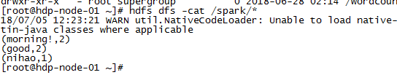

(2)

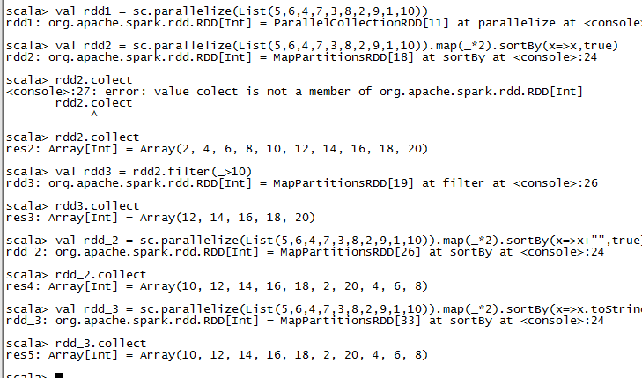

(3)

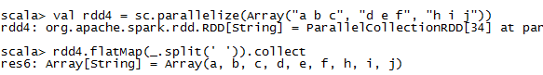

(4)

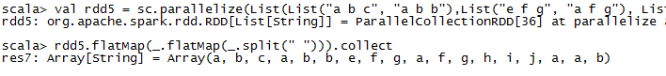

(5)

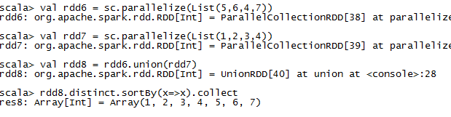

(6)

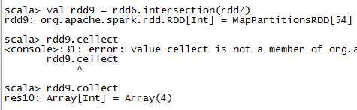

(7)

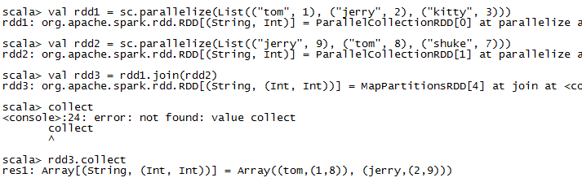

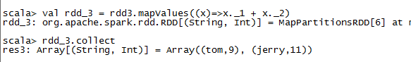

(8)

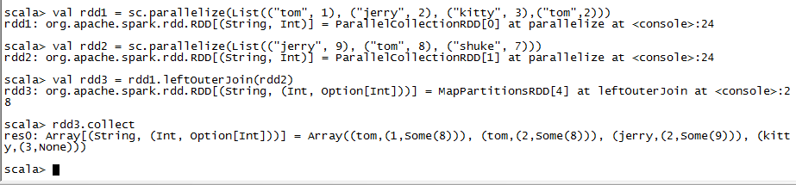

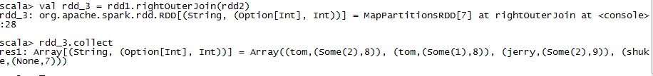

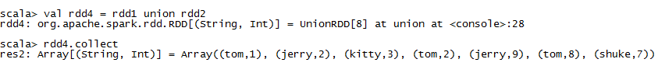



(9)

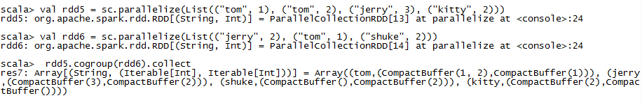

(10)

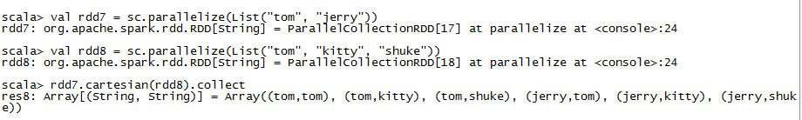

(11)

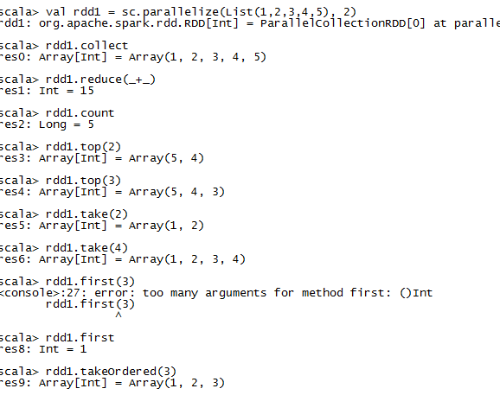

1. mapPartitionsWithIndex

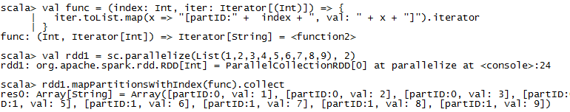

(13)aggregate

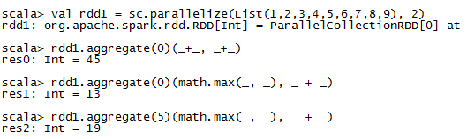

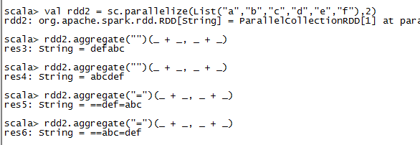

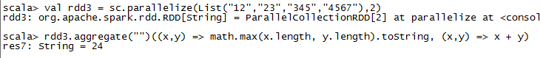

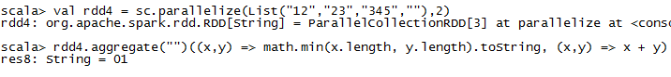

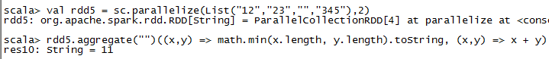

(14)aggregateByKey

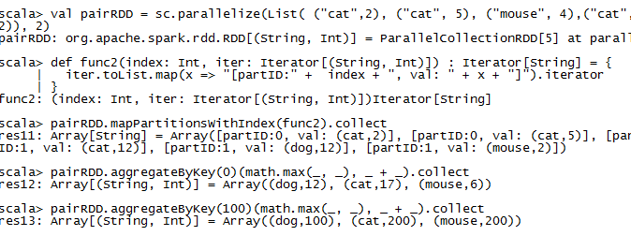

(14)checkpoint

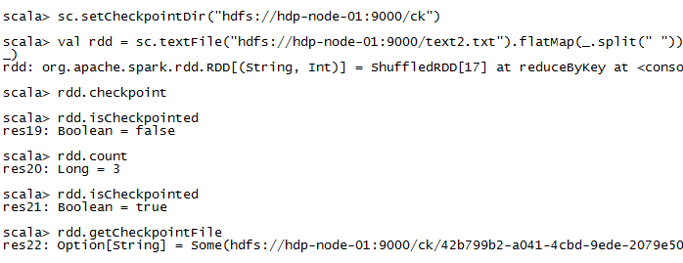

1. coalesce

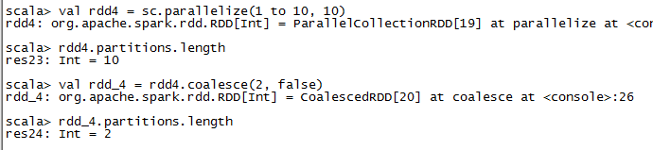

(16)combineByKey

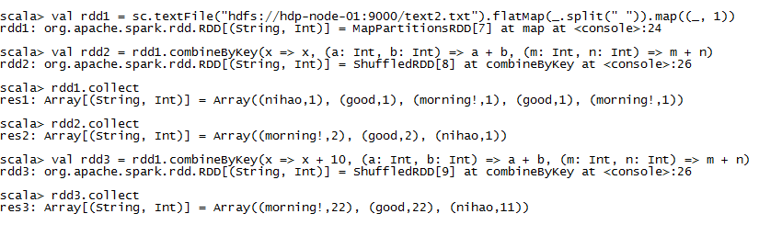

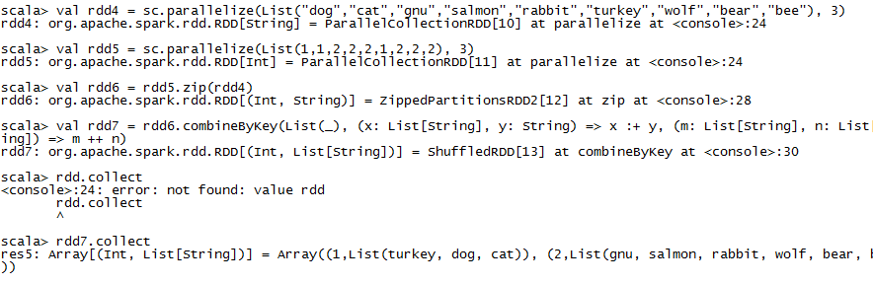

(17)countByKey

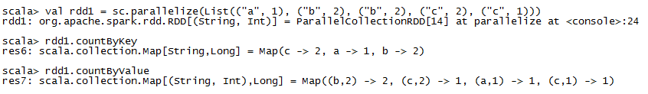

(18)filterByRange

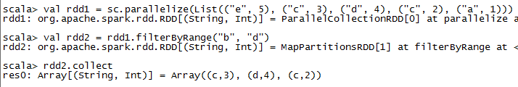

1. flatMapValues

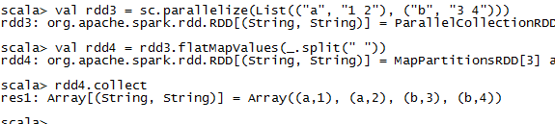

1. foldByKey

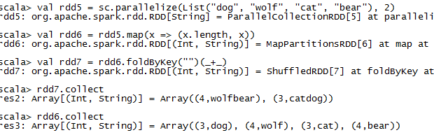

1. foreachPartition

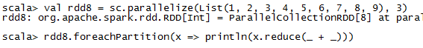

(22)keyBy

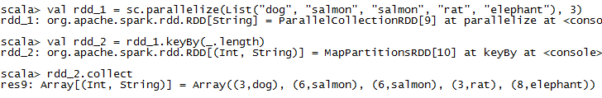

(23)keys values

