Array:
import Array._
object array {
def main(args: Array[String]): Unit = {
var arr = Array.iterate(0,3)(a=>a+1) //1
println(arr.length) //2
println(arr.toBuffer) //3
var arr2=arr.map((x:Int)=>x+3) //4
println(arr2.toBuffer)
println( concat(arr, arr2 ).toBuffer ) //5
}
}

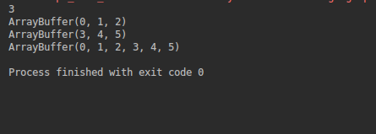

Map:
import scala.collection.mutable.Map
object map {
def main(args: Array[String]): Unit = {
var map = Map('a' -> 1, 'b' -> 1)
println(map)
println(map.empty) //1
println( map.contains( 'a' ) ) //2
map.put('c', 3) // 3
println(map)
println(map.isEmpty) //4
map += ('d' -> 4)
map ++= Map('e' -> 5)
println(map)
}
}

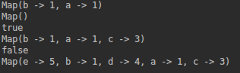
Set:
object set {
def main(args: Array[String]): Unit = {
val set = Set(0, 1, 2)
println(set.head)
println(set.tail)
println(set.isEmpty)
println(set.min)
println(set.max)
}
}

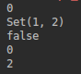

Tupple元组： 元组的方法很少，因为元组内的类型可以是混着的
object tupple {
def main(args: Array[String]): Unit = {
var t = (1, 3.14, "pai")
println(t)
println(t.toString()) //1
println(t._1 + t._2) //2
val t2 = new Tuple2("www.google.com", "www.runoob.com") //3
println("交换后的元组: " + t2.swap ) //4
val t3 = new Tuple3(1, "hello", Console //5
}
}

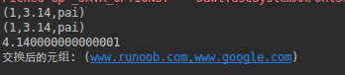

List：
object list {
def main(args: Array[String]): Unit = {
val nums: List[Int] = List(1, 2, 3, 4)
println(nums.min) //1
println(nums.max) //2
println( nums.mkString("{",",","}") ) //3
println(nums.drop(1)) //4
println(nums)
val nums2 = List.fill(10)(2)
println(nums2)
}
}

