作业：1/统计每一个用户（手机号）所耗费的总上行流量、下行流量，总流量

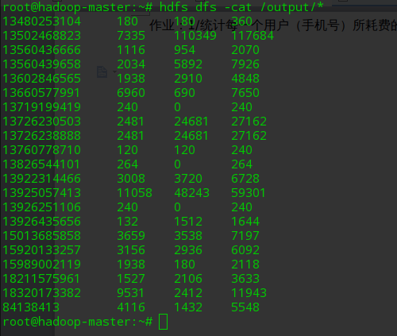

import java.lang.Iterable
import java.io.{DataInput, DataOutput, IOException}
import java.net.URI
import org.apache.hadoop.conf.Configuration
import org.apache.hadoop.fs.{FileSystem, Path}
import org.apache.hadoop.io.{ LongWritable, Text}
import org.apache.hadoop.mapreduce.{Job, Mapper, Reducer}
import org.apache.hadoop.mapreduce.lib.input.FileInputFormat
import org.apache.hadoop.mapreduce.lib.output.FileOutputFormat
import org.apache.hadoop.io.WritableComparable
object flowControl {
class Flow extends WritableComparable[Flow] {
private var upFlow,downFlow,sumFlow : Int = 0
def this(upFlow:Int, downFlow:Int) {
this()
this.upFlow = upFlow
this.downFlow = downFlow
this.sumFlow = upFlow+downFlow
}
def compareTo(o: Flow): Int = {
return if (this.sumFlow > o.sumFlow) -1 else 1
}
@throws[IOException] //没有进行处理，所以才会告知抛出
def readFields(dataInput: DataInput): Unit = {
this.upFlow = dataInput.readInt
this.downFlow = dataInput.readInt
this.sumFlow = upFlow+downFlow
}
@throws[IOException]
def write(dataOutput: DataOutput): Unit = {
dataOutput.writeInt(this.upFlow)
dataOutput.writeInt(this.downFlow)
dataOutput.writeInt(this.sumFlow)
}
def +=(other: Flow): Unit = {
this.upFlow += other.upFlow
this.downFlow += other.downFlow
this.sumFlow += other.sumFlow
}
override def toString: String = {
return upFlow+"\t"+downFlow+"\t"+sumFlow
}
}
//keyIn的类型还可以是Object
class flowControlMapper extends Mapper[LongWritable, Text, Text, Flow] {
override def map(key: LongWritable, value: Text, context: Mapper[LongWritable, Text, Text, Flow]#Context) {
try {
val words = value.toString().split("\t")
val flow = new Flow(words(words.length-3).toInt, words(words.length-2).toInt)
context.write(new Text(words(1)), flow)
}
catch {
case e: Exception => e.printStackTrace()
}
}
}
class flowControlReducer extends Reducer[Text, Flow, Text, Text]{
override def reduce(key: Text, value: Iterable[Flow], context: Reducer[Text, Flow, Text, Text]#Context) {
try {
var result = new Flow(0,0)
value.forEach(result.+=)
context.write(key, new Text(result.toString))
println(key.toString+"\t"+result.toString)
}
catch {
case e: Exception => e.printStackTrace()
}
}
}
def main(args: Array[String]) {
val conf = new Configuration()
val job = Job.getInstance(conf)
job.setJobName("flowControl-vega")
//如果是打包成jar文件，那么下面就需要
//job.setJarByClass(this.getClass)
FileInputFormat.addInputPath(job, new Path(classOf[Nothing].getClassLoader.getResource("flow.log").getPath()))
FileOutputFormat.setOutputPath(job, new Path("hdfs://172.18.0.2:9000/output"))//如何setOutputPath是向文件末尾增加内容
//设置Map,Combine,Reduce处理类
job.setMapperClass(classOf[flowControl.flowControlMapper])
// job.setCombinerClass(classOf[flowControl.flowControlReducer])
job.setReducerClass(classOf[flowControl.flowControlReducer])
//设置输出类型
job.setMapOutputKeyClass(classOf[Text])
job.setMapOutputValueClass(classOf[Flow])
job.setOutputKeyClass(classOf[Text])
job.setOutputValueClass(classOf[Text])
//delete exists dir
deleteOutDir(conf, "hdfs://172.18.0.2:9000/output")
System.exit(if (job.waitForCompletion(true)) 0 else 1)
}
private def deleteOutDir(configuration: Configuration, outUrl: String): Unit = {
val fileSystem = FileSystem.get(new URI(outUrl), configuration)
if (fileSystem.exists(new Path(outUrl))) fileSystem.delete(new Path(outUrl), true)
}
}

作业二：得出上题结果的基础之上再加一个需求：将统计结果按照总流量倒序排序
将Flow作为key，借助Flow的compareTo实现倒排

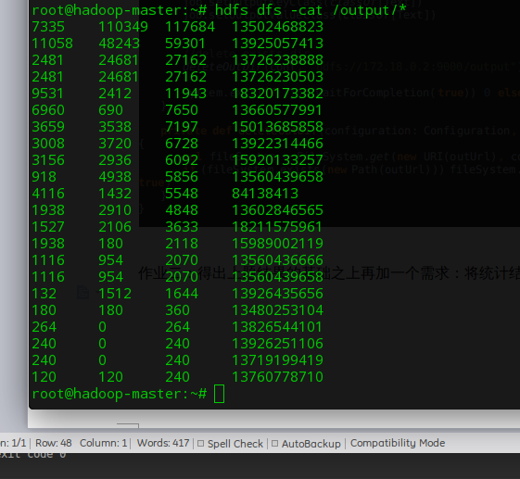

import java.lang.Iterable
import java.io.{DataInput, DataOutput, IOException}
import java.net.URI
import org.apache.hadoop.conf.Configuration
import org.apache.hadoop.fs.{FileSystem, Path}
import org.apache.hadoop.io._
import org.apache.hadoop.mapreduce.{Job, Mapper, Reducer}
import org.apache.hadoop.mapreduce.lib.input.FileInputFormat
import org.apache.hadoop.mapreduce.lib.output.FileOutputFormat
object flowControl {
class Flow extends WritableComparable[Flow] {
var upFlow,downFlow,sumFlow : Int = 0
def this(upFlow:Int, downFlow:Int) {
this()
this.upFlow = upFlow
this.downFlow = downFlow
this.sumFlow = upFlow+downFlow
}
def compareTo(o: Flow): Int = if (this.sumFlow > o.sumFlow) -1 else 1
@throws[IOException] //没有进行处理，所以才会告知抛出
def readFields(dataInput: DataInput): Unit = {
this.upFlow = dataInput.readInt
this.downFlow = dataInput.readInt
this.sumFlow = upFlow+downFlow
}
@throws[IOException]
def write(dataOutput: DataOutput): Unit = {
dataOutput.writeInt(this.upFlow)
dataOutput.writeInt(this.downFlow)
dataOutput.writeInt(this.sumFlow)
}
def +=(other: Flow): Unit = {
this.upFlow += other.upFlow
this.downFlow += other.downFlow
this.sumFlow += other.sumFlow
}
override def toString: String = upFlow+"\t"+downFlow+"\t"+sumFlow
}
// class FlowWritableDecreasingComparator extends Text.Comparator {
//
// }
//keyIn的类型还可以是Object
class FlowControlMapper extends Mapper[LongWritable, Text, Flow, Text ] {
override def map(key: LongWritable, value: Text, context: Mapper[LongWritable, Text, Flow, Text]#Context) {
try {
val words = value.toString().split("\t")
val flow = new Flow(words(words.length-3).toInt, words(words.length-2).toInt)
context.write(flow, new Text(words(1)))
} catch {
case e: Exception => e.printStackTrace()
}
}
}
class FlowControlReducer extends Reducer[Flow, Text, Text, Text]{
override def reduce(key: Flow, value: Iterable[Text], context: Reducer[Flow, Text, Text, Text]#Context) {
try {
context.write( new Text(key.toString),value.iterator.next)
} catch {
case e: Exception => e.printStackTrace()
}
}
}
def main(args: Array[String]) {
val conf = new Configuration()
val job = Job.getInstance(conf)
job.setJobName("flowControl-vega")
// job.setNumReduceTasks(1)
//如果是打包成jar文件，那么下面就需要
//job.setJarByClass(this.getClass)
FileInputFormat.addInputPath(job, new Path(classOf[Nothing].getClassLoader.getResource("flow.log").getPath()))
FileOutputFormat.setOutputPath(job, new Path("hdfs://172.18.0.2:9000/output"))//如何setOutputPath是向文件末尾增加内容
//设置Map,Combine,Reduce处理类
job.setMapperClass(classOf[flowControl.FlowControlMapper])
// job.setCombinerClass(classOf[flowControl.flowControlReducer])
// job.setSortComparatorClass(classOf[FlowWritableDecreasingComparator])
job.setReducerClass(classOf[flowControl.FlowControlReducer])
//设置输出类型
job.setMapOutputKeyClass(classOf[Flow])
job.setMapOutputValueClass(classOf[Text])
job.setOutputKeyClass(classOf[Text])
job.setOutputValueClass(classOf[Text])
//delete exists dir
deleteOutDir(conf, "hdfs://172.18.0.2:9000/output")
System.exit(if (job.waitForCompletion(true)) 0 else 1)
}
private def deleteOutDir(configuration: Configuration, outUrl: String): Unit = {
val fileSystem = FileSystem.get(new URI(outUrl), configuration)
if (fileSystem.exists(new Path(outUrl))) fileSystem.delete(new Path(outUrl), true)
}
}

作业三 将统计结果按照手机归属地不同省份输出到不同文件中
class PhonePartitioner extends Partitioner[Text,Flow] {
def getPartition(key: Text, value: Flow, numPartitions: Int): Int = {
}
}

没有要求，介绍思路，手机前几位表示不同省份，对前几位按照PhonePartitioner类，划分到不同的Partition中即可。

