Multi-player Snake Game

User Manual
Rachkovska Ievgeniia, Prokop Artem

Main menu
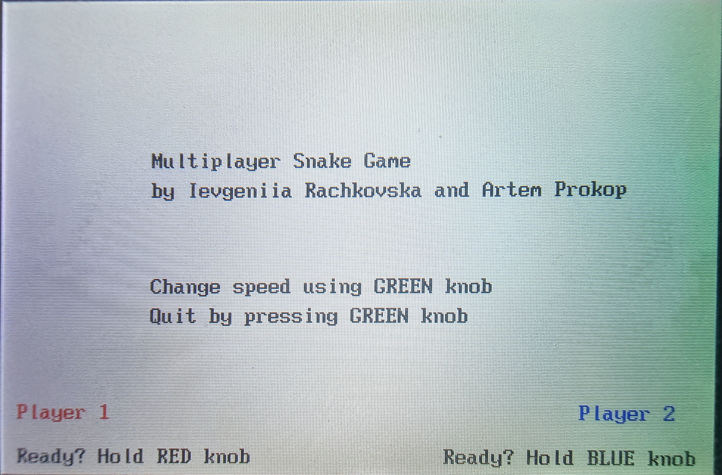
Main menu allows the user to set speed and start the game.

Controls
- Control speed: rotate Green Knob
- Set player 1 ready: hold Red Knob
- Set player 2 ready: hold Blue Knob
- Quit: press Green Knob

Game Lifecycle
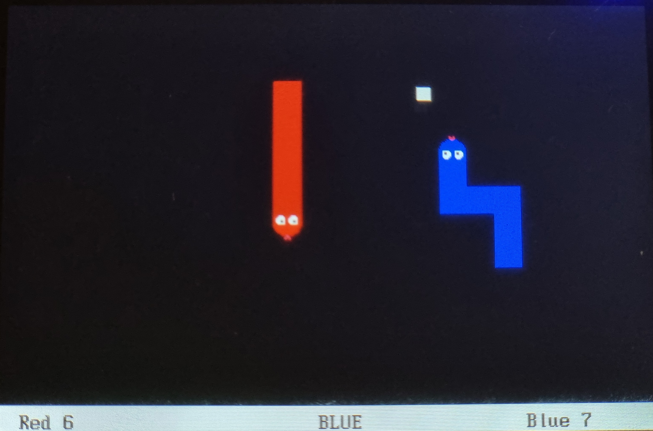
"Snake" for two players, i.e. there are two snakes in the game, each for one of the players. The goal of the player is to control their snake so that it collects as much food as possible to achieve a higher score than opponent.

Controls
- Change direction for snake 1 (left): rotate Red Knob
- Change direction for snake 2 (right): rotate Blue Knob
The snake can only move up, down, left and right. The knob can be turned one degree to the left or right. If the position of the knob does not change, the snake continues in the previous direction.

Positions
- Snake 1 (left) starting position: top left
- Snake 2 (right) starting position: bottom right
There is always one piece of food on the screen, represented by a white square.
The snake eats this piece at the moment when snake's head touches it. Eating food increases the player's score by 1 and a new piece of food appears on the screen at a random position.

Score
Score of each snake equals to number of eaten fruits (which is the same as length of the snake). Score is also affected by penalties and bonuses (see «Game Over» chapter).

Game Over
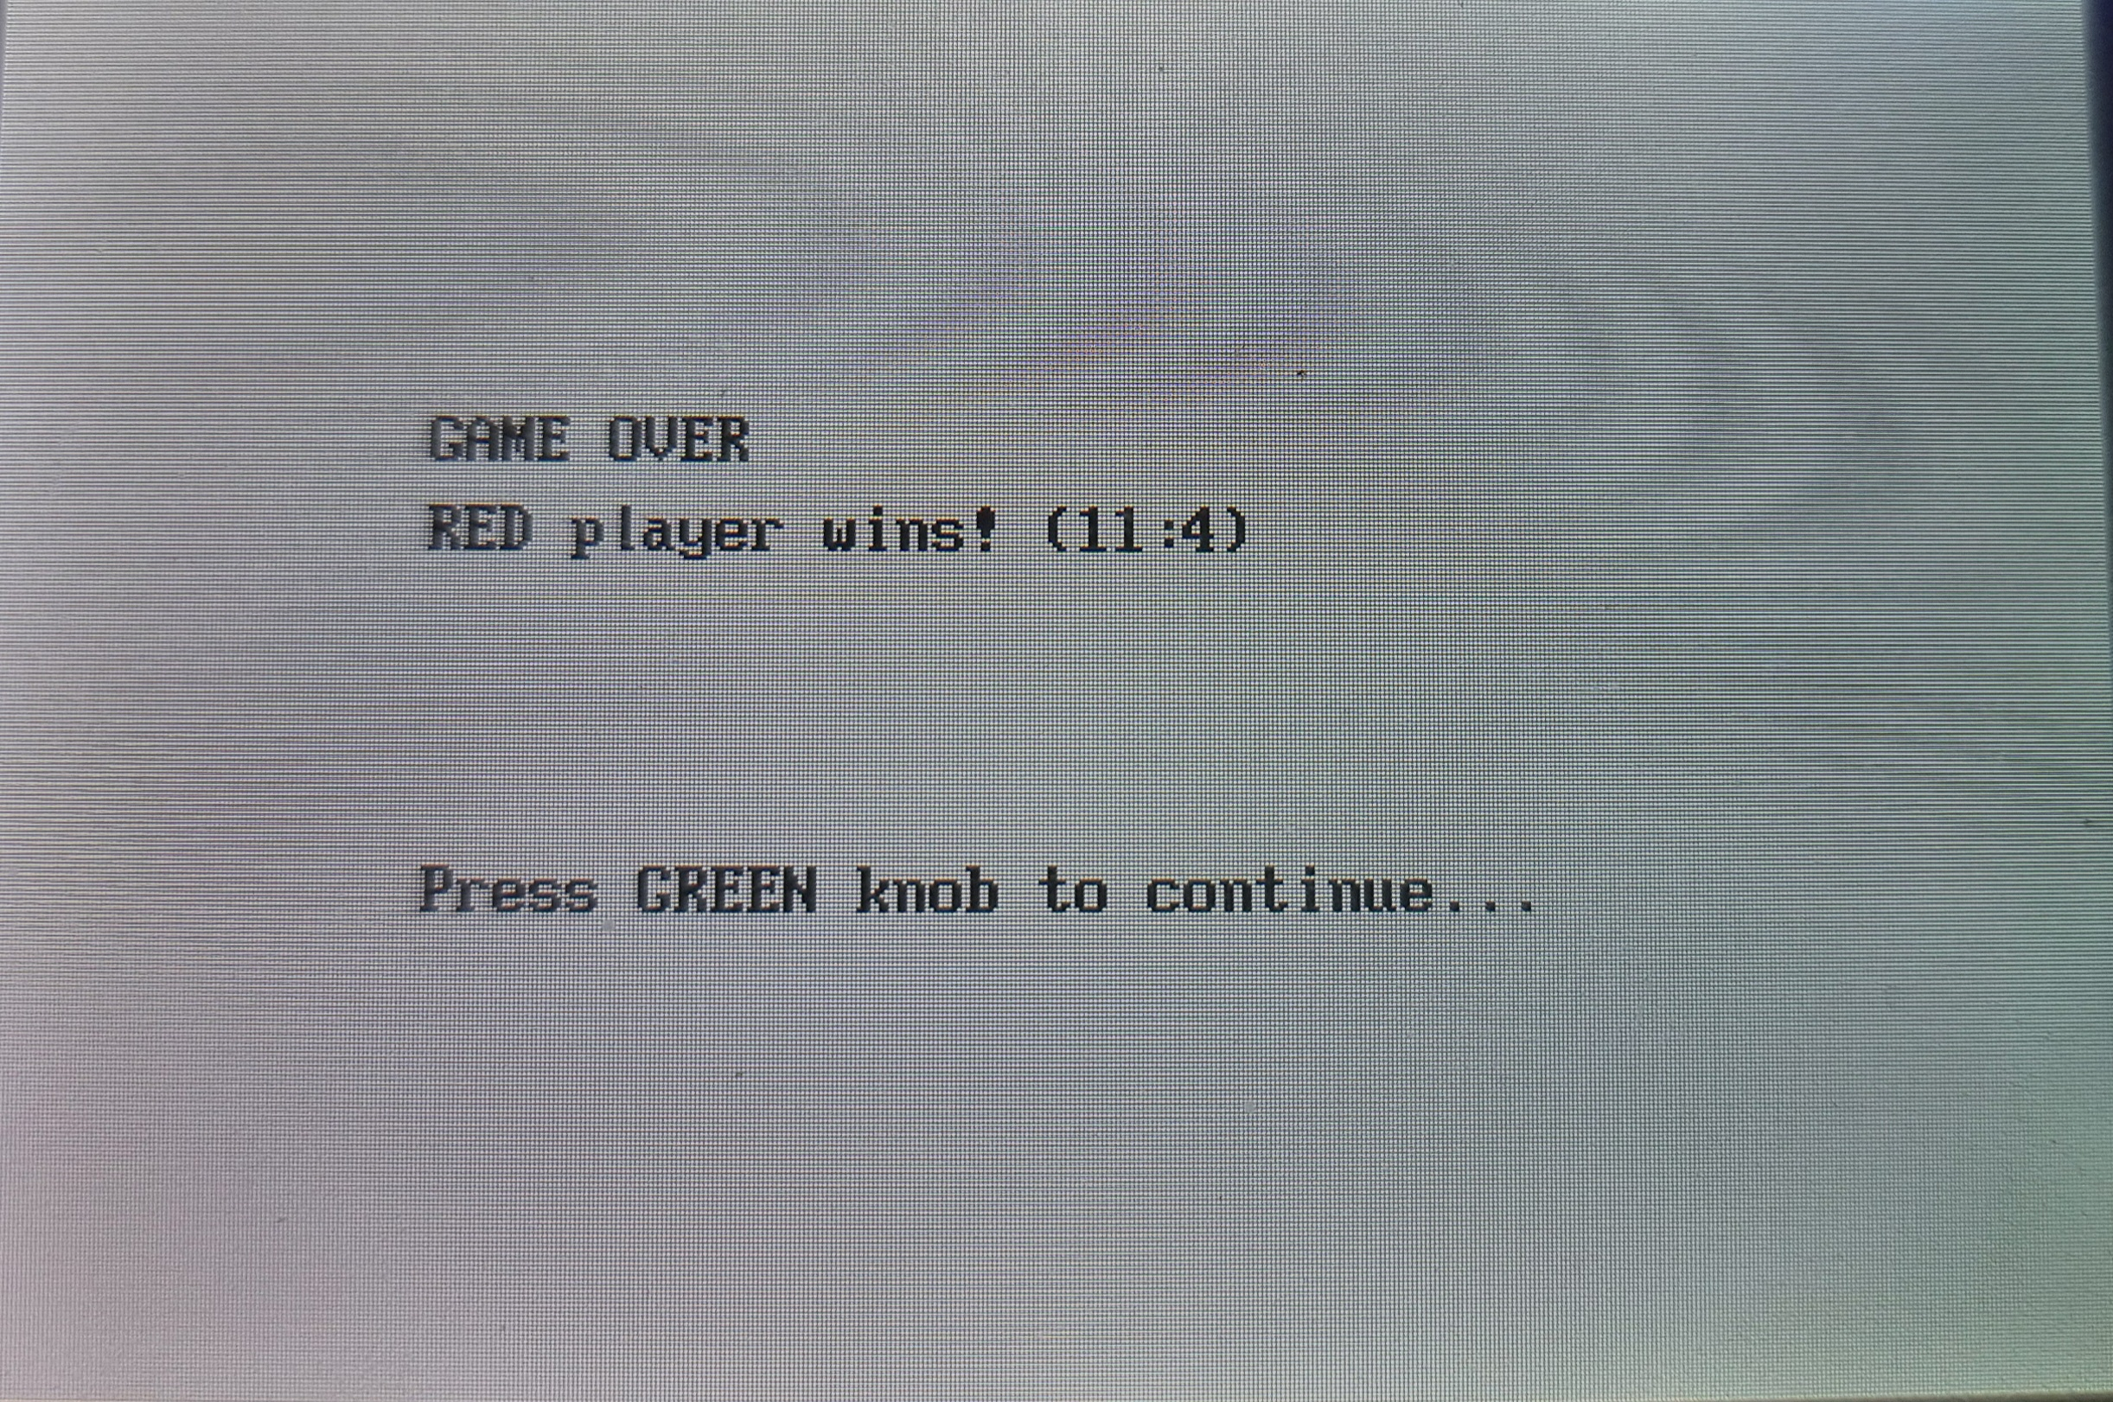
The game ends when one snake bumps into another one. The crashed snake gets -10 score points penalty and the snake which crashed another one gets +5 score points bonus.
The game is won by the player who has achieved a higher score during the game, including penalty and a bonus.
After snake crash, Game Over screen will appear. The final scores will be displayed there.

Buttons
• Continue: Green Knob

