Generating ECAD Manufacturing Files

# Requirements:

KiCAD 5.1.0 or above

# Prerequisite:

Make sure that the PCB you intend to create manufacturing files for is finished and reviewed. Every time there are changes on the PCB, the manufacturing files have to be re-generated.

# Manufacturing Files:

## Gerber Files

|  |  |  |
| --- | --- | --- |
| Gerber File | Purpose | Description |
| xyz.F_CU.grb | Front side copper | Copper pads |
| xyz.B_CU.grb | Back side copper | Copper pads |
| xyz.F_Mask.grb | Front side mask | Solder mask. A thin lacquer layer. |
| xyz.B_Mask.grb | Back side mask | Solder mask. A thin lacquer layer. |
| xyz.F_Paste.grb | Front side soldering paste | The solder paste for the components (only needed for machine PCB manufacturing) |
| xyz.B_Paste.grb | Back side soldering paste | The solder paste for the components (only needed for automated SMD production) |
| xyz.F_SilkS.grb | Front side Silk Screen | All the markings, including text. |
| xyz.B_SilkS.grb | Back side Silk Screen | All the markings, including text. |
| xyz.Edge_Cuts.grb | Edge Cuts | The outline of the PCB. For CNC cutting. |
| xyz.PTH.grb | Plated through holes | Holes in the PCB who are plated. Like vias or THT component holes for example. |
| xyz.NPTH.grb | Non plated through holes | Holes without plating. Like mounting holes for screws. |

Table

## Pick and Place data.

Normally *.csv files. One for the front and one for the back. Those files include all the SMD components and their exact location and rotation. Only needed for automated SMD production.

## Bill of Material (BOM)

Bill of Material with all the needed components.

# Process:

## Gerber Files:

* Open the PCB you want to create the Manufacturing Files for, in KiCAD’s Pcbnew.
* Select “Plot” from the “File” menu.
* In the included Layers you need: F.Cu, B.Cu, F.Paste, B.Paste, F.SilkS, B.SilkS, F.Mask, B.Mask and Edge.Cuts.
* Set the Output directory to where you want the files to be created.
* Set the rest of the options as followed:

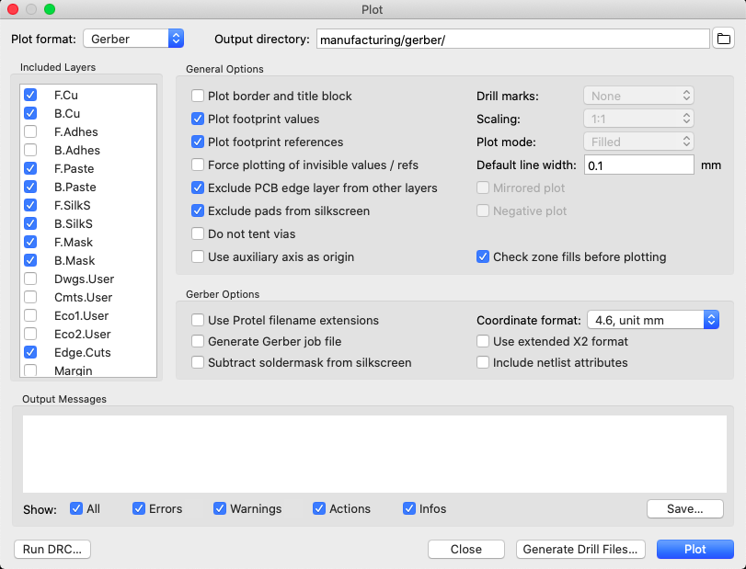

Figure

* Press “Plot”
* If you get asked to refill the zone-fills, because they are out of date, do so.
* KiCAD now generates all the gerber files and stores them in the above specified path.
* Now press “Generate Drill Files”
* Set the Output directory to where you want the files to be created.
* Set the rest of the options as followed:
* (Change Drill unit to Inches, if you need imperial measurements).

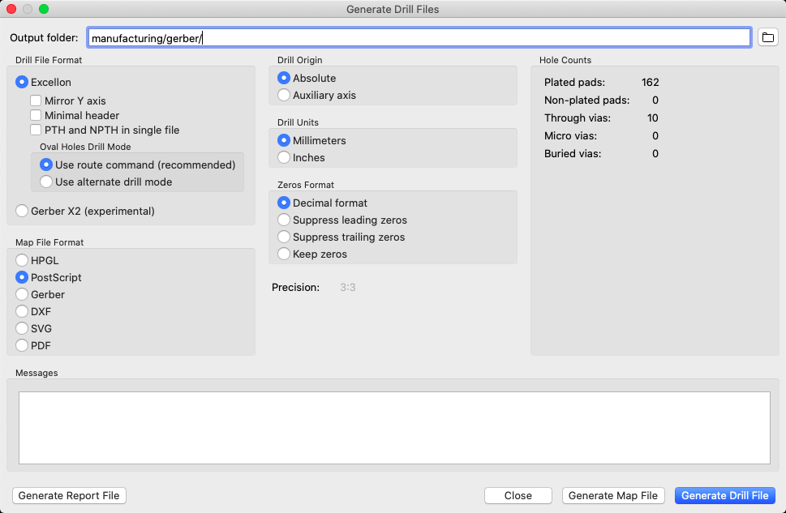

Figure

* KiCAD now generates the PTH and NPTH files and stores them in the above specified path.
* You should now have a full set of Gerber files, ready to send to a PCB manufacturer.

## Pick and Place Files

* To generate the pick and place data, select “File” -> “Fabrication Outputs” -> “Footprint Position (.pos) File”
* Set the Output directory to where you want the files to be created.
* Set the options as follows:
* (Change Units to Inches if you need imperial measurements).

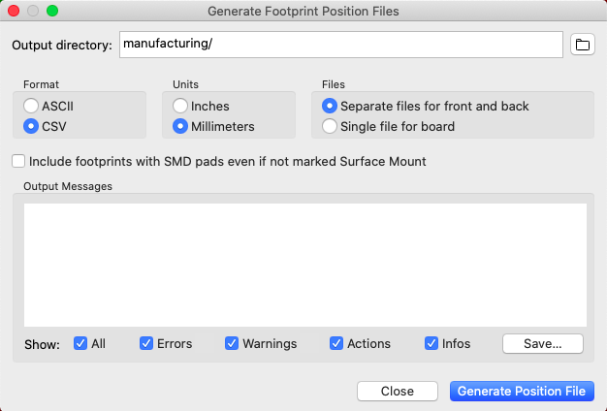

Figure

* Press “Generate Position Files”
* KiCAD now generates the Pick and Place files and stores them in the above specified path.

## BOM File

* Finally, to generate the BOM, select “File” -> “Fabrication Output” -> “BOM File”
* Select a location to save your BOM file and hit “Save”

# Addendum

* Depending on the manufacturer, you may have to change some titles in the Pick and Place files. For example, jlcpcb.com requires the titles to be “Designator”, “Mid X”, “Mid Y”, “Layer” and “Rotation”. You can open the *.csv files in every text editor. Or even better, in MS Excel. There you can change the tiles and save the file. The same may apply to the BOM.