Are you tired of having problems with relative paths?

Has Noctum broken your project file again?

Worry no more just follow these steps

Select configure paths on the application that is failing to load.

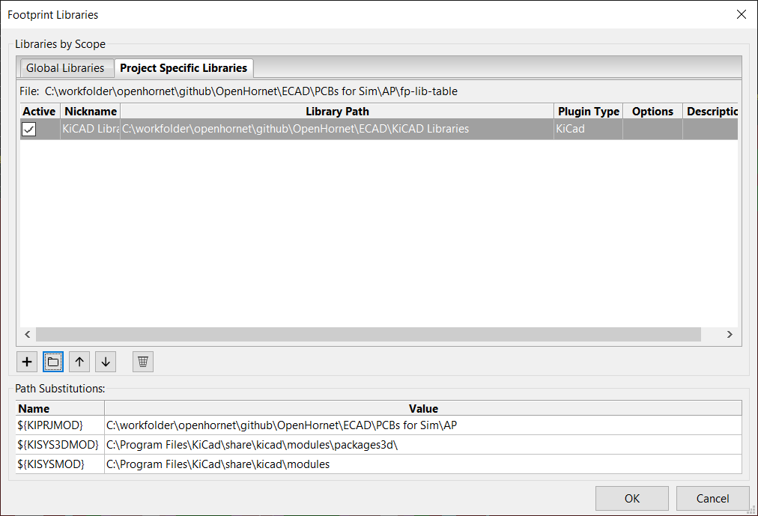

Replace the path with the appropriate path substitution from the same window.

