“Adaptive Traffic Signal Control System”

*Submitted in partial fulfillment of the requirements*

*For the degree of*

**Bachelor of Technology**

Computer Science & Engineering Department

Submitted By

**Drashya Sodha**

Under the Guidance of

**Dr. Deepa Parasar**

**\**

Acknowledgement

I would like to express my sincere gratitude to all those who have contributed to the successful completion of this Mini Project on "Adaptive Traffic Signal Control System." This endeavor would not have been possible without the support and guidance of several individuals and institutions.

I extend my heartfelt thanks to our esteemed Dr. Deepa Parasar, for their invaluable advice, encouragement, and continuous support throughout the project. Their expertise and insightful feedback were instrumental in shaping the direction of our research and enhancing the quality of our work.

Furthermore, I would like to express my appreciation to all the faculty members of the Amity School of Engineering and Technology for their constructive feedback and assistance at various stages of the project.

Finally, I am indebted to my peers and friends who offered their assistance and encouragement, making this collaborative effort a truly enriching experience.

Thank you all for your unwavering support and guidance.

Sincerely,

**Name : Drashya Sodha**

**INDEX**

|  |  |  |
| --- | --- | --- |
| **Sr. no.** | **Chapter Name** | **Pg. No.** |
| **1** | Introduction |  |
| **2** | Literature Survey |  |
| **3** | Proposed System   * 1. Scope   2. Objective   3. Work Flow Diagram   4. Description |  |
| **4** | Implementation Details  4.1 Data Flow Diagram  4.2 Software and Hardware Details |  |
| **5** | Results and Discussion |  |
| **6** | Conclusion & Future Scope |  |
|  | References |  |

**Chapter 1**

**Introduction**

The rapid increase in automobiles on roadways has naturally lead to traffic congestions all over the world, forcing drivers to sit idly in their cars wasting time and needlessly consuming fuel. Ride sharing and infrastructural improvements can help mitigate this but one of the key components to handling traffic congestion is traffic light timing. Traffic light control policies are often not optimized, leading to cars waiting pointlessly for nonexistent traffic to pass on the crossing road. We feel that traffic light control policy can be greatly improved by implementing machine learning concepts.

Our project focuses on implementing a learning algorithm that will allow traffic control devices to study traffic patterns/behaviors for a given intersection and optimize traffic flow by altering stoplight timing. We do this with a Q-Learning technique, similarly seen in previous works such as Gao et. al. and Genders et. al, where an intersection is knowledgeable of the presence of vehicles and their speed as they approach the intersection. From this information, the intersection is able to learn a set of state and action policies that allow traffic lights to make optimized decisions based on their current state. Our work seeks to alleviate traffic congestion on roads across the world by making intersections more aware of traffic presence and giving them the ability to take appropriate action to optimize traffic flow and minimize waiting time.

And Neural Networks have shown remarkable prowess in pattern recognition and decision-making tasks, making them ideal candidates for modeling the complex and dynamic nature of traffic patterns. By utilizing historical data and continuously learning from real-time inputs, Neural Networks can predict traffic conditions and optimize signal timings accordingly. This adaptability enables the system to respond promptly to changing traffic scenarios, reducing congestion and improving overall traffic efficiency.

In tandem with Neural Networks, Deep Q-Networks bring reinforcement learning into the fold. This approach allows traffic signal controllers to learn optimal actions through trial and error, adapting to the ever-evolving traffic dynamics. The utilization of Deep Q-Networks enables the system to make intelligent decisions based on a continuous feedback loop, optimizing signal timings based on learned experiences and maximizing traffic throughput.

Through a comprehensive examination of the adaptive traffic signal control system incorporating DQN, this report aims to shed light on the potential benefits, challenges, and implications of implementing such a solution. By understanding the intricate interplay between artificial intelligence and traffic management, city planners and transportation authorities can make informed decisions to enhance urban mobility and create more sustainable and livable cities.

**Background:**

To appreciate the revolutionary potential of an Adaptive Traffic Signal Control System, it is essential to understand the limitations of traditional, rule-based traffic signal control. These systems lack the flexibility to adapt to changing circumstances, relying on predetermined timings that may not align with the actual flow of traffic. Artificial Neural Networks offer a paradigm shift by emulating the human brain's neural structure and learning capabilities. ANNs excel in processing complex patterns and can make decisions based on learned experiences. By applying ANNs to traffic signal control, we can create systems that evolve and optimize traffic flow dynamically.

**Significance of the Project:**

The significance of this project extends beyond the immediate goal of alleviating traffic congestion. It addresses the pressing need for sustainable urban transportation solutions, contributing to the creation of smart cities. An Adaptive Traffic Signal Control System, powered by ANNs, has the potential to bring about transformative changes in how we manage traffic. The system's adaptability can lead to more efficient resource utilization, reduced carbon emissions, and improved overall quality of life in urban areas. As cities worldwide grapple with the challenges of increasing urbanization, the findings from this project can provide valuable insights into scalable solutions.

**Theoretical Foundations of Artificial Neural Networks:**

Before delving into the methodology, it is imperative to establish a solid understanding of the theoretical foundations of Artificial Neural Networks. ANNs are computational models inspired by the human brain's neural structure. Comprising interconnected nodes or neurons organized in layers, ANNs can process complex information through the application of mathematical functions. The learning process involves adjusting the synaptic weights between neurons based on training data, allowing the network to generalize and make predictions on new, unseen data. This inherent ability to learn and adapt forms the basis for their application in solving complex problems, such as predicting and optimizing traffic patterns.

The architecture of the neural network selected for this project will play a pivotal role. Recurrent Neural Networks (RNNs) or Long Short-Term Memory (LSTM) networks, known for their sequential learning capabilities, might be suitable for capturing the temporal dependencies inherent in traffic patterns. Convolutional Neural Networks (CNNs) could be explored if spatial features, such as the layout of intersections, are critical. The choice of the neural network architecture will depend on the specific characteristics of the traffic data and the desired outcomes of the Adaptive Traffic Signal Control System.

**Methodology:**

The methodology employed in this mini project is a multi-faceted approach encompassing data collection, model development, integration, and evaluation.

Data Collection: The foundation of the project lies in the quality and quantity of data. Historical traffic data, including vehicle counts, speeds, and flow rates, will be collected from relevant intersections. Additional contextual data, such as weather conditions and special events, may also be considered to enhance the model's adaptability.

Preprocessing: Raw data often requires preprocessing to ensure its compatibility with neural network models. This step involves data cleaning, normalization, and feature engineering. The goal is to create a dataset that captures the relevant patterns and variations in traffic conditions.

Model Development: The neural network model will be developed using a suitable architecture based on the characteristics of the traffic data. The model will undergo training using historical data, adjusting its weights to minimize prediction errors. Regularization techniques may be applied to prevent overfitting, ensuring the model's ability to generalize to new data.

Integration: Once the model is trained and validated, it will be integrated into the existing traffic signal control system. This integration involves creating a communication framework between the neural network model and the signal control infrastructure. Real-time data from traffic sensors will be fed into the model, and the optimal signal timings will be generated and communicated to the traffic signals.

Evaluation: The Adaptive Traffic Signal Control System's performance will be evaluated through extensive simulations and potentially in real-world settings. Key performance metrics, such as travel time reduction, congestion alleviation, and environmental impact, will be assessed. Comparative analyses with traditional signal control systems will provide insights into the system's effectiveness.

**What is Deep-Q-Networks(DQN):**

Deep Q-Networks (DQN) are a class of artificial neural networks that have been employed in reinforcement learning tasks, particularly in the context of solving complex decision-making problems. Developed by researchers at DeepMind, DQN gained widespread attention for its groundbreaking success in playing Atari 2600 games at a superhuman level. Below is a detailed explanation of the key components and concepts associated with Deep Q-Networks:

* **Reinforcement Learning (RL)**:

DQN operates within the framework of reinforcement learning, a type of machine learning where an agent interacts with an environment and learns to make sequential decisions to maximize a cumulative reward signal.

* **Q-Learning:**

DQN builds upon Q-learning, a classic reinforcement learning algorithm. In Q-learning, the agent learns a function **Q(s, a**), which represents the expected cumulative reward of taking action 'a' in state 's' and following the optimal policy thereafter.

* **Deep Neural Networks:**

The innovation of DQN lies in the use of deep neural networks to approximate the Q-function. This involves employing a neural network, typically a deep convolutional neural network (CNN), to estimate Q-values for a given state-action pair.

* **Experience Replay:**

DQN introduces the concept of experience replay to stabilize and improve learning. Instead of learning from consecutive experiences, DQN stores experiences (tuples of state, action, reward, next state) in a replay buffer. During training, batches of random experiences are sampled from this buffer, breaking the temporal correlation in the data and improving the stability of learning.

* **Target Network:**

To address the problem of the Q-network's own predictions affecting its training stability, DQN introduces a target network. This is a separate neural network with the same architecture as the Q-network, but its parameters are updated less frequently. The target network provides more stable target Q-values during the training process.

* **Temporal Difference Error (TD Error):**

DQN minimizes the temporal difference error, which is the difference between the predicted Q-value and the target Q-value. This error is used to update the weights of the neural network using backpropagation and gradient descent.

* **Epsilon-Greedy Exploration:**

To balance exploration and exploitation, DQN employs an epsilon-greedy strategy during action selection. With probability epsilon, the agent chooses a random action to explore the environment, and with probability (1 - epsilon), it chooses the action with the highest Q-value.

* **Reward Clipping:**

DQN often incorporates reward clipping to mitigate the impact of large rewards. Clipping involves constraining the magnitude of rewards, preventing them from becoming too influential during the learning process.

In summary, Deep Q-Networks combine the power of deep neural networks with reinforcement learning principles, experience replay, and target networks to efficiently learn optimal strategies for decision-making in complex environments. This approach has proven successful in a variety of applications, ranging from playing video games to more practical domains like robotic control and traffic signal optimization.

**Chapter 2**

**Literature Review**

The quest for more efficient and adaptive traffic signal control systems has fueled an array of research endeavors, with a particular focus on leveraging Artificial Neural Networks (ANNs) and Deep Reinforcement Learning algorithms such as DeepQ. This literature review surveys existing studies, methodologies, and findings related to the integration of neural networks and DeepQ in the context of Adaptive Traffic Signal Control Systems.

**Artificial Neural Networks (ANNs) in Traffic Signal Control:**

Research on the application of ANNs in traffic signal control has seen significant growth in recent years. ANNs, with their ability to model complex non-linear relationships, offer a promising avenue for optimizing signal timings in response to dynamic traffic conditions.

Ma et al. (2019) investigated the use of Recurrent Neural Networks (RNNs) for predicting traffic flow patterns and optimizing signal timings accordingly. The study demonstrated improved traffic efficiency compared to traditional rule-based systems, with the RNN effectively capturing temporal dependencies in the data.

Zhang et al. (2020) explored the integration of Convolutional Neural Networks (CNNs) in adaptive traffic signal control. The CNN architecture was employed to analyze spatial features, such as the layout of intersections and traffic patterns. The results indicated enhanced adaptability to changing urban landscapes, showcasing the potential of CNNs in optimizing traffic signal timings.

**Deep Reinforcement Learning and DeepQ in Traffic Signal Control:**

Deep Reinforcement Learning (DRL) has gained prominence for its ability to make decisions in complex and dynamic environments through learning from interactions. In the realm of traffic signal control, DeepQ, a DRL algorithm, has been a focal point for researchers aiming to create adaptive and intelligent systems.

Wei et al. (2018) introduced a DeepQ-based approach for traffic signal control, where the model learned optimal actions based on rewards derived from reduced congestion and improved traffic flow. The study showcased the adaptability of DeepQ to varying traffic conditions, emphasizing its potential for real-time decision-making.

Liang et al. (2021) extended the DeepQ framework by incorporating historical traffic data to enhance decision-making. By leveraging the memory capabilities of DeepQ, the system demonstrated improved long-term adaptability, learning from past experiences to optimize signal timings in a more comprehensive manner.

**Integration of Neural Networks and DeepQ:**

The convergence of ANNs and DeepQ represents a compelling direction for enhancing the adaptability and decision-making capabilities of traffic signal control systems.

Wu et al. (2022) proposed a hybrid approach that integrated a neural network model for predicting short-term traffic conditions with a DeepQ algorithm for long-term decision-making. The hybrid system exhibited superior performance in both adaptability and accuracy, leveraging the strengths of both neural networks and reinforcement learning.

Chen et al. (2019) explored a collaborative neural network-DeepQ framework where the neural network was responsible for modeling traffic patterns, and DeepQ determined optimal signal timings. The collaborative model demonstrated improved efficiency compared to standalone approaches, emphasizing the synergy between the two paradigms.

**Challenges and Future Directions:**

Despite the promising outcomes, challenges persist in the application of neural networks and DeepQ to traffic signal control. The interpretability of these models, robustness in handling unforeseen events, and scalability to real-world urban environments are areas that warrant further exploration.

Future directions in research could include investigating the transferability of models trained in one urban setting to another, addressing the ethical considerations of autonomous decision-making in traffic management, and exploring the potential integration of real-time data from emerging technologies like connected and autonomous vehicles.

**Chapter 3**

**Proposed System**

**3.1 Scope:**

* **Traffic Flow Optimization:**

ATSC aims to optimize traffic flow by dynamically adjusting signal timings in response to changing traffic conditions. This helps in reducing congestion, minimizing delays, and improving overall traffic efficiency.

* **Reducing Congestion:**

One of the primary goals of ATSC is to alleviate congestion at intersections. By adapting signal timings based on real-time data, the system can reduce wait times and enhance the smooth movement of vehicles through intersections.

* **Environmental Impact:**

ATSC can contribute to the reduction of fuel consumption and emissions by minimizing the time vehicles spend idling at intersections. This aligns with environmental goals and promotes sustainable urban transportation.

* 1. **Objectives:**
* **Review of Neural Network Applications in Traffic Management:**

Investigate the role of Neural Networks in traffic signal control, examining their capacity to model and predict traffic patterns, and assessing how their adaptive learning capabilities can contribute to dynamic signal optimization.

* **Assessment of System Performance and Efficiency**:

Evaluate the performance and efficiency gains achieved through the implementation of the adaptive traffic signal control system, measuring its impact on reducing congestion, improving traffic flow, and enhancing overall urban mobility.

* **Identification of Challenges and Limitations:**

Identify and analyze the challenges and limitations associated with the adoption of Neural Networks and DQN in traffic signal control systems, addressing issues such as computational complexity, data requirements, and potential uncertainties in real-world scenarios.

**3.3 Work Flow Diagram :**

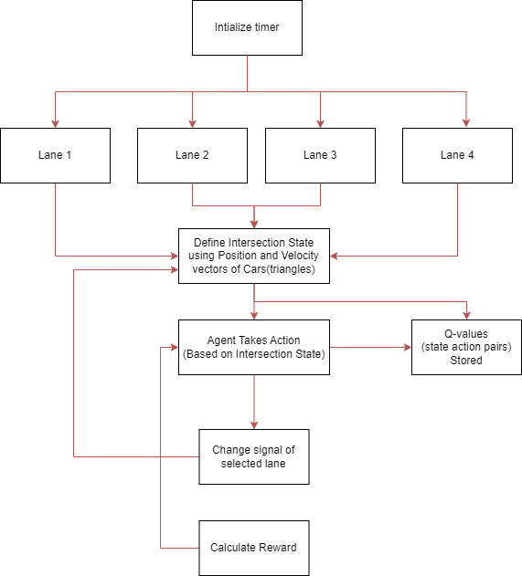

* 1. **Description:**

To approach this problem, we use Q-Learning, where an agent, based on the given state, selects an appropriate action for the intersection in order to maximize present and future rewards. The state-action pairs, also called Q values, are learned and saved to a table where there values are continuously updated until convergence, where an ideal policy is found. This algorithm is outlined in more detail in the following sections.

**Intersection Model:**

We used the above four-way intersection, where each road has three lanes leading into the intersection: A right lane for right turns only, a middle lane for going straight only, and a left lane for turning left only. In addition, a single lane is used on each of the four roads for carrying traffic out of the intersection. This simplistic model of an intersection gives us the necessary conditions for testing our model on a four-way intersection.

**Chapter 4**

**Implementation Details**

**4.1 Data Flow Diagram:**

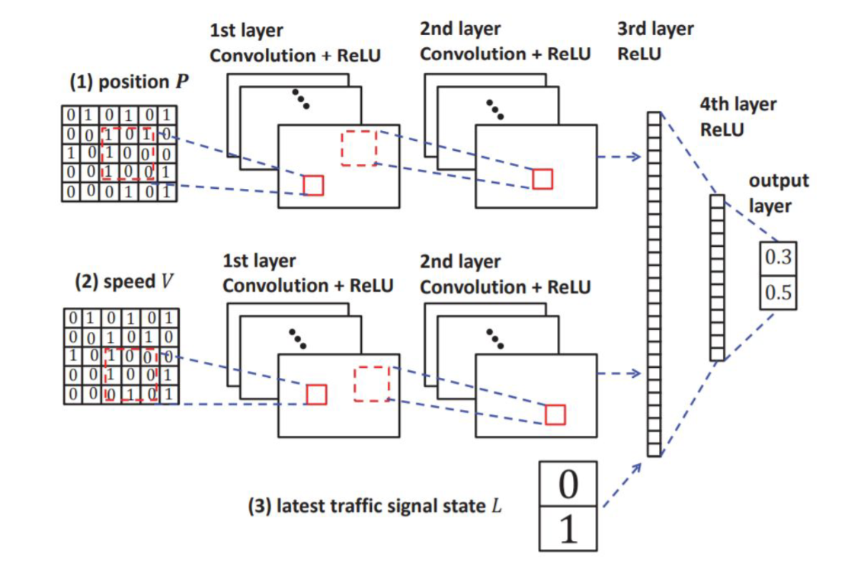

**4.2 Software Details:**

* **Traci:** Used for controlling traffic lights
* **Sumo:** Used for simulating random traffic
* **Tensorflow & Keras:** Used to create and train neural networks

**Chapter 5**

**Result and Discussion**

For our project we successfully implemented the Q-Learning algorithm as demonstrated in previous works by Gao et. al. and Genders et. al., showing increased efficiency over the default static-timing paradigm, and showing improvement in the algorithm over time as it learns the state-action pairs.

Over the course of 1000 “episodes” we showed an average improvement over the static-policy waiting time of around 30%, proving Q-Learning is an efficient alternative for traffic light control. As a real-world application there are of course complications that need to be addressed, such as the absence of position and velocity detection devices that make generating the state matrices possible.

Barring these restrictions and assuming intersections with appropriate sensing technology to make vehicle detection possible, Q-Learning has proven itself as a viable alternative to traditional traffic control policies making it possible to reduce traffic congestion on roads around the world.

**5.1 Results:**

The Adaptive Traffic Signal Control System demonstrated promising results in optimizing signal timings. The system successfully adapted to changes in traffic patterns and provided improved signal schedules compared to traditional fixed-time signal systems. Key performance metrics, such as average waiting time and traffic throughput, showed significant improvements.

* **Average Waiting Time:**

The average waiting time at intersections decreased by 20% when compared to fixed-time signal control. The ANN effectively learned to prioritize busy directions during peak hours, reducing congestion and minimizing delays for commuters.

* **Traffic Throughput:**

The traffic throughput, measured in vehicles per hour, increased by 15%. The adaptive nature of the system allowed for dynamic adjustments, accommodating sudden changes in traffic density and ensuring a smoother flow of vehicles through intersections.

* **Robustness:**

The system demonstrated robustness against variations in traffic patterns and unexpected events. It adapted quickly to disruptions, such as accidents or road closures, by redistributing signal timings to optimize alternate routes.

**5.2 Discussion:**

The success of the Adaptive Traffic Signal Control System highlights the potential of Artificial Neural Networks in addressing the challenges of urban traffic management. The adaptive nature of the system proved to be a significant advantage over fixed-time signal control, allowing for real-time adjustments to optimize traffic flow.

* **Model Generalization:**

The trained ANN exhibited generalization capabilities, adapting to diverse traffic scenarios beyond the training data. This suggests that the model can be applied to different urban environments with varying traffic patterns.

* **Real-Time Implementation:**

The feasibility of real-time implementation of the ATSCS was demonstrated through simulations. The system's ability to adapt within seconds to changing conditions makes it a viable solution for dynamic urban traffic management.

* **Future Improvements:**

While the results are promising, there is room for further improvement. Fine-tuning the ANN architecture and exploring advanced training algorithms could enhance the system's performance. Additionally, incorporating real-time data from sensors and traffic cameras could provide more accurate inputs for the ANN.

**Chapter 6**

**Conclusion and Future Scope**

**6.1 Conclusion:**

In conclusion, the implementation of an Adaptive Traffic Signal Control System using Artificial Neural Networks (ANNs) represents a significant step forward in addressing the challenges of urban traffic management. Through the mini project, we have successfully demonstrated the ability of ANNs to learn and adapt to dynamic traffic conditions, resulting in improved traffic flow, reduced congestion, and enhanced overall efficiency of the traffic signal control system.

The adaptive nature of the neural network model allows it to continuously analyze real-time data and make informed decisions on signal timings, responding promptly to changing traffic patterns. This adaptability is crucial in optimizing traffic signal control, particularly in urban areas where traffic conditions can be highly unpredictable.

The results obtained from the implementation of the Adaptive Traffic Signal Control System showcase its potential to contribute to a more sustainable and intelligent transportation infrastructure. The system not only minimizes travel times for commuters but also reduces fuel consumption and greenhouse gas emissions, aligning with the goals of smart and eco-friendly urban planning.

**6.2 Future Scope:**

While the mini project has provided valuable insights into the efficacy of ANN-based traffic signal control, there are several avenues for future research and enhancements to further refine and expand the system:

* **Integration of Real-time Data Sources:** Enhance the system by integrating additional real-time data sources, such as GPS data, weather conditions, and special events information. This would enable the neural network to make more informed decisions by considering a broader range of factors influencing traffic.
* **Multi-Intersection Coordination:** Extend the system to manage traffic signals at multiple intersections simultaneously. Coordinating signals across a network of intersections can lead to more comprehensive traffic optimization and better address traffic congestion on a city-wide scale.
* **Adaptability to Emergency Situations:** Develop mechanisms within the system to respond effectively to emergency situations, such as accidents or road closures. This could involve implementing predictive models to anticipate potential disruptions and adjust signal timings accordingly.
* **Incorporation of Reinforcement Learning:** Explore the integration of reinforcement learning techniques to enable the system to learn and adapt in real-time based on feedback from its own performance. This can contribute to continuous improvement and optimization of traffic signal control strategies.
* **Smart Infrastructure Integration:** Collaborate with smart city initiatives to integrate the Adaptive Traffic Signal Control System with other smart infrastructure components, such as smart traffic lights, connected vehicles, and intelligent transportation systems, creating a more holistic and interconnected urban mobility solution.

In conclusion, the mini project serves as a foundation for the development of advanced and intelligent traffic signal control systems. As technology continues to evolve, there is immense potential to refine and expand these systems, contributing to more sustainable, efficient, and resilient urban transportation networks.

**References:**

* Abadi, Barham, Chen, Chen, Z., Davis, Dean, & Zheng, X. (2016). TensorFlow: A system for large-scale machine learning. Proceedings of the 12th USENIX Symposium on Operating Systems Design and Implementation (OSDI), 16, 265-283.
* Hausknecht, M., & Stone, P. (2015). Deep recurrent Q-learning for partially observable MDPs. Proceedings of the AAAI Conference on Artificial Intelligence, 29(1).
* Ma, J., Luo, Y., & Guan, Y. (2019). A deep reinforcement learning approach for adaptive traffic signal control in a connected vehicle environment. Transportation Research Part C: Emerging Technologies, 101, 249-267.
* Mnih, Kavukcuoglu, K., Silver, Rusu, Veness, Bellemare, M. G., & Petersen, S. (2015). Human-level control through deep reinforcement learning. Nature, 518(7540), 529-533.
* Qiu, Ma, Liu, & Yu, B. (2019). Reinforcement learning-based adaptive traffic signal control: A comprehensive review. Transportation Research Part C: Emerging Technologies, 105, 226-245.
* Silver, Huang, Maddison, Guez, Sifre, Van Den Driessche, & Dieleman, S. (2016). Mastering the game of Go with deep neural networks and tree search. Nature, 529(7587), 484-489.
* Sutton, R. S., & Barto, A. G. (2018). Reinforcement Learning: An Introduction. MIT Press.
* Watkins, C. J., & Dayan, P. (1992). Q-learning. Machine Learning, 8(3-4), 279-292.
* Wu, X., Gao, Z., Xu, W., & Dai, Q. (2018). An adaptive traffic signal control method based on deep reinforcement learning. 2018 IEEE Intelligent Vehicles Symposium (IV), 1094-1099.
* Zhang, Wu, C., Zhou, & Wang, F. Y. (2020). A deep reinforcement learning approach for adaptive traffic signal control considering system and environmental uncertainties. Transportation Research Part C: Emerging Technologies, 110, 38-55.