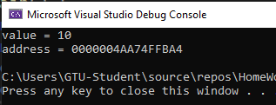
Задание 1. Работа с указателями
#include <iostream>
using namespace std;
int main() {
int v = 10;
int* v_pointer = &v;
cout << "value = " << *v_pointer << endl;
cout << "address = " << v_pointer << endl;
}
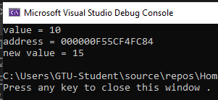
Задание 2. Изменение значения через указатель
#include <iostream>
using namespace std;
int main() {
int v = 10;
int* v_pointer = &v;
cout << "value = " << *v_pointer << endl;
cout << "address = " << v_pointer << endl;
*v_pointer = 15;
cout << "new value = " << *v_pointer << endl;
}
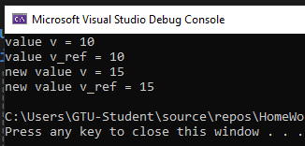
Задание 3. Работа со ссылкой
#include <iostream>
using namespace std;
int main() {
int v = 10;
int& v_ref = v;
cout << "value v = " << v << endl;
cout << "value v_ref = " << v_ref << endl;
v_ref = 15;
cout << "new value v = " << v << endl;
cout << "new value v_ref = " << v_ref << endl;
}
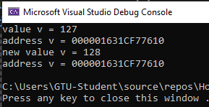
Задание 4. Динамическая память (одна переменная)
#include <iostream>
using namespace std;
int main() {
int* v = new int(127);
cout << "value v = " << *v << endl;
cout << "address v = " << v << endl;
*v = 128;
cout << "new value v = " << *v << endl;
cout << "address v = " << v << endl;
delete v;
v = nullptr;
}

Задание 5. Динамический массив
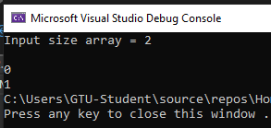
#include <iostream>
using namespace std;
int main() {
int s;
cout << "Input size array = ";
cin >> s;
int* a = new int[s];
for (int i = 0; i < s; i++) {
*(a + i) = i;
}
for (int i = 0; i < s; i++) {
cout << endl << a[i];
}
delete[] a;
a = nullptr;
}
Задание 6*. Динамический массив
#include <iostream>
using namespace std;
int main() {
int n, min, max, sum;
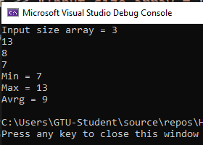
cout << "Input size array = ";
cin >> n;
int* a = new int[n];
for (int i = 0; i < n; i++) {
*(a + i) = 5 * i ^ 12 % 100 + 1;
cout << a[i] << endl;
}
min = a[0];
max = a[0];
sum = a[0];
for (int i = 1; i < n; i++) {
if (a[i] < min)
min = a[i];
if (a[i] > max)
max = a[i];
sum += a[i];
}
cout << "Min = " << min << endl;
cout << "Max = " << max << endl;
cout << "Avrg = " << (sum / n) << endl;
delete[] a;
a = nullptr;
}

