а)
#include <iostream>
using namespace std;

int main()
{
int price_of_piece = 17;
float wallet = 400;
int max_for_buy;

max_for_buy = static_cast<int>(wallet / price_of_piece);
cout << "Number of products by price " << price_of_piece << " lari,"
<< " which can be purchased for " << wallet << " lari equals "
<< max_for_buy << " pieces\n";

}
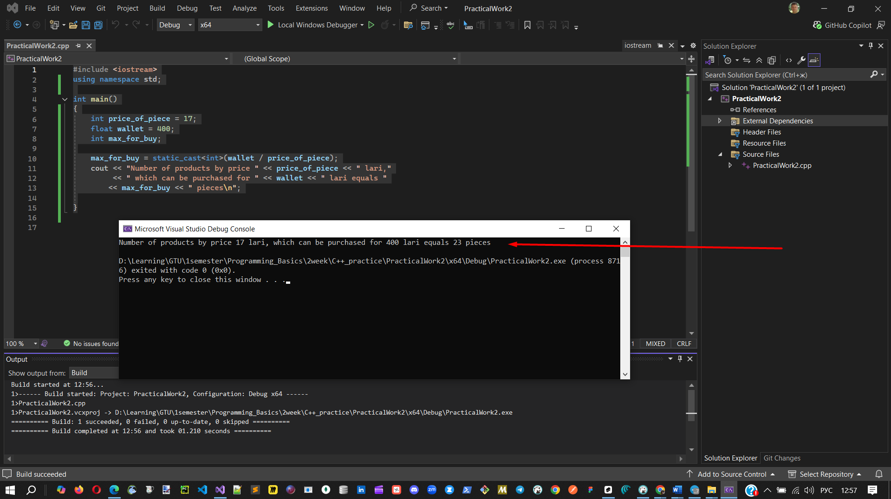

б)
#include <iostream>
using namespace std;

int main()
{
float a, b, f;

cout << "Input float A: ";
cin >> a;
cout << "Input float B: ";
cin >> b;
cout << "Input float F: ";
cin >> f;

float result = (a + b - f / a) + f * a * a - (a + b);
cout << result;

return 0;
}
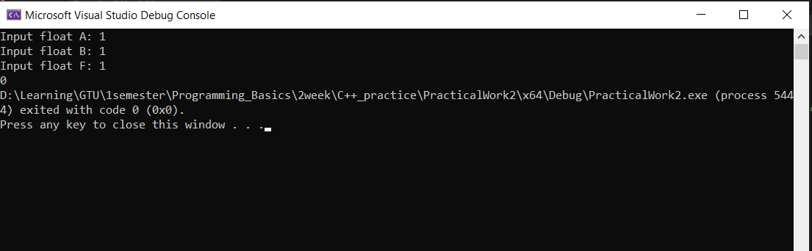

в)
#include <iostream>
using namespace std;

int main()
{
int a = 2;
int b = a * 3;
int c = a + b;
cout << a << '\n' << b << '\n' << c;
}
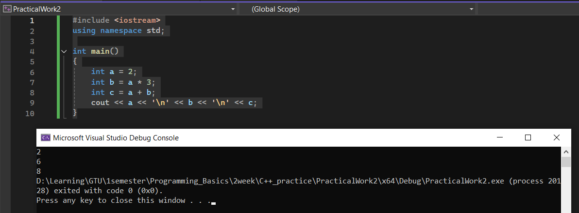

г)
#include <iostream>
using namespace std;

int main()
{
float meter, kilometer;

cout << "Enter the number of meters: ";
cin >> meter;
kilometer = meter / 1000;
cout << meter << " meters equal " << kilometer << " kilometers\n";
} 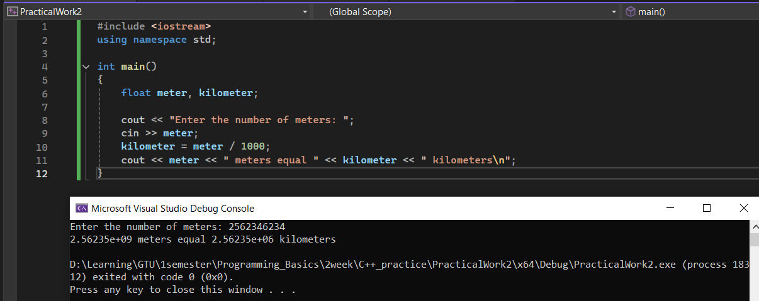
д)
#include <iostream>
using namespace std;

int main()
{
int n = 4321;
while (n > 0) {
cout << (n % 10);
n = n / 10;
}
}
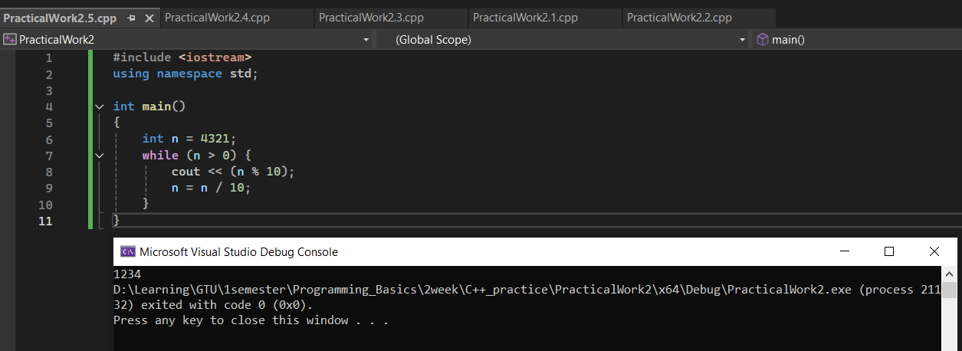

3а)
#include <iostream>
using namespace std;

int main()
{
float i;
cout << "Input float: ";
cin >> i;
cout << "Round up = " << ceilf(i) << "\nRound down = " << floorf(i);
} 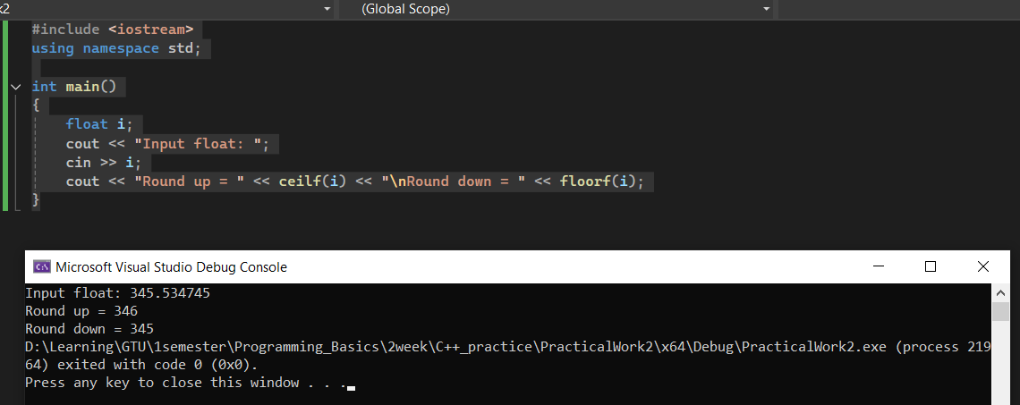

3б)#include <iostream>
using namespace std;

int main()
{
double x, y;
cout << "Input any number: ";
cin >> x;
y = (x / 4 + sqrt(3 * x / 2) / (4 * x) + 23 * (pow(x, 2) + 2)) / (2 * x / 5 + sqrt(3 + 5 * (pow(x, 3) + 3 / 5)));
cout << "(x / 4 + sqrt(3 * x / 2) / (4 * x) + 23 * (pow(x, 2) + 2)) / (2 * x / 5 + sqrt(3 + 5 * (pow(x, 3) + 3 / 5))) = "
<< y;
} 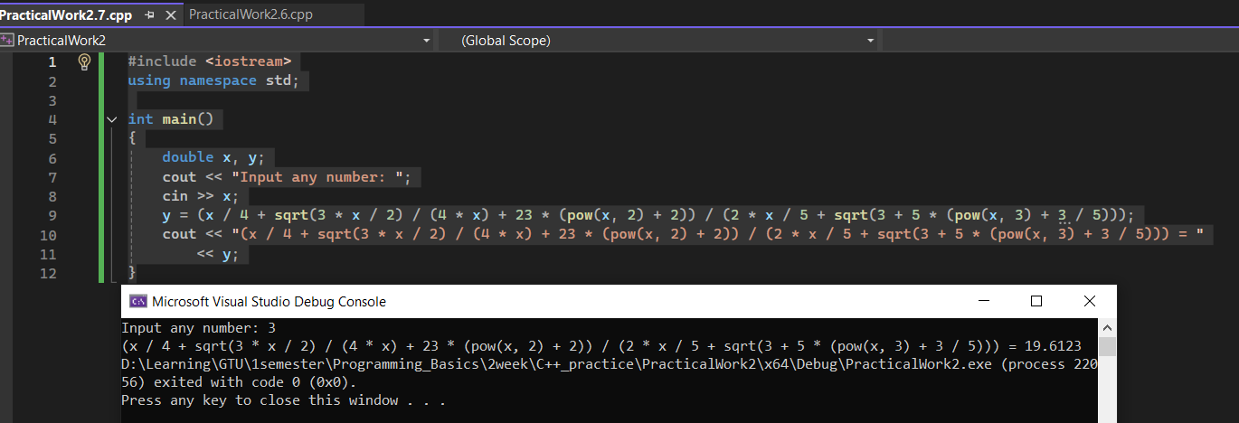
3в)
#include <iostream>
using namespace std;

int main()
{
float a, y;
cout << "Input angle: ";
cin >> a;
y = 2 * sin(a / 2) * cos(a / 2) / (pow(sin(a / 2), 2) + pow(cos(a / 2), 2));
cout << "2 * sin(a / 2) * cos(a / 2) / (pow(sin(a / 2), 2) + pow(cos(a / 2), 2)) = " << y << "\n\n\n";
} 