а) индексы максимального элемента
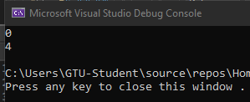
#include <iostream>
using namespace std;

int main() {
int arr [5][5]{
{0, 1, 2, 3, 4},
{1, 0, 1, 2, 3},
{2, 1, 0, 1, 2},
{3, 2, 1, 0, 1},
{4, 3, 2, 1, 0}
};
int max_i = 0, max_j = 0, max = arr[0][0];

for(int i = 0; i < 5; i++)
for(int j = 0; j < 5; j++)
if (max < arr[i][j]) {
max = arr[i][j];
max_i = i;
max_j = j;
}
cout << max_i << endl << max_j << endl;
}

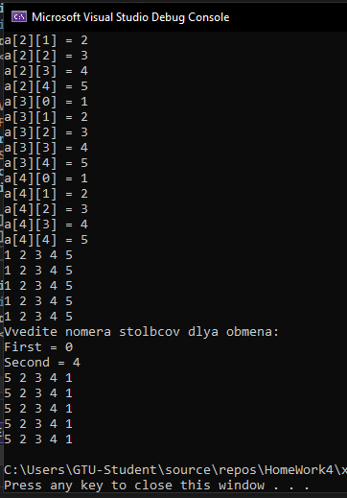
б) обмен столбцами
#include <iostream>
using namespace std;

int main() {
int arr[5][5], tmp, first, second;
cout << "Vvedite elementi massiva:\n";
for (int i = 0; i < 5; i++)
for (int j = 0; j < 5; j++) {
cout << "a[" << i << "][" << j << "] = ";
cin >> arr[i][j];
}

for (int i = 0; i < 5; i++) {
for (int j = 0; j < 5; j++)
cout << arr[i][j] << " ";
cout << endl;
}

cout << "Vvedite nomera stolbcov dlya obmena:\n";
cout << "First = ";
cin >> first;
cout << "Second = ";
cin >> second;
for (int i = 0; i < 5; i++) {
tmp = arr[i][first];
arr[i][first] = arr[i][second];
arr[i][second] = tmp;
}

for (int i = 0; i < 5; i++) {
for (int j = 0; j < 5; j++)
cout << arr[i][j] << " ";
cout << endl;
}
}

в)
#include <iostream>
using namespace std;

int main() {
int arr[100][100], n;
cout << "Vvedite razmer massiva = \n";
cin >> n;
for (int i = 0; i < n; i++)
for (int j = 0; j < n; j++)
arr[i][j] = abs(j - i);
for (int i = 0; i < n; i++) {
for (int j = 0; j < n; j++)
cout << arr[i][j] << " ";
cout << endl;
}



