а)
#include <iostream>

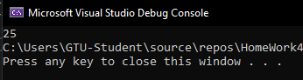
int main() {
int arr[5] = { 1, -5, 20, -2, 4 };
int sum = 0;
for (int i = 0; i < 5; i++)
if (arr[i] > 0)
sum += arr[i];
std::cout << sum;
}

б)
#include <iostream>

int main() {
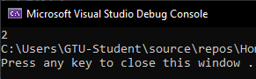
int arr[5] = { 1, -5, 20, -2, 4 };
int max = arr[0], index = 0, i = 1;
do {
if (arr[i] > max) {
max = arr[i];
index = i;
}
} while (i++ < 4);
std::cout << index;
}

в)
#include <iostream>

int main() {
int arr[10] = { 1, -5, 20, -2, 4, -8, 0, -10, 3, -15};
int s = 0;
for (int i = 0; i < 10; i++)
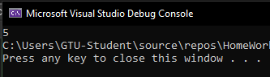
if (arr[i] < 0)
s++;
std::cout << s;
}

г)
#include <iostream>

int main() {
int arr[10] = { 1, -5, 20, -2, 4, -8, 0, -10, 3, -15};
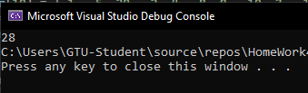
int s = 0;
for (int i = 0; i < 10; i++)
if (i % 2 == 0)
s += arr[i];
std::cout << s;
}

д)
#include <iostream>

int main() {
int arr[10] = { 1, 5, 20, -2, 4, 75, -3, 85, 9, 21 };
int x, y = 0;
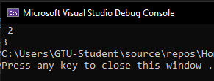
for (int i = 0; i < 10; i++)
if (arr[i] < 0) {
x = i;
y = arr[i];
break;
}
std::cout << y << "\n" << x;
}

е)
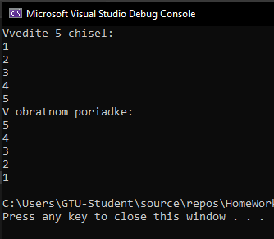
#include <iostream>
using namespace std;

int main() {
int arr[5];
cout << "Vvedite 5 chisel:\n";
for (int i = 0; i < 5; i++)
cin >> arr[i];
cout << "V obratnom poriadke:\n";
for (int i = 4; i >= 0; i--)
cout << arr[i] << endl;
}

