1 а) светофор
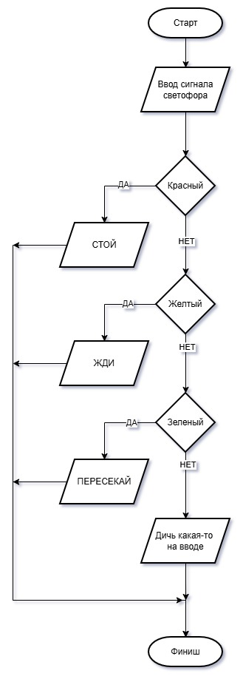

1 б) високосный год
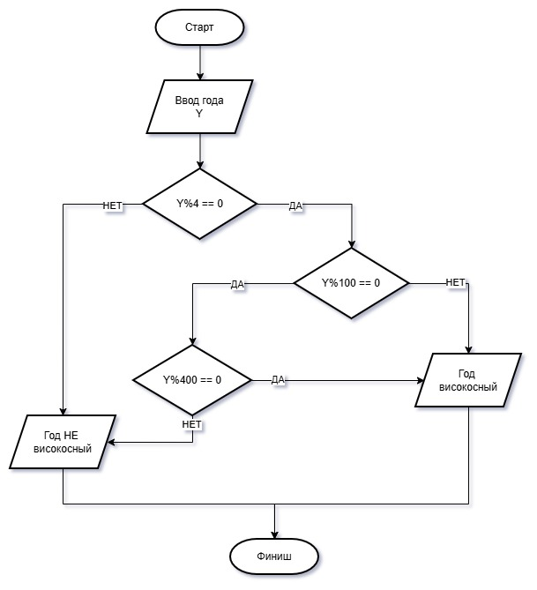

1 в) корни квадратного уравнения
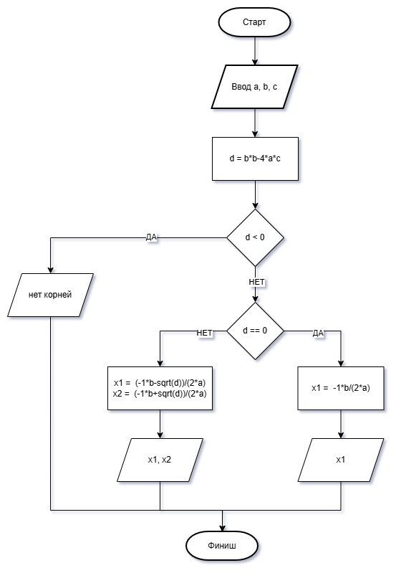

2а) светофор
#include <iostream>
using namespace std;

int main()
{
int i;
cout << "Input color of light.\n";
cout << "If color = red, please type 1.\n";
cout << "If color = yellow, please type 2.\n";
cout << "If color = green, please type 3.\n";
cout << "Input color of light: ";
cin >> i;
if (i == 1)
cout << "STOP";
else
if (i == 2)
cout << "WAIT";
else
if (i == 3)
cout << "GO-GO-GO!!!";
else
cout << "Chush kakaya-to )))";
}
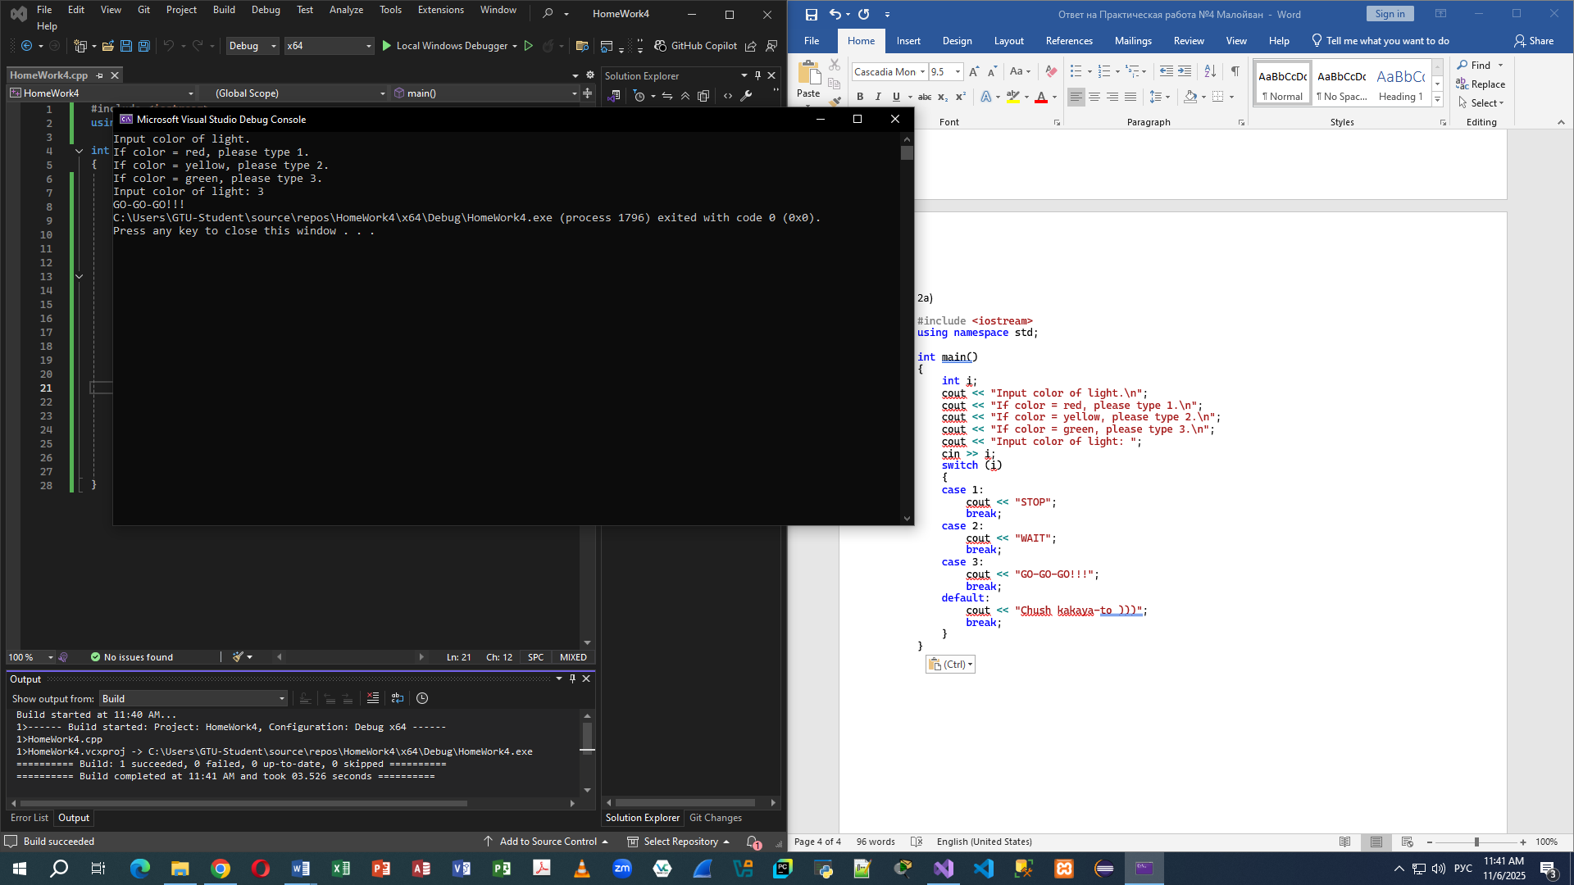

2б) високосный год
#include <iostream>
using namespace std;

int main()
{
int year;
cout << "Input year: ";
cin >> year;
if (year % 4 == 0)
{
if (year % 100 == 0)
{
if (year % 400 == 0)
{
cout << "Visokosniy";
}
else
{
cout << "Ne visokosniy";
}
}
else
{
cout << "Visokosniy";
}
}
else
{
cout << "Ne visokosniy";
}
}
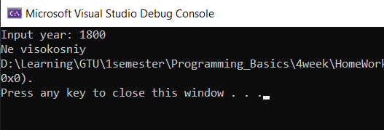

2в) квадратное уравнение
#include <iostream>
using namespace std;

int main()
{
float a, b, c, d, x1, x2;
cout << "Reshenie kvadratnogo uravneniya vida: A * x^2 + B * x + C = 0\n";
cout << "Vvedite A, B & C\n";
cout << "Vvedite A = ";
cin >> a;
cout << "Vvedite B = ";
cin >> b;
cout << "Vvedite C = ";
cin >> c;
cout << "===============================================================\n";
d = b * b - 4 * a * c;
if (d < 0)
{
cout << "Net korney\n\n";
}
else
{
if (d == 0)
{
x1 = -b / (2 * a);
cout << "Edinctvenniy koren uravneniya x = " << x1 << "\n\n";
}
else
{
x1 = (-b + sqrt(d)) / (2 * a);
x2 = (-b - sqrt(d)) / (2 * a);
cout << "Korni uravneniya:\n x1 = " << x1 << endl << " x2 = " << x2 << "\n\n";
}
}
}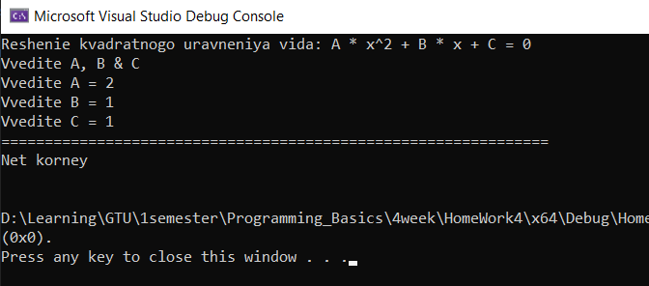

2г) поиск максимума из 3х чисел
#include <iostream>
#include <iso646.h>
using namespace std;

int main()
{
int a, b, c, tmp;
cout << "Vvedite pervoe chislo: ";
cin >> a;
cout << "Vvedite vtoroe chislo: ";
cin >> b;
cout << "Vvedite tretie chislo: ";
cin >> c;
cout << "=====================================================\n";

if (a == b and b == c)
{
tmp = a;
cout << "Vse chisla ravni\n Maximum = ";
}
else
{
if (a == b or b == c or c == a)
{
cout << "Est 2 odinakovih chisla\n Maximum = ";
if (a == b)
a < c ? tmp = c : tmp = a;
else
a < b ? tmp = b : tmp = a;

}
else
{
cout << "Vse chisla raznie\n Maximum = ";
a < b ? tmp = b : tmp = a;
if (tmp < c)
tmp = c;
}
}
cout << tmp << endl;
}
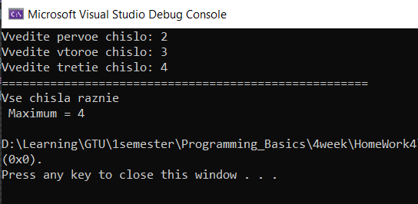
1а) калькулятор
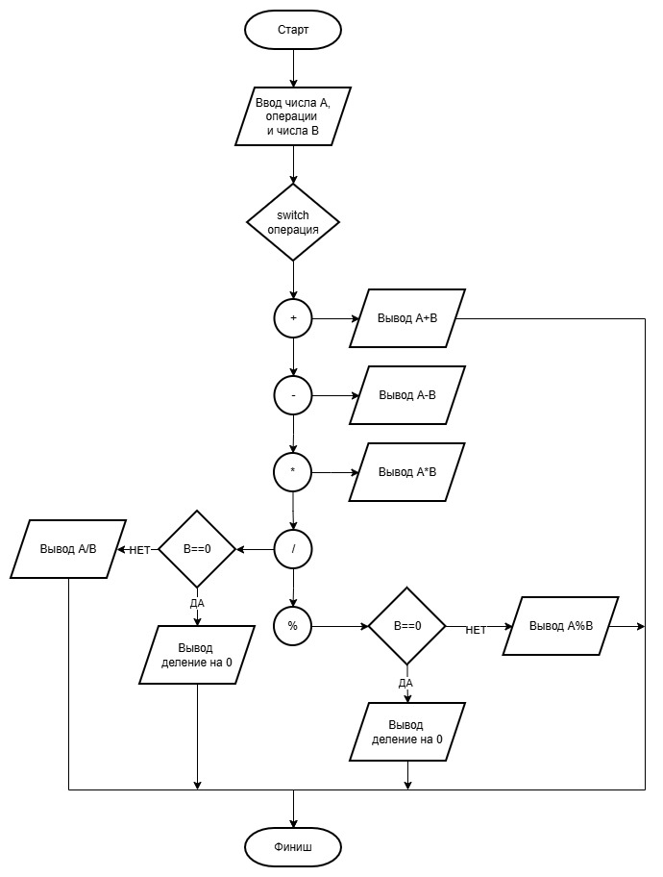
2а) калькулятор
#include <iostream>
using namespace std;

int main()
{
int a, b;
char operation;

cout << "Vvedite pervoe chislo: ";
cin >> a;
cout << "Vvedite operaciu (varianti: +, -, *, /, %): ";
cin >> operation;
cout << "Vvedite vtoroe chislo: ";
cin >> b;
cout << "================================================================\n";

switch (operation)
{
case 43:
cout << a << " + " << b << " = " << a + b;
break;
case 45:
cout << a << " - " << b << " = " << a - b;
break;
case 42:
cout << a << " * " << b << " = " << a * b;
break;
case 47:
if (b == 0)
cout << "Delenie na nol\n";
else
cout << a << " / " << b << " = " << a / b;
break;
case 37:
if (b == 0)
cout << "Delenie na nol\n";
else
cout << a << " % " << b << " = " << a % b;
break;
default:
cout << "Ne validnie dannie\n";
}
}
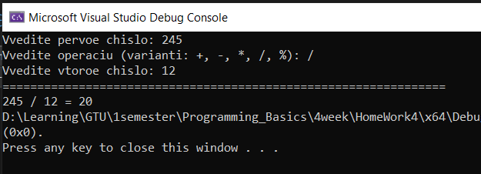
2б) метро с номерами станций
#include <iostream>
using namespace std;

int main()
{
int target_station;
cout << "Station name:\n" <<
"1. Qwerty\n" <<
"2. Asdfgh\n" <<
"3. Zxcvbn\n" <<
"4. Poiuyt\n" <<
"5. Lkjhgf\n" <<
"Vi stoite na stancii 'Qwerty'. Ukajite nomer stancii poezdki(ot 2 do 5) : ";
cin >> target_station;
while (target_station < 2 || target_station > 5)
{
cout << "=====================================\n" <<
"Net takoi stancii.Poprobuyte esho raz\n" <<
"Vi stoite na stancii 'Qwerty'. Ukajite nomer stancii poezdki(ot 2 do 5) : ";
cin >> target_station;
}
cout << "================================================================\n";
switch (target_station) {
case 2:
cout << "Vi otpravlayetes na stanciyu 'Asdfgh' i rasstoyanie do nee = 2km.\n";
break;
case 3:
cout << "Vi otpravlayetes na stanciyu 'Zxcvbn' i rasstoyanie do nee = 4km.\n";
break;
case 4:
cout << "Vi otpravlayetes na stanciyu 'Poiuyt' i rasstoyanie do nee = 6km.\n";
break;
case 5:
cout << "Vi otpravlayetes na stanciyu 'Lkjhgf' i rasstoyanie do nee = 8km.\n";
break;
}
}
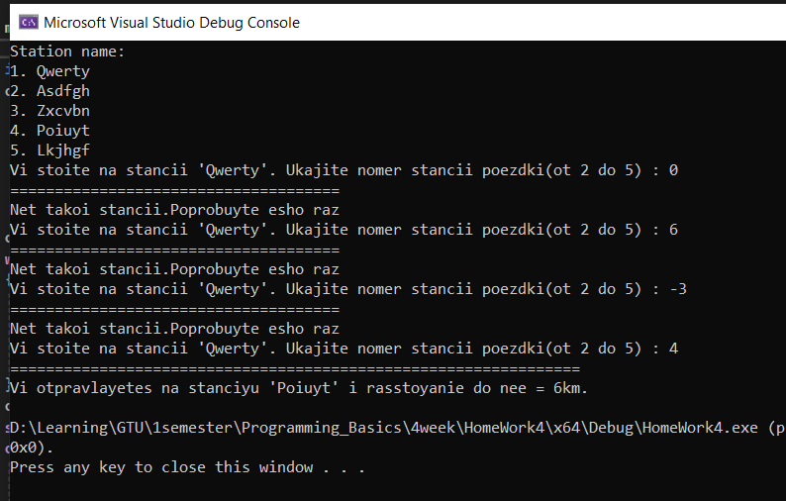
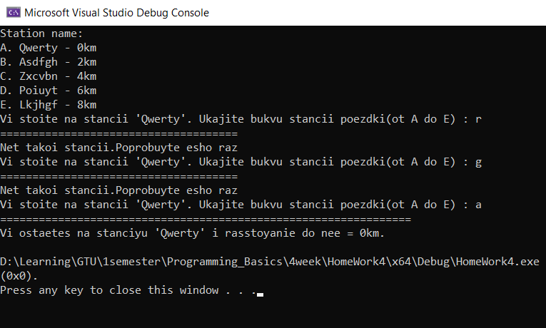
2в) метро с буквами
#include <iostream>
using namespace std;

int main()
{
char target_station;

cout << "Station name:\n" <<
"A. Qwerty - 0km\n" <<
"B. Asdfgh - 2km\n" <<
"C. Zxcvbn - 4km\n" <<
"D. Poiuyt - 6km\n" <<
"E. Lkjhgf - 8km\n" <<
"Vi stoite na stancii 'Qwerty'. Ukajite bukvu stancii poezdki(ot A do E) : ";
cin >> target_station;
while ((target_station < 65 || target_station > 69) && (target_station < 97 || target_station > 101))
{
cout << "=====================================\n" <<
"Net takoi stancii.Poprobuyte esho raz\n" <<
"Vi stoite na stancii 'Qwerty'. Ukajite bukvu stancii poezdki(ot A do E) : ";
cin >> target_station;
}
cout << "================================================================\n";
switch (target_station) {
case 65:
case 97:
cout << "Vi ostaetes na stanciyu 'Qwerty' i rasstoyanie do nee = 0km.\n";
break;
case 66:
case 98:
cout << "Vi otpravlayetes na stanciyu 'Asdfgh' i rasstoyanie do nee = 2km.\n";
break;
case 67:
case 99:
cout << "Vi otpravlayetes na stanciyu 'Zxcvbn' i rasstoyanie do nee = 4km.\n";
break;
case 68:
case 100:
cout << "Vi otpravlayetes na stanciyu 'Poiuyt' i rasstoyanie do nee = 6km.\n";
break;
case 69:
case 101:
cout << "Vi otpravlayetes na stanciyu 'Lkjhgf' i rasstoyanie do nee = 8km.\n";
break;
}
}

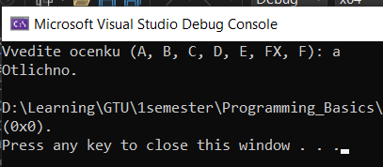
2г) оценка студента
#include <iostream>
#include <string>
using namespace std;

int main()
{
string ocenka;
int int_ocenka;

cout << "Vvedite ocenku (A, B, C, D, E, FX, F): ";
cin >> ocenka;
if (ocenka == "FX" || ocenka == "fx" || ocenka == "fX" || ocenka == "Fx")
int_ocenka = 1;
else
int_ocenka = ocenka[0];
switch (int_ocenka)
{
case 65:
case 97:
cout << "Otlichno.\n";
break;
case 66:
case 98:
cout << "Ochen horosho.\n";
break;
case 67:
case 99:
cout << "Horosho.\n";
break;
case 68:
case 100:
cout << "Udovletvoritelno.\n";
break;
case 69:
case 101:
cout << "Dostatochno.\n";
break;
case 1:
cout << "Ne sdal. Dostupna odna peresdacha\n";
break;
case 70:
case 102:
cout << "Srezalsya. Oplatit i proiti kurs zanovo\n";
break;
default:
cout << "Ne validnie dannie\n";
}
}

