1а)
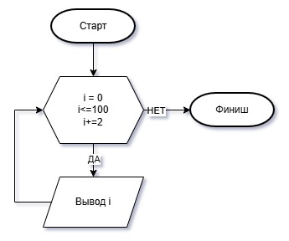
#include <iostream>
using namespace std;

int main()
{
for (int i = 0; i <= 100; i += 2)
cout << i << " ";
}
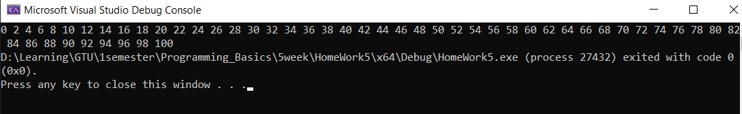

1б)
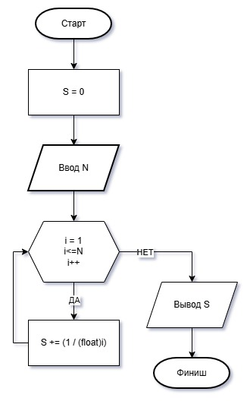
#include <iostream>
using namespace std;

int main()
{
float n, s = 0;

cout << "Vvedite N = ";
cin >> n;

for (int i = 1; i <= n; i++)
s += (1 / (float)i);
cout << "Summa ryada = " << s;
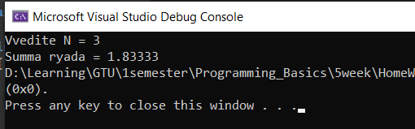
}

1в)
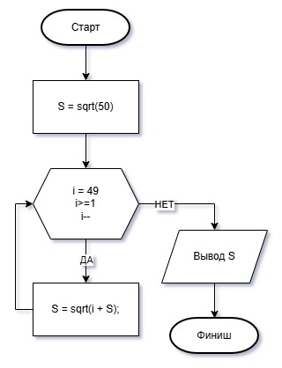
#include <iostream>
using namespace std;

int main()
{
float s = sqrt(50);
for (int i = 49; i >= 1; i--)
s = sqrt(i + s);
cout << s;
}
