а) сумма чисел делящихся на 5
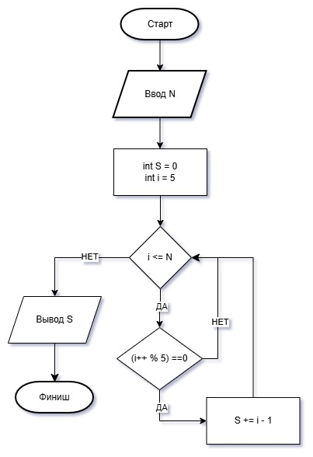
#include <iostream>
using namespace std;
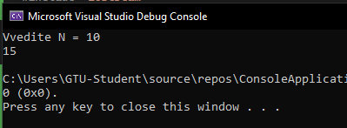
int main()
{
int S = 0;
int N, i = 5;

cout << "Vvedite N = ";
cin >> N;

while (i <= N)
if ((i++ % 5) == 0)
S += i - 1;
cout << S << endl;
}
б) сумма положительных и произведение отрицательных
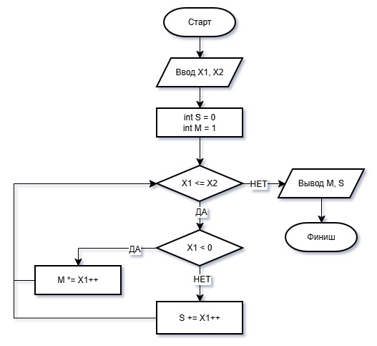
#include <iostream>
using namespace std;
int main()
{
int x1, x2;
int S = 0;
int M = 1;
cout << "Pri vvode X1 i X2 dolgno bit X1<=X2" << endl << "Vvedite X1 = ";
cin >> x1;
cout << "Vvedite X2 = ";
cin >> x2;
while (x1 <= x2)
if (x1 < 0)
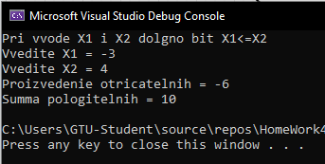
M *= x1++;
else
S += x1++;
cout << "Proizvedenie otricatelnih = " << M << endl;
cout << "Summa pologitelnih = " << S << endl;
}
в) сумма 1+3+…+99
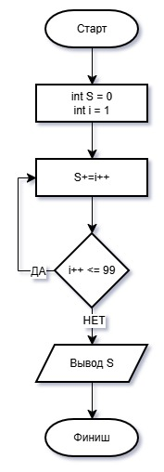

#include <iostream>
using namespace std;

int main() {
int S = 0, i = 1;
do {
S += i++;
} while (i++ <= 99);
cout << S;
}
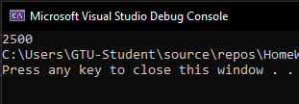

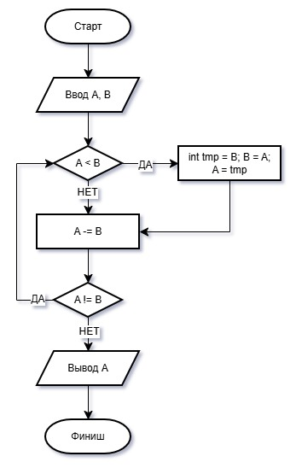
г) НОД

#include <iostream>
#include <algorithm>
using namespace std;

int main() {
int a, b;
cout << "Vvedite A = ";
cin >> a;
cout << "Vvedite B = ";
cin >> b;
do {
if (a < b) {
int tmp = b;
b = a;
a = tmp;
}
a -= b;
} while (a != b);
cout << a;
}
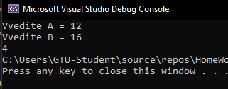

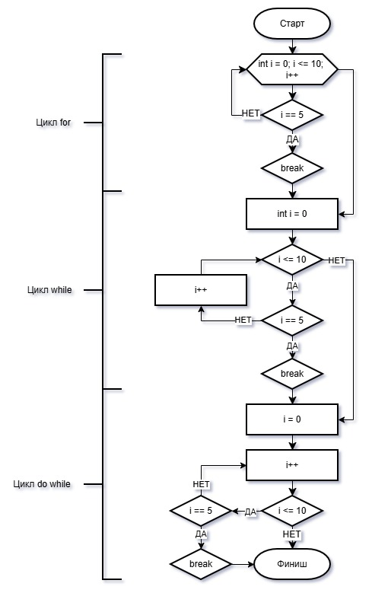
д)

int main() {
for (int i = 0; i <= 10; i++)
if (i == 5) break;
int i = 0;
while (i <= 10)
if (i == 5) break;
else i++;
i = 0;
do {
i++;
if (i == 5) break;
} while (i <= 10);
}
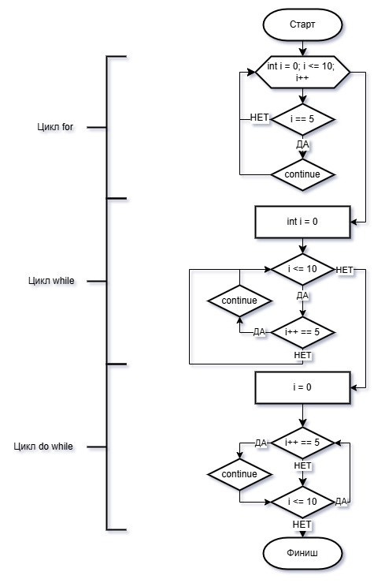
е)

int main() {
for (int i = 0; i <= 10; i++)
if (i == 5) continue;
int i = 0;
while (i <= 10)
if (i++ == 5) continue;
i = 0;
do {
if (i++ == 5) continue;
} while (i <= 10);
}

ж)
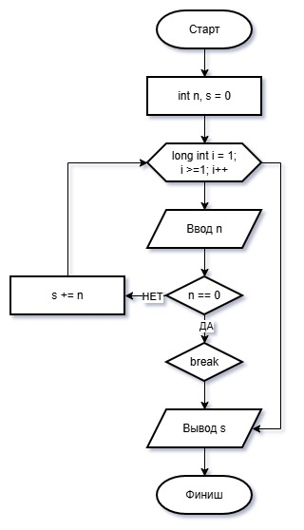

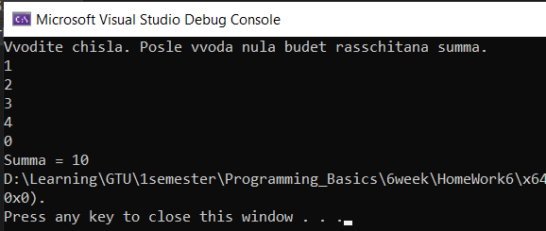

#include <iostream>
using namespace std;

int main() {
int n, s = 0;
cout << "Vvodite chisla. Posle vvoda nula budet rasschitana summa.\n";
for (long int i = 1; i >= 1; i++) {
cin >> n;
if (n == 0)
break;
s += n;
}
cout << "Summa = " << s;
}

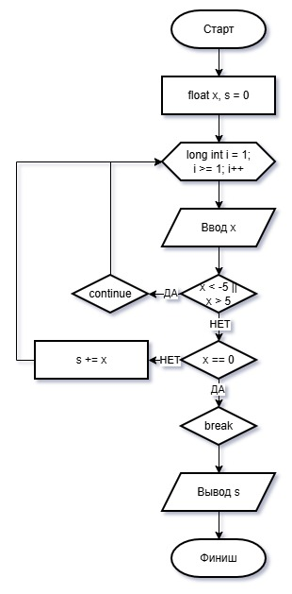
з)

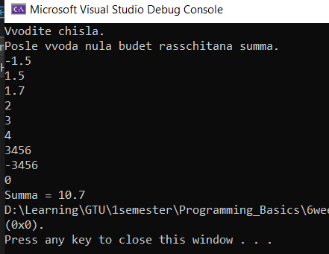

#include <iostream>
using namespace std;

int main() {
float x, s = 0;
cout << "Vvodite chisla.\n";
cout << "Posle vvoda nula budet rasschitana summa.\n";
for (long int i = 1; i >= 1; i++) {
cin >> x;
if ((x < -5) || (x > 5))
continue;
if (x == 0)
break;
s += x;
}
cout << "Summa = " << s;
}

