

LIFE EVOLUTION SIMULATOR

Introduction

The strongest survives - Simulator of the evolution of unicellular organisms. In fact, this is more a game than a real simulation, because the universe of TSS is subject to fictional rules. In this universe, there are many constants that affect events in it. You can change them and observe the pathetic attempts of unicellular creatures to adapt to the new conditions. Such a simulator of God.

The game is available on the web site, but the web version is heavily truncated compared to the version for Windows.

The sources of TSS are open, you can also participate in its development. All references are available in the chapter "Useful links".

Description

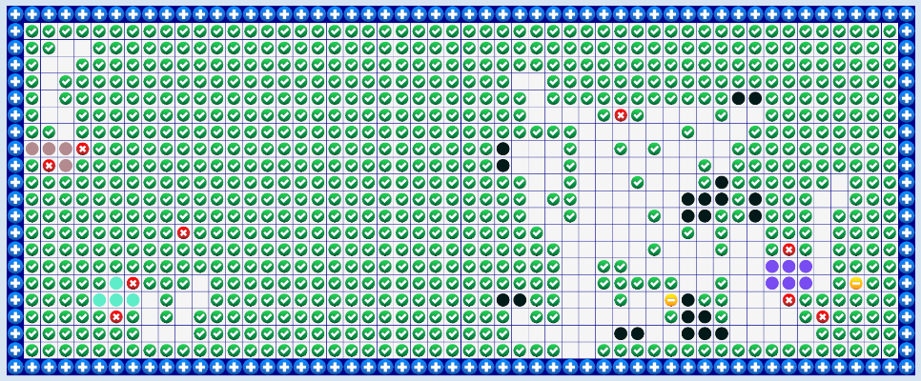The TSS universe is a rectangular field (the size is set by the player) consisting of squares in which organisms live. In addition to them, other objects can be located here: food, poison, dead cells. Cells can have a different genome, which affects their behavior and color. In general, "The strongest survive" is similar to John Conway's "Game of life", but has a number of cardinal differences.

The TSS has its own time unit - the universal tick.

Each cell has its own level of energy and age. It depends on how much energy the cell receives, its survival depends. In TSS cells can influence their fate. Depending on the parameters of its genome, it behaves differently. I focus on this attention, the genome affects the behavior, rather than the physical characteristics of the cell (they all have the same). There are such parameters in the genome: hunger, aggression, attraction to poison, collectivity, attraction to dead cells, reproductivity. Their age is also affected by their behavior. Each tick cell can look around for a few squares and, depending on the objects seen and its behavior, decide on which of the four sides to move it. A simple algorithm, but it can generate many events. More details in the chapter "Cell Walk."

In general, you can talk a lot about the work of this simulator, but it's much easier and more interesting to just try to play. The main thing you need to know is how constants work.

Cell move

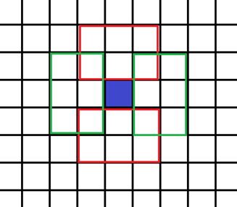A cage can make one stroke once in a tick. More precisely, she looks around the area around, as shown in the picture and selects the priority direction: up, down, left, right or stand in place. And after the cell was determined the event takes place. If there is an empty space, it will simply move there, if there is food, poison, or a dead cell, it will get their energy level and also move there. If there is a living cell - it will remain in place and, depending on what cell there is a certain event. If there is a cell with the same genome, then both will get energy if with another genome - this cell will take away some of its energy.

Another event may occur depending on the age and energy level of the cell. If the cell is adult and has enough energy, it can divide. When dividing, the energy level is divided in half. There is a chance that the second cell mutates. If the energy level is less than zero or the cell is too old, it dies.

Consts of universe

**MaxCountOfCellTypes** is the maximum number of cell genomes.

**Mutation_Enable** - allows you to enable or disable mutation of cells during reproduction.

**Mutation_AttackChildrenMutantsOfFirstGeneration** - if this property is disabled, then cells can not attack their first generation descendants when they mutate.

**Mutation_AttackParentIfCellIsYouMutant** - if this property is disabled, the mutated cells can not attack their ancestors of the first generation.

**Mutation_ChangedValuesAtOne** - shows how many times the values ​​responsible for the behavior of cells change with each mutation. For example, if the value is 10, then 10 times will be selected and changed to 1 random property of the cell, which is responsible for the behavior. It can be from 1 to 200.

**Mutation_ChancePercent** - the chance of mutation in reproduction.

**CellAge_Max** is the maximum age of the cell.

**CellAge_AdultCell** - the age of the adult cell. In child cells, the level of aggression is not higher than CellGenome_Child_Aggression and they can not reproduce.

**EnergyLevel_CreatingCell** - the level of energy in the cells when they are generated at the start.

**EnergyLevel_NeededForReproduction** is the energy level at which the cell can multiply. Can vary due to CellGenome_ReproductionRange.

**EnergyLevel_MaxForCell** - the maximum level of energy that a cell can accumulate.

**EnergyLevel_DeadCell** - the energy level obtained from dead cells.

**EnergyLevel_DefFood** - the level of energy received from food.

**EnergyLevel_PoisonedFood** - the level of energy received from poison.

**EnergyLevel_MovesFriendly** - the level of energy received by the cell when a relative moves towards it or it moves towards it. As a rule, it is much less than the energy level of ordinary food. Promotes the creation of colonies.

**EnergyLevel_MovesAggression** - shows how much energy takes a cell from foreign cells during an attack.

**CellsCount_MaxWithOneType** - the maximum number of cells on a field with the same genome.

**CellGenome_Child_Aggression** - level of aggression in child cells.

**CellsCount_MaxAtField** - the maximum number of cells on the field.

**EnergyEntropyPerSecond** is the energy level that a cell loses at every tick.

**Special_FoodCountForTick** is the amount of food generated at each tick of the universe.

**Special_PoisonCountForTick** is the amount of poison generated at each tick of the universe.

**CellGenome_HungerRange** - range of values ​​of hunger when generating cells.

**CellGenome_AggressionRange** - range of aggression values ​​for cell generation.

**CellGenome_ReproductionRange** - range of reproductive values ​​in cell generation. The higher the value, the less energy the cell needs for reproduction.

**CellGenome_FriendlyRange** - the range of collectivity values ​​for cell generation.

**CellGenome_PoisonRange** - the range of values ​​of craving for poison when generating a cell. Usually negative.

**CellGenome_CorpseRange** - range of values ​​of craving for dead cells during cell generation.

Useful links

Vk - <https://vk.com/yura_mysko>

Youtube chanel with demonstrations of my programs- <https://www.youtube.com/channel/UCiIj3Q0z1pNJ2KyNRcspoZw>

Blog on Habrahabr - <https://habrahabr.ru/users/kogercoder/>

Telegram - <https://t.me/yura_mysko>

Github with source of this game - <https://github.com/KogerCoder>