XIQ Ekahau Importer Guide
by Tim Smith, SA – 9/2/2026 – v1.0

Update Access Point locations in XIQ based on Ekahau floor plan data

Overview:

The XIQ Ekahau AP Update script is a Python utility that automates the process of updating Access Point (AP) locations in Extreme Networks' XIQ platform based on data extracted from Ekahau site survey files (.esx format). This tool is essential for network administrators who use Ekahau for wireless site planning and need to synchronize AP placements with XIQ.

Target Audience: Semi-Technical


Definitions:

XIQ | ExtremeCloud IQ
VIQ | Virtual ExtremeCloud IQ

Table of Contents
Overview 1
Target Audience 1
Definitions: 1
Table of Contents 2
Prerequisites: 3
Scripting Environment Preparation: 3
Information: 3
Device Choice: 3
Python Installation: 3
Mac OSX Ventura 4
Windows 11 4
Required Modules: 4
Checking for existing Modules 4
Installing required modules 4
4
Ekahau File Preparation: 5
Information: 5
Floors not assigned to Buildings in Ekahau: 5
Floors assigned to Buildings in Ekahau: 6
Assign AP locations from the Ekahau File: 7
Running The Script: 7
Site groups, sites, buildings, floors, and floorplans 8
Access Points 8
Arguments 9
CSV File 9
Log File 10

Key Capabilities:
- Extracts AP data from Ekahau survey files
- Matches AP names with serial numbers using optional CSV files
- Updates AP coordinates (x, y) and floor assignments in XIQ
- Supports multiple buildings and floors
- Provides comprehensive logging and error handling
- Supports managed account (external VIQ) deployments
- Validates AP serial numbers and prevents duplicate entries

Prerequisites:

System Requirements
- Python 3.7 or higher
- pip (Python package manager)
- Active internet connection

Account Requirements
- XIQ user account with administrator privileges
- XIQ platform access (extremeplatformone.com)
- Access to building and floor definitions in XIQ

Data Requirements
- Ekahau site survey file (.esx format)
- Buildings and floors pre-configured in XIQ matching Ekahau names
- AP serial numbers associated with APs in XIQ
- Optional: CSV file with AP name to serial number mappings
Note: The script requires that buildings, floors, and floor plans already exist in XIQ. The script will not create new buildings or floors; it only updates existing AP locations within pre-configured building/floor structures.

Scripting Environment Preparation:

Information:
The XIQ_Ekahau_AP_Placement_Update.py script requires, at minimum, Python 3.7 and is tested up to Python 3.12. This script has been tested with macOS and Windows but may also be able to be executed from any device with Python and the needed modules installed. This device must be able to access the Ekahau files and reach out to ExtremeCloud IQ, and Ekahau does not need to be installed on the device.
The script, when run, will create a ekahau_ap_update.log file. This log file will show information about site groups, sites, buildings, and floors created and the APs throughout the process. Any API errors experienced will also show up in the log file.

Device Choice:
This script has only been tested in MacOS (Big Sur, Monterey, and Ventura) and Windows (10 and 11). This script may be executed from any device running Python 3.7 or higher. The device will need to reach ExtremeCloud IQ, which can be done through a proxy, and proxy config is beyond the scope of this guide.

Python Installation:
Depending on the device used, you may need to install Python or a different version. The easiest way to check the Python version is to open the terminal and type this command.
python3 --version

Below is an example of installing python3 for Mac OSX and Windows.

Mac OSX Ventura
- Open the terminal and enter python3 --version
  - This triggers the installation of Developer Tools
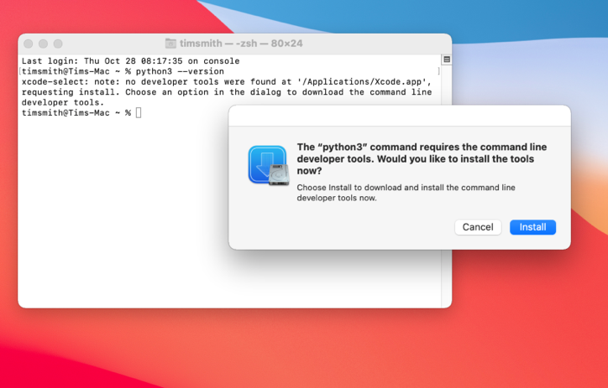
- Click Install
- Click Agree

- The Developer tools that installed python3 will also install pip3 in Ventura
- The Mac terminal will be used to install Python modules

Windows 11
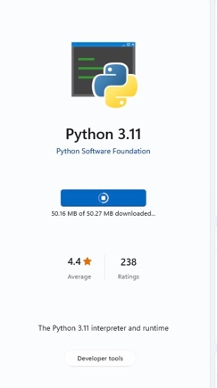
- Search Microsoft Store for Python 3.11 and click install
- Log in with Microsoft credentials

- The Windows store installs pip3 with python3. Pip3 will be used to install the needed modules.

Required Modules:
The requests, pandas, and opencv-python modules are required for the XIQ_Ekahau_Import.py script.

Checking for existing Modules
You can check if the required modules are installed using the terminal. For each module, run the following command.
python3 -c “import requests”

python3 -c “import pandas”
python3 -c “import opencv-python”
”

The module is not installed if a ‘ModuleNotFoundError: No module named '<module name>' error is returned.

Installing required modules
The required modules can be installed using pip3 using the downloaded requirements.txt file with the following command.
pip3 install -r requirements.txt

Or the modules can be installed individually using
pip3 install requests
pip3 install pandas
pip3 install opencv-python

Ekahau File Preparation:

Information:
For the XIQ_Ekahau_AP_Placement_Update.py script to work, an Ekahau 10.x file will need to be used. If you have a file with a previous version of Ekahau, you will need to open it with Ekahau version 10 and save it before you can use it with this script.
If you define the name of the building in the Ekahau file and the name matches an existing building in XIQ, that building will be used.

Ekahau file load:
When you launch the script, it will prompt for the Ekahau File. If the Ekahau file name is in the same folder as your script, you can enter just the file name. Otherwise, you can enter the full file path and file name or drag the file into the terminal window.

The script will then prompt you to select whether the floorplan was 1) imported natively with XIQ (or ExtremePlatformOne) or 2) imported with the XIQ_Ekahau_Import.py script (https://github.com/ExtremeNetworksSA/XIQ_Ekahau_Importer)

Below are the differences between these 2 methods, why you may choose one over the other, why this script needs to know, and what happens if you choose incorrectly.

Method 1: XIQ Native Import

This method was introduced more recently. A guide on using this method can be found here. (https://github.com/ExtremeNetworksSA/XIQ_Ekahau_Importer/blob/master/Documentation/Extreme%20Ekahau%20Import.pdf)
This method, in addition to uploading the floorplans, placing the APs on the map, can also set the channel and power level of the APs, and will import all the wall objects into XIQ/EP1.

This method requires that the AP serial numbers are added as tags in the Ekahau file. If the AP serial numbers are not added or if you have ‘Import custom AP configuration’ unchecked, the tool will just import the floor plans and wall data.
There is a script that will add the serial number tags to an Ekahau file using a CSV map file.
(https://github.com/ExtremeNetworksSA/Ekahau_add_tags_XIQ)

Currently, this tool does not crop or rotate files to match how they are in Ekahau. So if you have the files cropped or rotated in Ekahau, XIQ will import the full floor plan image in the original orientation. There is a feature request open to fix this issue.
NOTE: When this feature request comes to fruition, this script will need to be updated to crop and rotate for the native import or the script will think all APs were moved and move them to incorrect locations.

If the import was originally done with the script but native was selected, most likely the tool would say Serial numbers were not found for any AP, since the script maps APs to serial numbers differently.

If you had both serial numbers in the hostname and the serial number tags, and used cropping and rotating in the Ekahau file, the APs would be moved to the wrong locations as the script supports cropping and rotating the floorplan images but the native import does not.

Method 2: XIQ_Ekahau_Importer.py Script
(https://github.com/ExtremeNetworksSA/XIQ_Ekahau_Importer)
This method can be found on the ExtremenetworksSA GitHub and is supported by the Extreme Networks Global Solutions Architect team.
This script, currently, requires serial numbers to be added to the hostnames in the Ekahau file. The host names need to have :: followed by the serial number appended to them. <hostname :: serial number> That script, and this script also support a csv file that maps the hostname to serial number, if you prefer not to add them to the Ekahau file directly.

Currently, this script does not support the import of walls, but a new API was just released to do this, so the script may support that in the future. But currently the script imports the floorplan into XIQ (supports crop and rotation) and places the APs on the map in the correct location. This script does not support assigning power or channels to the APs, the script will walk through selecting a Network Policy. When it onboards the APs it will assign them to the specified Network Policy.

If the import was originally done with the native import but the script was selected, most likely the tool would say Serial numbers were not found for any AP, since the native import maps APs to serial numbers differently.

If you had both serial numbers in the hostname (or used the csv map) and the serial number tags, and used cropping and rotating in the Ekahau file, the APs would be moved to the wrong locations as the script supports cropping and rotating the floorplan images but the native import does not.

Ekahau building name not found in XIQ:
If the building name is not found, a list of existing building in XIQ will be presented. Choose the building that the Ekahau floors are part of.
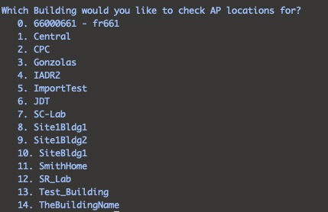

The floor names in the Ekahau file must match the names of the floors in XIQ.
If the floor name is not found in the selected building the script will not proceed.
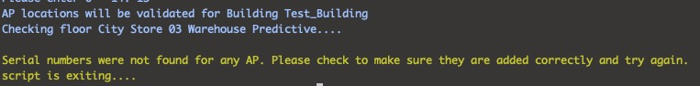

Floors assigned to Buildings in Ekahau:
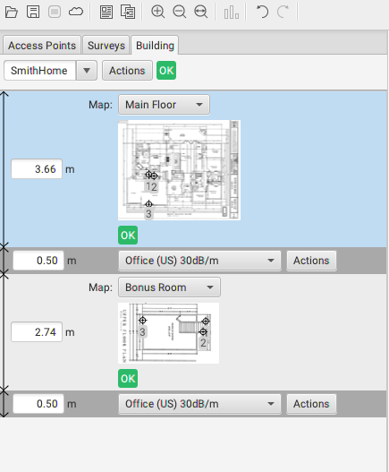
If the Ekahau file contains the building(s) with floors assigned to them, the script will use the name of the building(s) and the names of the floor(s) underneath. If the building name is not found in XIQ, then the user can select from a list of Buildings.
The names of the floors from Ekahau will still be used.
The names of the floors in Ekahau must match the names of the floors of the Building in Ekahau. If the floor is not found the script will exit.

Assign AP locations from the Ekahau File:
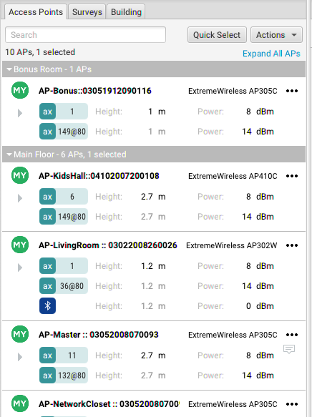
For the script to place APs in the correct location in XIQ, the script needs to know the serial number of the APs. There are two ways to do this. The first is to add the serial numbers to the AP's names in the Ekahau file. (Covered in this section) The second option is to use a CSV to map the AP names to the serial numbers. (See CSV section)
To add the serial numbers to the APs names in the Ekahau file, you must format the AP name by adding the serial numbers to the AP name, separating them by two colons as shown.
<AP Name> :: <Serial Number>

The script omits spaces.

Running The Script:
To run the script, open the terminal to the location of the script and run the following:
Python3 XIQ_Ekahau_AP_Placement_Update.py
chmod +x XIQ_Ekahau_AP_Placement_Update.py
You can also make the script executable by running
Then, you can run the script by typing
./ XIQ_Ekahau_AP_Placement_Update.py

The script will ask you to enter an Ekahau file. You can either enter the file's name, including the full path to the file, or in macOS, you can drag the file into the terminal and hit enter. You can enter the file's name if you add the Ekahau file to the same folder as the script. The script will collect the needed information from the Ekahau file. Once that is complete, the script will ask for your XIQ username and password.
- Note: The User account will need an administrator or operator role.

Access Points
After the floor names are validated, the script will check the serial numbers of the APs in the Ekahau File. The script will do this differently based on how the floor plan was originally imported. The script will let you know of any devices that do not have serial numbers, or if there are any duplicate serial numbers found. If duplicates are found the script will stop and prompt you to fix the file.

The script will then proceed with the serial numbers it found. The script will print a line for each AP moves checking for floor changes and x,y coordinate changes.

Once the script goes through all APs, if there were any moves, it will list the pending updates and confirm if you want them to be moved.
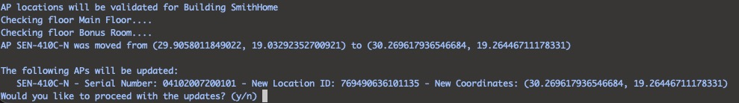

Arguments
Two optional arguments can be added when running the script.
--CSV
This flag is used when a CSV maps the AP names to the serial numbers. (See CSV section below) To run the script using a CSV, in the terminal, you would run the following:
Python3 XIQ_Ekahau_Importer.py --csv <path & name of csv file>

On macOS, an easy way to get the path and name of a file in the terminal is to drag and drop the file in the terminal window. If the CSV file is in the same folder as the script, you can enter the CSV file name.
--external
This flag allows you to import the Ekahau floorplans into a VIQ that you are an external user of.
To run the script on an externally managed VIQ in the terminal, you would run.
Python3 XIQ_Ekahau_Importer.py --external

The script will start as usual and ask for an Ekahau file and your XIQ login. After logging in, you will be presented with a choice of which VIQ you want to import into.
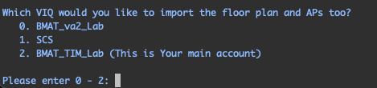

CSV File
A CSV file can map AP serial numbers to AP names. This is most beneficial for large Ekahau files, so you don’t have to go through and add the serial numbers to each AP name. This CSV file will need two columns with “AP Name” and “Serial Number” as the headers. Additional columns can be added but will be ignored by the script. This file could be a switch port worksheet, or something used for other purposes.
AP #,AP Name,Model,Serial Number,Mac Address
1,AP-Bonus,ExtremeWireless AP305C, 03052008070096, 7467F79B3B70

Log File
Upon running the script, a log file will be created named map_importer.log. This log file contains the same type of information printed on the screen. It is also an excellent place to check if any issues arise as there sometimes is more information in the log file.