# XIQ-SE RadSec IP

# Update Workflow

27 Oct 2022 Version 1.1

Table of Contents

Introduction 3

Installing the Workflow 3

Setting Email list for Workflow 4

Running the RadSac IP Updater Workflow 5

Scheduling Workflow 7

Introduction

This document covers installing and using the RadSec IP Update Workflow in XIQ-SE. This Workflow will do an NSLookup on the FQDN of the RadSec server, collect the IP addresses returned, and update the Radius Servers IP addresses in XIQ-SE.

There are 3 different versions of the workflow. The number of IP addresses need to match in the FQDN, Authentication rule, and version of the workflow.

**Note:** The API calls used by this script require XIQ-SE version 22.9.10.14 or later

Installing the Workflow

The RadSec IP Updater workflow can be imported into a XIQ-SE appliance.

* Go to the **Tasks** tab on the left
* Select the **Workflows** tab
* Select either the **Workflows** folder or a **subfolder**
* Click the **gear** on the bottom and select **import**

* Choose **Select Files** and locate the **.xwf** file
* Click **Import**

Setting Email list for Workflow.

The Workflow will email if any part of the workflow has an error. You can update the email list before running by selecting the Email Failure module, the inputs section, and selecting the Email list, you would

like to use. Click save to save the changes.

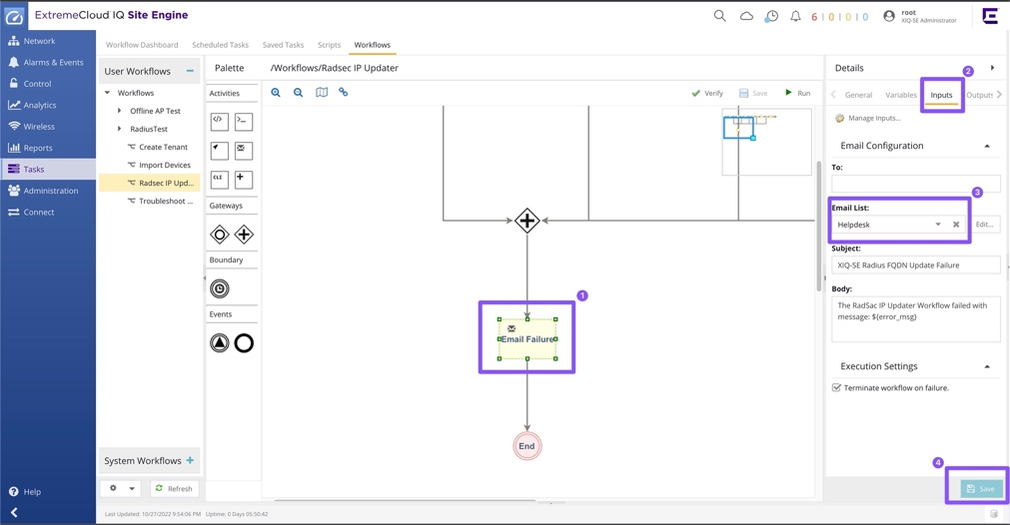

Running the RadSec IP Updater Workflow

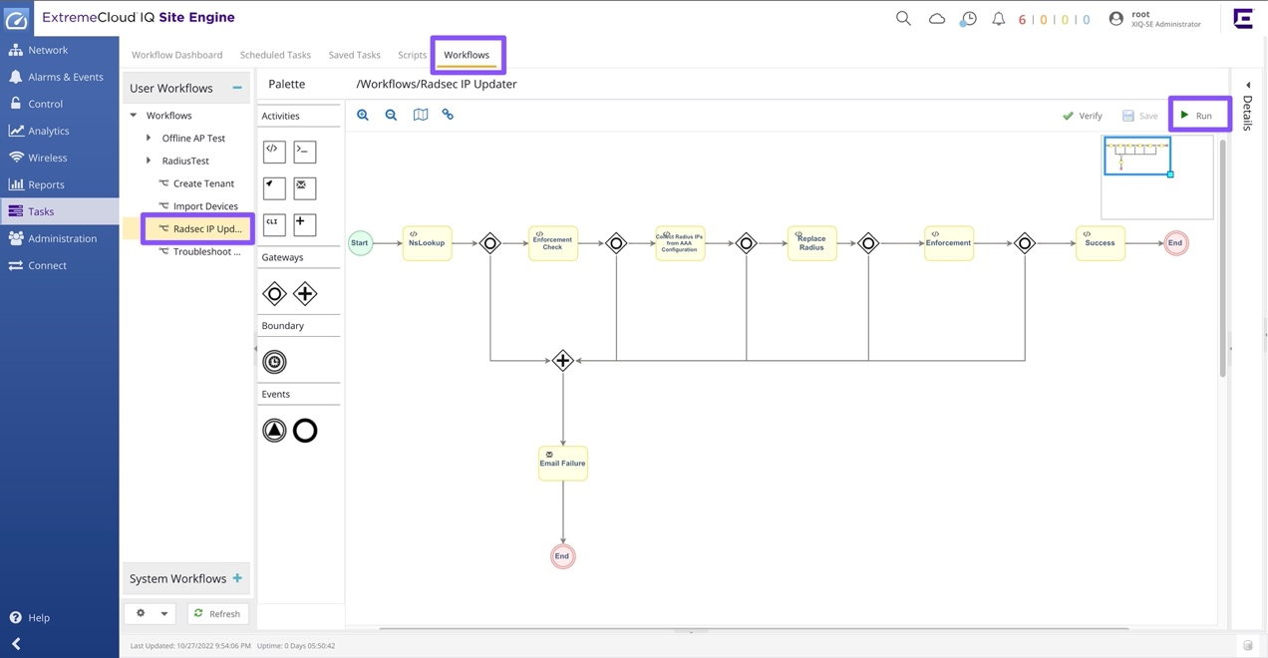In the Workflows Tab, select the newly imported RadSec IP Updater. Clicking Run will bring up the workflows input window.

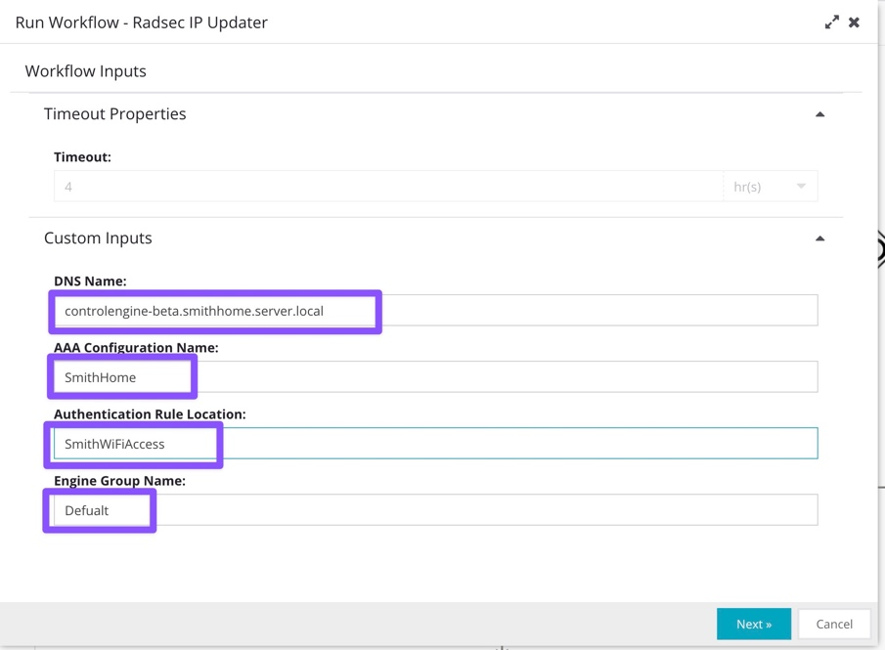

Add the FQDN of the RadSec servers to the **DNS Name** field. This will be used for the nslookup to obtain the needed IP addresses.

Add the **AAA Configuration Name** used in XIQ-SE Control.

Enter the location name in the Authentication Rules in the **Authentication Rule Location** field.

Enter the name of the Control Engine Group in the **Engine Group Name** field. It will be set to Default but you can change it in needed.

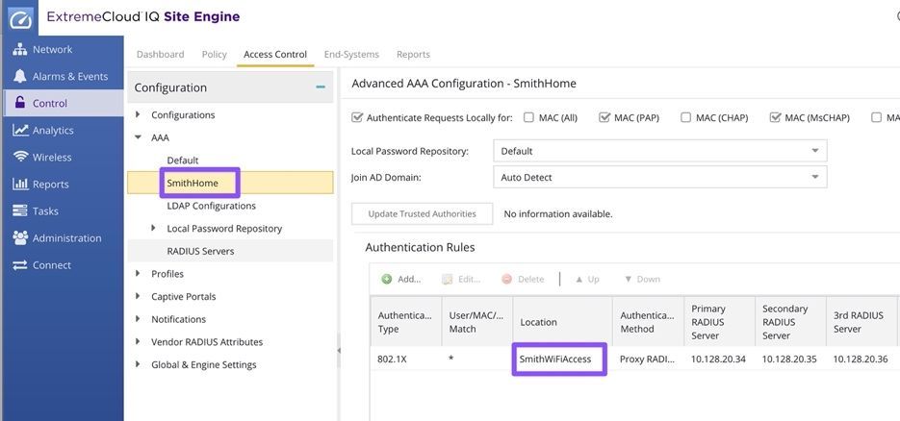The AAA Configuration Name and the Authentication Rule Location can be found in the **Control** > **Access Control** tab.

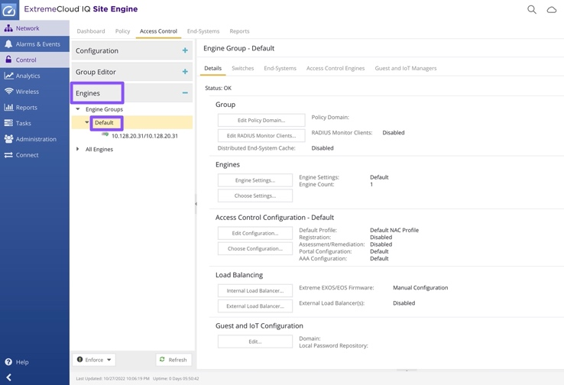

The Control Engine Group Name can be found in the **Control** > **Access Control** Tab. The Engine Groups are located under the **Engines** section.

After clicking **Next,** click **Run** in the Schedule Task window.

After the Workflow runs, you can go to the Workflow Details view to check the status.

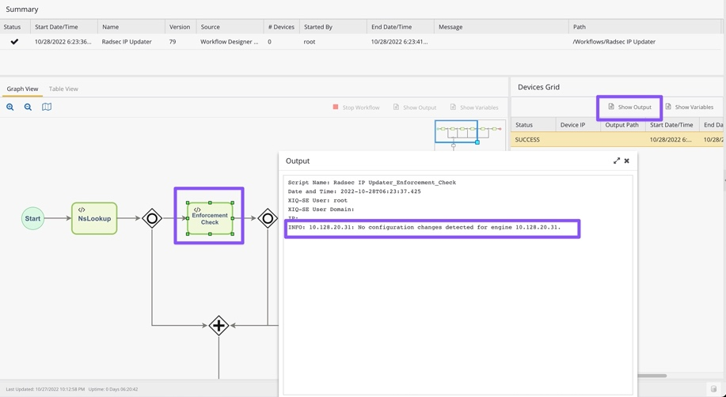In the Workflow Details view, each module will be green is succeeded. If a box is red, there was an issue, and an email should have been sent with the details. You can select boxes and click Show output on the right to view the outputs. The outputs will include details for success and errors.

Scheduling Workflow

After clicking **Next** in the Workflow Inputs window, you can enable a Schedule Task. Adding a **Check mark** in the enable box will allow you to Name the task, and set the recurrence Pattern, Date/Time range, and email settings.

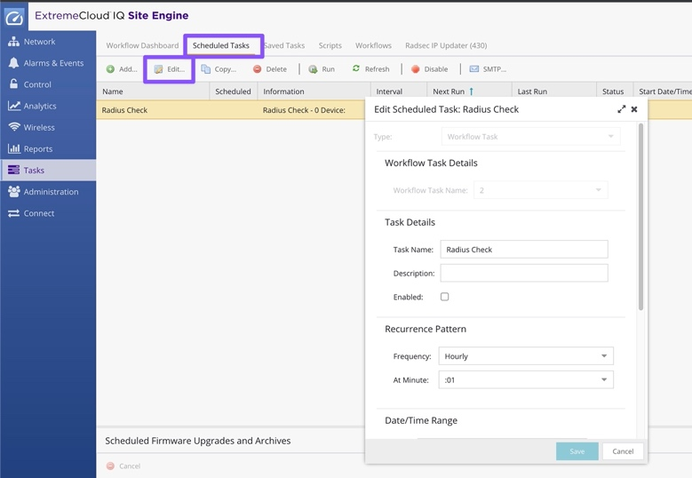You can edit a Schedule in the **Scheduled Tasks** tab.