MAPRO Test Report
Multimarket Analytics Portfolio Tracker

Date: 2026-05-18
Version: 1.0

Executive Summary
This report summarizes the test execution results for the MAPRO application.
A total of 75 test cases were executed across three modules: Scraping Engine, Caching & TTL, and IPC.

Total Tests | 75
Passed | 0
Failed | 0
Skipped | 75
Errors | 0

Environment Information
Platform: Darwin (macOS)
Python: 3.14.4
pytest: 9.0.3
Report Generated: 2026-05-18 01:17:41

Section 1: Scraping Engine
Screenshot:
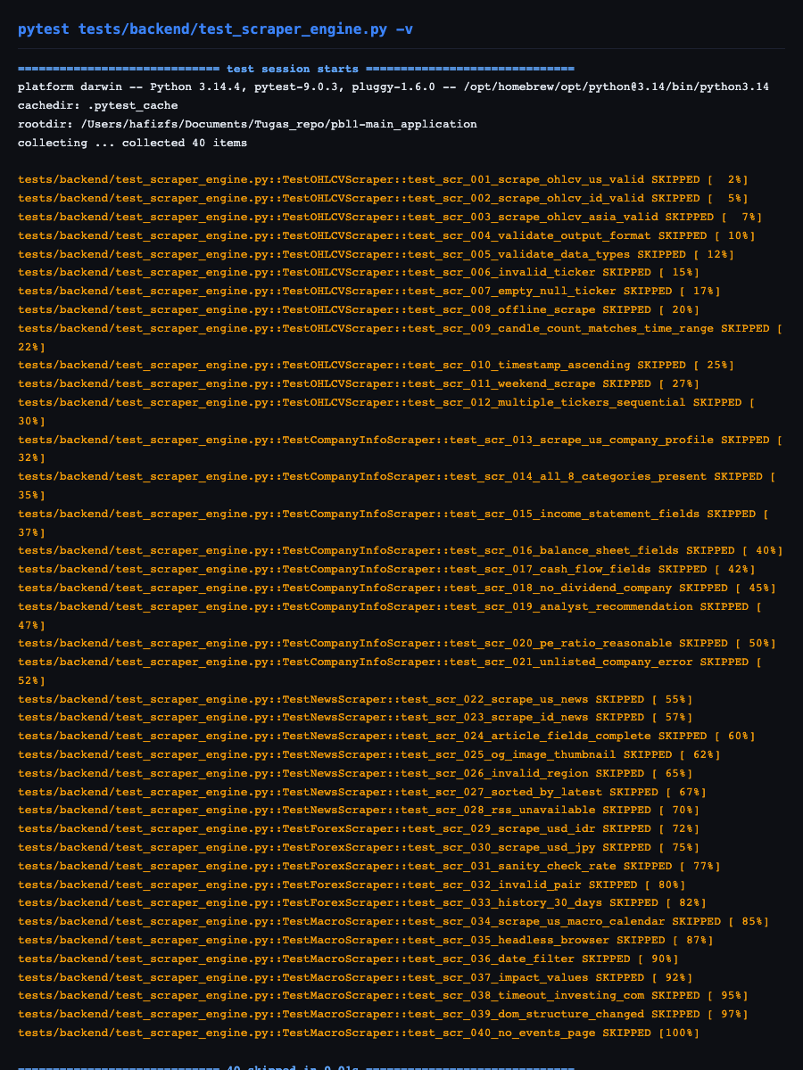

Total test cases in this section: 40

Test ID | Description | Result | Screenshot Reference
SCR-001 | Scrape OHLCV ticker saham US valid | SKIPPED | task-23-scraper-tests.png
SCR-002 | Scrape OHLCV ticker saham Indonesia valid | SKIPPED | task-23-scraper-tests.png
SCR-003 | Scrape OHLCV ticker saham Asia valid | SKIPPED | task-23-scraper-tests.png
SCR-004 | Validasi format output OHLCV | SKIPPED | task-23-scraper-tests.png
SCR-005 | Validasi tipe data OHLCV | SKIPPED | task-23-scraper-tests.png
SCR-006 | Scrape ticker tidak valid/tidak ada | SKIPPED | task-23-scraper-tests.png
SCR-007 | Scrape ticker kosong/null | SKIPPED | task-23-scraper-tests.png
SCR-008 | Scraper berjalan saat tidak ada internet | SKIPPED | task-23-scraper-tests.png
SCR-009 | Jumlah candle sesuai rentang waktu | SKIPPED | task-23-scraper-tests.png
SCR-010 | Urutan timestamp ascending | SKIPPED | task-23-scraper-tests.png
SCR-011 | Scrape saat market tutup (weekend) | SKIPPED | task-23-scraper-tests.png
SCR-012 | Scrape multiple ticker secara berurutan | SKIPPED | task-23-scraper-tests.png
SCR-013 | Scrape profil perusahaan US valid | SKIPPED | task-23-scraper-tests.png
SCR-014 | Kelengkapan 8 kategori output | SKIPPED | task-23-scraper-tests.png
SCR-015 | Scrape income statement | SKIPPED | task-23-scraper-tests.png
SCR-016 | Scrape balance sheet | SKIPPED | task-23-scraper-tests.png
SCR-017 | Scrape cash flow statement | SKIPPED | task-23-scraper-tests.png
SCR-018 | Scrape saham tanpa dividen | SKIPPED | task-23-scraper-tests.png
SCR-019 | Scrape data analis (rekomendasi) | SKIPPED | task-23-scraper-tests.png
SCR-020 | Validasi PE ratio reasonable | SKIPPED | task-23-scraper-tests.png
SCR-021 | Scrape perusahaan tidak terdaftar di market | SKIPPED | task-23-scraper-tests.png
SCR-022 | Scrape berita region US | SKIPPED | task-23-scraper-tests.png
SCR-023 | Scrape berita region ID | SKIPPED | task-23-scraper-tests.png
SCR-024 | Kelengkapan field per artikel | SKIPPED | task-23-scraper-tests.png
SCR-025 | Ekstraksi og:image thumbnail | SKIPPED | task-23-scraper-tests.png
SCR-026 | Scrape region tidak valid | SKIPPED | task-23-scraper-tests.png
SCR-027 | Berita ter-sort berdasarkan waktu terbaru | SKIPPED | task-23-scraper-tests.png
SCR-028 | Ketahanan saat RSS feed tidak tersedia | SKIPPED | task-23-scraper-tests.png
SCR-029 | Scrape kurs USD/IDR | SKIPPED | task-23-scraper-tests.png
SCR-030 | Scrape kurs USD/JPY | SKIPPED | task-23-scraper-tests.png
SCR-031 | Validasi nilai kurs wajar | SKIPPED | task-23-scraper-tests.png
SCR-032 | Scrape pair tidak valid | SKIPPED | task-23-scraper-tests.png
SCR-033 | Kelengkapan history 30 hari | SKIPPED | task-23-scraper-tests.png
SCR-034 | Scrape kalender ekonomi US | SKIPPED | task-23-scraper-tests.png
SCR-035 | Playwright browser terbuka headless | SKIPPED | task-23-scraper-tests.png
SCR-036 | Filter tanggal berjalan dengan benar | SKIPPED | task-23-scraper-tests.png
SCR-037 | Validasi nilai `impact` | SKIPPED | task-23-scraper-tests.png
SCR-038 | Timeout saat investing.com tidak responsif | SKIPPED | task-23-scraper-tests.png
SCR-039 | DOM structure berubah di investing.com | SKIPPED | task-23-scraper-tests.png
SCR-040 | Scrape kalender saat tidak ada event | SKIPPED | task-23-scraper-tests.png

Section 2: Caching & TTL
Screenshot:
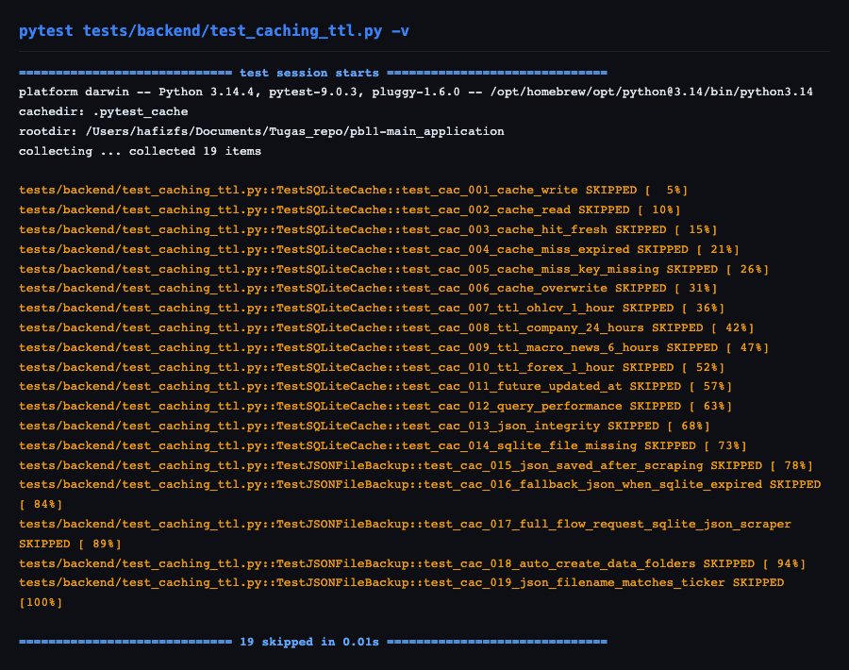

Total test cases in this section: 19

Test ID | Description | Result | Screenshot Reference
CAC-001 | Cache write — data tersimpan ke SQLite | SKIPPED | task-23-caching-tests.png
CAC-002 | Cache read — data terbaca dari SQLite | SKIPPED | task-23-caching-tests.png
CAC-003 | Cache hit — data masih segar (dalam TTL) | SKIPPED | task-23-caching-tests.png
CAC-004 | Cache miss — data sudah expired | SKIPPED | task-23-caching-tests.png
CAC-005 | Cache miss — key tidak ada | SKIPPED | task-23-caching-tests.png
CAC-006 | Update cache (overwrite) | SKIPPED | task-23-caching-tests.png
CAC-007 | TTL OHLCV = 1 jam | SKIPPED | task-23-caching-tests.png
CAC-008 | TTL Company Info = 24 jam | SKIPPED | task-23-caching-tests.png
CAC-009 | TTL Macro & News = 6 jam | SKIPPED | task-23-caching-tests.png
CAC-010 | TTL Forex = 1 jam | SKIPPED | task-23-caching-tests.png
CAC-011 | Cache tidak terpengaruh TTL yang salah | SKIPPED | task-23-caching-tests.png
CAC-012 | Performa query SQLite | SKIPPED | task-23-caching-tests.png
CAC-013 | Integritas data JSON tersimpan | SKIPPED | task-23-caching-tests.png
CAC-014 | SQLite file tidak ada | SKIPPED | task-23-caching-tests.png
CAC-015 | Data disimpan ke file JSON setelah scraping | SKIPPED | task-23-caching-tests.png
CAC-016 | Fallback ke file JSON saat SQLite expired | SKIPPED | task-23-caching-tests.png
CAC-017 | Alur lengkap: Request → SQLite → JSON → Scraper | SKIPPED | task-23-caching-tests.png
CAC-018 | Struktur folder `data/` terbentuk otomatis | SKIPPED | task-23-caching-tests.png
CAC-019 | Nama file JSON sesuai ticker/key | SKIPPED | task-23-caching-tests.png

Section 3: IPC (Inter-Process Communication)
Screenshot:
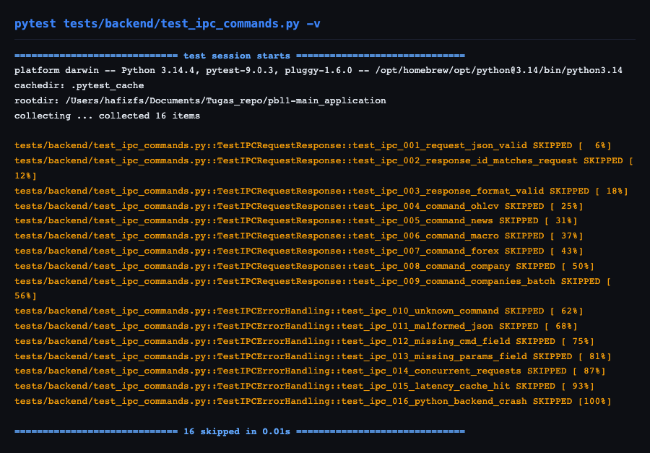

Total test cases in this section: 16

Test ID | Description | Result | Screenshot Reference
IPC-001 | Request format JSON valid ke Python | SKIPPED | task-23-ipc-tests.png
IPC-002 | Response ID cocok dengan request ID | SKIPPED | task-23-ipc-tests.png
IPC-003 | Format response JSON valid | SKIPPED | task-23-ipc-tests.png
IPC-004 | Command `ohlcv` berjalan | SKIPPED | task-23-ipc-tests.png
IPC-005 | Command `news` berjalan | SKIPPED | task-23-ipc-tests.png
IPC-006 | Command `macro` berjalan | SKIPPED | task-23-ipc-tests.png
IPC-007 | Command `forex` berjalan | SKIPPED | task-23-ipc-tests.png
IPC-008 | Command `company` berjalan | SKIPPED | task-23-ipc-tests.png
IPC-009 | Command `companies` (batch) berjalan | SKIPPED | task-23-ipc-tests.png
IPC-010 | Command tidak dikenal | SKIPPED | task-23-ipc-tests.png
IPC-011 | Request JSON malformed | SKIPPED | task-23-ipc-tests.png
IPC-012 | Request tanpa field `cmd` | SKIPPED | task-23-ipc-tests.png
IPC-013 | Request tanpa field `params` | SKIPPED | task-23-ipc-tests.png
IPC-014 | Concurrent request (multiple sekaligus) | SKIPPED | task-23-ipc-tests.png
IPC-015 | Latency IPC pipe | SKIPPED | task-23-ipc-tests.png
IPC-016 | Python backend crash/restart | SKIPPED | task-23-ipc-tests.png

Additional Screenshots
The following screenshots were captured during test execution:

Loading Screen:
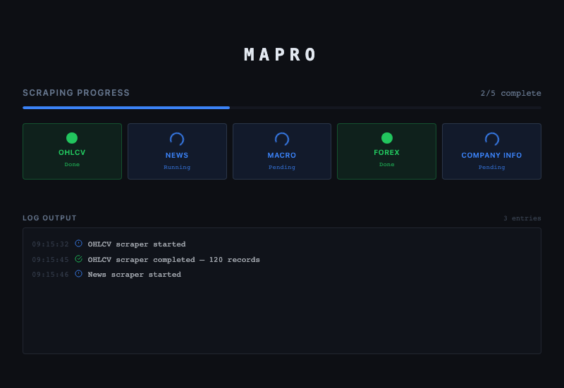

New Data Badge:


End of Report
Report generated on 2026-05-18 01:17:41
This document was automatically generated by tests/generate_report.py

