PS AIS – DEMO APP

Quick-Start

Contents

1 Introduction - 2 -

2 Call of Kibana and Grafana - 2 -

2.1 Kibana - 2 -

2.2 Grafana - 3 -

2.2.1 Description of the Graph - 3 -

2.2.2 Prediction of the Stock Exchange - 4 -

1.2.3 General Information about Grafana - 5 -

# Introduction

The following documentation describes the usage of the visualization applications Kibana and Grafana for our Demo App. This documentation explains the

* first opening of Kibana and Grafana
* login function of Kibana and Grafana
* first steps in Kibana and Grafana
* functions of our visualization in Kibana and Grafana

# First Opening of Kibana and Grafana

A brief overview of Kibana and Grafana can be found here:

Kibana: <https://www.elastic.co/de/products/kibana>

Grafana: <http://grafana.org/features/>

For opening of Kibana and Grafana it is necessary to be within the network of the Heilbronn University.

## Kibana

Opening Kibana is made with the address <http://141.7.63.160:5601/>. Kibana runs on port 5601.

We use Kibana for the visualization of tweets during the last minutes.

The graphic at the top describes the number of tweets which were recorded. The time interval is 30 seconds. So it is possible to see the number of tweets for every 30 seconds.

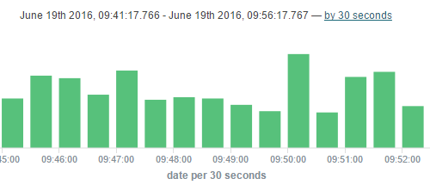

The individual tweets are listed under the graphic with the number of tweets.

For every tweet you can see the following attributes:

* Date and timestamp of the tweet (date)
* Author of the tweet (author)
* the message respectively the tweet itself (message)
* The ID of the tweet (_id)
* The sentiment-score of the tweet (_score)



It is possible to change the view for the tweets. So you can see the tweets for an individual timeslot. The setting for the timeslot is on the right side of the page. Here you can change the timeslot.

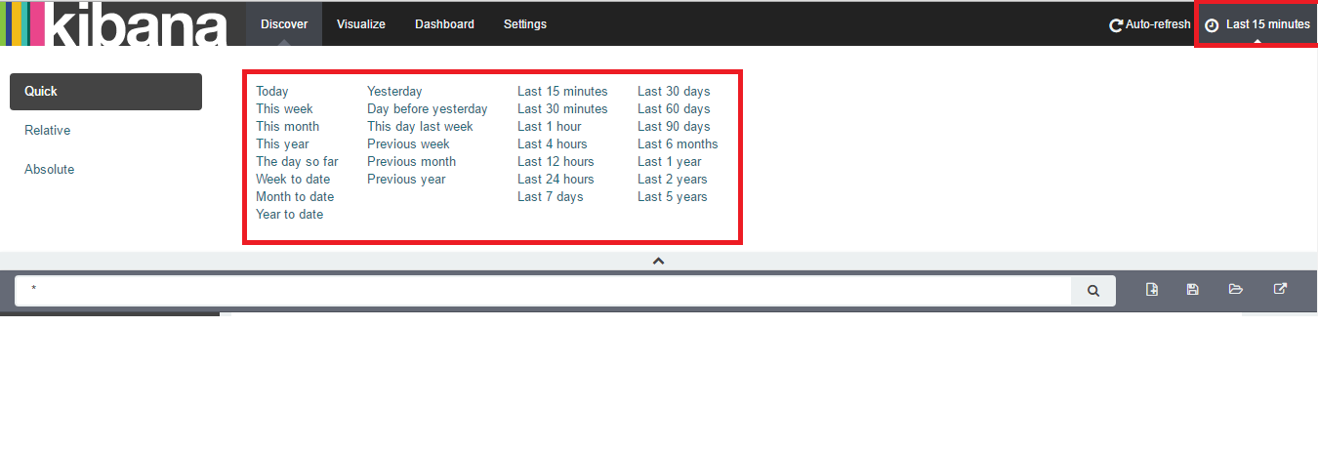

On the left side of the page it is possible to select the tweets, for example according to the author or the sentiment-score.

## ****Grafana****

Opening Grafana is made with the address <http://141.7.63.160:3000/>. Grafana runs on port 3000. To log on to Grafana, use the default user name and password “admin/admin”.

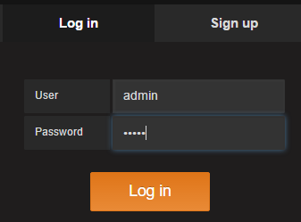

We use Grafana for the visualization of the stock exchange prediction.

On the first page you can see the different dashboards. For our Demo App we have only one dashboard at the moment: PS AIS.

You can call it on the left side of the page under the menu “Home”.

### Description of the Graph

The graphic on the page shows the stock exchange course and the trend of the sentiment relation.

On the left side (Y-Axis) you can see the stock exchange course and on the right side (second Y-Axis) the average of the sentiment relation.

The yellow graph describes the trend of the sentiment relation. You can only see the sentiment relation when the tweets have been analysed.

The blue graph describes the stock exchange course. A gap in the graph shows that there was no recording of the stock exchange values, for example on weekends.

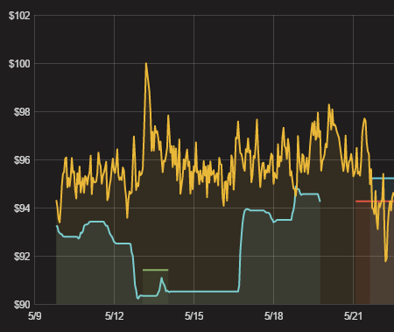

### Prediction of the Stock Exchange

For the prediction there are two important facts in the graph.

The green line predicts, that the stock exchange course will rise up because of the sentiment.

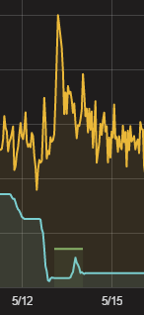The red line predicts, that the stock exchange course will fall because of the sentiment

Here an example for the rise of the stock exchange:

* + The green line describes that there will be a rise of the course (prediction)
  + The yellow line describes a rise of the sentiment relation for the time slot
  + The blue line describes that the stock exchange rises up really (shows the stock exchange course)

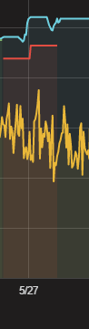

Here an example for the fall of the stock exchange:

* + The red line describes that there will be a fall of the course (prediction)
  + The yellow line describes a fall of the sentiment relation for the time slot
  + The blue line describes that the stock exchange rises up really (shows the stock exchange course)

### 1.2.3 General Information about Grafana

On the top of the page you can change the timeslot of the graph:



It is possible to zoom in the actual graph. Always when you go with the courser over the graph, you can see a cross to zoom in the graph.

