**Content:**

1. Myeongdong

+The areas surrounding Myeongdong Theater  intersection is a shopper’s paradise, offering many different shopping experiences ranging from prestige brand stores to street stalls. In particular, select shops selling new designers’ brands have recently gained popularity. A number of mega shopping malls, including Lotte Department Store, Shinsegae Department Store, and Migliore are also located in the vicinity. Myeong-dong is not only known for shopping and fashion trends, but also has a variety of places to dine. Visitors can find some of the top gourmet restaurants in the city, as well as a vast assortment of delectable street food.

+Myeong Station – Exit 6 or 7 – 1min walk

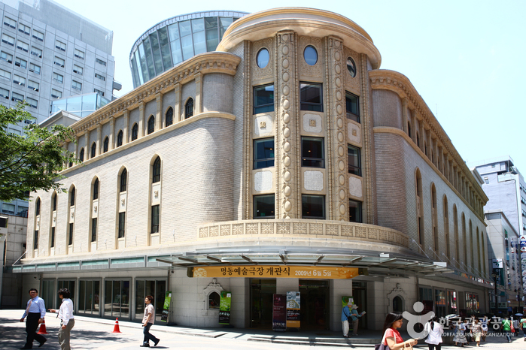

Myeongdong theater

1. Hongdae

+Hongdae is a neighborhood known for its youthful and romantic ambience, underground culture, and freedom of self-expression. Unique cafes, cozy galleries, accessory stores, fashion shops, live cafés and clubs, art markets, and gourmet eateries make this a popular hang-out for local youth and a fascinating place to walk around. These unique places plus the cultural events, street performances, and festivals held here make Hongdae an area that is always packed with people and excitement. Special streets such as ateliers’ street (lined with private institutions for art students preparing for university entrance exams), Picasso’s Street, and Club Street are also must-go places if you’re hoping to fully experience the Hongdae area.

+Hongik University Station (Subway Line 2, Gyeongui-Jungang, AREX), Exit 9.  
Go 150m straight, and cross the street.  
Turn left, and go 500m straight towards Hongik University.  
Turn right to arrive at Hongik Children's Park.

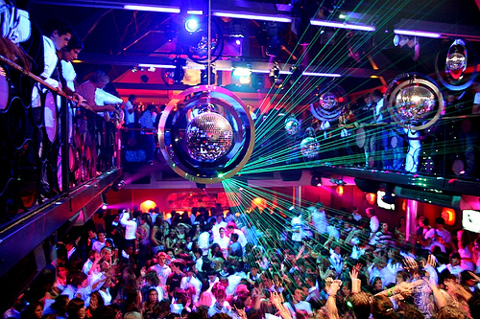

1. Itaewon

+Travelers can taste authentic cuisine and experience culture from around the globe on the World Food Street where there are 40 restaurants operated by foreigners. Since the late 1990s, an increase in the number of tourists from Southeast Asia and the Middle East has transformed the streets from being US Army-oriented into culturally diverse. Varied performance and events are held in the area. In particulary, Itaewon Global Village Festival, held every October, is a famous festival. Tourists can pay in US dollars, Japanese Yen or another currency freely. In addition, visitors can use various languages like English, Japanese, and Chinese with the sellers.

+Itaewon Station / Noksapyeong Station / Hangangjin Station (Seoul Subway Line 6)

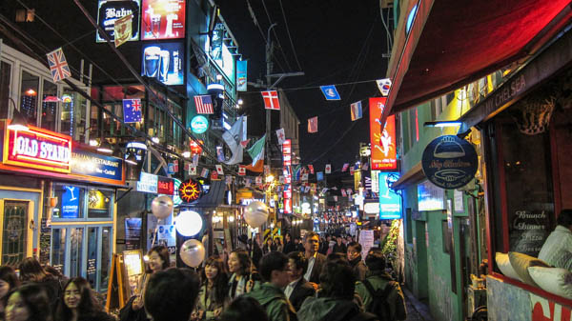

1. Seoul Museum of Art

+Jeongdong-gil Road is a representative cultural street in Seoul. Conveniently located in the center, the Seoul Museum of Art (SeMA) is a Korean modern art museum where visitors can view a combination of modern architecture and art. Formerly the Supreme Court building, SeMA moved into the location in 2002. The old façade was preserved, while the building was renovated into a three-story building with 6 exhibition halls, a lecture hall for educational programs, and a library where a collection of 3,500 pieces of art from famous writers are available. An outdoor sculpture garden is also available, serving as a good promenade for a leisure stroll.

+City Hall Station, Exit 1

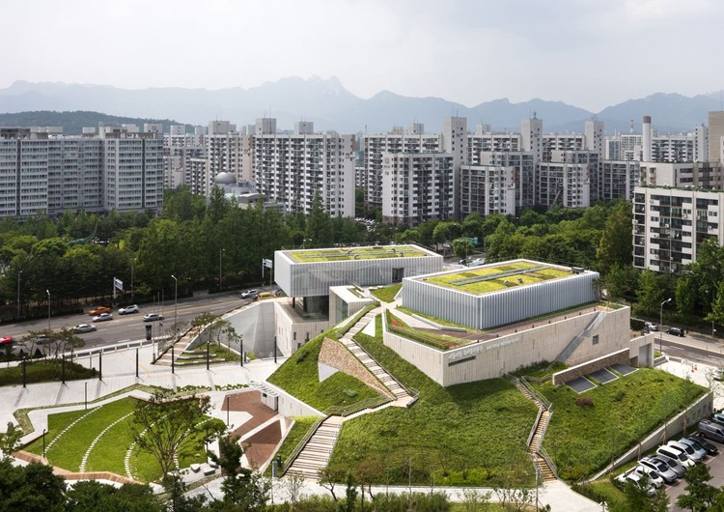

1. Changdeokgung Place

+Changdeokgung Palace was the second royal villa built following the construction of Gyeongbukgung Palace in 1405. It was the principal palace for many kings of the Joseon Dynasty, and is the most well-preserved of the five remaining royal Joseon palaces. The palace grounds are comprised of a public palace area, a royal family residence building, and the rear garden. Known as a place of rest for the kings, the rear garden boasts a gigantic tree that is over 300 years old, a small pond and a pavilion.

+Anguk Station (Seoul Subway Line 3), Exit 3.   
Walk straight from the exit (towards east) for about 5-min to arrive at the palace entrance.

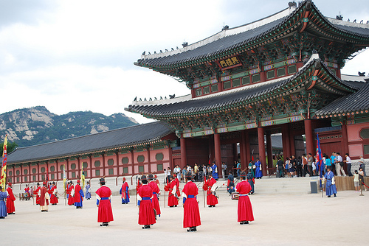

1. Gwanghwamun

+ Gwanghwamun Square, located in the middle of Sejongro Street, has transformed into a human-centered space that harmonizes with the beautiful scenery of Gyeongbokgung Palace and Bukaksan Mountain. The most recommended itineraries to see some of the best sights the city has to offer usually start off from the square to explore Gyeongbokgung Palace, before continuing past Cheonggye Plaza along City Hall (Seoul Plaza) and then take a stroll along Jeong-dong Street to Deoksugung Palace. The two statues of Admiral Yi Sun-Shin and King Sejong the Great are the symbols of Gwanghwamun Square

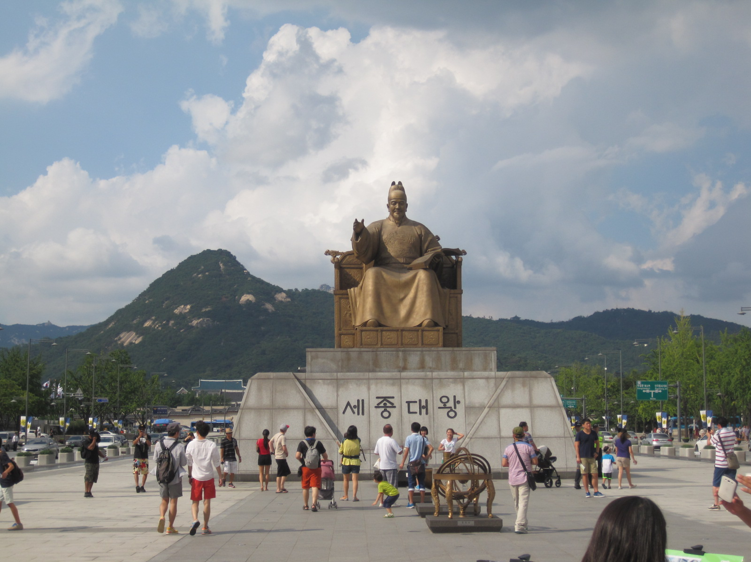+Gwanghwamun Station, Exit 1,2 or 8