Students

Eyad Yehia Mohammed 211001231

Elena Magdy Kamel 211001719

Abdelrahman Magdi Khalaf 211000890

Dr / Sameh Abdelrahman Ahmed  
Spring/2023

Cinema Seat Reservation Project

Cinema Seat Reservation

The Cinema Seat Reservation project is a JavaFX application that allows users to reserve seats in a cinema hall. The application provides a graphical user interface where users can view available seats, select seats for reservations, and cancel existing reservations. The project is implemented using the JavaFX framework, providing an interactive and user-friendly experience.

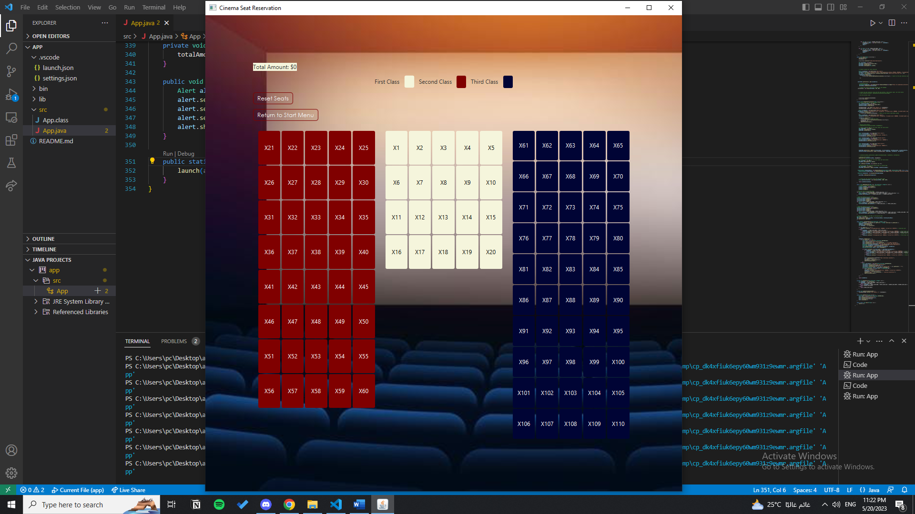

**Features**

Seat Selection: Users can view the layout of the cinema hall and select seats for reservation. The seat layout consists of three classes: First Class, Second Class, and Third Class. Each class has a different seating arrangement and price.

Seat Availability: The application displays the availability of seats by color-coding them. Available seats are indicated with different colors for each class, making it easy for users to identify and select their preferred seats.

Seat Reservation: Users can reserve available seats by clicking on them. Once a seat is reserved, its color changes to indicate that it is no longer available for selection.

Seat Cancellation: If a user has already reserved a seat, they can cancel the reservation by clicking on the seat. A confirmation dialog is displayed to confirm the cancellation. Upon cancellation, the seat becomes available for other users to reserve.

Total Amount Calculation: The application calculates and displays the total amount for the selected seats based on their class and price. The total amount is updated dynamically as seats are reserved or canceled.

Reset Seats: Users have the option to reset all seat selections and start over. This clears all reservations and restores the initial state of the seat layout.

**Usage**

Start Menu: The application starts with a start menu where users can click the "Show Seats" button to view the seat selection screen.

Seat Selection Screen: The seat selection screen displays the seat layout and availability. Users can select seats for reservation by clicking on them. The selected seats are marked as reserved, and the total amount is updated accordingly.

Seat Cancellation: If a seat is already reserved, users can click on it to cancel the reservation. A confirmation dialog is displayed to confirm the cancellation.

Total Amount: The total amount for the selected seats is displayed at the top of the screen. It is updated dynamically as seats are reserved or canceled.

Reset Seats: Users can click the "Reset Seats" button to clear all seat selections and start over. This restores the initial state of the seat layout and total amount.

**Class Documentation**

App: The main class that extends the JavaFX Application class. It initializes the seat layout, creates the user interface, handles seat selection and cancellation, and displays reservation information.

Pair: A generic class representing a pair of values. It is used to store seat information, including availability and seat number.

**Dependencies**

JavaFX: The JavaFX framework is required to run the application. It provides the necessary libraries for building the graphical user interface.

**Conclusion**

The Cinema Seat Reservation project is a user-friendly application that allows users to reserve seats in a cinema hall. It provides an interactive interface for seat selection, cancellation, and total amount calculation. The project demonstrates the use of JavaFX for building graphical user interfaces and handling user interactions.