A .

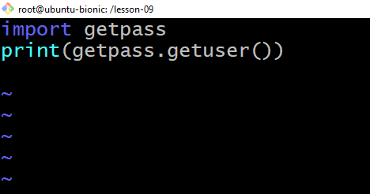

B.

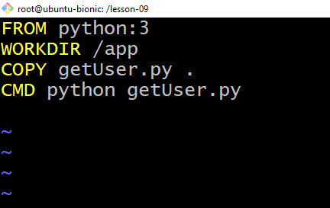

C

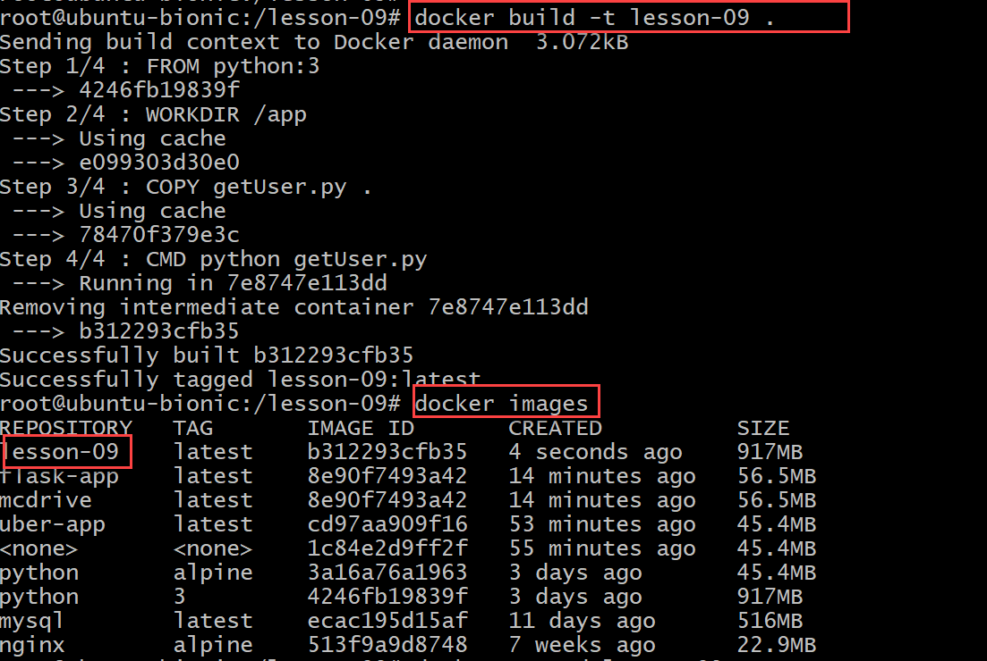

D

Q2 :

<https://hub.docker.com/repository/docker/eyabtest/lesson-09>

