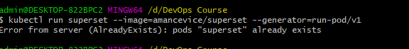



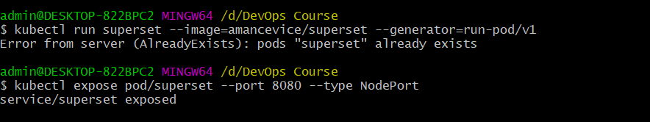

1. 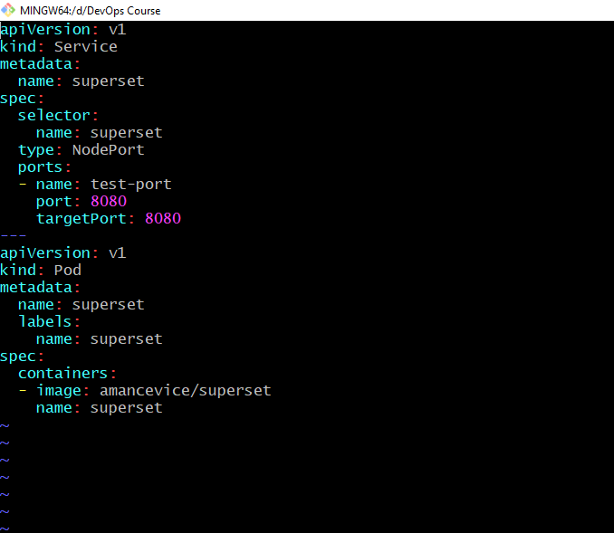
2. 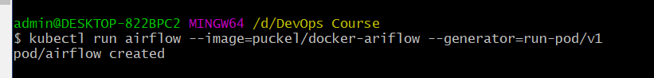

there was an issue with the pull of (airflow) so I couldn't to expose it



from describe of the pod