**Campus resource management system**

**Phase 3**

Subject: System Analysis and Design

Code: SECD2613

Section 07

Prepared by

Abdalla Ali Abdalla Ali A23CS3022

EYAD AIMEN ELSHEIKH KHALIL A23CS3024

Othman Hassan Othman A23CS3026

Ali Isameldin Ali A23CS3001

**1.0 Overview of the project:**

This project is designed to solve this university systems issues. The main focus of the project is to deliver IS that handles large amounts of data and automates most of the processes to reduce errors. This project covers four important areas to enhance its processes: Facility and booking management, Event management, student management and communication and notification.

**2.0 Problem statement:**

The current system suffers from frequent input errors and delaying of processes and the system output is usually similar or close to its input due to lack of critical processes. The system also lacks some essential technical hardware equipment, while depending mainly on human workforce without much computerized intervention.

Not to mention that the system is difficult to use for new users.

**3.0 Proposed solutions:**

To develop more advanced subsystems that can function together to maximize the output of the program, reduce the input errors, speed up the processes and can ease the management processes.

**4.0 Current business Process and workflow:**

**4.1 Facility booking and reservation management subsystem:**

In this subsystem we have 2 main entities student and booking management officer, so the processes are as follows:

1. Student: can book campus resources such as sport fields, libraries, restaurants, entertainment facilities, classrooms, etc..., they also can make all types of facility reservations as an example rooms reservations, suites reservations and facility reservations.
2. Booking management officer: can check the availability of facilities, confirm or deny reservations, issuing reservation slip containing information about the users, the reserved facility and the date, and can be stored in reservation data store.

The workflow:

The student goes to the booking management office. Then the student provides his/her information including name, ID. Then the student provides the reservation details, including date and what facility wants to book. Then the officer checks for the availability of the requested facility. Then the officer provides information about if the facility is available on that date or not to the student. And then the officer asks the student if they would like to confirm the reservation. If the student confirms the officer will issue a slip containing the information about the reservation and make another copy to store it and change the availability of the facility.

Functional requirements:

1. Input:
   1. Student information.
   2. Reservation details.
2. Process:
   1. Checking for facility availability.
   2. Confirming reservation.
   3. Issuing slip.
3. Output:
   1. Slip.

Non-functional requirements:

1. Performance:

The performance is not good, since the officer must search for facility availability manually and the officer might make some mistakes when issuing the slip.

1. Control:

If the facility is not available, the reservation cannot be confirmed and the student cannot make a reservation on the specified date.

**4.2 Event management subsystem:**

In this subsystem we have 2 main entities student and event management officer, so the processes are as follows:

1. Student: can register for the events.
2. Booking management: can make schedules for upcoming events, manage events for the students to register and can confirm registration for students and prints a paper with the attendance list.

The workflow:

The student goes to the event management office. Then the student provides his/her information including name, ID. Then the student provides the event details that wishes to go to. Then the officer checks the event information. Then the officer registers the student for the event. The officer confirms the registration for and student and the student’s information in the attendance list. In the same day as the event the officer prints a list of the students that can enter the event.

Functional requirements:

Input:

* 1. Student information.
  2. Event details.

1. Process:
2. Checking for facility availability.
3. Confirming event registration.
4. Writing student name in the attendance list.
5. Output:
   1. Attendance list.

Non-functional requirements:

1. Performance:

The performance is decent, since there are not many events and a mistake can take place only if the officer wrote student information wrong.

2. Control:

After checking for event information, if there is no event with the received information the officer cannot confirm the registration and the student cannot register for the event.

**4.3 Student management subsystem:**

In this subsystem we have 2 main entities student and administrator, so the processes are as follows:

1. Student: can enroll for the university, register for courses, access schedule and academic profile.
2. Booking management officer: can complete Enrollment of new students, complete course registration for students, manage student records (edit, store, delete, show it to the student) and manage student activities.

The workflow:

The student goes to the administrator’s office. Then the student provides his/her information including name, passport, faculty and etc… (for enrollment). The administrator takes the information to complete the enrollment. Then the administrator issues student card with the student ID for the student after the enrollment confirmation, issues a slip for the student and creates a student record for the student that also includes the student academic profile. The administrator provides information about available courses that the student can register for and the limit for credit hours. Then the student chooses the courses he/she would like to register for. Then the administrator registers the courses for the students and stores it in the student record. Finally, the administrator gives the student the schedule for the registered courses.

Functional requirements:

1. Input:
   1. Student information.
   2. Courses details.
2. Process:
   1. Enrolling the new student.
   2. Issuing student card.
   3. Registering courses.
   4. Storing student information and registered records.
   5. Providing student with the schedule
3. Output:
   1. Enrollment slip.
   2. Student card.
   3. Schedule.

Non-functional requirements:

1. Performance:

The performance is not good, due to the large number of new students that want to enroll. The current system is not good in terms of organizing and storing the student records, so the administrator must search it manually and modify it.

1. Control:

If the student information is not completed or the student did not pay for the enrollment the enrollment cannot be completed. If the student exceeds his/her credit hour limit the student cannot complete the registration unless he/she reduces the number of courses, he/she would like to register for

**4.4 Communication and notification management subsystem:**

In this subsystem we have 3 main entities student, management, and other stakeholders.

The Workflow:

The current system includes Communication Between:

Management-Stakeholders:

Management takes the hard-copied data and summarizes it to write a report which is submitted to the stakeholders via email, and it includes brief info of the benefits, complaints and materials used in each time.

Management-Students:

Students communicate with the management to get specific info about current availability of courses and important dates in the future, they communicate via email or phone calls.

Management-Management:

Management members communicate within themselves in case of complications in the registration process of students or when finding difficulties with the stakeholders.

Also, the students can communicate with each other for group projects or research or just for activities.

There are also some cases where the data delivery should be urgent and done now. The management uses a hot dialing number to deliver such information.

Functional requirements:

1. Input:
   1. Data for summarization.
   2. Student information (contact information, results).
2. Process:
   1. Summarizing data.
   2. Sending result to students or other management departments.
3. Output:
   1. Summarized data.
   2. Student results information.

Non-functional requirements:

1. Performance:

The current performance of the sub-system is slow due to data redundancy and the data is separated between the email, messaging applications and the database.

1. Control:

There are also some cases where the data delivery should be urgent and done now. The management uses a hot dialing number to deliver such information.

**5.0 Logical DFD (AS-IS):**

We could not find the same shapes for entities and data stores stated in the slides, so we used these ones.

**5.1 DFD CONTEXT DIAGRAM**

**5.2 DFD ZERO DIAGRAM FOR THE SYSTEM**

**5.3 Facility booking and reservation management subsystem child diagram**

**5.4 Communication and notification management subsystem Child diagram**

**6.0 System Analysis and Specification:**

We could not find the same shapes for entities and data stores stated in the slides, so we used these ones.

**6.1 Logical DFD (TO-BE):**

**6.1.1 DFD Context diagram**

**(context diagram image)**

**6.1.2 DFD Diagram 0**

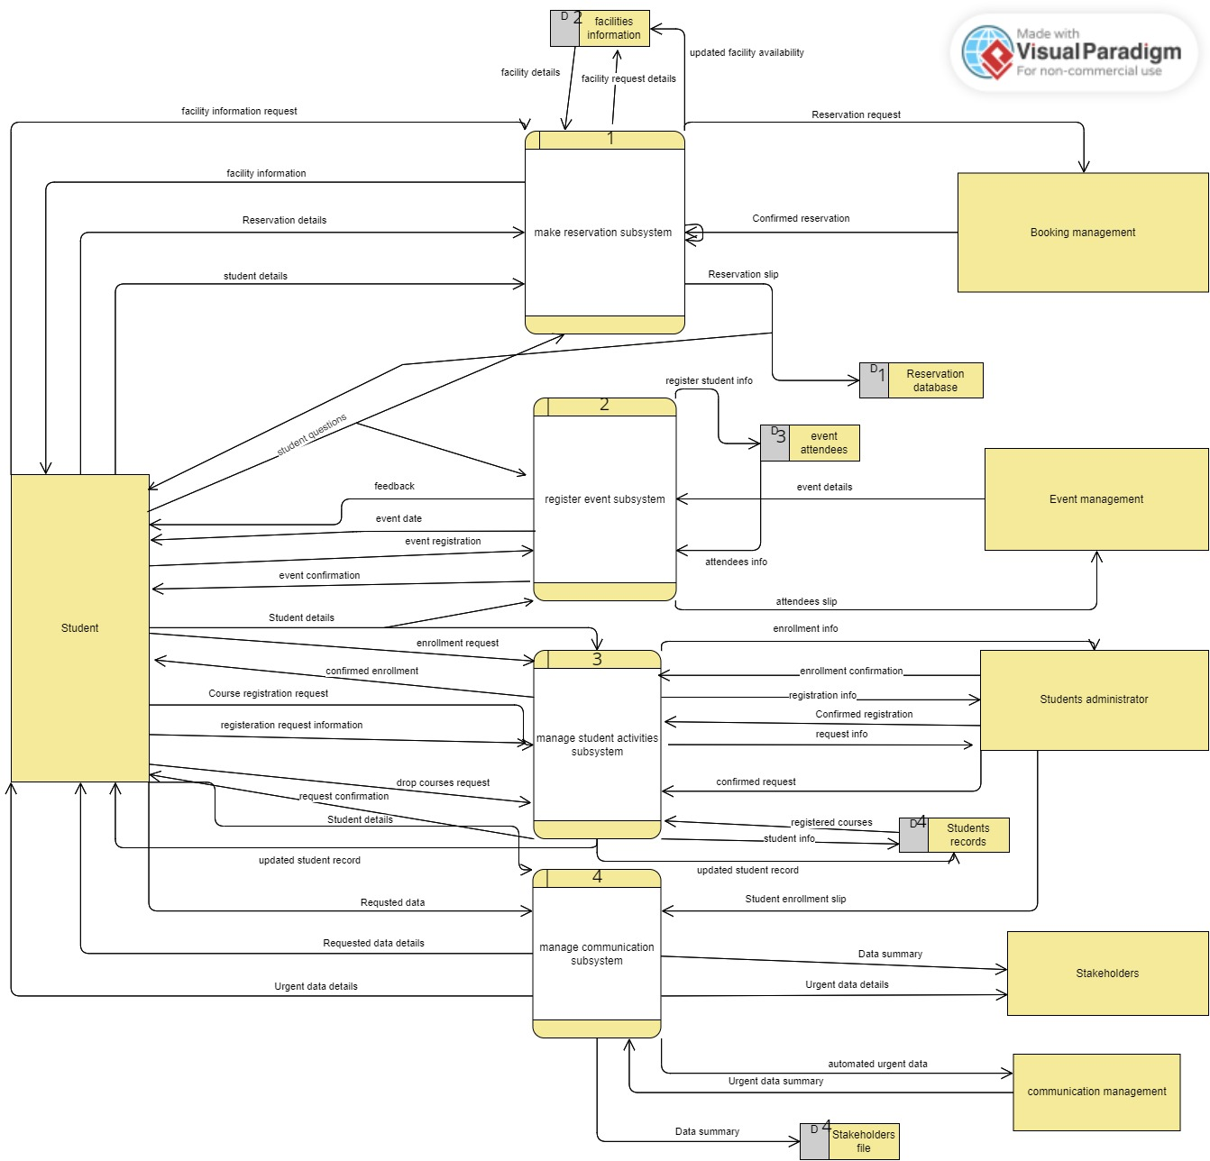

**6.1.3 Facility booking and reservation management subsystem child diagram** 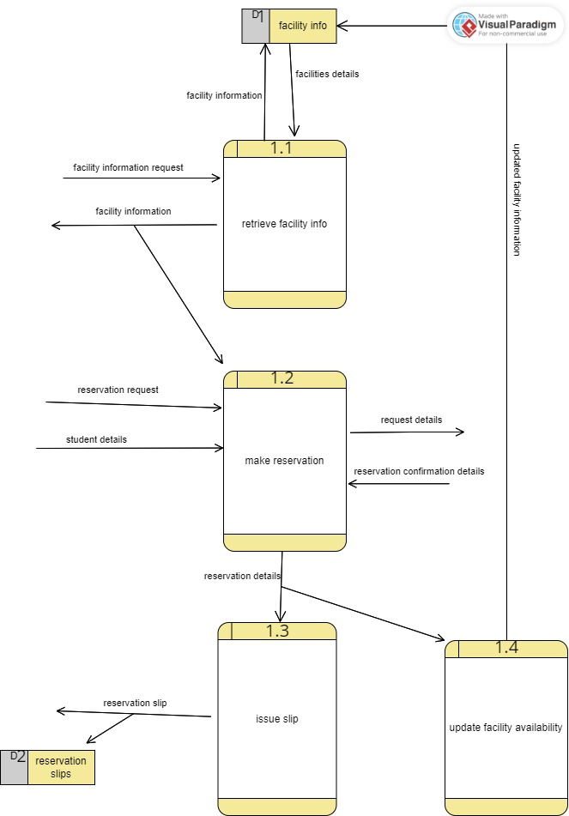

**6.1.4 register events subsystem child diagram**

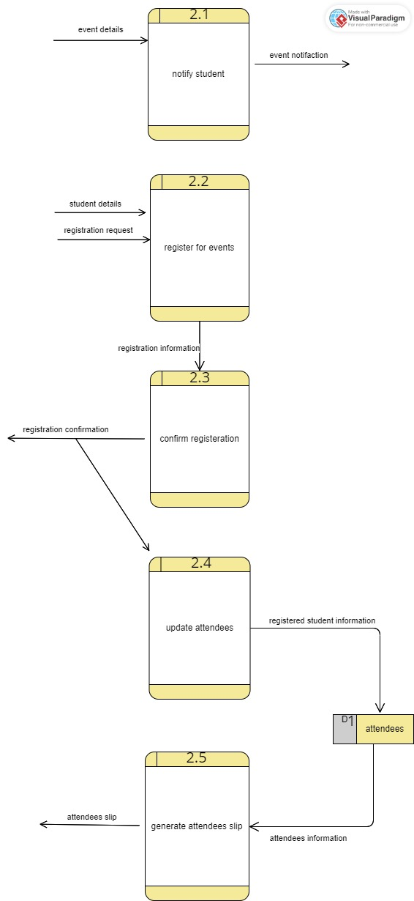

**6.1.5 Manage student activities subsystem child diagram**

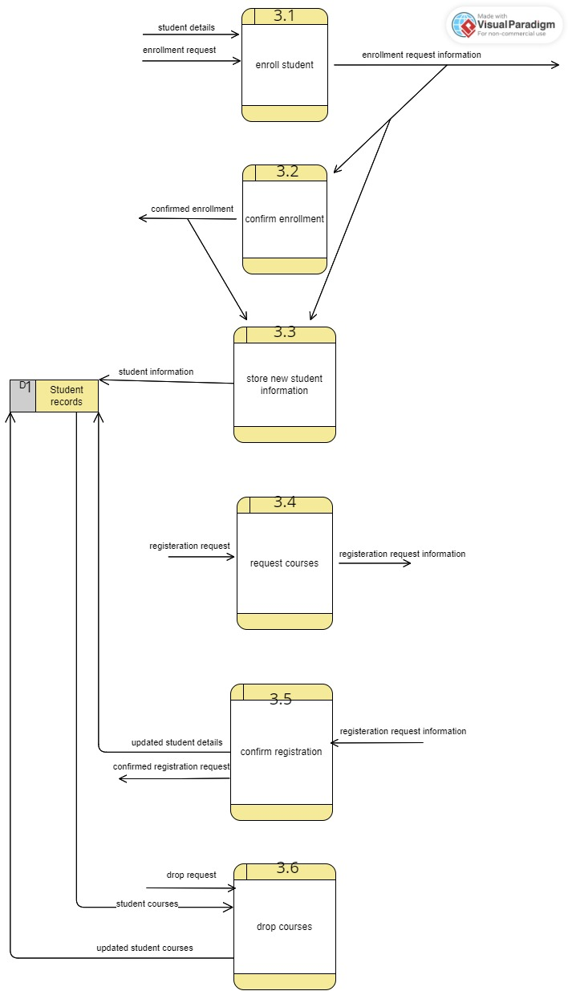

**6.2 Process Specification:**

**gggg**